Leaf Disease Classification and Affected-Area Analysis for Apple and Corn Crops: A Comparison of VGG16–SVM and CNN Approaches
Healthy vs. diseased leaf classification, lesion segmentation and severity staging
Naman Agarwal – 20233195 | Naman Katiyar – 20233196
Nishant Mohan – 20233367 | Nitya Binoy Vettical – 20233540
Department of Computer Science and Engineering, Motilal Nehru National Institute of Technology Allahabad
Abstract
Early and accurate recognition of leaf diseases is central to protecting crop yield. This project builds an end-to-end pipeline that (i) classifies apple and corn leaves into eight classes (six diseases and two healthy classes) and (ii) quantifies how much of each leaf is affected, mapping the result to one of three severity stages. Two classifiers were developed in sequence on a subset of the Kaggle New Plant Diseases Dataset. The first combines a frozen, ImageNet-pretrained VGG16 feature extractor with an RBF-kernel Support Vector Machine (SVM) and reaches 97.88% accuracy on 800 held-out validation images. The second is a compact convolutional neural network (CNN) of about 130,000 parameters trained from scratch, which reaches 99.12% accuracy, precision and recall on the same 800 images and labels all ten test leaves correctly. A classical computer-vision module combining K-means colour clustering, HSV/LAB thresholding, edge detection and Otsu leaf extraction then estimates the percentage of diseased leaf area. On ten test leaves, affected area ranged from 0% to 15.4%, with corn common rust the most heavily affected. The compact CNN gave the best accuracy at a small fraction of the training cost of the feature-based pipeline.
Keywords: leaf disease detection, transfer learning, VGG16, SVM, CNN, image segmentation, disease severity.
1. Introduction
Apple and maize are economically important crops whose yield and quality are reduced by fungal diseases such as apple scab, black rot, cedar apple rust, common rust, gray leaf spot and northern leaf blight. Manual scouting is slow, subjective and requires trained pathologists, which most farmers cannot access in time. Image-based diagnosis offers a scalable alternative: a photograph of a single leaf can be analysed automatically, as demonstrated for large public leaf-image collections [1], [2].
Knowing which disease is present is only half of the decision. Treatment urgency depends on how far the infection has spread, so our system also reports the affected leaf-area percentage and a severity stage. The work was carried out in two phases that mirror our experimentation: we first tried a classical machine-learning route (deep features + SVM), and then trained a CNN to test whether an end-to-end learned model could do better with less compute. The objectives are therefore to (1) classify healthy and diseased leaves, (2) compare the two model families fairly, and (3) estimate affected area and severity from the same image.
2. Methodology
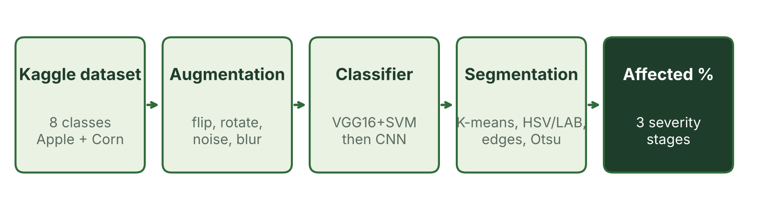
Figure 1. Overall pipeline: data preparation, classification and severity analysis.
2.1 Dataset and subset selection
We used the New Plant Diseases Dataset from Kaggle, which holds more than 87,000 RGB images of healthy and diseased crop leaves in 38 classes with an 80/20 train/validation split [3]. Because of the dataset size, only the Apple and Corn (maize) classes were kept, giving eight classes: apple scab, black rot, cedar apple rust, healthy apple, gray leaf spot, common rust, northern leaf blight and healthy corn. A separate folder of ten apple and corn images served for visual testing and severity analysis. Because the dataset provides only these ten test images, we also tested on a part of the training set; these checks are therefore not fully independent of training. Random seeds were fixed (42) for reproducibility.
2.2 Data augmentation
Training images were enlarged by applying one to three randomly chosen transformations: horizontal or vertical flip, 90° rotation, gamma brightness change, Gaussian noise, Gaussian blur, random 80% crop-and-resize and hue shift. The CNN phase used a lighter set (horizontal flip, 0/90/180/270° rotation and brightness scaling; two augmented copies per image). Augmentation is applied to training data only; validation images stay untouched so that the reported scores are unbiased.
2.3 Phase 1: VGG16 features with an SVM
VGG16 [4], pretrained on ImageNet and with its classification head removed, was frozen and used as a feature extractor. Each 224×224 image passes through the convolutional stack and global average pooling to yield a 512-dimensional descriptor. Descriptors were standardised and fed to an RBF-kernel SVM [5]. Hyperparameters C ∈ {1, 5, 10, 20} and γ ∈ {scale, auto, 0.01, 0.1} were tuned by 3-fold grid search on a 3,000-image sample; the best setting was C = 20, γ = scale (cross-validation accuracy 95.17%). Training used 500 images per class augmented three-fold (16,000 images) and validation used 100 images per class (800 images).
2.4 Phase 2: CNN trained from scratch
The second model is a compact CNN trained from scratch: three Conv(3×3)–ReLU blocks with 32, 64 and 128 filters (the first two followed by max-pooling and batch normalisation), global average pooling, Dropout (0.5), a 256-unit dense layer with batch normalisation and an 8-way softmax. It has only 129,736 parameters (about 0.5 MB). Pixels were scaled to [0, 1]. Training used Adam (learning rate 10⁻³), categorical cross-entropy and batch size 32 for up to 30 epochs, with early stopping, best-checkpoint saving and learning-rate reduction on plateau. The training set had 12,000 images (500 originals per class plus two augmented copies each) and the validation set 800 images (100 per class).
2.5 Affected-area and severity analysis
Severity is computed independently of the classifier by the following steps. (1) The image is resized to at most 800 px and smoothed with a 5×5 Gaussian filter, then converted to HSV and LAB. (2) Three lesion masks are produced: K-means colour clustering (k = 4) with the “diseased” cluster chosen by a disease-specific rule, a colour threshold (orange–brown HSV range for rusts, low brightness for scab, yellow–brown for blights, adaptive LAB thresholding otherwise) and Canny edges. (3) A pixel is labelled diseased when at least two of the three masks agree, and the mask is cleaned by morphological closing and opening. (4) The leaf is isolated with Otsu thresholding [6] and its largest contour. (5) Affected area = diseased pixels inside the leaf ÷ leaf pixels × 100. The value maps to Initial stage (0–15%), Middle stage (15–40%) or Severe damage (40–100%).
3. Results and Discussion
3.1 Classification performance
Table 1 summarises the two classifiers. The VGG16–SVM model correctly classified 783 of 800 validation images (97.88%), with every class above 0.96 F1. The CNN reached 99.12% accuracy, precision and recall on the same 800 images. Its training history (Figure 2) shows an unstable start (24% validation accuracy in epoch 1), steady improvement to 98–99% from epoch 19, and the best validation loss at epoch 26. Training accuracy ended near 98.0%, close to validation accuracy, so there is no sign of serious overfitting.
Table 1. Classification results on held-out validation images.
Model | Training images | Validation images | Accuracy | Precision | Recall
VGG16 + SVM (RBF) | 16,000 | 800 | 97.88% | 0.98 | 0.98
Custom CNN (3 conv blocks) | 12,000 | 800 | 99.12% | 99.12% | 99.12%

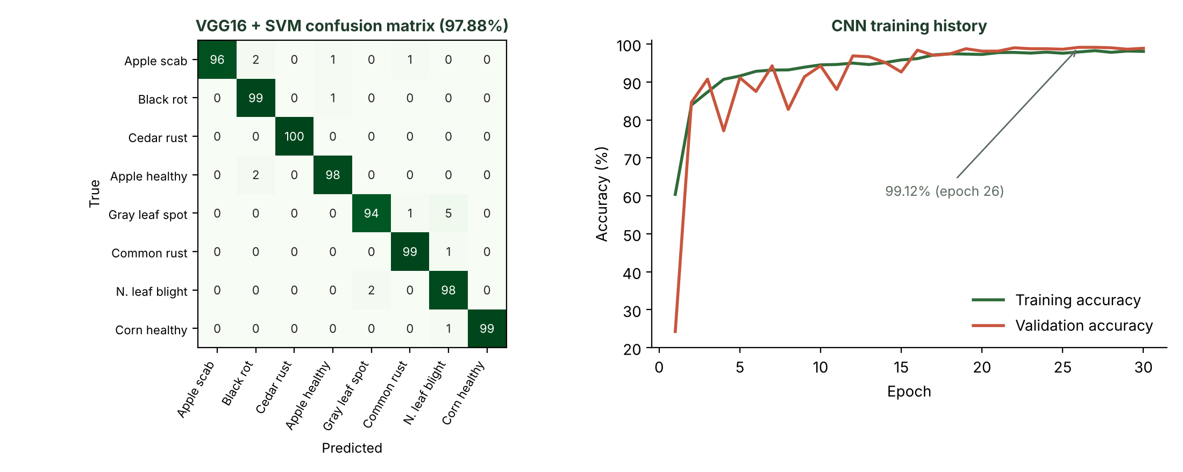
Figure 2. VGG16–SVM confusion matrix (left) and CNN training history (right).
The SVM confusion matrix (Figure 2, left) shows small, scattered errors; the largest is five gray-leaf-spot leaves labelled northern leaf blight, two diseases that both produce elongated tan lesions on maize. Common rust, with its distinctive pustules, was recognised almost perfectly (99 of 100). The CNN matches or beats this without any pretrained weights: batch normalisation and global average pooling regularise a very small network, and it needs only about 20 s per epoch on a GPU, whereas extracting VGG16 features for the SVM took 59 minutes on CPU. The CNN is also small enough for mobile deployment. A per-class breakdown for the CNN was not recorded in our run and is left for future work.
3.2 Behaviour on test leaves
On the ten test photographs (and on the part of the training set we additionally tested) both models labelled every leaf with the expected disease. The CNN’s confidence was 97.0–100% (mean 99.65%); the lowest was an apple scab leaf. The SVM’s lowest confidence was also an apple scab leaf (66.6%), so the CNN was the more confident classifier. Because these checks overlap with training data and are few in number, the 800-image validation accuracy remains the main performance measure, and the real-world figure still has to be measured (Section 3.4). The SVM notebook’s automated filename-based check printed 70%, which disagrees with its displayed labels; we attribute the mismatch to the check rather than the model, but treat it with caution.
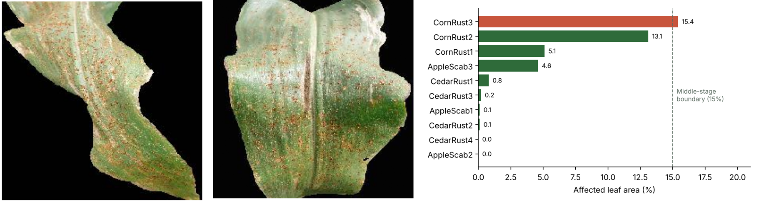
Figure 3. Severity analysis on test leaves: two corn common rust examples and affected-area percentages for all ten leaves.
3.3 Affected area and severity
Affected area was small for most test leaves (Figure 3). With the CNN’s predicted classes, nine of ten leaves fell in the Initial stage and one (corn common rust, 15.4%) in the Middle stage; the mean was 3.95% (median 0.48%, maximum 15.45%). Corn common rust averaged about 11.2% (range 5.1–15.4%), apple scab about 1.6% and cedar apple rust about 0.3%. The result is plausible because rust forms dense pustules across the maize blade, whereas the apple samples carry a few isolated spots. The SVM pipeline gave nearly identical figures (mean 3.97%). Because the segmentation rule is chosen from the predicted class, severity estimates are only as trustworthy as the classification step.
3.4 Limitations
(i) Severity estimates were not compared against expert-annotated lesion masks. (ii) Colour-based segmentation needs good lighting and may miss very early or low-contrast symptoms. (iii) The system must still be tested in a real environment, such as a working farm, to measure its true accuracy, because the dataset images have uniform backgrounds and field conditions will differ. (iv) Feature extraction for 16,000 images took 59 minutes on CPU, and the pixel-wise voting loop takes about 2–5 s per image; both can be vectorised or moved to GPU. (v) Only overall CNN metrics were logged, so a per-class analysis is missing.
3.5 Practical uses
The pipeline can support (a) a smartphone advisory tool, since the CNN is small enough to export to TensorFlow Lite; (b) early-warning and field scouting, by flagging Initial-stage infections before they spread; (c) targeted spraying, with dosage guided by affected-area percentage; (d) agricultural extension services and crop insurance, which need an objective severity record; and (e) teaching material on plant pathology and computer vision.
4. Conclusion
We developed a complete leaf-disease analysis system for apple and corn that classifies eight leaf classes and reports affected-area percentage with a three-stage severity label. The VGG16 + SVM model achieved 97.88% validation accuracy, and the compact CNN trained from scratch achieved 99.12% accuracy, precision and recall; both labelled all ten test images correctly. The CNN was the more accurate, far cheaper to train and small enough for mobile use, while the SVM showed that transfer-learned features give strong results with almost no tuning. Severity analysis on the test leaves found mostly Initial-stage infections, with corn common rust the most affected (up to 15.4%). Because evaluation relied on dataset images, the next step is to test the system on a real farm to measure true accuracy. Future work also includes fine-tuning a pretrained CNN (e.g., EfficientNet or MobileNet), recording per-class CNN metrics, validating severity against annotated masks and replacing hand-tuned colour rules with a learned segmentation network.
References
[1] D. P. Hughes and M. Salathé, “An open access repository of images on plant health to enable the development of mobile disease diagnostics,” arXiv:1511.08060, 2015.
[2] S. P. Mohanty, D. P. Hughes and M. Salathé, “Using deep learning for image-based plant disease detection,” Frontiers in Plant Science, vol. 7, art. 1419, 2016.
[3] “New Plant Diseases Dataset,” Kaggle (vipoooool/new-plant-diseases-dataset).
[4] K. Simonyan and A. Zisserman, “Very deep convolutional networks for large-scale image recognition,” in ICLR, 2015.
[5] C. Cortes and V. Vapnik, “Support-vector networks,” Machine Learning, vol. 20, pp. 273–297, 1995.
[6] N. Otsu, “A threshold selection method from gray-level histograms,” IEEE Trans. Syst., Man, Cybern., vol. 9, no. 1, pp. 62–66, 1979.

