**B.M.S COLLEGE OF ENGINEERING BENGALURU**

Autonomous Institute, Affiliated to VTU



An Internship Report

Industrial/Internship Training: Network & Cyber Security (4w)

*Submitted in partial fulfillment for the award of degree of*

Bachelor of Technology

in

Computer Science and Engineering

*Submitted by:*

Naman Agarwal

1BM18CS057

Internship Carried Out

*at*

|  |  |  |
| --- | --- | --- |
| Bharat Sanchar Nigam Limited |  | Duplex Flats, Block P, Sector 23, Kamla Nehru Nagar, Ghaziabad, Uttar Pradesh 201002 |

**Internal Guide** **External Guide**

Name of the Guide: Dr. B.G. Prasad Name of the Guide:

Designation: Professor Designation:

College Name: BMS College Of Engineering Organization:

Department of Computer Science and Engineering

B.M.S College of Engineering

Bull Temple Road, Basavanagudi, Bangalore 560 019

2019-2020

**B.M.S College of EngineerinG**

**DEPARTMENT OF COMPUTER SCIENCE AND ENGINEERING**



***DECLARATION***

I, Naman Agarwal (1BM18CS057) student of 4th Semester, B.E, Department of Computer Science and Engineering, BMS College of Engineering, Bangalore, hereby declare that, this Internship entitled “Industrial/Internship Training: Network & Cyber Security (4w)" has been carried out under the guidance of Dr. B.G. Prasad (Internal), Professor, Department of CSE, BMS College of Engineering, Bangalore during the academic semester Jan- May 2020. I also declare that to the best of our knowledge and belief, the Internship report is not from part of any other report by any other students.

**Signature of the Candidate**

Naman Agarwal (1BM18CS057)

Insert here the copy of your company certificate

**TABLE OF CONTENTS**

|  |  |  |
| --- | --- | --- |
| **CHAPTER**  **NO.** | **TITLE** | **PAGE NO.** |
| 0 | **Abstract** | 1 |
| 1 | **About The Organization** | 2 |
| 2 | **About The Technology Used** | 4 |
| 3 | **Tasks Performed** | 5 |
| 3.1 | Mini-Project 1 | 6 |
| 3.2 | Mini-Project 2 | 7 |
| 3.3 | Mini-Project 3 | 8 |
| 3.4 | Project | 10 |
| 3.5 | Significance Of The Project | 11 |
| 3.6 | Conclusion | 12 |
| 4 | **Reflection Notes** | 13 |
| 4.1 | References And Annexures | 14 |

**Abstract**

This work presented the re-engineering of a university’s telephone system through the design of alternative implementation and a specification scenario for a campus-wide telephony system based on Voice over Internet Protocols (VoIP) technology; and demonstrates that the technology can be adapted for use in our university community to make cheaper calls using the desk Internet Protocol (IP) phone and data services. This research drew inspirations from similar efforts by some institutions to replace their old PSTN telephony system with the VoIP-based architecture. Prototyping was deployed to build a prototype VoIP-based telephony system and Cisco Packet tracer was configured to run several simulation sessions of the developed specifications. The simulation results showed that VoIP can be successfully deployed to provide in a flexible manner, additional data-driven services in campus-wide telephony through a merger of telephone and information technology facilities.

Keywords- VOIP, Telephony, Prototyping, Cisco packet tracer (version 6.0), Design specification

1

**Chapter 1: About the Company/Organization**

**Particulars of Organization:**

Incorporated on 15.9.2000, vide Registration No. 55-107739, dated the 15th September, 2000 and became entitled to commence business with effect from 19th September, 2000.

**Date of incorporation:**

Incorporated on 15.9.2000, vide Registration No. 55-107739, dated the 15th September, 2000 and became entitled to commence business with effect from 19th September, 2000.

The Company (BSNL) took over the .business of providing telecom services and network management throughout the country except the metro cities of Delhi and Mumbai of the erstwhile service providing departments of the Govt. of India, i.e., the Departments of Telecom Services and Telecom Operations w.e.f. 1.10.2000 pursuant to anMoU signed between the BSNL and the Govt. of India.

**Type of Company:**

Government Company under section 617 of the companies act, 1956

Administrative Ministry:

Govt. of India, Ministry of Communication and Information Technology, Department of Telecommunications.

**Details of Disinvestments:**

The entire share capital of the Company is held by the Govt. of India.

**Shareholding pattern:**

Government of India is holding 100% of the share capital of the Company.

**Share Capital:**

Authorized Capital – Rs.17,500crores, divided into 1,000,00,00,000[One Thousand Crores] Equity Shares of Rs.10/- each; and 750,00,00,000 [Seven Hundred and Fifty Crores] Preference Shares of Rs.10/- each.

2

**Objectives of the company:**

As set out in the objects clause of the Company’s Memorandum of Association.

**ASPIRATIONS:**

Be the leading Telecom Service Provider in India with Global presence.

Create a customer focused organization with excellence in sales, marketing and customer care.

Leverage technology to provide affordable and innovative products / services across customer segments.

Provide a conductive work environment with strong focus on performance.

Establish efficient business processes enabled by I.T.

**PROFILE OF THE COMPANY’S BUSINESS**

**A. GLIMPSES OF MAIN SERVICES OFFERED**

BASIC AND LIMITED MOBILE TELEPHONE SERVICES

CELLULAR MOBILE TELEPHONE SERVICES

INTERNET SERVICES

Intelligent Network

BROADBAND SERVICES

**B. DEVELOPMENT OF RURAL TELECOM NETWORK**

Rural DELs :

Village Public Telephones (VPTs) & RCPs and Public Telephones

**C. NETWORK MANAGEMENT**

**D. Setting up KU Band VSAT network**

**E. Policy on transmission network maintenance**

**F. Annual Maintenance contracts for switching system & WLL**

**G. Fault Repair Services**

**H. COMPUTERISATION**

**I. BUSINESS DEVELOPMENT**

3

**Chapter 2: About the Technology Used**

The technology of Voice over Internet Protocol (VoIP) involves using the technology of the Internet Network to deliver voice communications and multimedia session as packets over the network. Due to the affordances of Internet-ready phones, and the fact that the IP is the communication protocol of most devices, VoIP is best positioned to be the service platform for next-generation application.

The Public Switched Transfer Network (PSTN) on the other hand is a connection-oriented, circuit-switched network that uses dedicated channels for transmission. The PSTN had switched to transmitting digital signals to solve the problems associated with its original analog transmission using Pulse Code Modulation (PCM) to convert all analog signals into digital transmissions at the calling and receiving ends. However, the PSTN suffers two significant disadvantages: high cost resulting from the expensive bandwidth and an inefficient use of networking channels. VoIP is built on an open infrastructure and several vendors can provide applications and access. While the PSTN technology involves vendors only building applications specific for their equipment and its current architecture has not made it possible for many vendors to write new applications for it, VoIP allows the development of more creative solutions and applications as well as the convergence of data, voice and video in one channel.

This research is aimed at stimulating a VoIP-based telephony service using a university communication system. We believe that if we can successfully implement the simulation, and given the advantages of VoIP over the traditional PSTN technology, a modern telephony system can be implemented for the campus. The researchers aimed at reducing cable clusters around offices, facilitating in-office communication and enabling conference calling at any point where the IP phone or VoIP phone is being installed. The project covered the interconnection of different offices and the researchers, with the help of simulation showed that it was possible to make cheaper calls using the desk IP phone and video streaming on the Soft Phones and interfaces installed on Personal Computers (PC).

4

**Chapter 3: Tasks performed**

The internship started with a week of technical lectures about topics like

* Traditional networks and current networks
* Understanding of IP address with the help of breaking down the traditional landline numbers into fragments to understand the number allocation for each house
* Network elements like hubs, Bridge, router, modem etc.
* Categories of networks
* MAC address
* IPv4 and IPv6
* Private IP and Global/Public IP
* National internet backbone.

Followed by the tour of the physical equipment's such as server rooms, local Tx, D-Tax server etc.

Followed by another week of training in Cisco Packet tracer and them the internship project and a separate project as well.

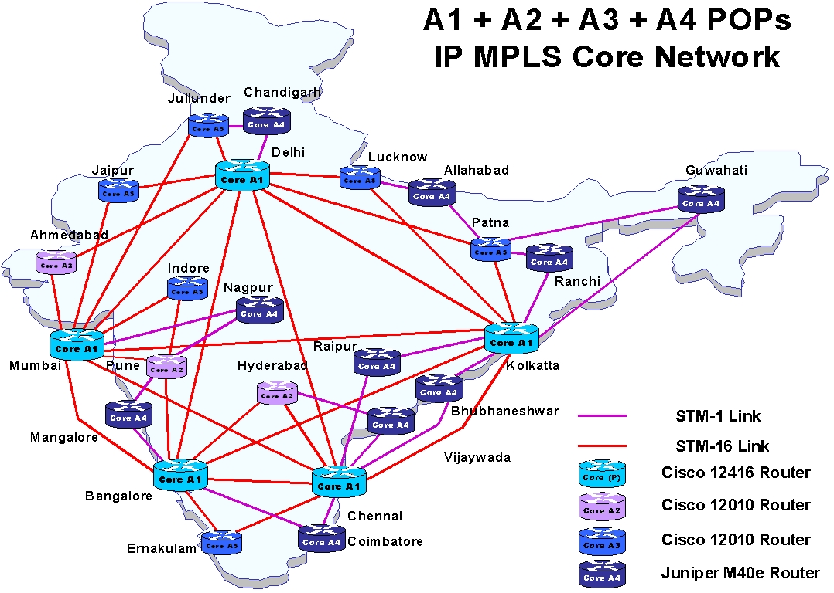

5

**Mini Project 1**

**Components Used:**

There are 8 computers, 1 Router (2811 series), 2 Switches (2960-24TT series) used in the project.

**Interface:**

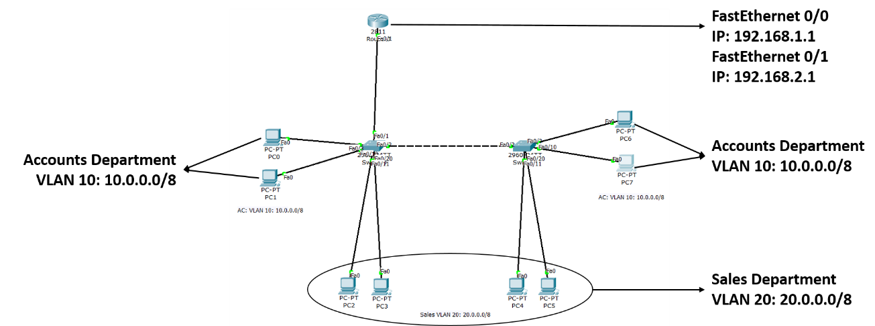

This was created to understand the basics of cisco packet tracer and how it simulates the real-world hardware and can be useful in learning about networking. Here 2 separate departments naming: - Sales and Accounts are created with a different set of IP addresses and are distributed equally between 2 different switches to simulate the real world application in a professional environment where the workforce is distributed into multiple floors or even buildings.

6

**Mini Project 2**

**Components Used:**

There are 3 computers, 2 wireless devices, 2 Routers (2811 series), 2 Switches (2960-24TT series) used in the project.

**Interface:**

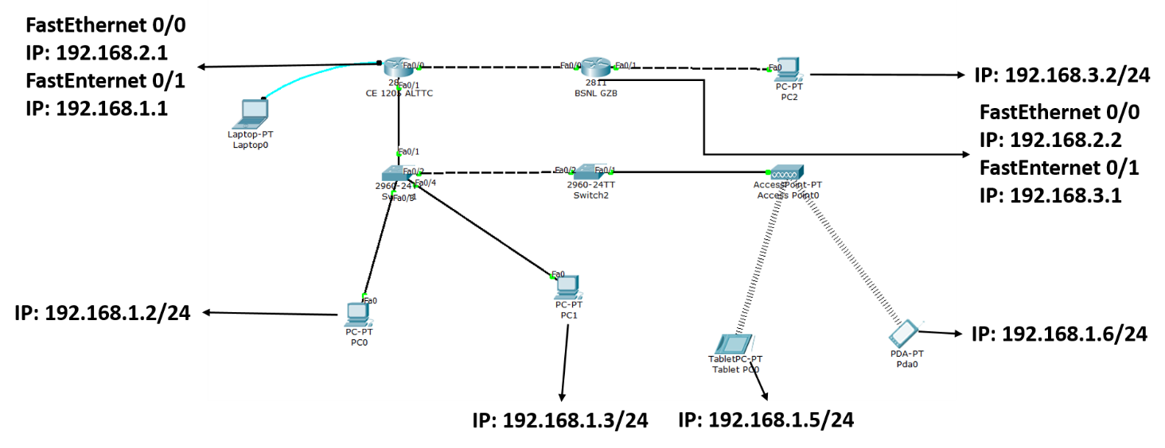

Here emphasis is given between connecting two different routers and how the operate separately with separate IP addresses. This is a model of the main router in the district being connected to the ALTTC router to give internet access throughout the area. The connectivity with the wireless devices is also been shown here.

7

**Mini Project 3**

**Components Used:**

There are 4 computers, 2 wireless devices, 2 Routers (2811 series), 3 Switches (2960-24TT series), 1 DHCP Server, 2 DNS server used in the project.

**Interface:**

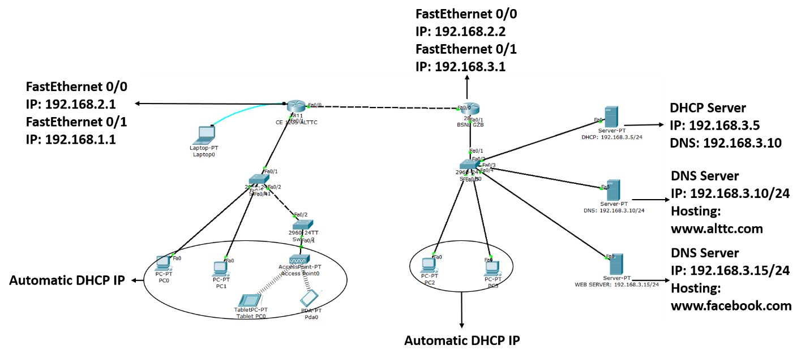

**DHCP**: The primary reason DHCP is needed is to simplify the management of IP addresses on networks. It stands for dynamic host configuration protocol and is a network protocol used on IP networks where a DHCP server automatically assigns an IP address and other information to each host on the network so they can communicate efficiently with other endpoints. In addition to the IP address, DHCP also assigns the subnet mask, default gateway address, domain name server (DNS) address and other pertinent configuration parameters.

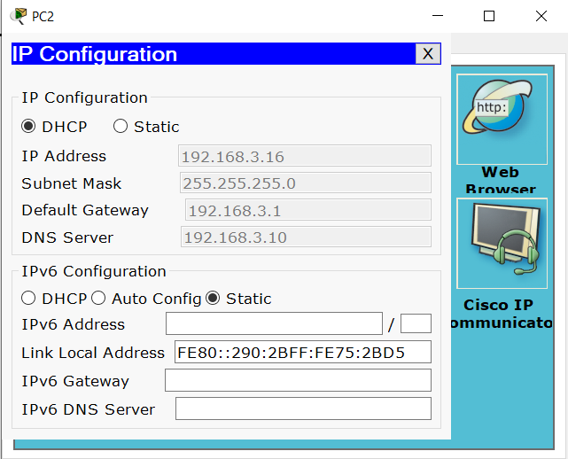

8

**DNS**: DNS is the phonebook of the Internet. Humans access information online through domain names, like nytimes.com or espn.com. Web browsers interact through Internet Protocol (IP) addresses. DNS translates domain names to IP addresses so browsers can load Internet resources. Each device connected to the Internet has a unique IP address which other machines use to find the device.

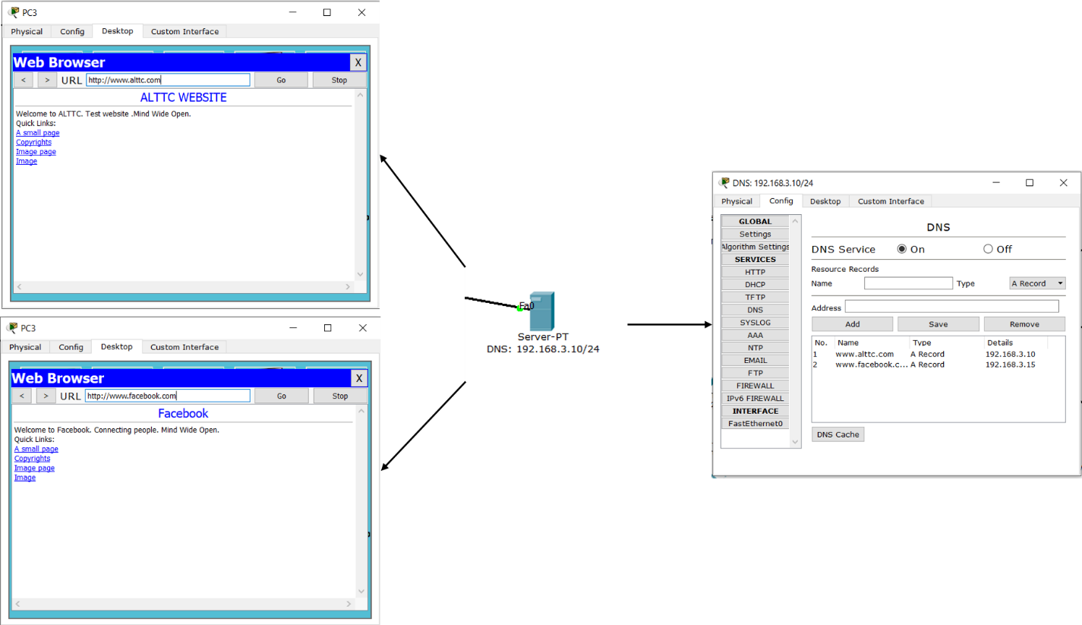

Here DHCP Server as well as multiple DNS Servers are used to show how the Automatic IP allocation is done and how websites are stored on the web with their IPs stored in the various DNS.

9

**Project**

**Components Used:**

There are 3 computers, 3 IP phones, 1 Router (2811 series), 1 Switch (2960-24TT series) used in the project.

The Router is connected to the Switch through straight wire which is then connected to the 3 IP phones which are further connected through straight wire to the 3 Computers.

**Interface:**

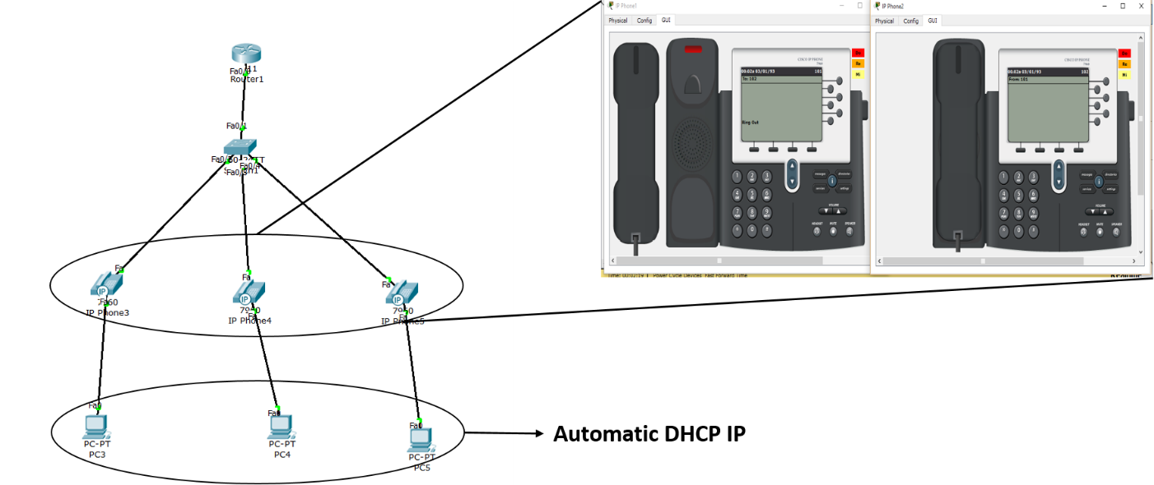

**Output:**

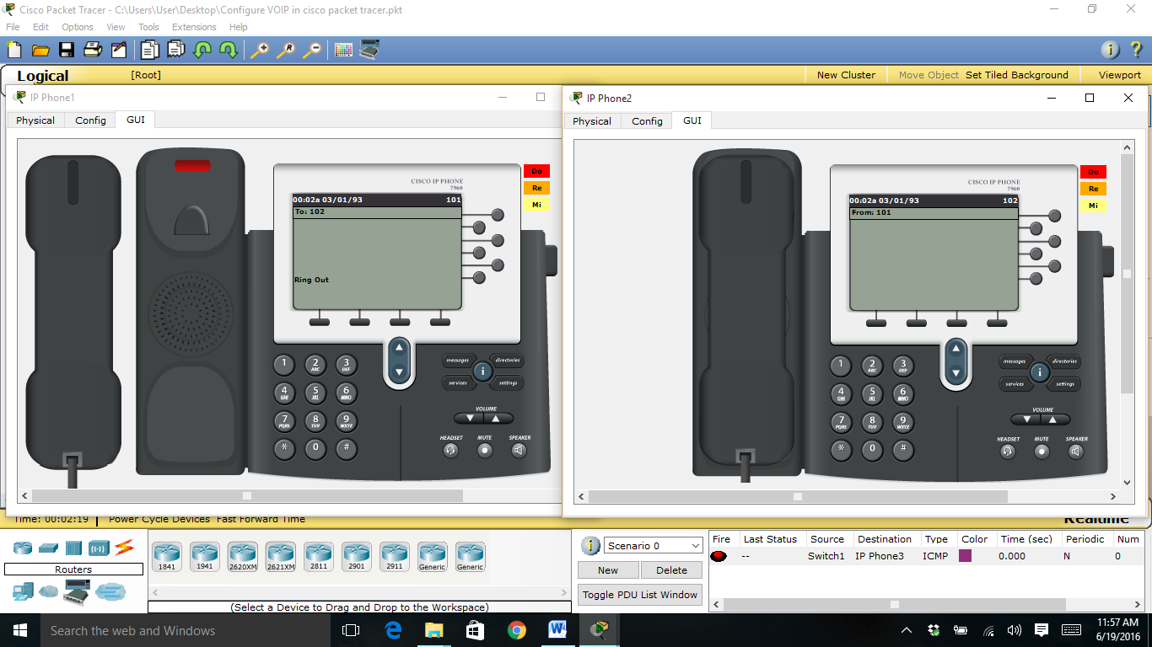

10

**Significance of the project**

* The project simply points out the working of a Voice over IP phone (VoIP) and how it is configured to be used in a real time business organization.
* VoIP is important because, for the first time in more than 100 years, there is an opportunity to bring about significant change in the way that people communicate. In addition to being able to use the telephones we have today to communicate in real-time, we also have the possibility of using pure IP-based phones, including desktop and wireless phones. We also have the ability to use videophones, much like those seen in science fiction movies. Rather than calling home to talk to the family, a person can call home to see the family.
* One of the more interesting aspects of VoIP is that we also have the ability to integrate a stand-alone telephone or videophone with the personal computer. One can use a computer entirely for voice and video communications (softphones), use a telephone for voice and the computer for video, or can simply use the computer in conjunction with a separate voice/video phone to provide data conferencing functions, like application sharing, electronic white boarding, and text chat.
* VoIP allows something else: the ability to use a single high-speed Internet connection for all voice, video, and data communications. This idea is commonly referred to as convergence and is one of the primary drivers for corporate interest in the technology. The benefit of convergence should be fairly obvious: by using a single data network for all communications, it is possible to reduce the overall maintenance and deployment costs. The benefit for both home and corporate customers is that they now have the opportunity to choose from a much larger selection of service providers to provide voice and video communication services. Since the VoIP service provider can be located virtually anywhere in the world, a person with Internet access is no longer geographically restricted in their selection of service providers and is certainly not bound to their Internet access provider.
* In short, VoIP enables people to communicate in more ways and with more choices. Hence the project has been made to bring about the widespread scope of the VoIP.

11

**Conclusion**

The researchers in this work had examined the underlining technologies of Voice over Internet Protocols (VoIP) and the possibilities of implementing a campus-wide telephony system using the technology. A prototype design was specified and a simulation was ran using the Cisco Packet Tracer to demonstrate that VoIP can be successfully deployed to provide in a flexible manner, additional data-driven services in campus-wide telephony through a merger of telephone and information technology facilities. While this work had demonstrated the feasibility of leveraging on the affordances of IP-enabled telephones and developing a VOIP-based campus-wide telephony, further research is recommended to test for voice quality and network performance as well as ability for network capacity planning when the system is fully implemented.

12

**Chapter 4: Reflection Notes**

At an internship, a student can practice and improve their industry skills while also learning how to work. I as a student gained a better understanding of how the learning’s in the college can help me with my future. ...

The major learning’s from the internship for me are - New and improved skills and how to apply them is the most important learning of my life, Professional communication , Taking constructive criticism well –which I think one should definitely know, Work hard no matter what you're doing etc. And now further talking of soft skills, these are some which I learned during the internship:

* The first thing we need to mention is definitely team work.
* Problem Solving Skills and basically how to solve and what should be the starting logic.
* Work Ethics.
* Adaptability Skills because as we know survival of the fittest is the truth as per Darwin’s theory as well.
* Corporate communication skills are different from school and colleges and are very important to learn.
* One can never ignore how important it is to be responsible with work.
* Time Management is the major soft skill required throughout the life…

Some Common Internship Challenges which I Faced during internship are:

* Issues with Time Management / Self-Management.
* Hesitant to Ask Questions.
* Competitive Co-interns.

And by the end of my internship I can say I am a different personality who is ready to take any challenge and complete it.

Ready for the corporate culture.

13

**REFERENCES AND ANNEXURES**

* Kumar, A. (2006), AnOverview of Voice over Internet Protocol (VoIP). Rivier college online academic journal 2(1).
* Pan, Y., Chung, J., Zhang, Z. (2012), Analysis of Performance of VoIP Over various scenarios OPNET 14.0. Group 11 Final Report on ENSC 427 Communication Networks, Simon Fraser University Spring 2012 http://www.sfu.ca/~ypa11/Ensc%20427/427.html.
* Kaul, A. (2012), IP Telephony: Review and Implementation. M.Sc. thesis, Department of Electrical Engineering and Computer Science and the Faculty of the Graduate School of the University of Kansas, USA.
* Dilekci, D., Wang, C., FengXu, J. (2013), The Analysis and Simulation of VoIP Group 3 Final Project Report on ENSC 427 Communication Networks, Simon Fraser University. Spring 2013 http://www.sfu.ca/~cjw11/427Project.html.
* Aguiño, G. I., (2007), Performance of VoIP strategies for hybrid Mobile Ad Hoc Networks. Masters thesis, Department of Computer Science, Karlstad University.
* Rabassa, A. H. (2010), Simulation Platform for the Planning and Design of Networks Carrying VoIP Traffic Masters of Applied Science in Electrical Engineering Thesis, Faculty of Graduate Studies and Research, Department of Systems and Computer Engineering, Ottawa-Carleton Institute for Electrical and Computer Engineering, Carleton University, Ottawa, Canada.

14