Shell script

cp -r /mnt/app/\* /var/www/html/

chmod -R 777 /var/www/html/

service httpd restart

Git Repo for 2023-Q1

Repo :- <https://github.com/NamanBahre/jenkins_2023_Q1-Q3_project.git>

Branch :- \*/2023-Q1

Git Repo for 2023-Q2

Repo :- <https://github.com/NamanBahre/jenkins_2023_Q1-Q3_project.git>

Branch :- \*/2023-Q2

Git Repo for 2023-Q3

Repo :- <https://github.com/NamanBahre/jenkins_2023_Q1-Q3_project.git>

Branch :- \*/2023-Q3

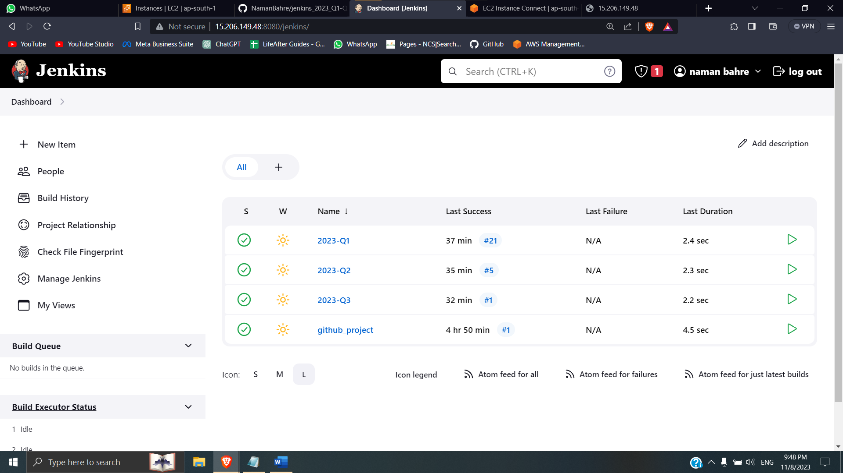

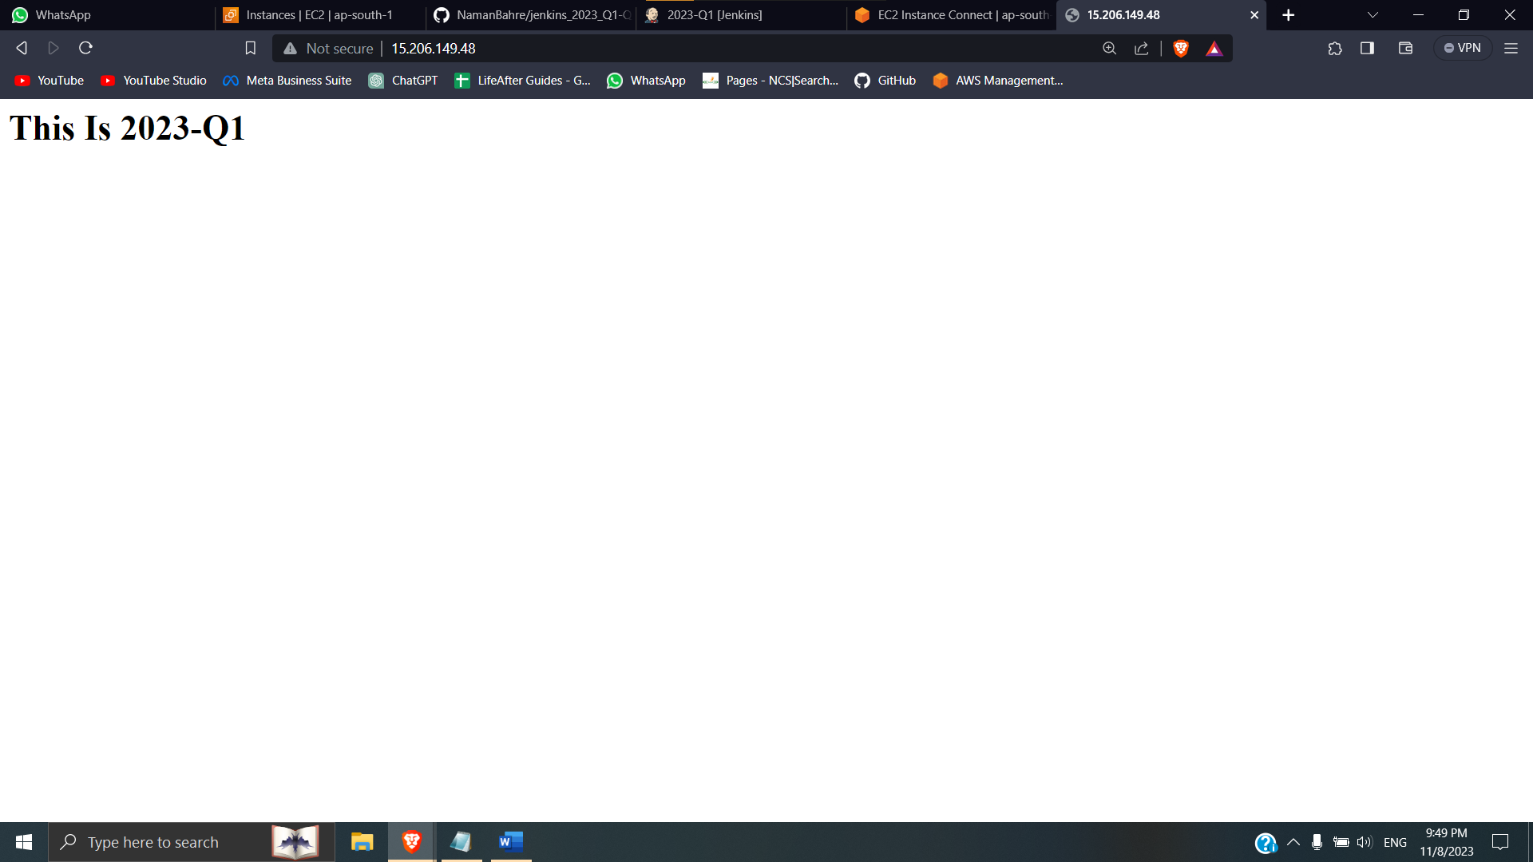 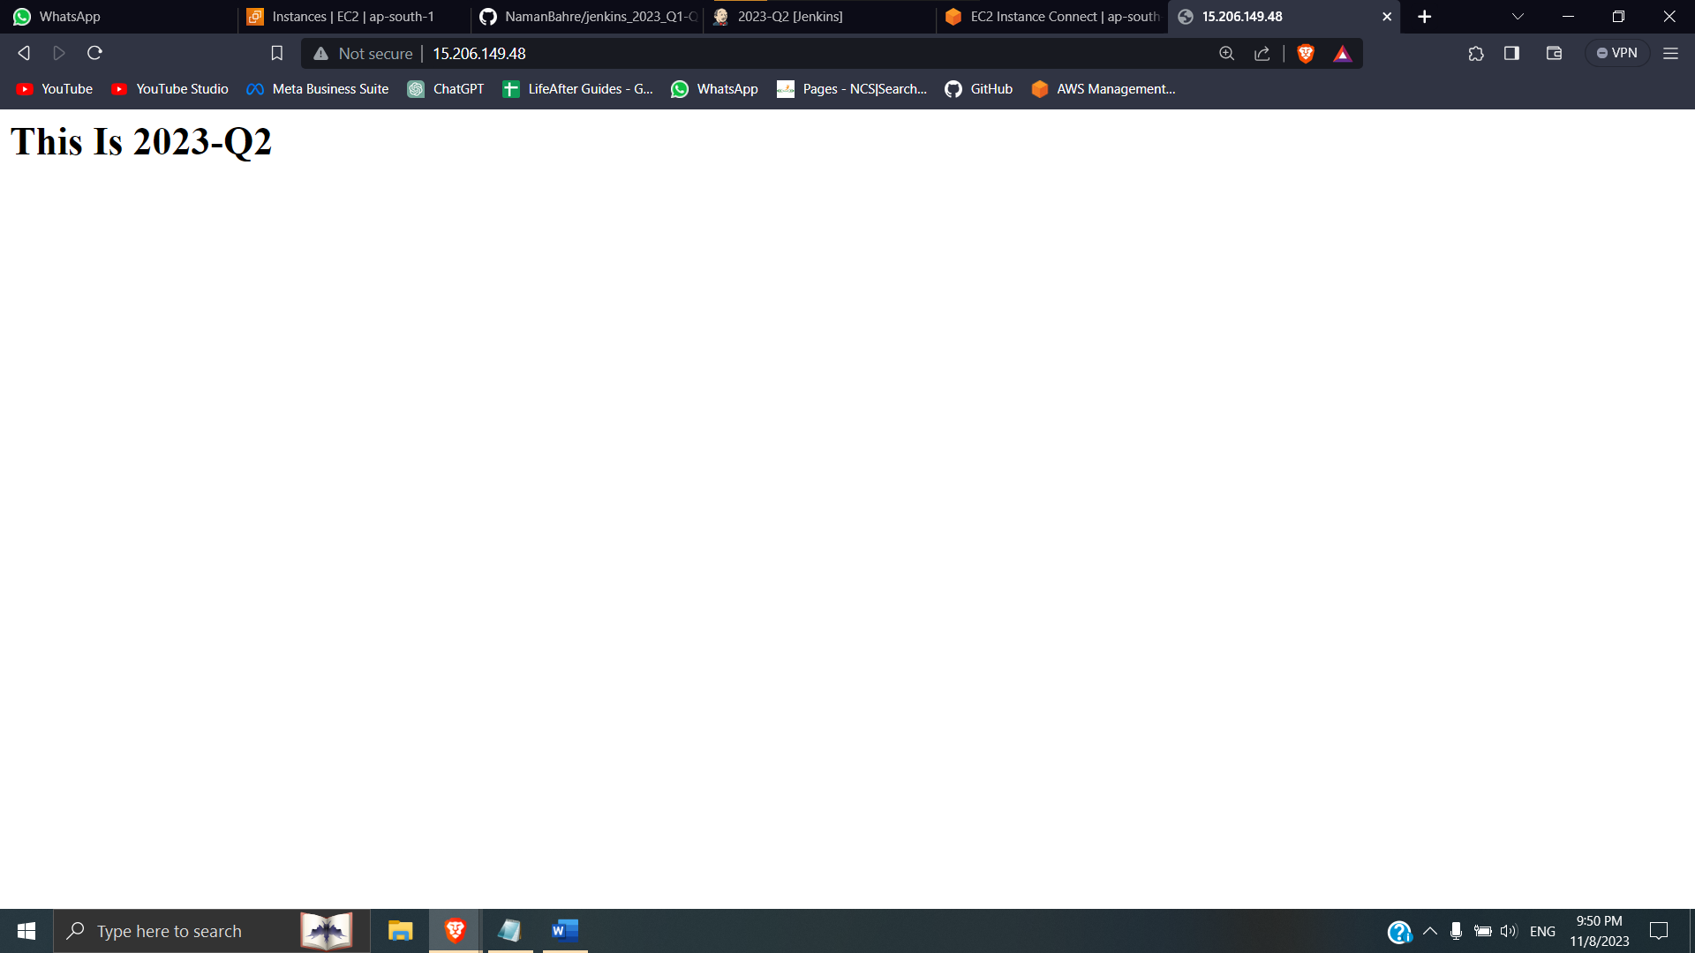

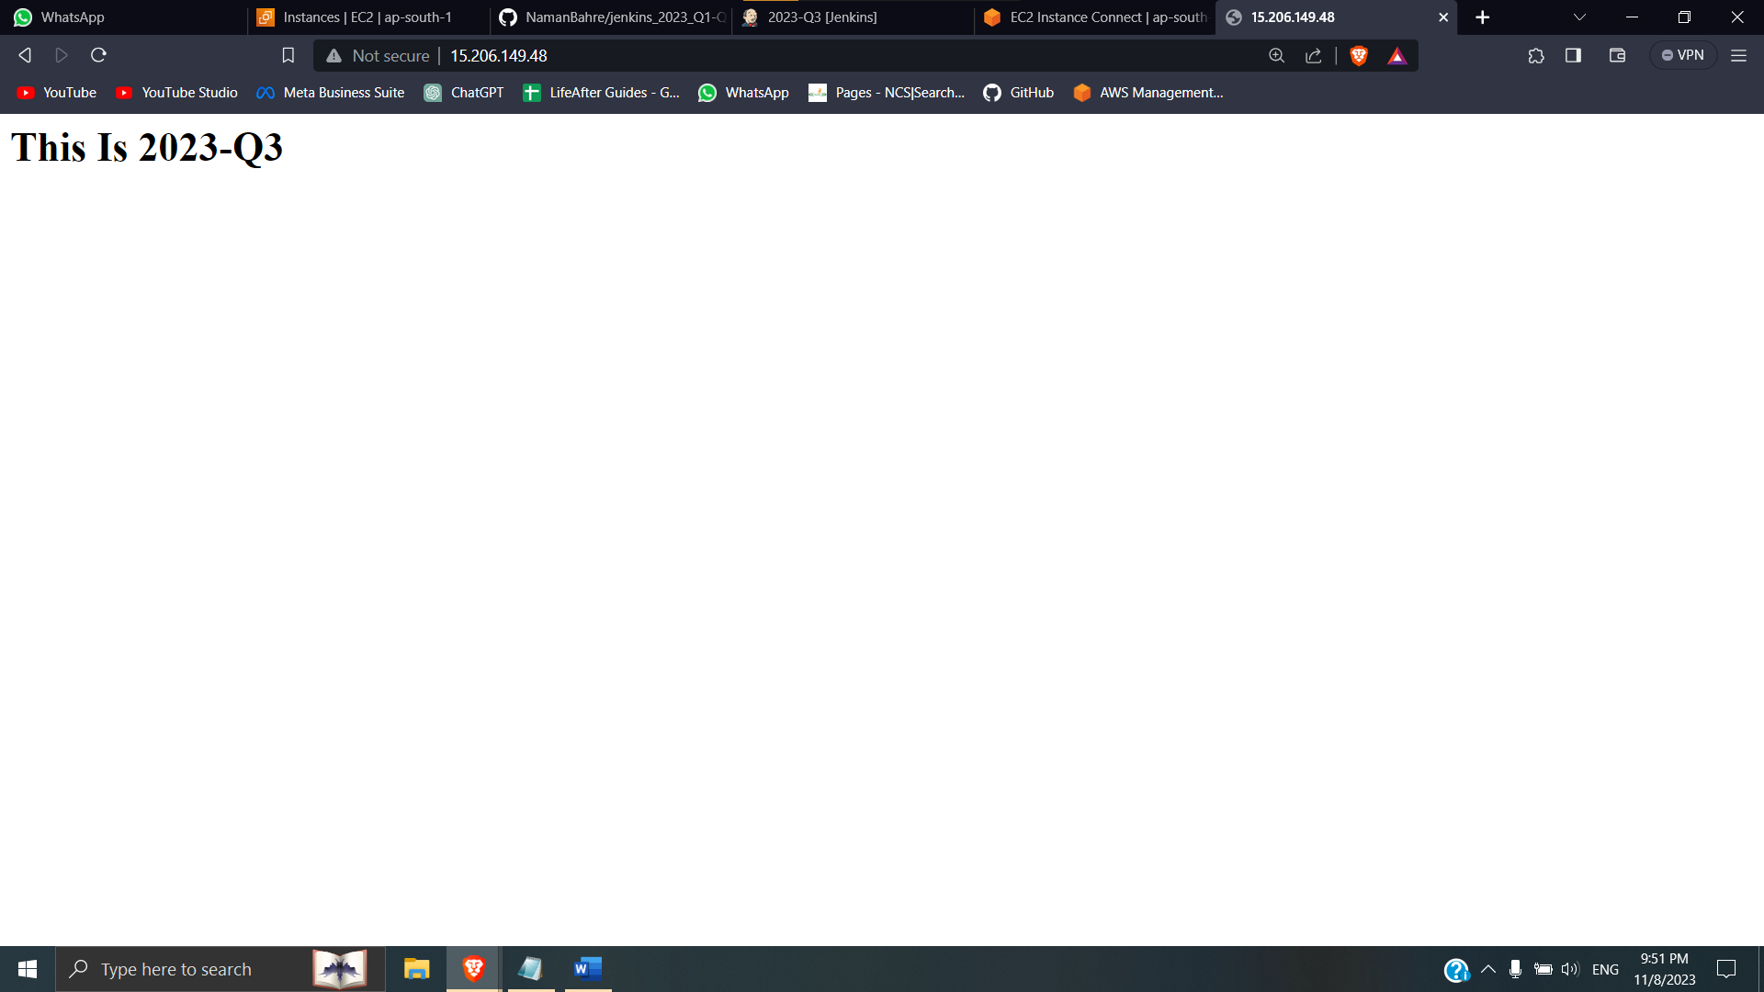

[root@ip-172-31-12-6 html]# ls

index.html

[root@ip-172-31-12-6 html]# cat index.html

<h1> This Is 2023-Q1 </h1>

[root@ip-172-31-12-6 html]# ls

index.html

[root@ip-172-31-12-6 html]# cat index.html

<h1> This Is 2023-Q2 </h1>

[root@ip-172-31-12-6 html]# ls

index.html

[root@ip-172-31-12-6 html]# cat index.html

<h1> This Is 2023-Q3 </h1>