Shell script

cp -r /mnt/app/\* /var/www/html/

chmod -R 777 /var/www/html/

service httpd restart

Git repo1

Repo :- <https://github.com/NamanBahre/repo1.git>

Git repo2

Repo :- <https://github.com/NamanBahre/repo2.git>

Git repo3

Repo :- <https://github.com/NamanBahre/repo3.git>

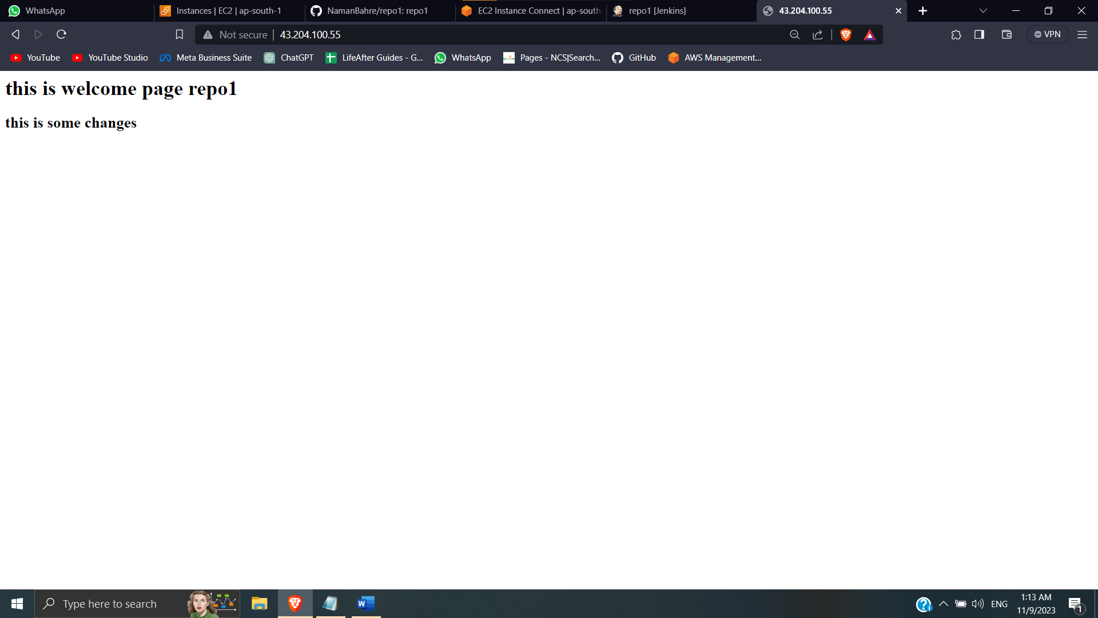

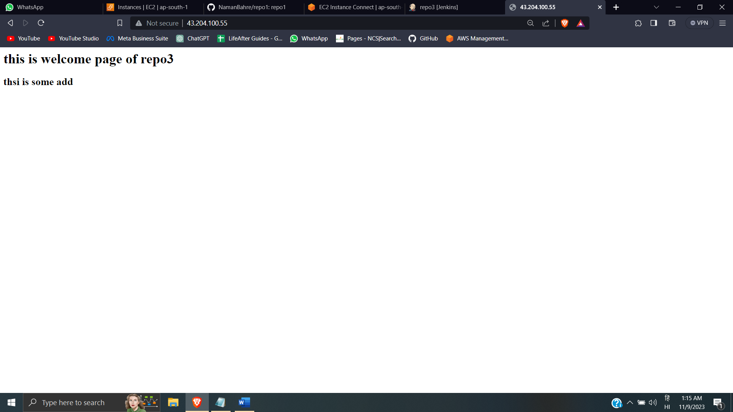 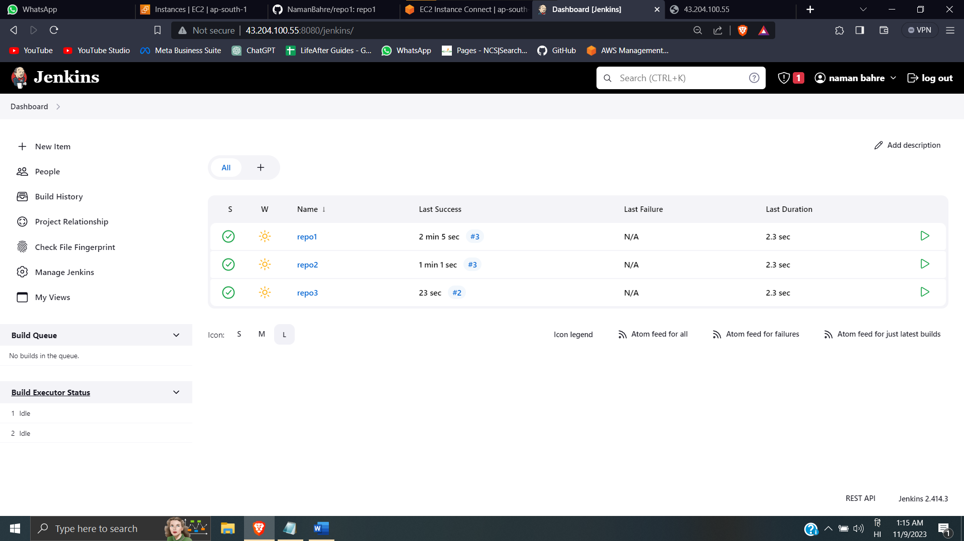

root@ip-172-31-7-133 html]# cat index.html

<h1> this is welcome page repo1 </h1>

<h2> this is some changes </h2>

[root@ip-172-31-7-133 html]# cat index.html

<h1> this is welcome page of repo2 </h1>

[root@ip-172-31-7-133 html]# cat index.html

<h1> this is welcome page of repo3 </h1>

<h2> thsi is some add </h2>