The Process:
- A process is a program in execution.
- A process is more than the program code, which is sometimes known as the text section.
- It also includes the current activity, as represented by the value of the program counter and the contents of the processor's registers.
- A process generally also includes the process stack, which contains temporary data (such as function parameters, return addresses, and local variables), and a data section, which contains global variables.
- A process may also include a heap, which is memory that is dynamically allocated during process run time. The structure of a process in memory is shown in Figure
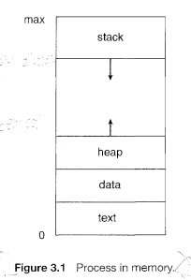
We emphasize that a program by itself is not a process; a program is a passive entity, such as a file containing a list of instructions stored on disk (often called an executable file), whereas a process is an active entity, with a program counter specifying the next instruction to execute and a set of associated resources.
Process State:
As a process executes, it changes state. The state of a process is defined in part by the current activity of that process. Each process may be in one of the following states:
New. The process is being created.
Running. Instructions are being executed.
Waiting. The process is waiting for some event to occur (such as an I/0 completion or reception of a signal).
Ready. The process is waiting to be assigned to a processor.
Terminated. The process has finished execution.
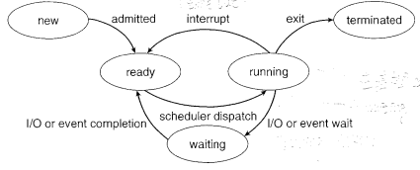
Fig: Process state
Process Control Block [PCMCAI]
Each process is represented in the operating system by a process_ control block _ (PCB)-also called a task control block. A PCB is shown in Figure . It contains many pieces of information associated with a specific process, including these:
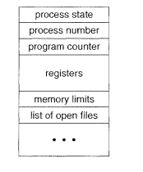
Process control block
Process state. The state may be new, ready running, waiting, halted, and so on.
Program counter. The counter indicates the address of the next instruction to be executed for this process.
CPU registers. The registers vary in number and type, depending on the computer architecture. They may include accumulators, index registers, stack pointers, and general-purpose registers, plus any condition-code information.
Memory-management information: This information may include such information as the value of the base and limit registers, the page tables, or the segment tables, depend on the memory system used by the operating system
CPU-scheduling information. This information includes a process priority, pointers to scheduling queues, and any other scheduling parameters.
Accounting information . This information includes the amount of CPU and real time used, time limits, account numbers, job or process numbers, and so on.
I/O status information
. This information includes the list of I/O devices allocated to the process, a list of open files, and so on.
In brief the PCB simply serves as the repository for any information that may vary from process to process.
Process scheduling:
The objective of multiprogramming is to have some process running at all times, to maximize CPU utilization. The objective of time sharing is to switch the CPU among processes so frequently that users can interact with each program while it is running. To meet these objectives, the process scheduler selects an available process (possibly from a set of several available processes) for program execution on the CPU. For a single-processor system, there will never be more than one running process. If there are more processes, the rest will have to wait until the CPU is free and can be rescheduled.
Scheduling Queues:
job queue : As processes enter the system, they are put into a job queue, which consists of all processes in the system.
ready queue : The processes that are residing in main memory and are ready and waiting to execute are kept on a list called the ready queue.
device queue : The system also includes other queues. When a process is allocated the CPU, it executes for a while and eventually quits, is interrupted, or waits for the occurrence of a particular event, such as the completion of an I/0 requests. Suppose the process makes an I/O request to a shared device, such as a disk. Since there are many processes in the system, the disk may be busy with the I/0 request of some other process. The process therefore may have to wait for the disk. The list of processes waiting for a particular I/0 device is called a device queue.
A common representation of process scheduling is a queueing diagram, such as that in Figure . Each rectangular box represents a queue. Two types of queues are present: the ready queue and a set of device queues. The circles represent the resources that serve the queues, and the arrows indicate the flow of processes in the system.
A new process is initially put in the ready queue. It waits there until it is selected for execution, or is dispatched. Once the process is allocated the CPU and is executing, one of several events could occur:
1.The process could issue an I/0 request and then be placed in an I/0 queue.
2.The process could create a new subprocess and wait for the subprocess's termination
3. The process could be removed forcibly from the CPU, as a result of an interrupt, and be put back in the ready queue.
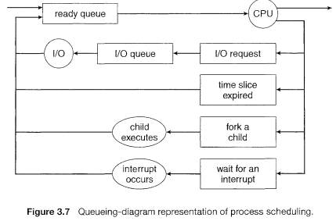
Schedulers:
A process migrates among the various scheduling queues throughout its lifetime. The operating system must select, for scheduling purposes, and the selection process is carried out by the appropriate scheduler.
The long-term scheduler, or job scheduler, selects processes from this pool and loads them into memory for execution. The short-term scheduler, or CPU scheduler, selects from among the processes that are ready to execute and allocates the CPU to one of them.
The primary distinction between these two schedulers lies in frequency of execution. The short-term scheduler must select a new process for the CPU frequently. A process may execute for only a few milliseconds before waiting for an I/0 request.
The long-term scheduler executes much less frequently; minutes may separate the creation of one new process and the next. The long-term scheduler controls the degree of multiprogramming (the number of processes in memory). If the degree of multiprogramming is stable, then the average rate of process creation must be equal to the average departure rate of processes leaving the system.
It is important that the long-term scheduler make a careful selection. In general, most processes can be described as I/ 0 bound or CPU bound. An I/O-bound process is one that spends more of its time doing I/O than it spends doing computations. A CPU-bound process, in contrast, generates I/0 requests infrequently, using more of its time doing computations. It is important that the long-term scheduler select a good process mix of I/O-bound and CPU-bound processes. 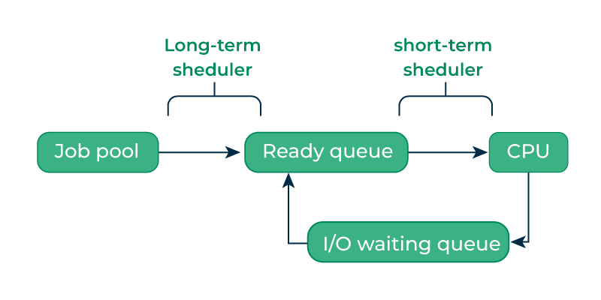
The key idea behind a medium-term scheduler is that sometimes it can be advantageous to remove processes from memory (and from active contention for the CPU) and thus reduce the degree of multiprogramrning. Later, the process can be reintroduced into memory, and its execution can be continued where it left off. This scheme is called swapping. The process is swapped out, and is later swapped in, by the medium-term scheduler.
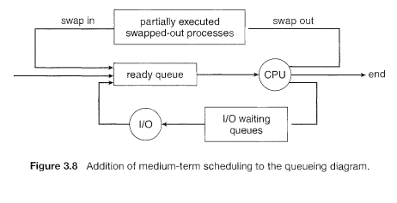
Context Switch
When an interrupt occurs, the system needs to save the current context of the process running on the CPU so that it can restore that context when its processing is done, essentially suspending the process and then resuming it. The context is represented in the PCB of the process; it includes the value of the CPU registers, the process state and memory-management information. Generically, we perform a state save of the current state of the CPU, and then a state restore to resume operations.
Switching the CPU to another process requires performing a state save of the current process and a state restore of a different process. This task is known as a context switch. When a context switch occurs, the kernel saves the context of the old process in its PCB and loads the saved context of the new process scheduled to run. Context-switch time is pure overhead, because the system does no useful work while switching. Its speed varies from machine to machine, depending on the memory speed.

Interprocess Comm/unication
Processes executing concurrently in the operating system may be either independent processes or cooperating processes. A process is independent if it cannot affect or be affected by the other processes executing in the system. Any process that does not share data with any other process is independent. A process is cooperating if it can affect or be affected by the other processes executing in the system. Clearly, any process that shares data with other processes is a cooperating process
Cooperating processes require an interprocess communication (IPC) mechanism that will allow them to exchange data and information. There are two fundamental models of interprocess communication: shared memory and message passing
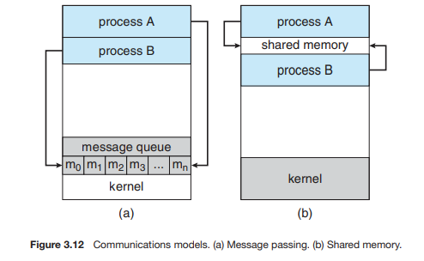
Shared-Memory Systems
Interprocess communication using shared memory requires communicating processes to establish a region of shared memory. Typically, a shared-memory region resides in the address space of the process creating the shared-memory segment. Other processes that wish to communicate using this shared-memory segment must attach it to their address space. Recall that, normally, the operating system tries to prevent one process from accessing another process’s memory. Shared memory requires that two or more processes agree to remove this restriction. They can then exchange information by reading and writing data in the shared areas. The form of the data and the location are determined by these processes and are not under the operating system’s control.

Message-Passing Systems
Message passing provides a mechanism to allow processes to communicate and to synchronize their actions without sharing the same address space. It is particularly useful in a distributed environment, where the communicating processes may reside on different computers connected by a network.
A message-passing facility provides at least two operations: send(message) receive(message) Messages sent by a process can be either fixed or variable in size. If only fixed-sized messages can be sent, the system-level implementation is straightforward. This restriction, however, makes the task of programming more difficult. Conversely, variable-sized messages require a more complex system-level implementation, but the programming task becomes simpler. If processes P and Q want to communicate, they must send messages to and receive messages from each other: a communication link must exist between them. Here are several methods for logically implementing a link and the send()/receive() operations:
- Direct or indirect communication
- Synchronous or asynchronous communication
- Automatic or explicit buffering
Under direct communication, each process that wants to communicate must explicitly name the recipient or sender of the communication. In this scheme, the send() and receive() primitives are defined as:
• send(P, message)—Send a message to process P.
• receive(Q, message)—Receive a message from process Q.
A communication link in this scheme has the following properties:
• A link is established automatically between every pair of processes that want to communicate. The processes need to know only each other’s identity to communicate.
• A link is associated with exactly two processes.
• Between each pair of processes, there exists exactly one link.
This scheme exhibits symmetry in addressing; that is, both the sender process and the receiver process must name the other to communicate. A variant of this scheme employs asymmetry in addressing. Here, only the sender names the recipient; the recipient is not required to name the sender. In this scheme, the send() and receive() primitives are defined as follows:
send(P, message)—Send a message to process P.
• receive(id, message)—Receive a message from any process.
The variable id is set to the name of the process with which communication has taken place.
With indirect communication, the messages are sent to and received from mailboxes, or ports. A mailbox can be viewed abstractly as an object into which messages can be placed by processes and from which messages can be removed. Each mailbox has a unique identification.
The send() and receive() primitives are defined as follows:
• send(A, message)—Send a message to mailbox A.
• receive(A, message)—Receive a message from mailbox A.
In this scheme, a communication link has the following properties:
• A link is established between a pair of processes only if both members of the pair have a shared mailbox.
• A link may be associated with more than two processes.
• Between each pair of communicating processes, a number of different links may exist, with each link corresponding to one mailbox.
Synchronization
Communication between processes takes place through calls to send() and receive() primitives. There are different design options for implementing each primitive. Message passing may be either blocking or nonblocking— also known as synchronous and asynchronous
- (synchronous)Blocking send. The sending process is blocked until the message is received by the receiving process or by the mailbox.
- (asynchronous )Nonblocking send. The sending process sends the message and resumes operation.
- Blocking receive. The receiver blocks until a message is available.
- Nonblocking receive. The receiver retrieves either a valid message or a null
Buffering:
Whether communication is direct or indirect, messages exchanged by communicating processes reside in a temporary queue. Basically, such queues can be implemented in three ways:
• Zero capacity. The queue has a maximum length of zero; thus, the link cannot have any messages waiting in it. In this case, the sender must block until the recipient receives the message.
• Bounded capacity. The queue has finite length n; thus, at most n messages can reside in it. If the queue is not full when a new message is sent, the message is placed in the queue (either the message is copied or a pointer to the message is kept), and the sender can continue execution without waiting. The link’s capacity is finite, however. If the link is full, the sender must block until space is available in the queue.
• Unbounded capacity. The queue’s length is potentially infinite; thus, any number of messages can wait in it. The sender never blocks.
Thread:
Thread is a basic unit of CPU utilization; it consists a thread ID, a program counter, a register set, and a stack. It shares with other threads belonging to the same process its code section, data section, and other operating-system resources, such as open files and signals. A traditional (or heavyweight) process has a single thread of control. If a process has multiple threads of control, it can perform more than one task at a time
Benefits
The benefits of multithreaded programming can be broken down into four major categories:
1. Responsiveness. Multithreading an interactive application may allow a program to continue running even if part of it is blocked or is performing a lengthy operation, thereby increasing responsiveness to the user. This quality is especially useful in designing user interfaces. For instance, consider what happens when a user clicks a button that results in the performance of a time-consuming operation. A single-threaded application would be unresponsive to the user until the operation had completed. In contrast, if the time-consuming operation is performed in a separate thread, the application remains responsive to the user.
2. Resource sharing. Processes can only share resources through techniques such as shared memory and message passing. Such techniques must be explicitly arranged by the programmer. However, threads share the memory and the resources of the process to which they belong by default
3. Economy. Allocating memory and resources for process creation is costly. Because threads share the resources of the process to which they belong, it is more economical to create and context-switch threads.
4.Scalability. The benefits of multithreading can be even greater in a multiprocessor architecture, where threads may be running in parallel on different processing cores. A single-threaded process can run on only one processor, regardless how many are available. We explore this issue further in the following section.
Multithreading Models
Our discussion so far has treated threads in a generic sense. However, support for threads may be provided either at the user level, for user threads, or by the kernel, for kernel threads. User threads are supported above the kernel and are managed without kernel support, whereas kernel threads are supported and managed directly by the operating system.
Many-to-One Model
The many-to-one model maps many user-level threads to one kernel thread. Thread management is done by the thread library in user space, so it is efficient However, the entire process will block if a thread makes a blocking system call.
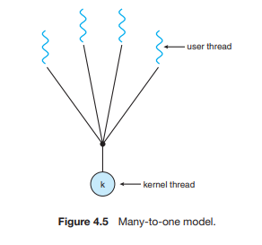

One-to-One Model
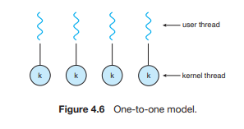
The one-to-one model (Figure 4.6) maps each user thread to a kernel thread. It provides more concurrency than the many-to-one model by allowing another thread to run when a thread makes a blocking system call. It also allows multiple threads to run in parallel on multiprocessors. The only drawback to this model is that creating a user thread requires creating the corresponding kernel thread.

Many-to-Many Model
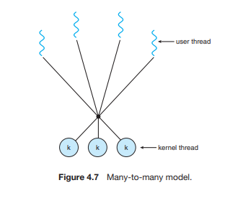
The many-to-many model (Figure 4.7) multiplexes many user-level threads to a smaller or equal number of kernel threads. The number of kernel threads may be specific to either a particular application Let’s consider the effect of this design on concurrency. Whereas the many to-one model allows the developer to create as many user threads as she wishes, it does not result in true concurrency, because the kernel can schedule only one thread at a time

