OOP: Assignment No. 1
Name: Naman Bharsakale
PRN No: 255200003
Branch: Computer Science and Engineering (AIDED)
Batch: S8
- Check Number is Even or Odd
Input:
#include <iostream>
using namespace std;

int main() {
int num;
cout << "Enter a number: ";
cin >> num;

if (num % 2 == 0)
cout << num << " is Even";
else
cout << num << " is Odd";

return 0;
}
Output:
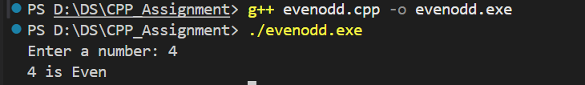

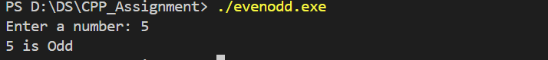

2) Find Largest Number Among 3 Numbers.
Input:
#include <iostream>
using namespace std;

int main() {
int a, b, c;
cout << "Enter three numbers: ";
cin >> a >> b >> c;

if (a >= b && a >= c)
cout << "Largest: " << a;
else if (b >= a && b >= c)
cout << "Largest: " << b;
else
cout << "Largest: " << c;

return 0;
}
Output:

3) Check Whether a Character is a Vowel or Consonant
Input:
#include <iostream>
using namespace std;

int main() {
char ch;
cout << "Enter a character: ";
cin >> ch;

if (ch=='a'||ch=='e'||ch=='i'||ch=='o'||ch=='u'||
ch=='A'||ch=='E'||ch=='I'||ch=='O'||ch=='U')
cout << ch << " is a Vowel";
else
cout << ch << " is a Consonant";

return 0;
}
Output:
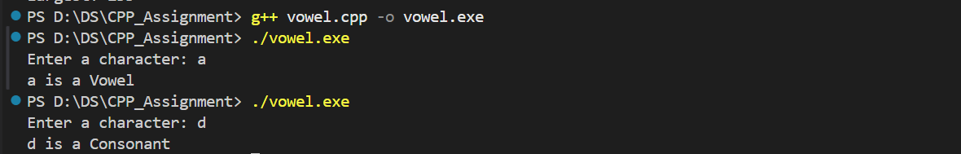

4)Check if a Given Year is a Leap Year
Input:

#include <iostream>
using namespace std;

int main() {
int year;
cout << "Enter a year: ";
cin >> year;

if ((year % 4 == 0 && year % 100 != 0) || (year % 400 == 0))
cout << year << " is a Leap Year";
else
cout << year << " is NOT a Leap Year";

return 0;
}

Output:
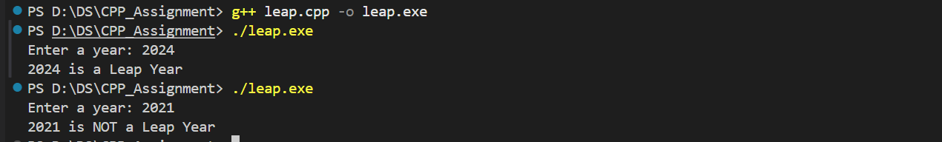

5)Print Multiplication Table of a Number
Input:
#include <iostream>
using namespace std;

int main() {
int num;
cout << "Enter a number: ";
cin >> num;

for (int i = 1; i <= 10; i++) {
cout << num << " x " << i << " = " << num * i << endl;
}

return 0;
}
Output:
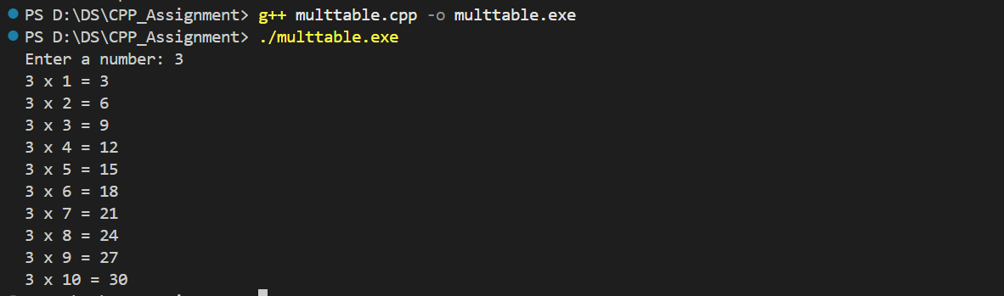

6)Calculate Sum of First n Natural Numbers
Input:
#include <iostream>
using namespace std;

int main() {
int n, sum = 0;
cout << "Enter n: ";
cin >> n;

for (int i = 1; i <= n; i++) {
sum += i;
}

cout << "Sum = " << sum;
return 0;
}

Output:

7)Find Factorial of a Number
Input:
#include <iostream>
using namespace std;

int main() {
int n, fact = 1;
cout << "Enter number: ";
cin >> n;

for (int i = 1; i <= n; i++) {
fact *= i;
}

cout << "Factorial = " << fact;
return 0;
}

Output:

8) Reverse a Number.
Input:
#include <iostream>
using namespace std;

int main() {
int n, rev = 0;
cout << "Enter number: ";
cin >> n;

while (n > 0) {
rev = rev * 10 + (n % 10);
n /= 10;
}

cout << "Reversed Number = " << rev;
return 0;
}
Output:
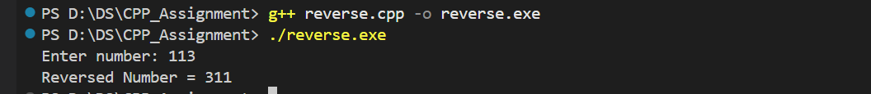

9)Find GCD
Input:
#include <iostream>
using namespace std;

int main() {
int a, b;
cout << "Enter two numbers: ";
cin >> a >> b;

while (b != 0) {
int temp = b;
b = a % b;
a = temp;
}

cout << "GCD = " << a;
return 0;
}
Output:

10)Find LCM
Input:
#include <iostream>
using namespace std;

int main() {
int a, b, lcm, gcd, x, y;
cout << "Enter two numbers: ";
cin >> a >> b;

x = a; y = b;

while (b != 0) {
int temp = b;
b = a % b;
a = temp;
}
gcd = a;
lcm = (x * y) / gcd;

cout << "LCM = " << lcm;
return 0;
}
Output:

11)Check Whether a Number is a Palindrome or Not
Input:
#include <iostream>
using namespace std;

int main() {
int n, rev = 0, temp;
cout << "Enter number: ";
cin >> n;
temp = n;

while (temp > 0) {
rev = rev * 10 + (temp % 10);
temp /= 10;
}

if (rev == n)
cout << n << " is Palindrome";
else
cout << n << " is NOT Palindrome";

return 0;
}
Output:
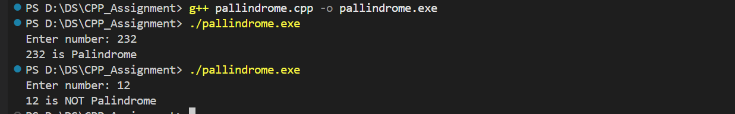

12)Check Whether a Number is Prime or Not
Input:
#include <iostream>
using namespace std;

int main() {
int n, flag = 1;
cout << "Enter number: ";
cin >> n;

if (n <= 1) flag = 0;
for (int i = 2; i <= n / 2; i++) {
if (n % i == 0) {
flag = 0;
break;
}
}

if (flag) cout << n << " is Prime";
else cout << n << " is NOT Prime";

return 0;
}
Output:
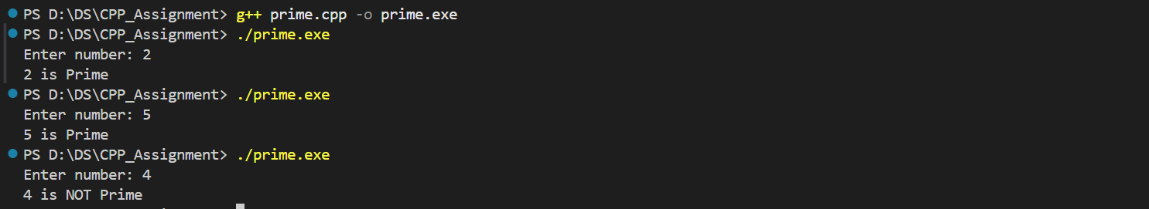

13)Display Prime Numbers Between Two Intervals
Input:
#include <iostream>
using namespace std;

int main() {
int low, high;
cout << "Enter range: ";
cin >> low >> high;

for (int n = low; n <= high; n++) {
int flag = 1;
if (n <= 1) flag = 0;
for (int i = 2; i <= n / 2; i++) {
if (n % i == 0) {
flag = 0;
break;
}
}
if (flag) cout << n << " ";
}

return 0;
}
Output:

14)Check Neon Numbers in a Given Range
Input:
#include <iostream>
using namespace std;

int main() {
int start, end;
cout << "Enter range: ";
cin >> start >> end;

for (int n = start; n <= end; n++) {
int sq = n * n, sum = 0, temp = sq;
while (temp > 0) {
sum += temp % 10;
temp /= 10;
}
if (sum == n)
cout << n << " ";
}

return 0;
}

Output:

15)Check Armstrong Number
Input:
#include <iostream>
using namespace std;

int main() {
int n, sum = 0, temp, digits = 0;
cout << "Enter number: ";
cin >> n;

temp = n;
while (temp > 0) {
int d = temp % 10;
sum += d*d*d;
temp /= 10;
}

if (sum == n) cout << n << " is Armstrong";
else cout << n << " is NOT Armstrong";

return 0;
}
Output:
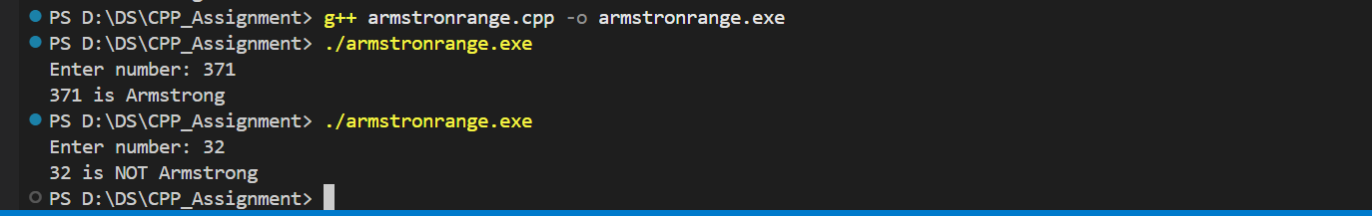
16)Display Armstrong Numbers Between 1 to 1000
Input:
#include <iostream>
using namespace std;

int main() {
for (int n = 1; n <= 1000; n++) {
int sum = 0, temp = n, digits = 0;
temp = n;
while (temp > 0) {
int d = temp % 10;
sum += d*d*d;
temp /= 10;
}
if (sum == n) cout << n << " ";
}

return 0;
}
Output:
17)Find nth Fibonacci Number
Input:
#include <iostream>
using namespace std;

int main() {
int n;
cout << "Enter n: ";
cin >> n;

int a = 0, b = 1, fib;
if (n == 1) fib = 0;
else if (n == 2) fib = 1;
else {
for (int i = 3; i <= n; i++) {
fib = a + b;
a = b;
b = fib;
}
}

cout << "Fibonacci(" << n << ") = " << fib;
return 0;
}
Output:
18)Sum of Fibonacci Numbers at Even Indexes up to N Terms
Input:
#include <iostream>
using namespace std;

int main() {
int n;
cout << "Enter n: ";
cin >> n;

int a = 0, b = 1, sum = 0;
for (int i = 1; i <= n; i++) {
if (i % 2 == 0) sum += b;
int temp = b;
b = a + b;
a = temp;
}

cout << "Sum = " << sum;
return 0;
}
Output:
19)Calculate the Power of a Number
Input:
#include <iostream>
using namespace std;

int main() {
int base, exp, result = 1;
cout << "Enter base and exponent: ";
cin >> base >> exp;

for (int i = 1; i <= exp; i++) {
result *= base;
}

cout << "Result = " << result;
return 0;
}
Output:
20)Display Factors of a Natural Number
Input:
#include <iostream>
using namespace std;

int main() {
int n;
cout << "Enter number: ";
cin >> n;

cout << "Factors: ";
for (int i = 1; i <= n; i++) {
if (n % i == 0)
cout << i << " ";
}

return 0;
}
Output:
21)Make a Simple Calculator
#include <iostream>
using namespace std;

int main() {
char op;
double a, b;
cout << "Enter expression (a + b): ";
cin >> a >> op >> b;

switch (op) {
case '+': cout << "Result = " << a + b; break;
case '-': cout << "Result = " << a - b; break;
case '*': cout << "Result = " << a * b; break;
case '/':
if (b != 0) cout << "Result = " << a / b;
else cout << "Division by zero not allowed";
break;
default: cout << "Invalid operator";
}

return 0;
}
Output:

