DBMS (Database Management System)

DBMS (Database Management System) is a software system that manages, stores, and retrieves data efficiently in a structured format.

It allows users to create, update, and query databases efficiently.

Ensures data integrity, consistency, and security across multiple users and applications.

Reduces data redundancy and inconsistency through centralized control.

Supports concurrent data access, transaction management, and automatic backups

1. Commercial DBMS

A Commercial DBMS is a paid, licensed database software developed and maintained by companies with professional support.

Examples

Oracle Database

Microsoft SQL Server

IBM DB2

2. Open-Source DBMS

An Open-Source DBMS is free software where the source code is publicly available and can be modified.

Examples

MySQL

PostgreSQL

MongoDB (community edition)

Task 1: Commercial DBMS
1. Oracle DBMS
Oracle DBMS is a powerful commercial relational database developed by Oracle Corporation.
It is mainly used for large-scale enterprise and mission-critical applications.
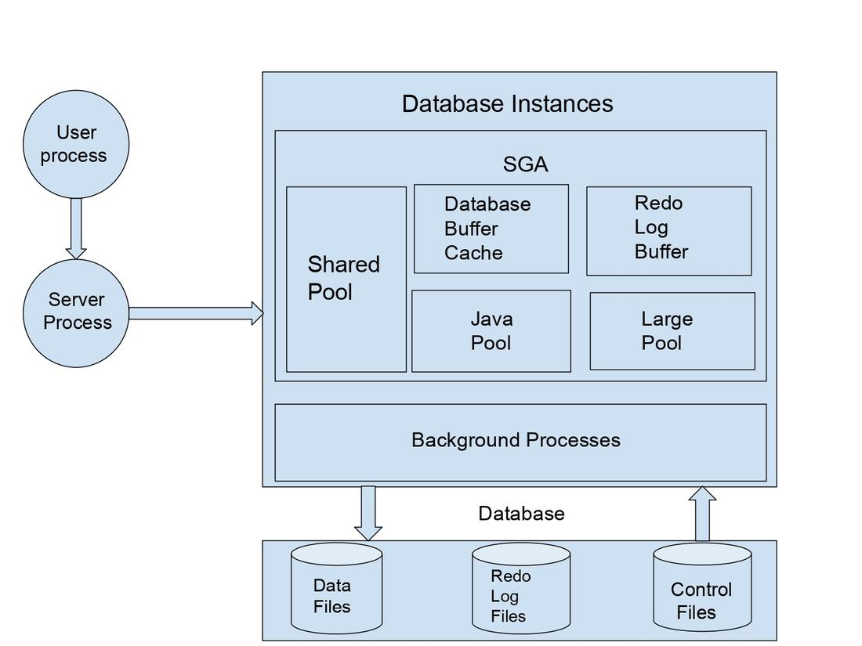
Fig. Oracle Archietecture
Uses :
- Banking and financial systems
- Large enterprise applications
- Government and telecom databases

Advantages :
- Very high security
- Excellent performance and scalability
- Strong backup and recovery support

Disadvantages :
- Very expensive license
- Complex to manage
- Requires high-end hardware
2. Microsoft SQL Server
SQL Server is a commercial DBMS developed by Microsoft. It is commonly used with Windows-based applications and enterprise systems.
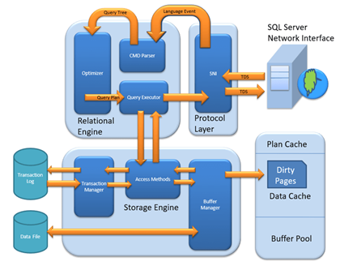
Fig. SQL Server Architecture
Uses :
- Business applications
- Data warehousing
- Web applications with .NET

Advantages :
- Easy to use and manage
- Strong integration with Microsoft tools
- Good security features

Disadvantages :
- High licensing cost
- Best performance only on Windows
- Limited support on non-Microsoft platforms

3. IBM DB2

IBM DB2 is a high-performance commercial database developed by IBM. It is mainly used in large enterprises and mainframe environments.
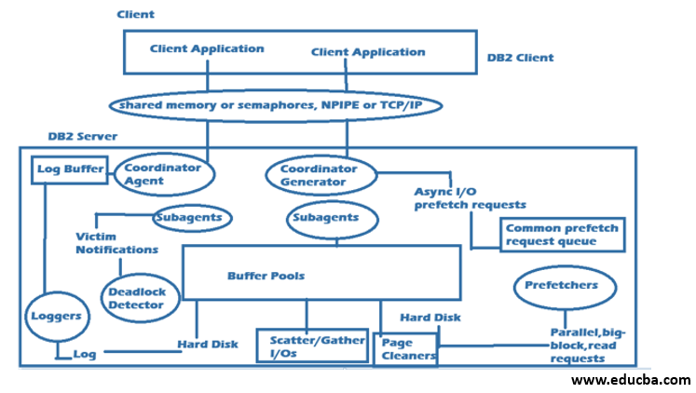
Fig. IBM DB2 Archietecture
Uses :

Banking and insurance systems

High-volume transaction systems
- Enterprise data processing
Advantages :
- Very fast data processing
- High reliability
- Strong support for big data
Disadvantages :
- Expensive licensing
- Complex installation
- Needs skilled professionals

Task 2: Open-Source DBMS
1. MySQL
MySQL is a popular open-source relational database developed by Oracle.
It is widely used for web-based and small to medium applications.
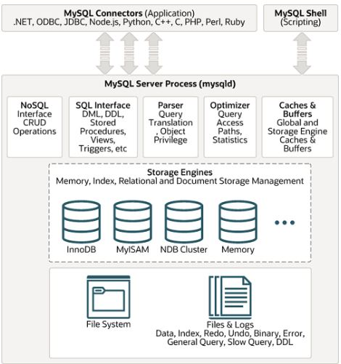
Fig. MySQL Architecture
Uses :
- Web applications
- Content management systems (CMS)
- Small to medium business databases

Advantages :
- Free and open source
- Easy to install and use
- Good performance for web apps

Disadvantages :
- Limited advanced features
- Not ideal for very large systems
- Weaker support compared to commercial DBMS
2. PostgreSQL
PostgreSQL is an advanced open-source object-relational database system. It is known for high reliability and standards compliance.
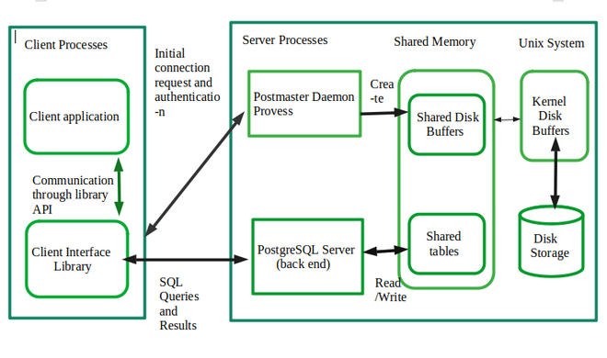
Fig. PostgreSQL Architecture
Uses :
- Enterprise applications
- Data analytics systems
- Complex and large databases

Advantages :
- Highly secure and reliable
- Supports advanced SQL features
- Excellent data integrity

Disadvantages :
- Slightly complex to learn
- Slower than MySQL for simple queries
- Requires skilled administration

3. MongoDB
MongoDB is an open-source NoSQL document-oriented database. It stores data in JSON-like documents instead of tables.
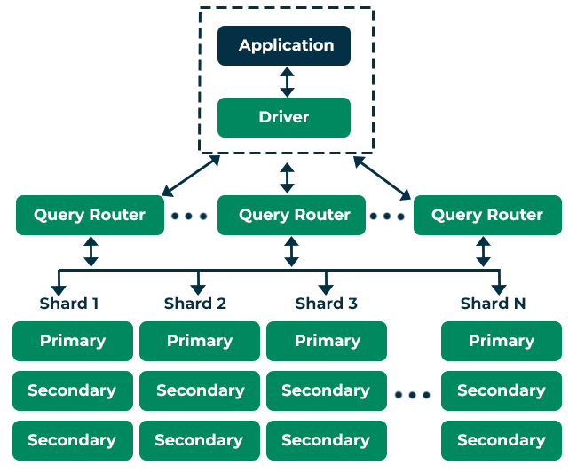
Fig. MongoDB Architecture
Uses :
- Big data applications
- Real-time analytics
- Web and mobile applications

Advantages :
- Schema-less and flexible
- High scalability
- Fast data access

Disadvantages :
- Not suitable for complex transactions
- High memory usage
- Limited joins compared to SQL DBMS

Task 3: Comparison tables
Comparison Table of Commercial DBMS
Parameter | Oracle DBMS | Microsoft SQL Server | IBM DB2
Type | Relational DBMS (RDBMS) | Relational DBMS (RDBMS) | Relational DBMS (RDBMS)
Architecture | Client–Server, Multi-tier | Client–Server | Client–Server, Mainframe
Data Model | Tables (Rows & Columns) | Tables (Rows & Columns) | Tables (Rows & Columns)
Scalability | Excellent vertical & horizontal | Good vertical, limited horizontal | Very high scalability
Performance | Very high for large workloads | High for enterprise apps | Extremely fast for transactions
Security | Advanced enterprise-level security | Strong security features | Very strong enterprise security
Transactions | Fully ACID compliant | Fully ACID compliant | Fully ACID compliant
Backup & Recovery | Advanced recovery & RMAN | Built-in backup tools | Advanced recovery tools
Use Case | Banking, telecom, ERP systems | Business & enterprise apps | Banking, insurance, mainframes
Licensing | Commercial (Paid) | Commercial (Paid) | Commercial (Paid)
Cost | Very expensive | Expensive | Expensive
Platform Support | Cross-platform | Mainly Windows | Cross-platform

Comparison Table of Open Source DBMS:

Parameter | MySQL | PostgreSQL | MongoDB
Type | Relational DBMS (RDBMS) | Object-Relational DBMS (ORDBMS) | NoSQL DBMS
Architecture | Client–Server | Client–Server | Distributed, Document-based
Data Model | Tables (Rows & Columns) | Tables + Objects | Documents (JSON-like)
Scalability | Vertical; limited horizontal | Vertical & horizontal | Excellent horizontal (Sharding)
Performance | Fast for read-heavy workloads | Balanced & consistent | High performance for large datasets
Security | Basic to moderate | Very strong, enterprise-level | Good, role-based security
Transactions | ACID compliant | Fully ACID compliant | Limited ACID (document-level)
Schema | Fixed schema | Fixed with flexibility | Schema-less
Backup & Recovery | Basic tools available | Advanced & reliable | Built-in replication & backup
Use Case | Web applications, CMS | Enterprise & analytics | Big data, real-time apps
Community Support | Large community | Strong developer community | Very active community
Licensing | GPL (Open source) | PostgreSQL License | SSPL (Open source)

