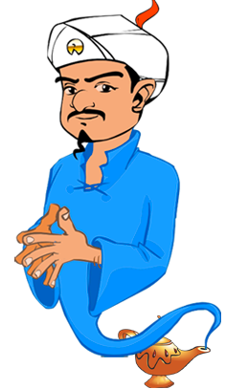 **OTAKUNATOR**

Made by -2017UCO1555(Naman Bhat)

2017UCO1556(Mohd. Saquib)

2017UCO1551(Ashish)

2017UCO1558(Sumit Yadav)

**INTRODUCTION :** An application that attempts to guess the character from Naruto-verse about which you may be thinking based on a few questions that you need to answer. This application makes use of Naïve Bayes to reduce the no. of questions to as small as possible, required to converge to the correct answer.

**DATASETS :** The application is dynamic and extends its own database by asking user a few questions if the character intended to be guessed does not exist in database. However, for initial database we have referred Naruto-pedia and Naruto-Fandom.

**U.I. :** Made use of PyQT5 package to implement a graphical user interface that lets user access our application and also extend our datasets.