Start of PDF Naman_Omar 1



Telematics and Informatics 75 (2022) 101907
Contents lists available at ScienceDirect

Telematics and Informatics
journal homepage: www.elsevier.com/locate/tele

Time-series based prediction for energy consumption of smart  home data using hybrid convolution-recurrent neural network
Naman Bhoj ª, Robin Singh Bhadoria ^{b,*}
ª Independent Researcher, Haldwani, Uttarakhand 263139, India
^{b} Department of Computer Engineering & Applications, GLA University, Mathura 281406, India

A R T I C L E I N F O

Keywords:
Time-Series Prediction Electrical Energy Consumption
Convolution-Recurrent Neural Network Gated Recurrent Unit (GRU)
Long Short-Term Memory (LSTM) Support Vector Regression (SVR)
A B S T R A C T

The rapid increase in technological development has led to the rise in usage of IoT devices for monitoring Electrical Energy Consumption. As countries around the world are committing to United Nations Sustainable Development Goals, reducing carbon footprint has become an eminent priority for policymakers, businesses, and the public. Clean and green energy in the form of electricity has emerged as an alternative to fossil fuel. Since electricity is scarce and in high demand it has become an important problem for identifying robust energy consumption pre- dictive models for powered smart residential homes. In our research we compare SVR, LSTM, GRU, CNN-LSTM, CNN-GRU models for predictive energy consumption data of smart residential homes. Empirical results indicate that with increase in the amount of data the performance of machine learning SVR degraded significantly more as compared to Deep Learning Techniques, which provides conclusive evidence that machine learning techniques are not suitable for the task. Whereas, our proposed CNN-GRU architecture performs 17.4% better in terms of Mean Absolute Error (MAE) with a value of 0.151 compared to the LSTM which has a value of MAE equals to 0.183 for days granularity of data and is only bested by the LSTM by 0.4% in terms of MAE for hour granularity data, where the CNN-GRU has MAE of 0.229 and LSTM achieves the MAE of 0.228. Additionally, CNN-LSTM and LSTM architectures were found effective in identi- fying outliers.

- Introduction

With the increase in growth of high-speed networks, the Internet has become an indistinguishable part of our life. We have advanced to the phase where access to anything, anywhere, anytime has become a reality. This has led the IoT (Internet of Things) to become an integral part of our daily life as wireless technologies like Bluetooth, Wi-Fi, RFID, ZigBee allow it to connect with the internet and interact with each other. IoT has also gained an increasing amount of popularity in academia and industry (Ahmad et al., 2019). It also has many other wide use cases such as Body Sensor network, Medical Body area network, Smart City, Smart Parking, Waste Management, Energy Consumption and Monitoring but not limited to these (Pan and Yang, 2019; He et al., 2014; Orsino et al., 2016; Spano et al., 2015). The continuous growth in economy and technological advancement has increased electrical power con- sumption in developing countries. The energy can be stored and reused later but there are challenges associated with it particularly load leveling, cost effectiveness, efficiency (Ibrahim et al., 2007). It is effective in designing strategies that can help the urban

* Corresponding author.
E-mail addresses: namanbhoj99@gmail.com (N. Bhoj), robin19@ieee.org (R. Singh Bhadoria).

https://doi.org/10.1016/j.tele.2022.101907
Received 1 June 2022; Received in revised form 28 September 2022; Accepted 21 October 2022
Available online 27 October 2022
0736-5853/© 2022 Elsevier Ltd. All rights reserved.

Related work on impact and importance of Energy.
Reference Description

Gonza´lez-Eguino (2015)
The authors suggest that Energy Poverty has a negative correlation with Economic Growth.

Reddy (2000) This paper explains how energy consumption is correlated to the position of women in society and how important it is to focus on energy strategy for a high quality of life.
Lawal et al. (2020) The authors suggest a threshold value for electricity consumption which is 48 % below this will have a positive impact on growth.

Charfeddine (2017) This work explains how electrical energy consumption is positively correlated to Ecological Footprint and negatively correlated to CO2 emission.

Helmers and Marx (2012)
The author explains how electric vehicles are efficient and environment friendly.

environment and to effectively deal with energy poverty as it has shown to have a major impact on health, GDP, environment, situation of women and population growth (Gonza´lez-Eguino, 2015; Reddy, 2000; Lawal et al., 2020). The Energy Consumption is also
negatively related to Carbon Footprint and has a positive correlation with Ecological Footprint (Charfeddine, 2017). The latest technological invention where electrical energy is playing a major role is the electricity-based transportation mediumas electric ve- hicles (EVs) are more efficient in terms of energy compared to Internal Combustion Engine Vehicles (Helmers and Marx, 2012).
Researchers have highlighted the impact of energy consumption on Environment, Economic growth, Sustainable growth, Growth in Population, Ecological Footprint and CO2 emission and Sustainable mobility. This impact makes it a problem of utmost importance with growing technology.
Gonz´alez-Eguino (2015) explained how energy poverty is an obstacle for growth and development and how it is correlated to
economic conditions prevailing in the country. One of the most promising growth has been of China where in a short period of time the country has achieved universal access to electricity. The consumption in China rose from 150 kWh per capita in 1970 to 3000 in 2010, which is more than 20 times, whereas in sub- Saharan African countries like Ethiopia where there has been no or little improvement consumption is up from 18 kWh per person in 1970 to 58 in 2010, leading to only 15 % of population having access to electricity.
Reddy (2000) suggested that energy can influence the status of women and urbanisation, he showed a dialectical relationship between universal issues and energy consumption and in turn how energy systems influence the issue shows why developing nations should focus on proper energy strategy for high quality, safe, and environment friendly growth.
Lawal et al. (2020) suggested that there is a two-way relationship and dependence between growth and electrical energy con- sumption. They also showed that energy consumption value below 48 % will have a constructive influence on growth and value greater than it will have an obstructive effect on growth. These thresholds can be properly implemented and monitored through energy-saving appliances and effectively dealing with energy theft and loss. Charfeddine (2017) suggested that Electricity consumption and Ecological Footprint have a positive correlation, as 1 % increase in electricity consumption increases the Ecological Footprint by 0.2275 % whereas there is a negative correlation between CO2 emission and Electricity consumption. This indicates that Electrical energy is a comparatively more favourable source of energy. Helmers and Marx (2012) suggested that electric cars hold a sustainable future in mobility, they showed that during the e-conversion of an electric car the CO2 emission can be reduced by more than 80 %. They also indicated that electric cars have an efficiency of 53 % to 70 % which is 4 times higher compared to Internal Combustion Engine Vehicle with an efficiency of 13 % to 20 %. The following research conducted on the impact and importance of Energy suggests that the problem of energy consumption prediction is of global importance both for the growth and development of the economy and environment. The important highlights are aggregated in Table 1.
Pertaining to the broad spectrum of application of electrical energy, particularly makes the problem of accurate electrical power consumption prediction of vital importance. Electrical Energy consumption can be identified and modelled as a multivariate problem with temporal features. Hence modelling machine learning and deep learning techniques can provide a robust solution which is what we investigate in this paper. The key contribution of the work is as follows:

- Performing empirical studies to investigate the effectiveness of various machine learning, deep learning and hybrid deep learning models for Time Series energy consumption on two different granularity of datasets based on energy smart residential homes.
- Identification of heavily data dependent models, which may not be effective with noisy data or when the granularity of data is
changed.
- Perform outlier analysis and identify models capable of outlier detection.
- Propose an architecture for a robust hybrid deep learning model which can be used for both the granularity of data to make ac- curate predictions.
- Unlike past researchers we focus upon using environmental features for our predictions, the major advantage being they are easy to
collect for a region rather than collecting data for every single home which could make data collection part of the problem solving pipeline expensive.

We investigate the performance of our machine learning, deep learning and hybrid deep learning models by creating two different granularity of input data which is openly available at Kaggle (Singh, 2019). The first dataset allowed to predict the next day

Table 2
Related work on Energy Consumption Prediction.
Author Techniques Description

(Chen et al., 2017) SVR Ambient temperature and electricity loads are used as features for load forecasting.
(Shabbir et al., 2019) Linear Regression, Tree Based Regression, SVM Household load forecasting is performed.

(Johannesen et al., 2019) Random Forest Regressor, K Nearest Neighbour Regression, Linear
Regression
(Ahmed Gassar et al., 2019) Random Forest, Multilayer Neural Network, Multiple Linear Regression, Gradient Boosting.
Urban area load forecasting.

Electricity and Gas consumption prediction.

(Kong et al., 2019) LSTM Individual household load forecasting.

(Li et al., 2017) Back Propagation Neural Network, SVR, Generalised RBFNN, Multiple Linear Regression, Stacked Autoencoders
Building Energy Consumption Prediction.

(de Oliveira and Cyrino Oliveira, 2018)
Bagging Arima Improving energy consumption predictions using Bagging Arima.

(Boroojeni et al., 2017) Autoregressive/Moving-average model. Short and medium term load forecasting.
(Rahman and Ahmar, 2017) ARIMA and Holts-Winter model Energy Consumption prediction.

consumption using historical energy data of previous one day and current day environmental features. In this sense, we resampled the original data from minutes to days, and for the second dataset we resampled the original data from minutes to hours and predicted the consumption for next hour using the historical energy consumption data from the previous one hour and current hour environmental features. The input data for our models consisted of weather features and energy consumption data of respective granularity to predict the output data which is the energy consumption for respective granularity.
We model the problem as a multivariate time series hence making it open to various statistical techniques such as ARIMA and ARMA. The problem of energy consumption contains environmental features and hence making it unsuitable to solve using statistical techniques. As due to the changing nature of environmental features they cannot be described with accurate and precise mathematical representation, using ARIMA and ARMA. Unlike past researchers we focus upon using environmental features for our predictions, the major advantage being they are easy to collect for a region rather than collecting data for every single home which could make data collection part of the problem solving pipeline expensive. This makes machine learning, deep learning, hybrid deep learning methods suitable as they are effective in constructing a non-linear mapping between input and output, while novel techniques like one shot and zero shot learning would be less effective for the problem as compared to machine learning, deep learning and hybrid deep learning techniques due to the presence of large amount of data and exceptional ability of LSTM and GRU models to find patterns in temporal data.
The model’s performance evaluation used the test data. We used MSE, MAE and RMSE as evaluation metrics. We observed that a machine learning model’s performance is heavily dependent on the granularity of training data whereas for deep learning and hybrid models the dependence on granularity of data is comparatively smaller.
The rest of the paper is structured as follows:

- Background work

This section presents and outlines the research related to the studies that have been conducted for Energy Consumption Prediction problems.
Pertaining to the importance and impact of electrical energy, past research has been conducted. Mainly-three techniques have been used for the problem of energy consumption prediction: statistical techniques, machine learning techniques, and deep learning techniques (Kieling et al., 2019). The goals of this section is to analyse and summarise the algorithmic techniques and the features of the dataset used in the past by researchers. Table 2 aggregates the studies pertaining to the past research.
Chen et al. (2017) introduced a new Support Vector Regression methodology for Load Forecasting. They improved the performance of the model by introducing ambient temperature on top of basic electricity load as a feature and took the temperature several hours before the Demand Response event. Number of variations were tested and it was found that reading taken 2 h before the Demand Response event gives the best performance.
Shabbir et al. (2019) presented a comparative analysis of three different machine learning techniques for load forecasting in households. The SVM based regression in this research outperforms the other two where the SVM based regression model is 28 % better than Tree-Based Regression and almost 50 % better than Linear Regression.
Johannesen et al. (2019) performed comparative analysis of different regression-based models on different time steps of 24 h and 30 min for urban area electrical energy consumption. KNN regressor performed the best for medium term prediction of 24 h and Random Forest Regressor was the best technique for short term prediction i.e. 30 min. The disadvantage is that present machine learning methods tend to overfit the data when the relationship between variables becomes complicated or when it is given a huge amount of data to train on, which restricts it to generalise well for medium term forecasting.
Ahmed Gassar et al. (2019)accurately predicts electricity and gas usage using deep learning techniques, machine learning and boosting techniques. The results indicate that the Multilayer Neural Network model performs the best followed by Random Forest.
Kong et al. (2019) used LSTM- Recurrent Neural Network for short term load forecasting. They used a density-based clustering technique and achieved better results by aggregating the individual forecast compared to forecasting loads collectively.

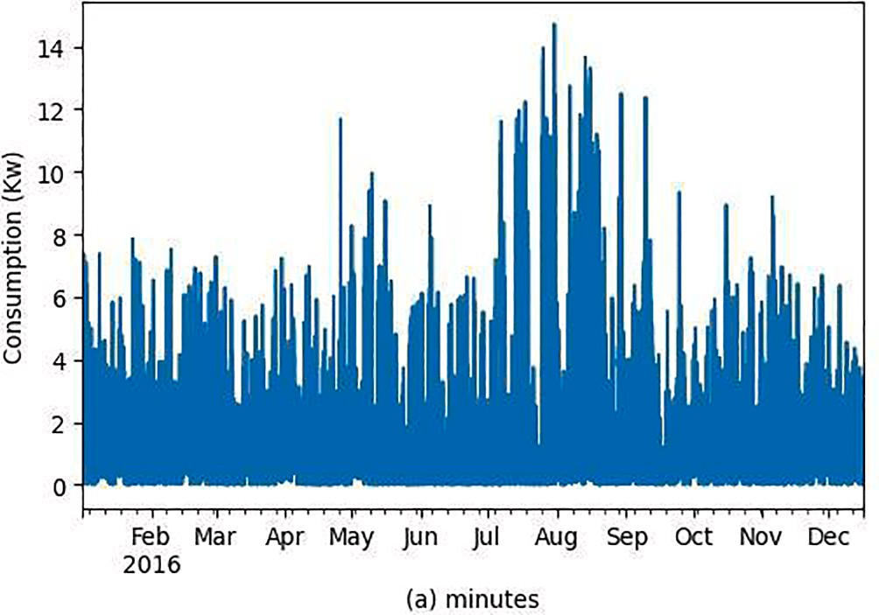

Fig. 1. Original Dataset.

Li et al. (2017) predicted energy consumption using Stacked Autoencoders combined with Extreme Learning Machines, they extract important features using Stacked Autoencoders and make predictions using the Extreme Learning Machines.
de Oliveira and Cyrino Oliveira (2018) performed univariate forecasting for monthly electric demand across various countries and devised a method to combine Bootstrap aggregating and decomposition. A new variation of Bagging is proposed i.e., Remainder Sieve Bootstrap. The method was effective in prediction for different experimental datasets.
Boroojeni et al. (2017) implemented an Autoregressive/Moving Average based forecasting model for short- and medium-term forecasting. The model only relies on historical data and no additional input.
Few other statistical models such as ARIMA, Holter-Winters, SARIMA have also been used for energy forecasting over time (Rahman and Ahmar, 2017; Pongdatu and Putra, 2018). The most significant impact of study lies in the fact that the study comprises empirical studies of all the 3 models namely: machine learning, deep learning and hybrid deep learning for two different granularity of data. This helps overcome a major drawback of past studies which only analyzed single granularity of data with similar model ar- chitectures. On top of that the study also identifies models which would be helpful to detect outliers in the Energy Consumption data.

- Materials and methods

This section delves into the dataset and techniques used by us in our research. The section is divided as follows:

- Acronyms used in in the paper
- Structure and attribute of dataset used for experimentation.
- Algorithms used for experimentation.
- Data Analysis and Pre-Processing steps used.
- The architecture of algorithms used for experimentation.

  - Acronyms

LSTM Long Short-Term Memory
GRU Gated Recurrent Unit
CNN-LSTM Convolutional Neural
Network - Long Short-Term Memory
CNN-GRU Convolutional Neural Network - Gated Recurrent Unit
SVR Support Vector Regression
MAE Mean Absolute Error
MSE Mean Squared Error
RMSE Root Mean Squared Error

  - Dataset

The smart home dataset with weather information (Singh, 2019) from Kaggle was used in the study to validate various electrical energy consumption prediction models; the dataset has real world significance, as the dataset was collected from real time IoT sensors of Smart Homes which now commonly have these technologies to monitor various appliances their performance and usage. Soon

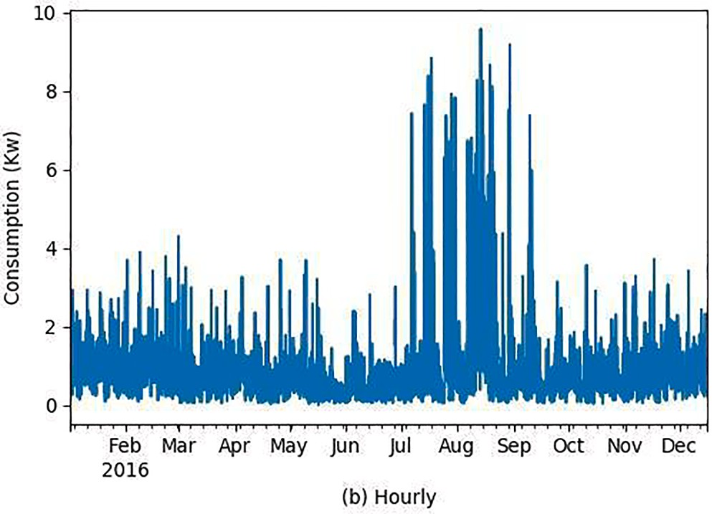

Fig. 2. Plot of Electrical Energy Dataset for Hourly Granularity.
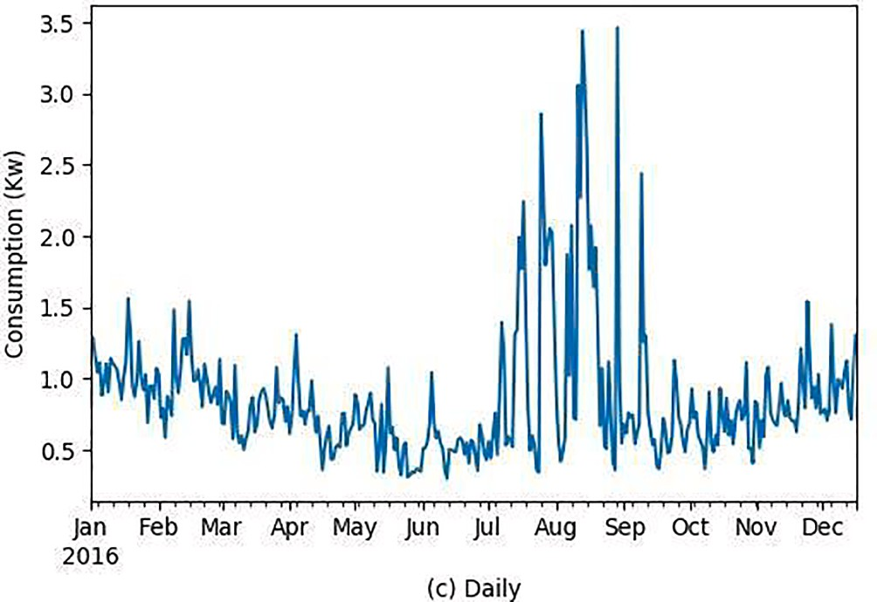

Fig. 3. Plot of Electrical Energy Dataset for Daily Granularity.

enough the technology is going to be an integral part of every home and then this prediction model could help to estimate the amount of energy required for a certain region. The dataset contains the energy usage of house appliances in kW and weather conditions at that time, with readings being taken every 1 min. Dataset initially contains 503,911 measurements with 32 features in Unix Time format (Wikipedia Contributors, 2020). We then change the granularity of the data into two different granularities of hours and days which creates two different datasets for short-term and medium-term predictions; respectively. The generated datasets have 8399 mea- surements ranging from 1 January 2016 05:00:00 to 16 December 2016 03:00:00 and 351 measurements ranging from 1 January 2016 to 16 December 2016 respectively. Fig. 1 shows the original dataset where the time index was in minute and the data consisted of a lot of noise.
Whereas Fig. 2 and Fig. 3 shows the dataset that were extracted from the original dataset by changing the granularity of the dataset.
Fig. 2 represents the dataset with hourly granularity whereas Fig. 3 represents the dataset with daily granularity.
Studying the same data in different granularities is of utmost importance. This paper deals in predicting energy consumption for short and medium periods. To better understand why 2 different granularities of data have been analyzed, let’s take an analogy as an example of a race track. Often for a 500 m race the speed is mentioned in meter/sec while for a 100 km race the speed is mentioned in km/hour. Everything boils down to what you want the final outcome to look like and at what granularity you the predictions are expected. Using the techniques discussed in the paper, it would now be easier to make both (short term) hourly predictions and hourly (short term) predictions, which would provide a fine grained control for the organization using the model and would average down the error rate.

  - Algorithmic models

For our Energy consumption prediction problem on both granularity of data we employ various models such as SVR, LSTM, GRU, CNN-LSTM, CNN-GRU. Our proposed Model Development and Evaluation Workflow is shown in Fig. 4.

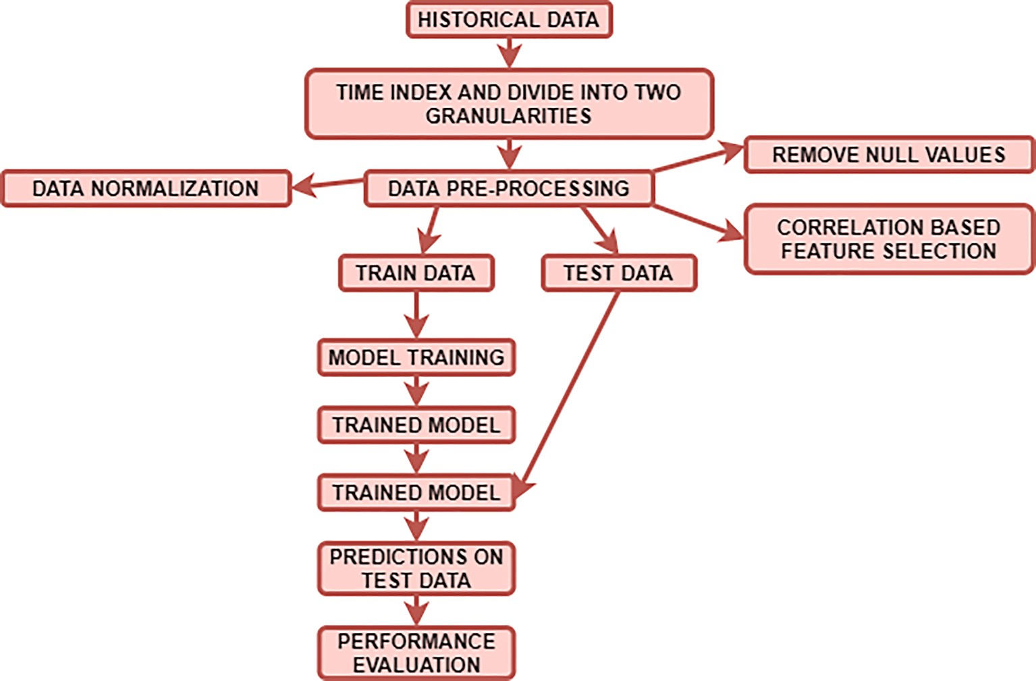

Fig. 4. Model Development and Evaluation Workflow.
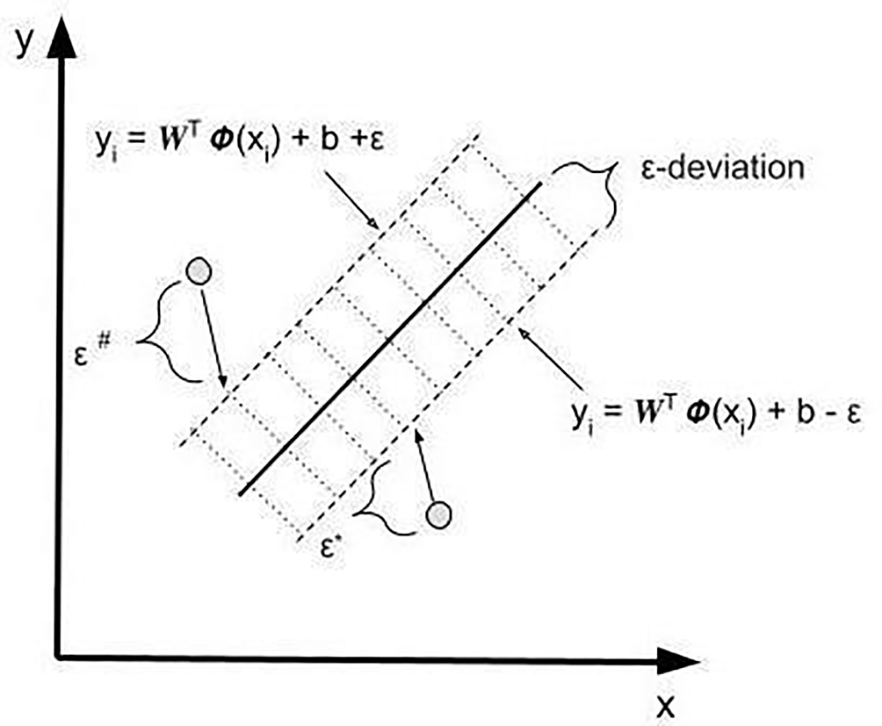

Fig. 5. Architecture of SVR.

    - Support vector Regression (SVR)
The Support Vector Machines (SVMs) were proposed by Sain and Vapnik (1996). It is an algorithm that constructs a hyperplane for separating different classes for a classification problem, whereas in case of a regression problem we use Support Vector Regression
(SVRs). For the given data G = {(x_{i},y_{i})} (^{N} ). (where x is the input vector, y is the actual value of output data and N is total number of
i=1
i
i
data examples), SVR maps the input vector x_{i} into higher dimensional feature space, the feature space builds an optimized hyperplane that represents the non-linear relationship between the input vector and the output data. The function is written in Eq.(1), The schematic of an SVR is shown in Fig. 5.
g(x) = W^{T} θ(x) + b (1)

L(y_{i}, g(x) ) = { |y — g(x) | — ε, if |y — g(x) |⩾ε
0 , otherwise

(2)

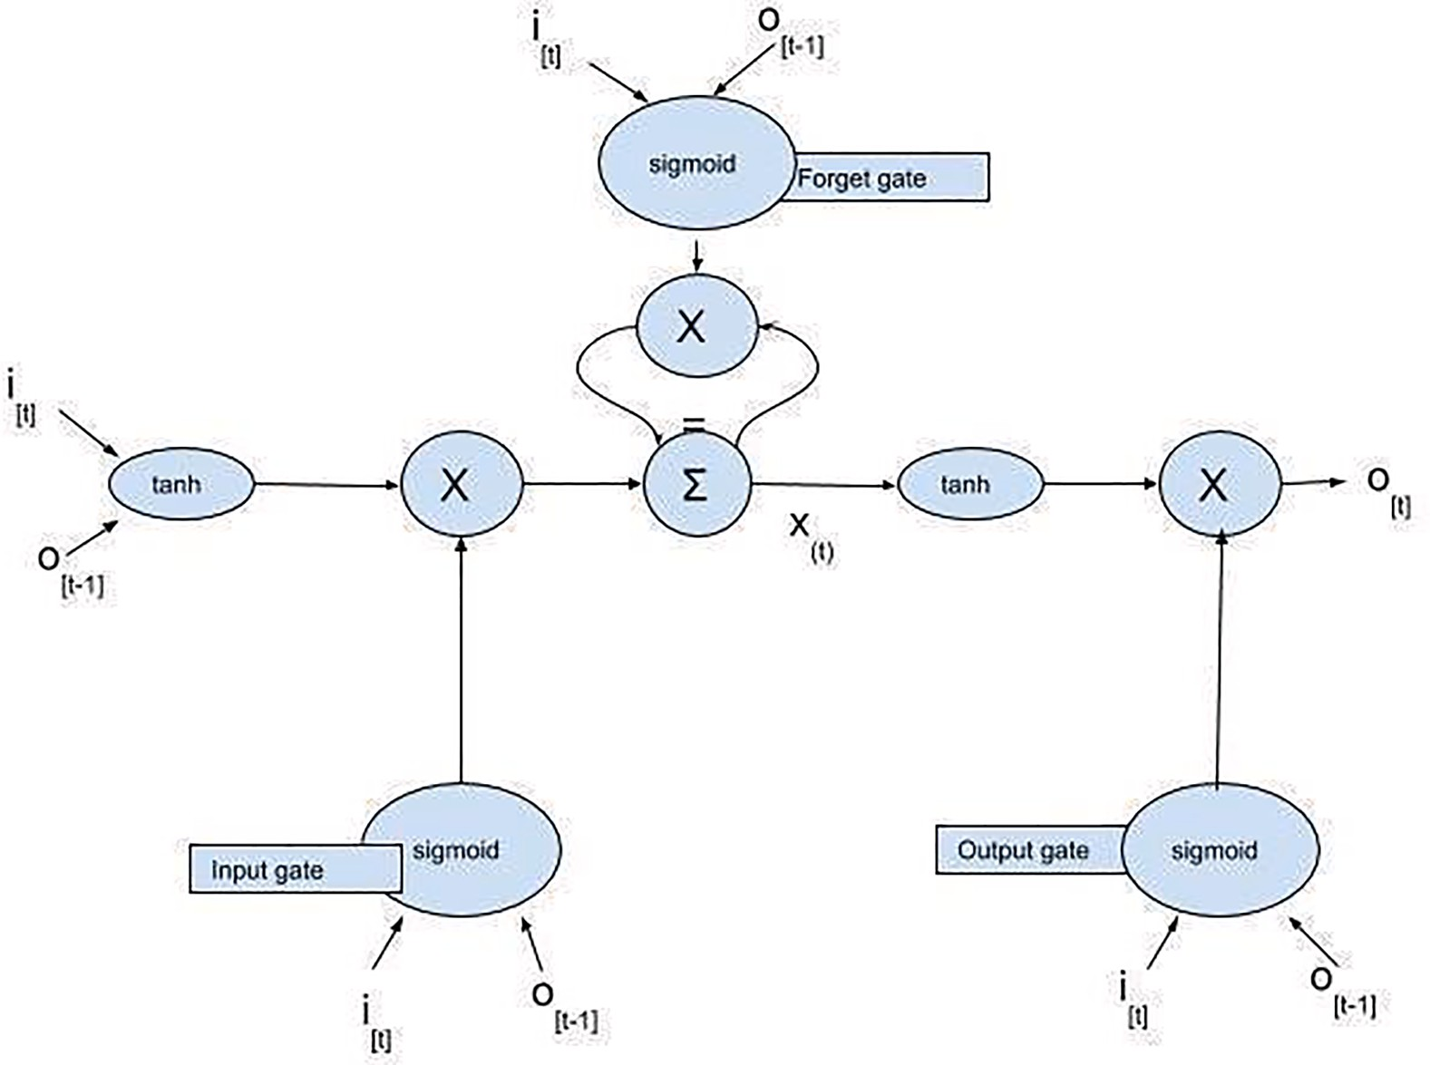

Fig. 6. LSTM Cell.

R(x, y) = y — g(x) (3)
— ε⩽y — g(x)⩽ε (4)
where g(x) is the prediction and the smoothness is governed by the weight vector W, b is the bias parameter. ɸ(x) is the higher dimensional feature space which is non-linearly mapped from input space x. Eq. (2) represents the ε-insensitive loss function which is used to measure the empirical risk, and where ε is the tube size. Eq. (3) shows the Residual and that is the difference between actual value and predicted value and Eq.(4) shows the ideal regression which includes the full residual within the range of tube size ε.
|y — g(x) | = ε (5)
Maximum distance is reached when the modulo of residual is equal to the tube size which is shown by Eq. (5). It is assumed that the largest distance between the hyperplane R(x,y) = 0 and data (x,y) is δ. The error might exceed the range [—ε,ε ], so training error greater than the value of ε is denoted by ε* and training error which has a value less than -ε is denoted by ε# defined in Eq. (6), (7).
ε# = { — maximum( R(x, y) — ε, 0 ) } (6)
ε* = { maximum( R(x, y) — ε, 0 ) } (7)
The objective is the minimization of error value between train data and ε. So, the objective function is given in Eq. (8).

Minf (W, B, ε# , ε*
1 W||² + CΣ^{N}

(ε# + ε*) (8)

) = ||
2
i=1

Under the following conditions:
y_{i} — W^{T} θ(x_{i}) — b⩽ ε + ε# , i is in the range[1, N] and ε# ⩾ 0
— (y_{i} — W^{T} θ(x_{i}) — b)⩽ ε + ε*, i is in the range[1, N] and ε*⩾ 0
C is the regularized constant and it controls the complexity of the SVR model, whereas ½ ||W||² is used to penalize to maintain the complexity of our model.
Finally after solving the optimization problem with constraints W from Eq. (1) is obtained as shown in Eq. (9).

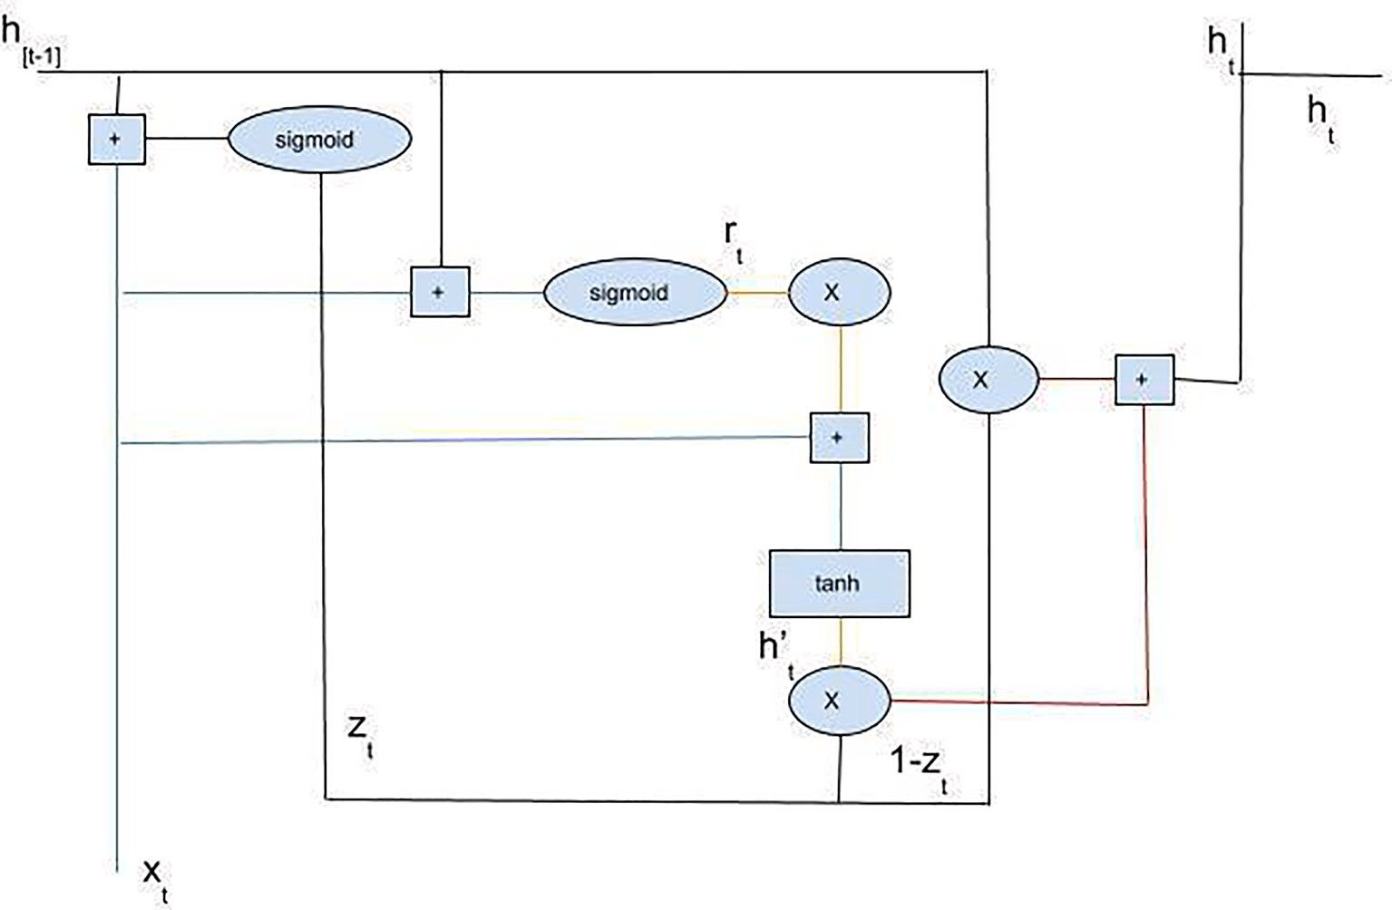

Fig. 7. Architecture of GRU.

N
∑
W = s (β* — β#)θ(x_{i}) (9)
i=1
Now β* and β# are Lagrange’s Multiplier and can be found by solving the Quadratic equation. Finally our SVR function is shown in Eq. (10).
N
∑
g(x) = (β* — β#)K(x_{i} — x) + b (10)
i=1

where the term K(x_{i} -x) is called a kernel function, which can nonlinearly map input vectors to higher dimension feature space and hence is effective in finding nonlinear relationship in Electricity Consumption Prediction problem for both granularity of data.

    - Long short term memory (LSTM)
Recurrent Neural Networks by design are different from the vanilla feed forward neural networks. RNNs are capable of establishing a relationship between historic data and current conditions. This could be really advantageous for any sequence-based problem like Time Series where a decision made at time step t-1 can affect the decision made at time step t. RNN learns information by Back- propagating through Time (Werbos, 1990). However, the problem of vanishing and exploding gradients make it a difficult task for RNN to learn long range dependencies (Bengio et al., 1994; Baghel et al., 2021).
To overcome the restriction imposed by the RNN model, LSTM Recurrent Neural Network was invented by Hochreiter and Schmidhuber (1997) which was later further improved by Gers (1999), where they added forget gates so that the network could reset itself at appropriate times and would not break down. To understand the LSTM network, let’s consider an input sequence {x₁, x₂,x₃,
….., x_{T}} which is a sequence input for the LSTM, where x_{T} denotes a f dimension real value for tth time step.
Fig. 6 represents the structure of a single LSTM Cell. It consists of a memory cell with self-loops. It stores time series information encoded in the cell’s state. The three gates Input, Forget, Output handle the flow of writing, erasing and reading respectively.
Input_{g} = sigmoid i_{[t]}W_{ix} + o_{[t—1]}W_{im} + b_{I} ) (11)
Forget_{g} = sigmoid i_{[t]}W_{fx} + o_{[t—1]}W_{fm} + b_{f} ) (12)
Output_{g} = sigmoid i_{[t]}W_{ox} + o_{[t—1]}W_{om} + b₀) (13)
U = tanh(i_{[t]}W_{ux} + o_{[t—1]}W_{um} ₊b_{u}) (14)
X_{[t]} = Forget_{g}* x_{[t—1]} + Input_{g}* U (15)

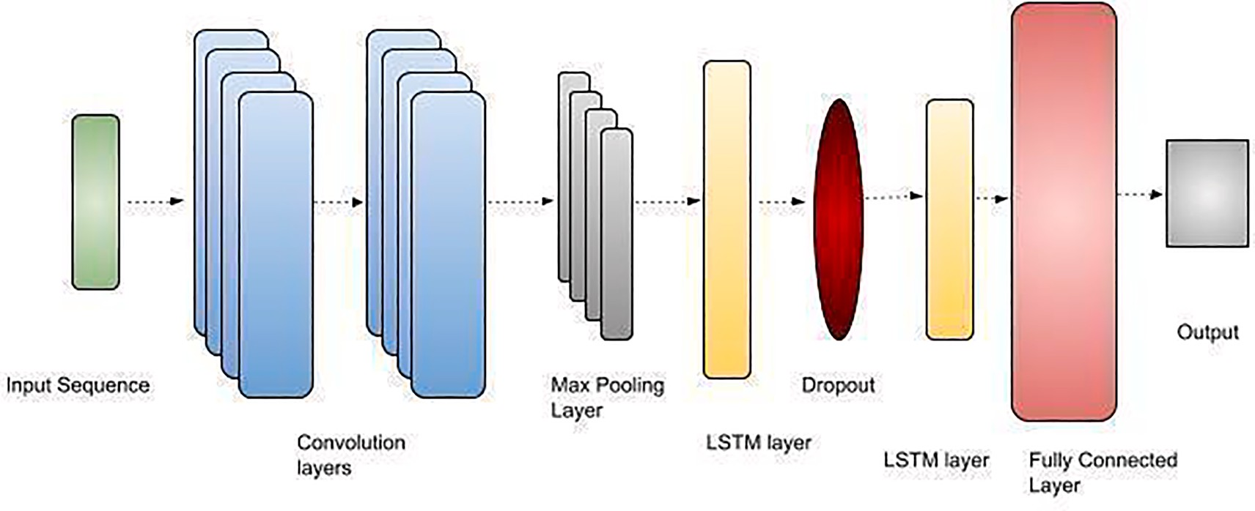

Fig. 8. CNN-LSTM.
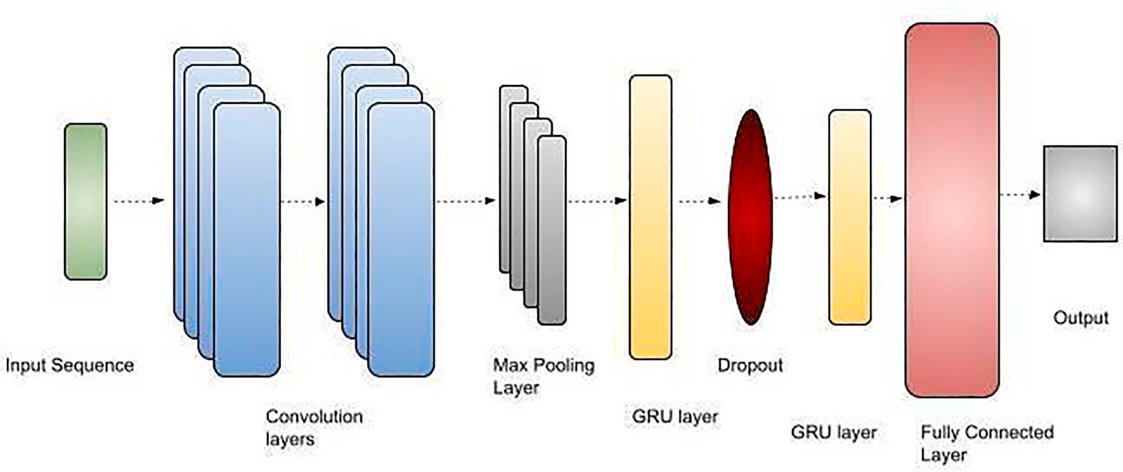

Fig. 9. CNN-GRU.

Output_{[t]} = Output_{g}* tanh(U) (16)
In the Eqs. (15), (16), * denotes element wise multiplication. The Eq. (11) and (16) correspond to single LSTM cell’s operation.
Input_{g}, Forget_{g}, Output_{g},X_{[t]}, O_{[t]}, U correspond to Input, Forget, and Output gate, input feature vector at time step t and Output for time step t and Update signal respectively. The modification in the memory state of the Update signal is decided by the Input gatet. Which is achieved with the help of sigmoid function whose state depends on current input and previous output. If Input_{g} is very small it has a negligible effect on update signal and if it is zero, the update signal in Eq. (15) gets multiplied by 0. Therefore, state would not be affected, the functioning is the same for the rest two gates.
In a similar fashion we can stack various LSTM cells to form a multilayer architecture for Electricity Load Forecasting in both granularity of data (Hasan et al., 2021).

    - Gated Recurrent Unit (GRU)
RNN are capable of extracting information from historical data. However, there is a major disadvantage to RNN’s when we consider long term dependencies as it suffers from exploding and vanishing gradient problems (Bengio et al., 1994; Baghel et al., 2021). Considering that a variant of RNN known as LSTM was developed by S. Hochreiter. It is a variant of RNN that could reset itself at appropriate times so as to avoid network breakdown. LSTM which consists of three different types of gates namely Input, Forget and Output (Hochreiter and Schmidhuber, 1997). LSTMs have shown to achieve great accuracy in Time-Series Prediction problems but they have a longer training time which imposes problems for larger datasets. To overcome this Cho et al. (2014) invented a Gated Recurrent Unit (GRU) which has a shorter training time than LSTM and has comparatively fewer parameters compared to LSTM (Chung et al., 2014). GRU has a Update gate which is the combination of Input gate and the Forget gate used in LSTM, also the cells current state and hidden state are also combined. These gates help GRU to store the information in the memory for a certain amount of time and use these values to carry information forward whenever required to update the future state.

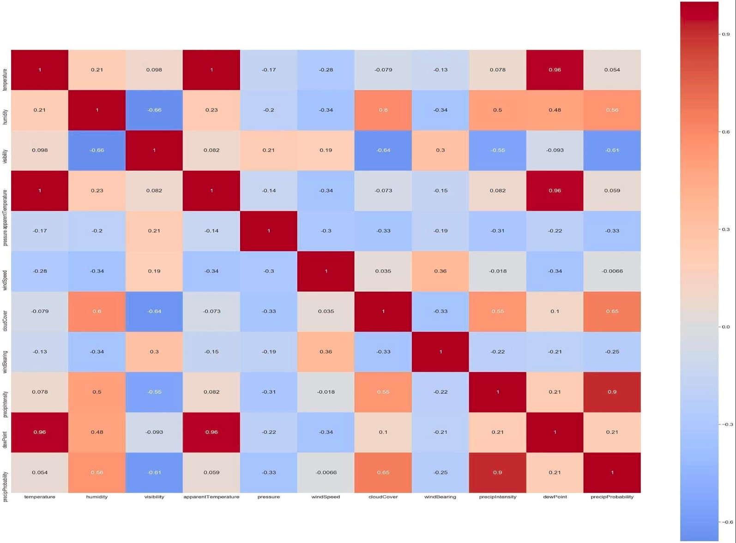

Fig. 10. Correlation Heatmap for days granularity of data.

Fig. 7 shows the architecture of GRU. In Fig. 7, z_{t} represents the update gate Eq. (17). It deals with the vanishing gradient problem. At every time step both the output from the previous unit h_{[t-1]} and the input xt are multiplied by weight vector W_{z} and are then summed up and to constrain the range of output between [0,1] a sigmoid function is used. Then the same operations are performed on the reset gate (r_{t}) Eq.(18). It is responsible for influencing and determining how much historical information to keep. Information currently present in memory is represented by h’_{t}. Eq. (19) gives us the equation which is responsible for passing the relevant in- formation. We calculate the product of x_{t} with W and h_{[t-1} is multiplied by r_{t} and then W and a tanh function is used.Fig. 9.
z_{t} = sigmoid W_{z}* [h_{[t—1]}, x_{t}] ) (17)
r_{t} = sigmoid Wr * [h_{[t—1]}, x_{t}] ) (18)
h_{t} = tanh W*[r_{t}*h_{[t—1]}x_{t}] ) (19)
h_{t} = (1 — z_{t})*h_{[t—1]} + z_{t}*h_{t} (20)
From Eq. (20) we can see that if z_{t} is close to 0 or equal to 0, then (1-z_{t}) ≅ 1, which makes the current information irrelevant and the network will pass the past information and vice versa. ht denotes the final memory, which stores the information of the current unit
which is then forwarded to the network. * denotes element wise multiplication in Eq. (17,18,19,20). This model is used for prediction of electricity load forecasting in both granularity of data.

    - CNN-LSTm
CNN-LSTM combines both the features of a CNN neural network and LSTM neural network. It contains a series of connections of CNN which was proposed by LeCun et al. (2015) and LSTM layers which were proposed by Hochreiter and Schmidhuber (1997) Schematic representation of the architecture is shown in Fig. 8. CNN consists of Convolution and pooling layers which are effective in filtering the input data and extract useful features (Rawat and Wang, 2017). The convolution operation by convolutional layers is applied on input data and the convolutional kernel then produces new feature values. The new feature values are then forwarded to the first layer of LSTM. The LSTM layer is then responsible for modelling and identifying the time dependent information and then the output of the first LSTM layer goes through Dropout Regularization (Srivastava et al., 2014). Dropout Regularization helps to prevent the problem of overfitting of the data in the network and then the output goes to the second LSTM layer as input. We then use a fully connected layer to produce the final output for Electrical Energy consumption prediction for both the granularity of our dataset.
Let I⁰ = {i ,i ,…..i } be the input vector where n is the number of normalized values. We pass i to first Convolutional Layer which
i 1 2 n i

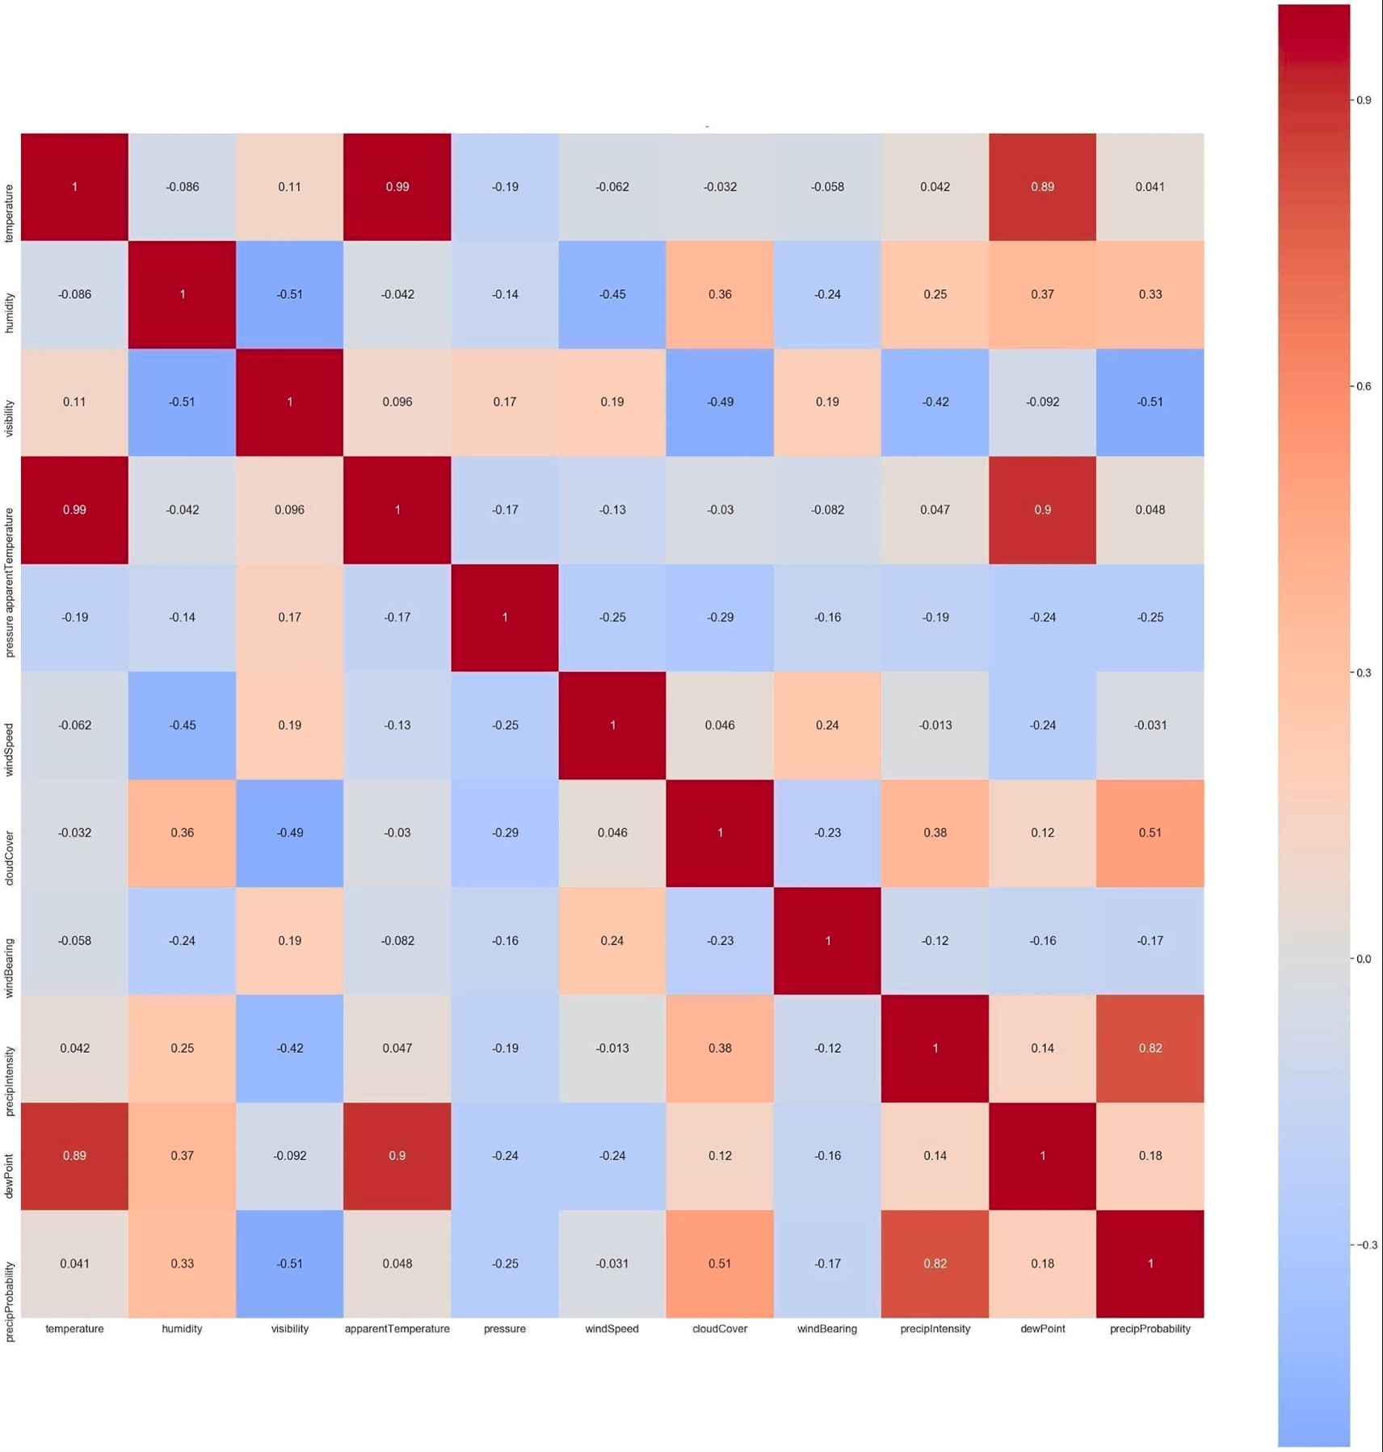

Fig. 11. Correlation Heatmap for hours granularity of data.

Table 3
Input data features and range of their values for predicting the electricity consumption.
Feature | Days Dataset Value Ranges | Hours
Cloud Cover | 0.008 to 1.00 | 0.00 to 1.00
Apparent Temperature | —15.18 to 84.16 | —31.35 to 100.93
Humidity | 0.32 to 0.94 | 0.13 to 0.98
Visibility | 3.21 to 10.00 | 0.28 to 10.00
Wind Speed | 2.00 to 16.17 | 0.16 to 22.67
Pressure | 995.10 to 1039.61 | 986.48 to 1042.43
Wind Bearing | 2.00 to 16.17 | 0.00 to 358.83
Precipitation Intensity | 0.00 to 0.04 | 0.00 to 0.17
Precipitation Probability | 0.00 to 0.50 | 0.00 to 0.83
Previous Day/Hour Electricity Consumption | 0.29 to 3.46 | 0.0008 to 9.58

Table 4
Architecture Specification of models.
Model | Total Model Layers(Units)/Specification | Optimizer | # of Train-able Parameters | Drop-out | Epoch/Batch Size
SVR | Kernel =‘sigmoid’, | – | – | – | –
 | Tolerance = 0.001, C = 1
LSTM | LSTM(64), Dense, | adam | 31,649 | 0.2 | 100,16
 | LSTM(32)
GRU | GRU(64),Dense, | adam | 23,745 | 0.2 | 100,16
 | GRU(32)
CNN– | CNN(100),CNN(100), | adam | 65,889 | 0.2 | 100,16
LSTM | LSTM(64),Dense,
 | LSTM(32)
CNN– | CNN(100),CNN(100), | adam | 52,225 | 0.2 | 100,16
GRU | GRU(64),Dense,
 | GRU(32)
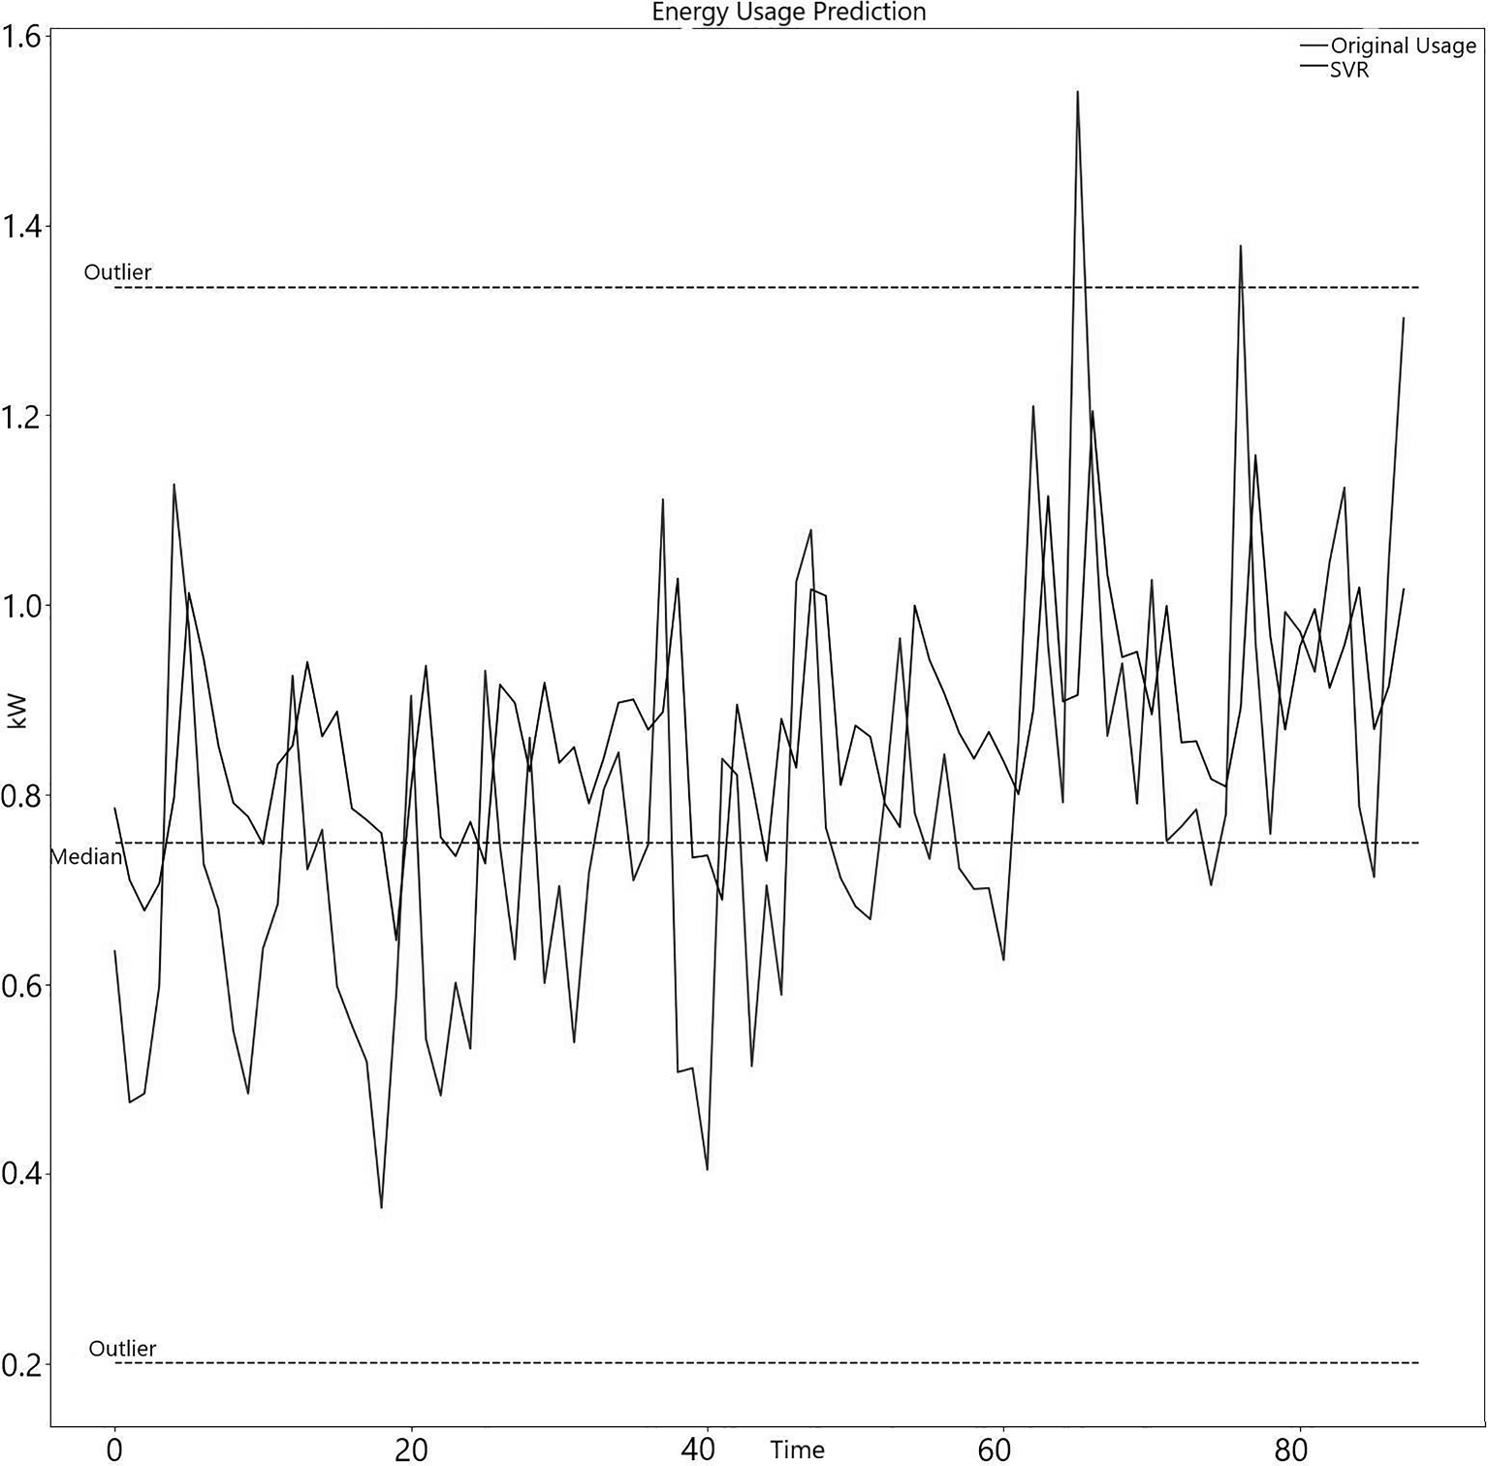

Fig. 12. Predictions of SVR for days granularity.

gives us the output vector y^{l} , the general equation is shown in Eq. (21)
ij

l tanh( ∑N
y =
ij

l l—1
w I
n j i
_{j} + b^{l})

(21)

, +m—1,
j
z=1
Output of the previous layer is represented by I^{l-1},weight is represented by w, index value is represented by z, whereas the bias term for jth convolution kernel is represented by b^{l}. Then a tanh activation function is used. The result of the first layer is forwarded to the
j

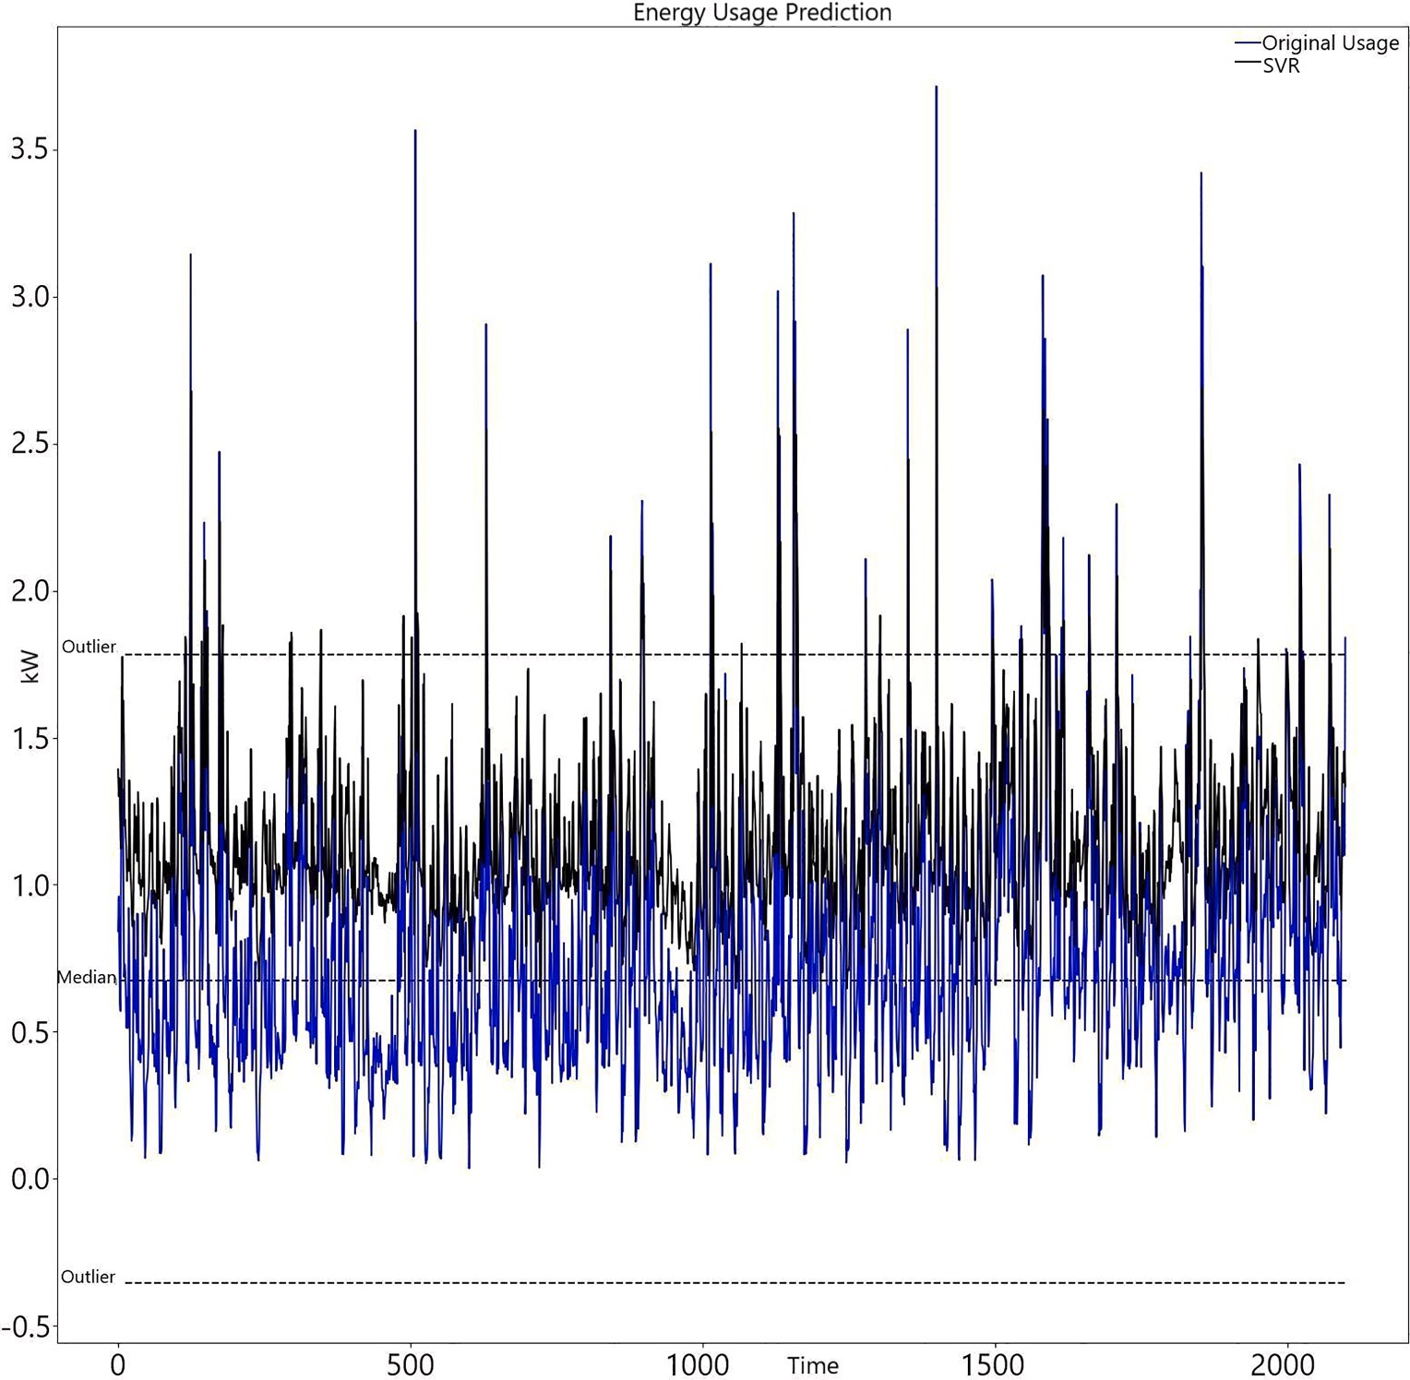

Fig. 13. Predictions of SVR for hours granularity.

second layer which is shown in Eq. (21). Then a pooling layer is used which takes the resultant of the second layer as the input, it reduces the space size and as a result the computational cost and the number of parameters reduces. Max pooling layer is given in Eq.
(22). To decide how far a leap to take is represented by T which is called as stride, and S represents the pooling size.

p^{l} = maxpool_{s} ∈ _{S}y^{l—1}
(22)

ij i× T + s . j
Then the information is flattened and passed to the LSTM layer, which can store historical information. A LSTM cell has three gates Input, Forget, Output which handle the flow of writing, erasing and reading respectively. The hidden value of the LSTM cell o_{t} shown in Fig. 4 above is updated at a time period of t.
Input_{g} = sigmoid i_{[t]}W_{ix} + o_{[t—1]}W_{im} + b_{i}) (23)
Forget_{g} = sigmoid i_{[t]}W_{fx} + o_{[t—1]}W_{fm} + b_{f} ) (24)
Output_{g} = sigmoid i_{[t]}W_{ox} + o_{[t—1]}W_{om} + b₀) (25)
U = tanh i_{[t]}W_{ux} + o_{[t—1]}W_{um} ₊b_{u}) (26)
X_{[t]} = Forget_{g}* x_{[t—1]} + Input_{g}*U (27)
O_{[t]} = Output_{g}*tanh(U) (28)
The last link of our CNN-LSTM model is a fully connected layer in Eq. (28) where we have used a tanh activation function.



Fig. 14. Predictions of LSTM on days granularity.

    - CNN-GRu
The CNN-GRU is another variant of the hybrid model. It involves a series of connections of CNN which was proposed by LeCun et al. (2015) and GRU layers which was proposed by Cho et al. (2014). As we know CNN consists of Convolution and pooling layers which are effective in filtering the input data and extract useful features (Rawat and Wang, 2017). The convolutional layers are used to apply convolution operation on the input data which is responsible for producing new feature values. These are then forwarded to the GRU layer so that it can model and identify the time dependent features. The output of the first GRU layer goes through Dropout Regu- larization (Srivastava et al., 2014). Dropout regularization is responsible for preventing the overfitting of data in the network and then the output goes to the second GRU layer. To produce the final output for Electrical Energy consumption a fully connected layer is used in both the granularity of our dataset. GRU’s have been found to have a much lesser number of training parameters when compared to LSTM and they also take a comparatively shorter period of time when compared to LSTM (Chung et al., 2014; Gul et al., 2021).
Let I⁰ = {i ,i …..i } represent the input vector where n represents the number of normalized values. The input to the first Con-
i 1 2 n
volutional Layer is i_{i} produces output vector y^{l} , the general equation is shown in Eq. (29).
ij

yl ( ∑N
ij = tanh
—1
n j i
j +
j
(29)
+m—1,

wl Il
,
bl )

z=1
Output of the previous layer is represented by I^{l-1}, weight is represented by w, index value is represented by z, whereas the bias term for jth convolution kernel is represented by b^{l}. Then a tanh activation function is used. The result of the first layer is forwarded to the second layer which is shown in Eq. (29). Then a pooling layer is used which takes the resultant of the second layer as the input, it reduces the space size and as a result the computational cost and the number of parameters reduces. Max pooling layer is given in Eq.
j
(30). To decide how far a leap to take is represented by T which is called as stride, and S represents the pooling size.



Fig. 15. Predictions of LSTM on hours granularity.

p^{l} = maxpool_{s} ∈ _{S}y^{l—1}
(30)

ij i× T + s . j
Then the information is flattened and passed to the GRU layer, which can store historical information. GRU uses the Update gate which is the combination of the Input and Forget gate of LSTM and the hidden state and cell state are also combined (Singh et al., 2021; Pradhan and Sharma, 2022; Shankhdhar et al., 2022). These gates help GRU to store the information in the memory and forward the information whenever required to update the future state of the model.
Fig. 7 shows the architecture of GRU. The z_{t} represents the update gate in Eq. (17). It deals with the vanishing gradient problem. At every time step both the output from the previous unit h_{[t-1]} and the input vector I_{t} are multiplied by weight vector W_{z} and are then summed up and to constrain the range of output between [0,1] a sigmoid function is used. Then the same operations are performed on the reset gate (r_{t}) Eq.(18). It is responsible for influencing and determining how much historical information to keep. Information currently present in memory is represented by h’_{t}. Eq.(33) gives us the equation which is responsible for passing the relevant infor- mation. We calculate the product of i_{t} with W and h_{t-1} is multiplied by r_{t} and then W and a tanh function is used.
z_{t} = sigmoid(W_{z}* [h_{t—1}, i_{t}] ) (31)
r_{t} = sigmoid(W_{r}* [h_{t—1}, i_{t}] ) (32)
h_{t} = tanh(W*[r_{t}*h_{t—1}i_{t}] ) (33)
h_{t} = (1 — z_{t})*h_{t—1} + z_{t}*h_{t} (34)

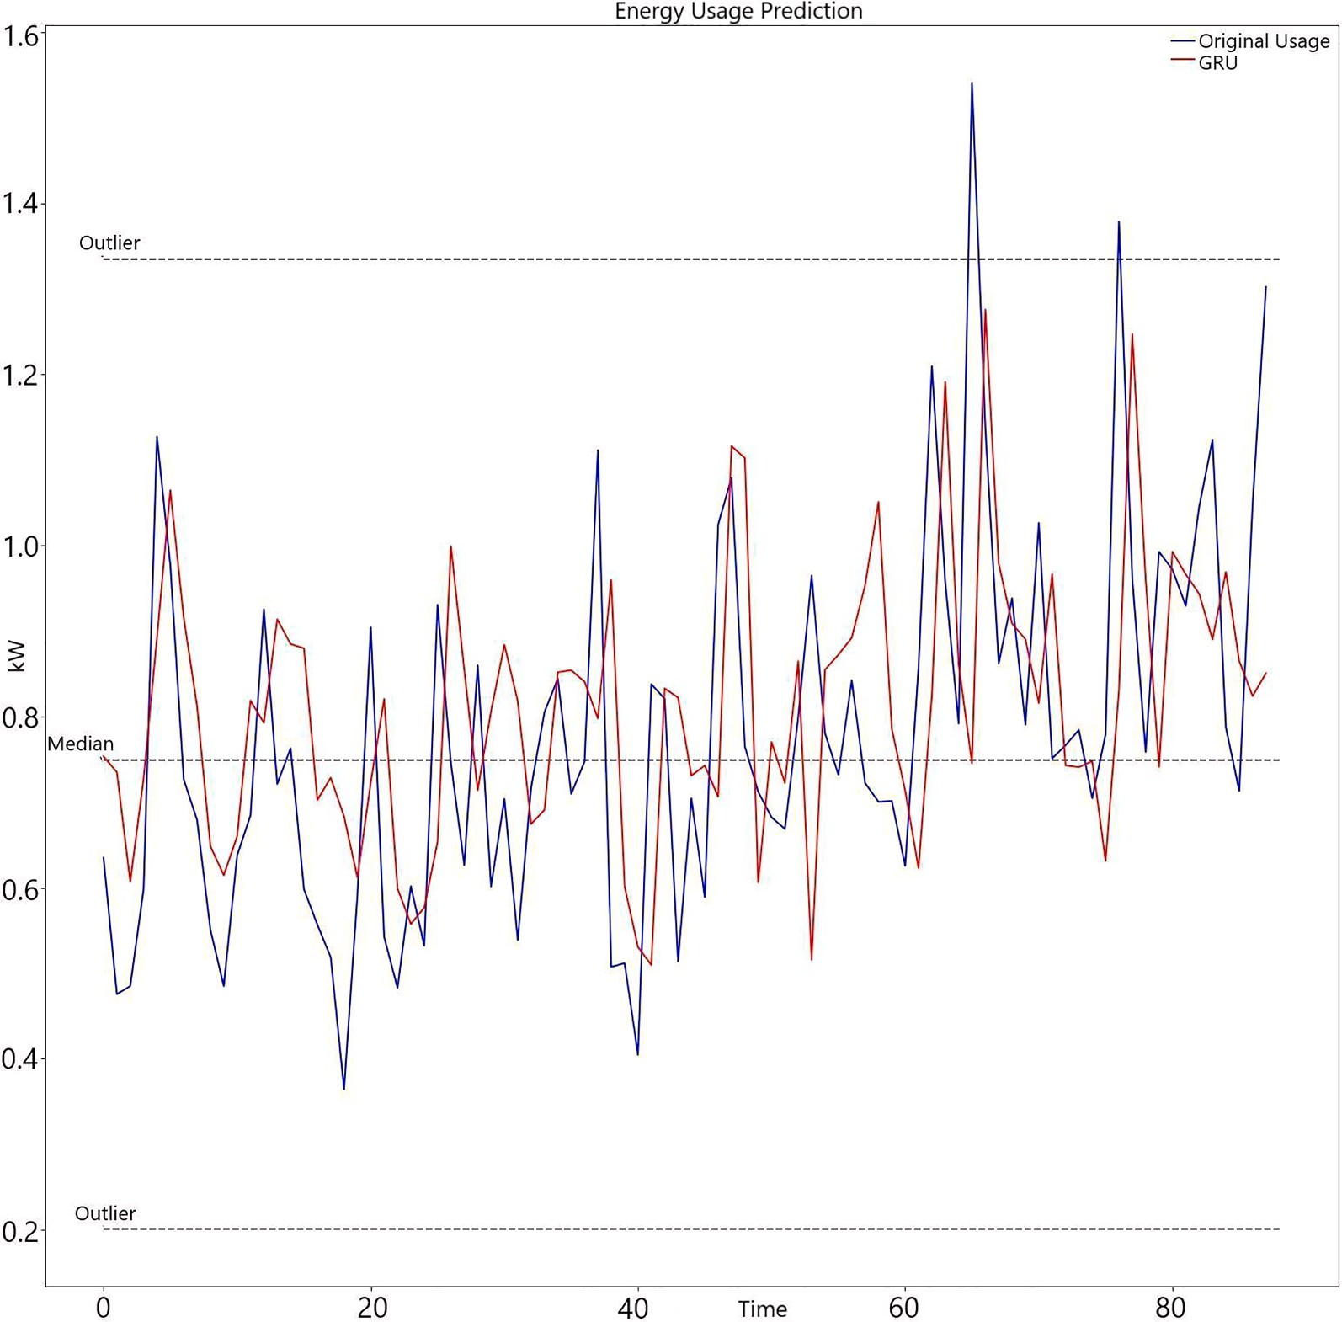

Fig. 16. Predictions of GRU on days granularity.

  - Data analysis and pre-processing

After creating two new dataset by changing the granularity of our original dataset we perform major preprocessing and data analysis steps in our dataset.
We drop 17 of the electricity data features and keep only the overall energy consumption feature from electricity data as all 17 of them sum up to overall energy consumption. Then we check for null values in energy consumption data and weather features and find that one of the weather features cloud Cover has mixed data type of float and in a few places as “cloudCover”, we treat the rows with the value of “cloudCover” as “NaN” and use the pandas backward filling method to fill float values instead of “cloudCover” (pandas, 2022b).
Then we perform correlation-based feature selection for finding the optimal set of weather features. Good feature set selection has shown to drastically improve the performance of learning algorithms and also decrease the dimensionality of data (Hall, 2000; Sharma et al., 2022; Rathor and Agrawal, 2021). We use Pearson correlation from python pandas dataframE (pandas, 2022c), which is a widely
used correlation method. It measures the linear correlation between the features and calculates the degree of correlation between the two features. The value of the coefficient lies in the range [—1,1].
A value closer to —1 indicates strong negative correlation and a value closer to 1 indicates strong positive correlation between the
two features, while a value of 0 means no correlation between the features and a value closer to 0 indicates weak correlation between the features. The correlation of a feature with itself always returns a value of 1. The correlation heatmap for weather features for granularity of days shown in Fig. 10 and for hours in Fig. 11.
From the correlation heatmap in Fig. 10 and Fig. 11 we can see there are 3 features which are highly correlated: dewPoint, temperature and apparentTemperature. We removed dewPoint and temperature from our feature set of both our datasets as these represent almost the same data as apparentTemperature as indicated by high value of coefficient of correlation.

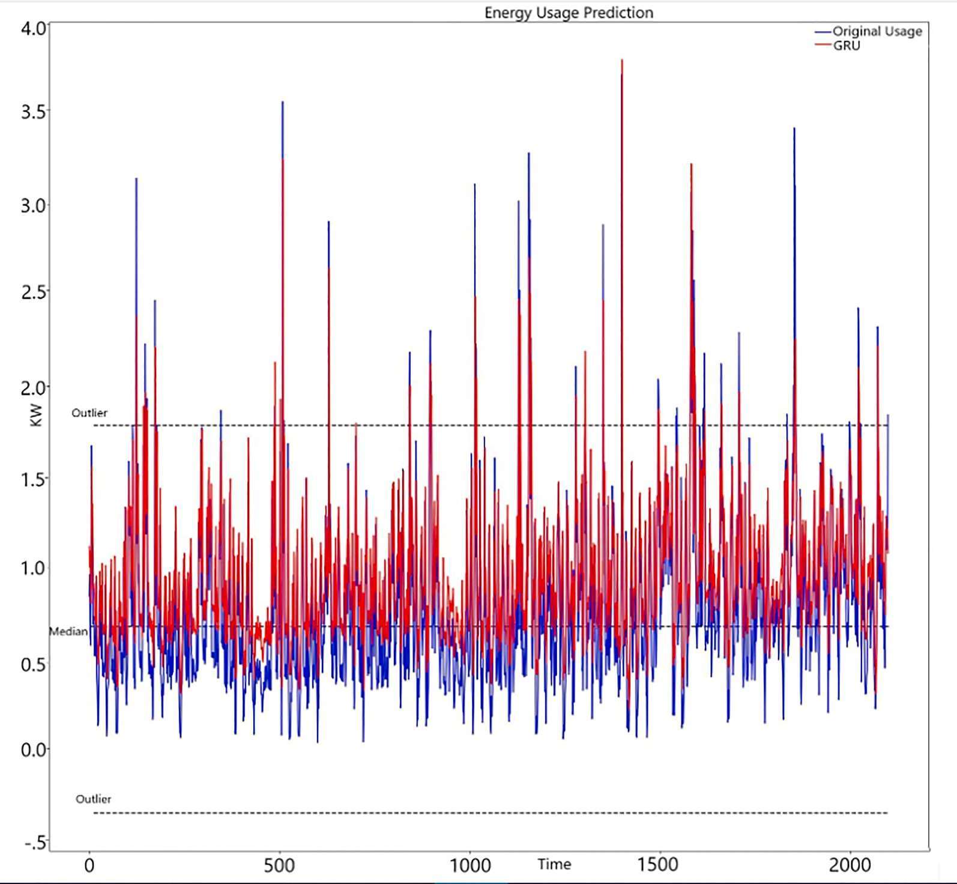

Fig. 17. Predictions of GRU on hours granularity.

Now we create the final dataset structure in which we use present day/hour weather features and previous day/hour electricity consumption as our input features for both our datasets of different granularity respectively. We model it as a time series problem in
, y
, y
…. y
^

which at any given point of time T the aim is to predict the Electrical Energy Consumption m steps in future (y^
T+1
^ T+2
^ T+3
T+m)

based on the data available in the previous n steps (..., x_{T}, x_{T-1},. x_{T-n}). Note that y^ _{+i} represents our prediction whereas x^ _{-i} is the

T T
feature vectors which are given as input to our model. The actual value of the variable to be predicted can be represented as y^
which

T+i
also goes as an input feature to (T + i + 1) time step prediction (Khan et al., 2021).
From Table 3 we can see final training features and the ranges of various features. The features are not on the same scale and this can vastly affect the prediction accuracy and training time of our model. Machine Learning and Deep Learning algorithms have been found to be robust, fast and perform better when the features are normalised and brought to the same scale see (Nawi et al., 2013; Crone et al., 2006). We use the Scikit learn library to perform min–max scaling and scale our features in between the range of 0 to 1 before giving them as inputs to our machine learning and deep learning models see (sklearn.preprocessing.MinMaxScaler).
We then finally split both our datasets into train and test sets. It is important to remember that as our data is Time Series, we cannot split it randomly but rather we have split it in a Time Sequenced manner. The train set comprises 75 % of data and the test set comprises 25 % of data. Our dataset with granularity as hours has 6299 train examples and 2099 test examples, while the dataset with granularity as days contains 262 train examples and 88 test examples. After training our models for both the granularities we provide our model test data, on which it makes predictions then we inverse scale our predictions to original scale using scikit learn inverse transform method (sklearn.preprocessing.MinMaxScaler, 2022). For evaluating the performance of our model different evaluation metrics such as RMSE, MSE and MAE are used.

  - Model architecture

The implementation code of the models was written in Python 3.7.3 on a (Intel(R) Core(™) i5-3230 M CPU @2.6 GHz,8 GB Ram) running on Windows 8.1 Operating System. The machine learning models were implemented using Scikit-Learn Library (G´eron, 2017). The deep learning models were implemented using Keras with TensorFlow backend (Gulli and Pal, 2017). The architecture of various



Fig. 18. Predictions of CNN-LSTM on days granularity.

models is shown in Table 4.

- Result and analysis

We experimented with two different granularity of input data i.e., daily and hourly respectively. All the 5 models were used to train models on both the granularity of data.
We use MSE, RMSE, MAE as evaluation metrics to evaluate the performance of our model.
MSE (Mean Squared Error) is defined as the measure of the average of the squares of the errors. Eq. (35) shows the formula for MSE.
N
= 1 ∑ ( — ) (35)
MSE y y ²
N n=1
RMSE measures how spread out our residuals are, Eq. (36) shows the formula for RMSE.
N
= (n
) )2

RMSE
1 ∑ ((y — y ² 1
n=1
(36)

Another metric that we have used is MAE which measures the average magnitude of prediction error and ignores the direction, whether our model underestimated or overestimated.
N
= 1 ∑ | — | (37)
MAE y y n n=1



Fig. 19. Predictions of CNN-LSTM on hours granularity.

After this we performed outlier analysis (Taylor, 2018) in our test dataset where the upper range of Outlier value of Energy Consumption for test dataset of daily granularity starts from 1.3340 Kw and above and the lower range of Outlier value of Energy Consumption starts 0.2013 Kw and below. The mathematics involved is shown below in Eq. (38–40) where Q1 and Q3 are first quartile and third quartile respectively. The median value Energy Consumption of days granularity test data is 0.7491 Kw. These were calculated using the pandas describe method (pandas, 2022a).
InterquartileRange = Q3 — Q1 (38)
UpperOutlier = Q3 + 1.5*IQR (39)
LowerOutlier = Q1 — 1.5*IQR (40)
We then also perform outlier analysis (Taylor, 2018) on our test dataset with hourly granularity using Eq. (38–40). We get a median value of 0.6725 Kw and upper outlier value which starts from 1.7835 Kw and above and lower outlier value starts from —0.3549 Kw and below.
The respective result for the test datasets with daily granularity and hourly granularity of test data can be seen from Figs. 10–19 below.
We evaluate the effectiveness of the five models on both the granularity of the test datasets that are days and hours respectively, using the above performance metric MSE, RMSE, MAE Eq. (35–37).
From the SVR prediction on test data of days and hours granularity respectively we can see in Fig. 12 and Fig. 13, that our SVR model is inefficient in predicting the values that are below the median value of consumption and hence don’t generalise very well to all the points in the dataset.
From the LSTM prediction on test data of days and hours granularity respectively in Fig. 14 and Fig. 15. We can see that our LSTM



Fig. 20. Predictions of CNN-GRU on days granularity.

model generalises well to all the data points in both the dataset and also is efficient in predicting the outliers in our data.
From the GRU prediction on test data of days and hours granularity respectively in Fig. 16 and Fig. 17. We can see that our GRU model generalises closely for both the granularity of data, and to some extent can also predict the outliers in the test dataset of hour granularity. We would also need to look at the numerical evaluation metrics to further verify the performance of our GRU model.
From Fig. 18 and Fig. 19 above we can see CNN-LSTM is robust in predicting the outliers in both granularity of data and even values just below and above the median value of consumption. To get a micro analysis about the performance of this particular model we will have to see the results for the evaluation metrics, combined with the graphical results.
From Fig. 20 and Fig. 21, we can see CNN-GRU is robust in prediction for test dataset in both granularity of dataset, as the difference between the predicted value and actual value graphically seems minimal when compared to other models. We will further need to verify and confirm the graphical results from the evaluation metrics for both granularity of data.
From Table 5. above, we can see that CNN-GRU model performs the best among all the other models where it performs 8.88 % better in terms of MSE and 16.5 % better than the second-best model which is SVR, and performs 21.15 % better in terms of MSE and
18.8 % when compared to the worst model which is CNN-LSTM.
In Table 5 our evaluation metrics shows that the SVR model is the second best model for the energy consumption prediction for daily granularity, while the model shows the worst performance in Table 6. From Figs. 12 and 13 above we can clearly see that the SVR model is unable to predict a large number of values below the median value of consumption, and hence making it ineffective for the problem.
In Figs. 14, 15 and 18, 19 above we can see that LSTM and CNN-LSTM models are robust models for outlier or anomaly prediction while Table 5 and Table 6 above indicate that LSTM may be better compared to CNN-LSTM generally and even for outlier detection in this particular problem. CNN-GRU for our particular problem gives the most robust and consistent performance both graphically and numerically as shown in Fig. 20, 21 and Table 5 and Table 6 above.

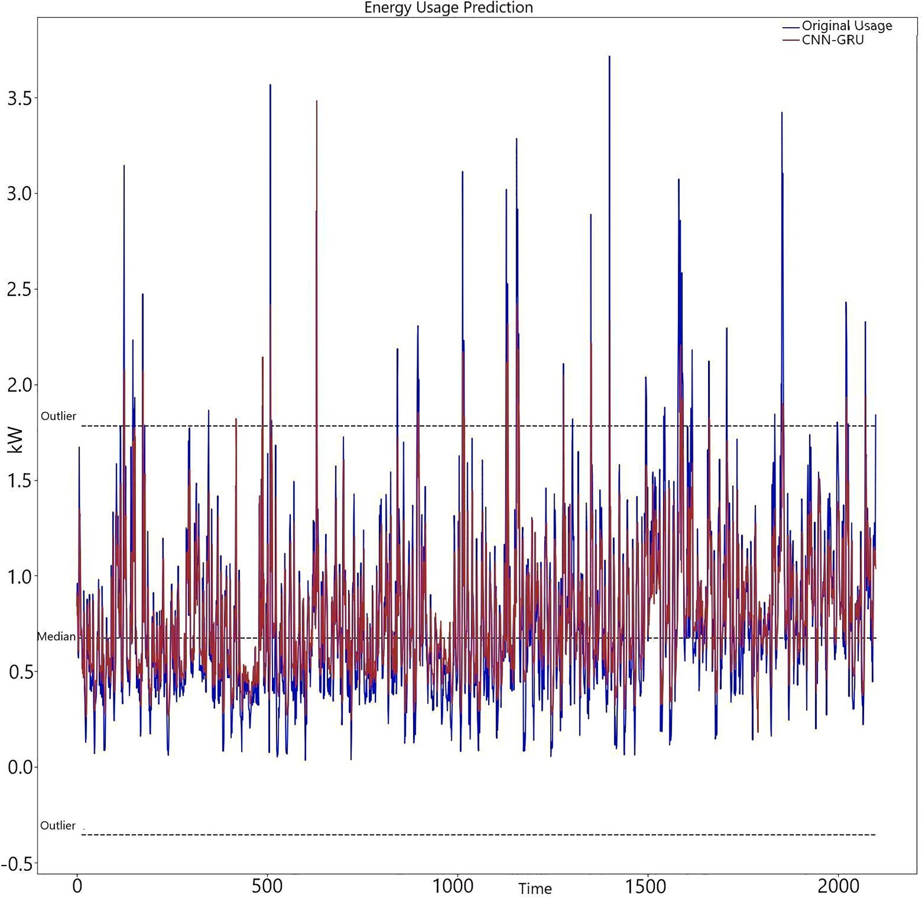

Fig. 21. Predictions of CNN-GRU on hours granularity.

Table 5
Performance of Models for Daily Granularity of test dataset.
Model | MSE | RMSE | MAE
SVR | 0.045 | 0.214 | 0.181
LSTM | 0.050 | 0.223 | 0.183
GRU | 0.048 | 0.219 | 0.175
CNN-LSTM | 0.052 | 0.228 | 0.186
CNN-GRU | 0.041 | 0.202 | 0.151

Table 6
Performance of Models for Hourly Granularity of test dataset.
Model | MSE | RMSE | MAE
SVR | 0.271 | 0.520 | 0.453
LSTM | 0.114 | 0.338 | 0.228
GRU | 0.140 | 0.374 | 0.284
CNN-LSTM | 0.120 | 0.346 | 0.231
CNN-GRU | 0.119 | 0.344 | 0.229

Performing a comparative analysis of our models from Table 6 above we see our SVR model which was performing better than three models namely LSTM, GRU, CNN-LSTM in Table 5 breaks down and degrades in performance by 60.044 % in terms of MAE as our test dataset increase almost 24 times [8399/351] which indicates that SVR model is incapable of modeling the complex features of our temporal data as the size of data increases and due to its dependence on making predictions based on the distance between 2 data points. The best model for hourly granularity test dataset is LSTM model which performs 4.2 % better in terms of MSE and 0.4 %better in terms of MAE when compared to the second-best model which is CNN-GRU and 57.9 % better in terms of MSE and 49.6 % better in terms of MAE when compared to the worst model for this particular granularity of data which is SVR. While the overall robust per- formance is shown by CNN-GRU model for both the granularity of data as it is only bested by LSTM model by a small margin of 0.4 % for hours granularity and beats the LSTM model by 17.4 % in terms of MAE when the granularity of data is in days.

- Conclusions

The study used a variety of models to find reliable models for predicting electric energy consumption at two different granularities of data.For days granularity, the proposed CNN-GRU architecture performed best, while for hours granularity, LSTM performed best. In terms of MAE, LSTM outperformed the proposed CNN-GRU architecture by 0.4 %, while when granularity was measured in days, CNN-GRU outperformed LSTM by 17.4 %. When compared to other models, the SVR model performed worse when data granularity varied from days to hours, and it was unable to predict many values below the median. Based on empirical evidence, CNN-LSTM and LSTM were able to accurately predict the outliers in our dataset. Regarding our investigation, the CNN-GRU model was found to be most reliable for predicting electrical energy consumption. Electricity consumption has an impact on poverty, the environment, and economic expansion. In order to achieve better outcomes in future work, evolutionary and genetic algorithms will be utilized.We can also try to collect broader feature ranges of data having household characteristics like user behavior, occupancy and household income which can help us to model and identify a more robust model.

Declaration of Competing Interest

The authors declare that they have no known competing financial interests or personal relationships that could have appeared to influence the work reported in this paper. The work conducted in this paper receives no funds from any known sources.

Data availability

Data will be made available on request.

References

Ahmad, U., Chaudhary, J., Ahmad, M., Naz, A., 2019. Survey on Internet of Things (IoT) for Different Industry Environments. Ann. Emerg. Technol. Comput. 3 (3), 28–43.
Ahmed Gassar, A.A., Yun, G.Y., Kim, S., 2019. Data-driven approach to prediction of residential energy consumption at urban scales in London. Energy 187, 115973. Baghel, V.S., Ali, S.S., Prakash, S., 2021. A non-invertible transformation based technique to protect a fingerprint template. IET Image Proc.
Bengio, Y., Simard, P., Frasconi, P., 1994. Learning long-term dependencies with gradient descent is difficult. IEEE Trans. Neural Networks 5 (2), 157–166.
Boroojeni, K.G., Amini, M.H., Bahrami, S., Iyengar, S.S., Sarwat, A.I., Karabasoglu, O., 2017. A novel multi-time-scale modeling for electric power demand forecasting: From short-term to medium-term horizon. Electr. Power Syst. Res. 142, 58–73.
Charfeddine, L., 2017. The impact of energy consumption and economic development on Ecological Footprint and CO2 emissions: Evidence from a Markov Switching Equilibrium Correction Model. Energy Econ. 65, 355–374.
Chen, Y., Xu, P., Chu, Y., Li, W., Wu, Y., Ni, L., Bao, Y., Wang, K., 2017. Short-term electrical load forecasting using the Support Vector Regression (SVR) model to calculate the demand response baseline for office buildings. Appl. Energy 195, 659–670.
Cho, K., van Merrienboer, B., Gulcehre, C., Bahdanau, D., Bougares, F., Schwenk, H., Bengio, Y., 2014. Learning Phrase Representations using RNN Encoder–Decoder for Statistical Machine Translation. Proceedings of the 2014 Conference on Empirical Methods in Natural Language Processing (EMNLP) [Accessed 12 May 2019].
Chung, J., & Gulcehre, C., Cho, K., & Bengio, Y., 2014. Empirical Evaluation of Gated Recurrent Neural Networks on Sequence Modeling.
Crone, F.S., Guajardo, J., Weber, R., 2006 .The Impact of Preprocessing on Support Vector Regression and Neural Networks in Time Series Prediction.
de Oliveira, E.M. and Cyrino Oliveira, F.L., 2018. Forecasting mid-long term electric energy consumption through bagging ARIMA and exponential smoothing methods. Energy, [online] 144, pp.776–788. Available at: https://www.sciencedirect.com/science/article/pii/S0360544217320820 [Accessed: 04 Jul. 2021].
Aur´elien G´eron, 2017. Hands-on machine learning with Scikit-Learn and TensorFlow concepts, tools, and techniques to build intelligent systems.
Gers, F.A., 1999. Learning to forget: continual prediction with LSTM. 9th International Conference on Artificial Neural Networks: ICANN ’99.
Gonz´alez-Eguino, M., 2015. Energy poverty: An overview. Available at: Renew. Sustain. Energy Rev., [online] 47, 377–385 https://www.sciencedirect.com/science/ article/pii/S1364032115001586.
Gul, M.J., Urfa, G.M., Paul, A., Moon, J., Rho, S., Hwang, E., 2021. Mid-term electricity load prediction using CNN and Bi-LSTM. J. Supercomput. 1–17.
Gulli, A., Pal, S., 2017. Deep learning with Keras: implement neural networks with Keras on Theano and TensorFlow. Packt Publishing, Birmingham, UK; Mumbai. Hall, A. M., 2000. Correlation-based feature selection of discrete and numeric class machine learning.
Hasan, S.M., Mahata, K., Hyder, M.M., 2021. Uplink Grant-Free NOMA with Sinusoidal Spreading Sequences. IEEE Trans. Commun. 69 (6), 3757–3770.
He, W., Yan, G., Xu, L.D., 2014. Developing Vehicular Data Cloud Services in the IoT Environment. IEEE Trans. Ind. Inf. 10 (2), 1587–1595. Helmers, E., Marx, P., 2012. Electric cars: technical characteristics and environmental impacts. Environ. Sci. Eur. 24 (1).
Hochreiter, S., Schmidhuber, J., 1997. Long Short-Term Memory. Neural Comput. 9 (8), 1735–1780.
Ibrahim, H., Ilinca, A. and Perron, J., 2007. Comparison and Analysis of Different Energy Storage Techniques Based on their Performance Index. in: 2007 IEEE Canada Electrical Power Conference.
Johannesen, N.J., Kolhe, M., Goodwin, M., 2019. Relative evaluation of regression tools for urban area electrical energy demand forecasting. J. Cleaner Prod. 218, 555–564.
Khan, N., Haq, I.U., Khan, S.U., Rho, S., Lee, M.Y., Baik, S.W., 2021. DB-Net: A novel dilated CNN based multi-step forecasting model for power consumption in integrated local energy systems. Int. J. Electr. Power Energy Syst. 107023.

Kieling, E.J., Rodrigues, F.C., Filippetto, A., Barbosa, J., 2019. Smartalloc: A model based on Machine Learning for human resource allocation in projects. In: Proceedings of the 25th Brazillian Symposium on Multimedia and the Web, pp. 365–368.
Kong, W., Dong, Z.Y., Jia, Y., Hill, D.J., Xu, Y., Zhang, Y., 2019. Short-Term Residential Load Forecasting Based on LSTM Recurrent Neural Network. IEEE Trans.
Smart Grid 10 (1), 841–851.
Lawal, A.I., Ozturk, I., Olanipekun, I.O., Asaleye, A.J., 2020. Examining the linkages between electricity consumption and economic growth in African economies.
Energy 208, 118363.
LeCun, Y., Bengio, Y., Hinton, G., 2015. Deep learning. Nature 521 (7553), 436–444.
Li, C., Ding, Z., Zhao, D., Yi, J., Zhang, G., 2017. Building Energy Consumption Prediction: An Extreme Deep Learning Approach. Energies 10 (10), 1525.
Nawi, N.M., Atomi, W.H. and Rehman, M.Z., 2013. The Effect of Data Pre-processing on Optimized Training of Artificial Neural Networks. Procedia Technology, [online] 11, pp.32–39. Available at: https://www.sciencedirect.com/science/article/pii/S2212017313003137?via%3Dihub [Accessed 25 Nov. 2019].
Orsino, A., Araniti, G., Militano, L., Alonso-Zarate, J., Molinaro, A., Iera, A., 2016. Energy Efficient IoT Data Collection in Smart Cities Exploiting D2D Communications. Sensors 16 (6), 836.
Pan, H., Yang, X., 2019. Application of Internet of Things Technology in 3D Medical Image Model. IEEE Access 7, 5508–5518.
pandas.pydata.org. pandas.DataFrame.describe — pandas 1.0.3 documentation. [online] Available at: https://pandas.pydata.org/pandas-docs/stable/reference/api/ pandas.DataFrame.describe.html.
pandas.pydata.org. . pandas.DataFrame.bfill — pandas 1.1.3 documentation. [online] Available at: https://pandas.pydata.org/pandas-docs/stable/reference/api/ pandas.DataFrame.bfill.html [Accessed 13 Oct. 2020].
pandas.pydata.org. . pandas.DataFrame.corr — pandas 1.0.3 documentation. [online] Available at: https://pandas.pydata.org/pandas-docs/stable/reference/api/ pandas.DataFrame.corr.html.
Pongdatu, G.A.N., Putra, Y.H., 2018. Seasonal Time Series Forecasting using SARIMA and Holt Winter’s Exponential Smoothing. IOP Conf. Series: Mater. Sci. Eng.
407, 012153.
Pradhan, R., Sharma, D.K., 2022. An ensemble deep learning classifier for sentiment analysis on code-mix Hindi-English data. Soft. Comput. 1–18.
Rahman, A. and Ahmar, A.S., 2017. Forecasting of primary energy consumption data in the United States: A comparison between ARIMA and Holter-Winters models. Rathor, S., Agrawal, S., 2021. A robust model for domain recognition of acoustic communication using Bidirectional LSTM and deep neural network. Neural Comput.
Appl. 33 (17), 11223–11232.
Rawat, W., Wang, Z., 2017. Deep Convolutional Neural Networks for Image Classification: A Comprehensive Review. Neural Comput. 29 (9), 2352–2449. Reddy, A., 2000. Energy and social issues. In: World Energy Council and UNEP, editors. Energy and the challenge of sustainability. New York, NY; 2000. Sain, S.R., Vapnik, V.N., 1996. The Nature of Statistical Learning Theory. Technometrics 38 (4), 409.
Shabbir, N., Ahmadiahangar, R., Kutt, L. and Rosin, A., 2019. Comparison of Machine Learning Based Methods for Residential Load Forecasting. in: 2019 Electric Power Quality and Supply Reliability Conference (PQ) & 2019 Symposium on Electrical Engineering and Mechatronics (SEEM).
Shankhdhar, A., Gupta, A., Singh, A.K., Pradhan, R., 2022. A Vocational Career Advisory Application Built Using Unsupervised Machine Learning Frameworks. In: International Conference on Artificial Intelligence and Sustainable Engineering. Springer, Singapore, pp. 471–480.
Sharma, K., Doriya, R., Pandey, S.K., Kumar, A., Sinha, G.R., Dadheech, P., 2022. Real-Time Survivor Detection System in SaR Missions Using Robots. Drones 6 (8), 219.
Singh, R., Singh, M., Garg, S., Perl, I., Kalyonova, O., Penskoi, A., 2021. Multicriteria decision making based optimum virtual machine selection technique for smart cloud environment. J. Ambient Intell. Smart Environ. 13 (3), 185–199.
Singh, T., 2019. Smart Home Dataset with weather Information. [online] kaggle.com. Available at: https://www.kaggle.com/taranvee/smart-home-dataset-with- weather-information.
sklearn.preprocessing.MinMaxScaler — scikit-learn 0.22.1 documentation. [online] Scikit-learn.org. Available at: https://scikit-learn.org/stable/modules/generated/
sklearn.preprocessing.MinMaxScaler.html.
Spano, E., Niccolini, L., Pascoli, S.D., Iannaccone, G., 2015. Last-Meter Smart Grid Embedded in an Internet-of-Things Platform. IEEE Trans. Smart Grid 6 (1), 468–476.
Srivastava, N., Hinton, G., Krizhevsky, A., Sutskever, I., & Salakhutdinov, R., 2014. Dropout: A Simple Way to Prevent Neural Networks from Overfitting (976944119 757407709 Y. Bengio, Ed.). Journal of Machine Learning Research 15 (2014), 1929-1958.
Taylor, C., 2018. Detect the Presence of Outliers With the Interquartile Range Rule. [online] ThoughtCo. Available at: https://www.thoughtco.com/what-is-the- interquartile-range-rule-3126244.
Werbos, P.J., 1990. Backpropagation through time: what it does and how to do it. Proc. IEEE 78 (10), 1550–1560.
Wikipedia Contributors (2020). Unix time. [online] Wikipedia. Available at: https://en.wikipedia.org/wiki/Unix_time.

Start of PDF Naman_Omar 2

Requirements Engineering and Agile Software Development

Frauke Paetsch Fachhochschule Mannheim frauke.paetsch@web.de
Dr. Armin Eberlein University of Calgary eberlein@enel.ucalgary.ca
Dr. Frank Maurer University of Calgary maurer@cpsc.ucalgary.ca

Abstract
This article compares traditional requirements engineering approaches and agile software development. Our paper analyzes commonalities and differences of both approaches and determines possible ways how agile software development can benefit from requirements engineering methods.

Index Terms Requirements Engineering, Agile Development

Introduction

Agile software development approaches have become more popular during the last few years. Several methods have been developed with the aim to be able to deliver software faster and to ensure that the software meets customer changing needs. All these approaches share some common principles: Improved customer satisfaction, adopting to changing requirements, frequently delivering working software, and close collaboration of business people and developers.
Requirements engineering, on the other hand, is a traditional software engineering process with the goal to identify, analyze, document and validate requirements for the system to be developed. Often, requirements engineering and agile approaches are seen being incompati8ble: RE is often heavily relying on documentation for knowledge sharing while agile methods are focusing on face-to-face collaboration between customers and developers to reach similar goals. The aim of this article is to find out if some requirements engineering techniques can be used within agile development and if this could result in improvements to agile approaches.
The next section briefly gives an overview on current requirements engineering approaches. Section 3 discusses agile approaches from a requirements engineering perspective. In Section 4, we evaluate how the incorporation of some requirements engineering techniques could improve agile methods. The last section summarizes our results.

Requirements Engineering
Requirements engineering is concerned with identifying, modeling, communicating and documenting the requirements for a system, and the contexts in which the system will be used. Requirements describe what is to be done but not how
they are implemented [6]. There are many techniques available for use during the RE process to ensure that the requirements are complete, consistent and relevant. The aim of RE is to help to know what to build before system development starts in order to prevent costly rework. This goal is based on two major assumptions:
- The later mistakes are discovered the more expensive it will be to correct them [3].
- It is possible to determine a stable set of requirements before system design and implementation starts.
The RE process consists of five main activities [2]: Elicitation, Analysis and Negotiation, Documentation, Validation, and Management. In the following, we will briefly examine each of these and discuss techniques that were developed for them.

Requirements Elicitation
Requirements elicitation tries to discover requirements and identify system boundaries by consulting stakeholders (e.g., clients, developers, users). System boundaries define the context of the system. Understanding the application domain, business needs, system constraints, stakeholders and the problem itself is essential to gain an understanding of the system to be developed.
The most important techniques for requirements elicitation are described in the remainder of this section.
Interviews Interviewing is a method for discovering facts and opinions held by potential users and other stakeholders of the system under development. Mistakes and misunderstandings can be identified and cleared up. There are two different kinds of interviews:
    - the closed interview, where the requirements engineer has a pre-defined set of questions and is looking for answers
    - the open interview, without any pre-defined questions the requirements engineer and stakeholders discuss in an open-ended way what they expect from a system.
In fact, there is no distinct boundary between both kinds of interviews. You start with some questions which are discussed and lead to new questions [2]. The advantage of interviews is that they help the developer to get a rich collection of information. Their disadvantage is that this amount of qualitative data can be hard to analyze and different stakeholders may provide conflicting information.

Use cases / Scenarios Use cases describe interactions between users and the system, focusing on what users need to do with the system. A use case specifies a sequence of interaction between a system and an external actor (e.g., a person, a piece of hardware, another software product), including variants and extensions, that the system can perform. Use cases represent functional requirements of the software system and can be used during the early stages in the development process. Analysts and customers should examine every use case proposed to validate it.
Scenarios are examples of interaction sessions where a single type of interaction between user and system is simulated. Scenarios should include a description of the state of the system before entering and after completion of the scenario, what activities might be simultaneous, the normal flow of events and exceptions to the events [2].
Observation and social analysis Observational methods involve an investigator viewing users as they work and taking notes on the activity that takes place. Observation may be either direct with the investigator being present during the task, or indirect, where the task is viewed by some other means (e.g. recorded video). It is useful for studying currently executed tasks and processes. Observation allows the observer to view what users actually do in context - overcoming issues with stakeholders describing idealized or oversimplified work processes.
Focus Groups Focus groups are an informal technique where a group of four to nine users from different backgrounds and with different skills discuss in a free form issues and concerns about features of a system prototype. Focus groups help to identify user needs and perceptions, what things are important to them and what they want from the system. They often bring out spontaneous reactions and ideas. Since there is often a major difference between what people say and what they do, observations should complement focus groups.
Focus groups can support the articulation of visions, design proposals and a product concept. Additionally, they help users in analyzing things that should be changed, and support the development of a ’shared meaning’ of the system [1].
Brainstorming Brainstorming helps to develop creative solutions for specific problems. Brainstorming contains two phases - the generation phase, where ideas are collected, and the evaluation phase, where the collected ideas are discussed. In the generation phase, ideas shouldn’t be criticized or evaluated. The ideas should be developed fast and be broad and odd. Brainstorming leads to a better problem under- standing and a feeling of common ownership of the result.
Prototyping A prototype of a system is an initial version of the system which is available early in the development process. Prototypes of software systems are often used to help elicit and validate system requirements. There are two different types of prototypes: Throw-away prototypes help to understand difficult requirements. Evolutionary prototypes deliver a workable system to the customer and often become a part of the final system. Prototypes can be paper based (where
a mock-up of the system is developed on paper), ”Wizard of Oz” prototypes (where a person simulates the responses of the system in response to some user inputs) or automated prototypes (where a rapid development environment is used to develop an executable prototype).

Requirements Analysis
Requirements Analysis checks requirements for necessity (the need for the requirement), consistency (requirements should not be contradictory), completeness (no service or constraint is missing), and feasibility (requirements are feasible in the context of the budget and schedule available for the system development). Conflicts in requirements are resolved through prioritization negotiation with stakeholders. Disputed requirements are prioritized to identify critical requirements. Solutions to requirements problems are identified and a compromise set of requirements is agreed upon. The main techniques used for requirements analysis are JAD sessions, Prioritization, and Modeling.
Joint Application Development (JAD) is a facilitated group session (or workshop) with a structured analysis approach. During the JAD sessions developers and customers discuss desired product features. This kind of discussion can be very productive if the session leader prevents the participants from ’running out of course’. The purpose of JAD is to define a special project on various levels of details, to design a solution, and to monitor the project until it’s completed. Participants include executives, project managers, users, system experts and external technical personnel [1]. JAD promotes cooperation, understanding and teamwork among the different groups of participants. As participants should come from different backgrounds, information considering various parts of the new system can be gathered and provide a base for further requirements elicitation.
Requirements Prioritization On a project with a tight schedule, limited resources, and high customer expectations it is essential to deliver the most valuable features as early as possible. Setting priorities early in the project helps to decide which features to skip under time pressure. Requirements prioritization should be done by the customer. Both customer and developer have to provide input to requirements prioritization. The customer marks features providing the greatest benefit to users with the highest priority. Developers point out the technical risks, costs, or difficulties. Based on this information, the customer might change the priority of some features. Developers also might propose to implement a feature having a higher impact on the system’s architecture but with lower priority earlier [13]. Various prioritization techniques (like pair-wise comparison or the Analytic Hierarchy Process) were developed.
Modeling System models are an important bridge between the analysis and the design process. A number of methods use different modeling techniques to describe system requirements. The most popular modeling techniques are [2]: data-flow models, semantic data models and object-oriented approaches.

Requirements Documentation
The purpose of requirements documentation is to communicate requirements between stakeholders and developers. The requirements document is the baseline for evaluating subsequent products and processes (design, testing, verification and validation activities) and for change control.
A good requirements document is unambiguous, complete, correct, understandable, consistent, concise, and feasible. Depending on the customer-supplier relationship, the requirements specification can be part of the contract.

Requirements Validation
The purpose of requirements validation is to certify that the requirements are an acceptable description of the system to be implemented. Inputs for the validation process are the requirements document, organizational standards, and organizational knowledge. The outputs are a list that contains the reported problems with the requirements document and the actions necessary to cope with the reported problems. Techniques used for requirements validation are requirements reviews and requirements testing. Requirements validation usually results in sing-offs from all project stakeholders.

Requirements Management
The goal of requirements management is to capture, store, disseminate, and manage information. Requirements manage- ment includes all activities concerned with change & version control, requirements tracing, and requirements status tracking. Requirements traceability provides relationships between requirements, design, and implementation of a system in order to manage changes to a system.

Agile Development Methods
In comparison to traditional software processes, agile development is less document-centric and more code-oriented. This, however, is not the key point but rather a symptom of two deeper differences between both [10]:
- Agile methods are adaptive rather than predictive. With traditional methods, most of the software process is planned in detail for a large time frame. This works well if not much is changing (i.e. low requirements churn) and the application domain and software technologies are well understood by the development team. Agile methods were developed to adapt and thrive on frequent changes.
- Agile methods are people-oriented rather than process- oriented. They rely on people’s expertise, competency and direct collaboration rather than on rigorous, document- centric processes to produce high-quality software.
In this section, the most common agile methods are briefly discussed.
Extreme Programming (XP) is based on values of simplicity, communication, feedback, and courage [3]. It works by bringing the whole team together in the presence of simple practices, with enough feedback to enable the team to see where they are. XP combines old, tried and tested
techniques in such a way that they reinforce each other.
XP does not explicitly talk about requirements techniques in detail but about the general software development process and what is to be done during the process. Several XP practices (or techniques used in these practices) can be compared with slightly modified RE techniques. Specifically, during the Planning Game, elicitation techniques like interviews, brainstorming and prioritization are used. XP uses story cards for elicitation. A user story is a description of a feature that provides business value to the customer. Use cases, on the other hand, are a description of interactions of the system and its users and do not mandatory have to provide business value.
Before story cards can be written, customers have to think about what they expect the system to do. This process can be seen as brainstorming. Thinking about a specific functionality leads to more ideas and to more user stories. Every story is discussed in an open-ended way before implementation. Initially, developers ask for enough details to be able to estimate the effort for implementing the story. Based on these estimates and the time available, customers prioritize stories to be addressed in the next iteration. XP emphasizes writing tests before coding. Acceptance tests are defined by the customer and are used to validate the completion of a story card. XP is based on frequent small releases. This can be compared with requirements review and with evolutionary prototyping. The difference between XP and prototyping is, that XP requires a tested, cleanly designed code while prototypes can be ’hacked together’. Customers can review and test the functionality and design of the delivered program and discuss issues they want to be changed or added in the next release.
Agile Modeling (AM) The basic idea of AM [4] is to give
developers a guideline of how to build models that resolve design problems but not ’over-build’ these models. Like XP, AM points out that changes are normal in software development. AM does not explicitly refer to any RE techniques but some of the practices support several RE techniques (e.g. tests and brainstorming). AM highlights the difference between informal models whose sole purpose is to support face-to-face communication and models that are preserved and maintained as part of the system documentation. The later are what is often found in RE approaches.
Scrum is a method for managing the system development process by applying ideas on flexibility, adaptability and productivity from industrial process control theory. Scrum focuses on how a team should work together to produce quality work in a changing environment [11, 7].
The main Scrum techniques are the product backlog, sprints, and daily scrums. With regard to Requirements Engineering the product backlog plays a special role in Scrum. All requirements regarded as necessary or useful for the product are listed in the product backlog. It contains a prioritized list of all features, functions, enhancements, and bugs. The product backlog can be compared with an incomplete and changing (a kind of: living) requirements document containing information needed for development. For each sprint (= 30 day

development iteration), the highest priority tasks from the backlog are moved to the sprint backlog. No changes are allowed to the sprint backlog during the sprint. I.e. there is no flexibility in the requirements to be fulfilled during a sprint but there is absolute flexibility for the customer reprioritizing the requirements for the next sprint. At the end of a Sprint a sprint review meeting is held that demonstrates the new functionality to the customer and solicits feedback.
The knowledge gathered in the sprint review meeting and the current product backlog is used in the next sprint planning meeting. The sprint review meeting can be compared to requirements review and a presentation of an evolutionary prototype to the customer.
The Crystal Methodologies The Crystal Methodologies are a family of different methodologies from which the appropriate methodologies can be chosen for each project. The different members of the family can be tailored to fit varying circumstances. The members of the Crystal family are indexed by different colors to indicate the ”heaviness”: Clear, Yellow, Orange, Red, Magenta, Blue, Violet [8]. Up to now three Crystal methodologies have been used. These are Clear, Orange, and Orange Web. The difference between Orange and Orange Web is that Orange Web does not deal with a single project. Some Crystal Clear and Orange policy standards can be compared with RE techniques [11]:
- Incremental time-boxed delivery (Prototyping, Reviews)
- Automated regression testing of functionality (Testing)
- Two user viewings per release (Review)
- Workshops for product- and methodology-tuning at the beginning and in the middle of each increment (Review)
Feature Driven Development (FDD) FDD is a short- iteration process for software development focusing on the design and building phase instead of covering the entire software development process [11]. In the first phase, the overall domain model is developed by domain experts and developers. The overall model consists of class diagrams with classes, relationships, methods, and attributes. The methods express functionality and are the base for building a feature list. A feature in FDD is a client-valued function. The features of the feature list are prioritized by the team. The feature list is reviewed by domain members [12]. FDD proposes a weekly 30-minute meeting in which the status of the features is discussed and a report about the meeting is written. Reporting can roughly be compared with requirements tracking.
Dynamic Systems Development Method (DSDM) provides a framework for rapid application development [9]. The first two phases of DSDM are the feasibility study and the business study. During these two phases the base requirements are elicited. Further requirements are elicited during the development process. DSDM does not insist on certain techniques. Thus, any RE technique can be used during the development process. In DSDM, testing is integrated throughout the lifecycle. The philosophy of DSDM is ’test as you go’ [9]. All sorts of testing (technical, functional) are carried out incrementally by the developer and the users on the
team. DSDM explicitly highlights the use of JAD sessions and emphasizes prototyping [9].
Adaptive Software Development (ASD) provides an framework for the iterative development of large, complex systems. The method encourages incremental, iterative development with constant prototyping [5]. ASD highlights that a sequential waterfall approach only works in well- understood and well-defined environments. But as changes occur frequently in software development, it is important to use a change-tolerant method. The first cycles of an ASD project should be short, ensure that the customer is strongly involved and confirm the project’s viability. Each cycle ends with a customer focus group review. During the review meetings a working application is explored. The results of the meetings are documented change requests. Although ASD explicitly refers to JAD sessions it does not propose schedules for holding JAD sessions.

RE techniques for agile approaches
In the previous section, we gave an overview on requirements engineering techniques as well as on agile methods. Here, we now analyze potential synergies between these approaches.
Customer involvement The CHAOS report [14] showed the critical importance of customer involvement. Customer involvement was found to be the number one reason for project success, while the lack of user involvement was the main reason given for projects that ran into difficulties. A key point in all agile approaches is to have the customer ’accessible’ or ’on-site’. Thus, traditional RE and agile methods agree on the importance of stakeholder involvement.
Agile methods often assume an “ideal” customer representative: the representative can answer all developer questions correctly, she is empowered to make binding decisions and able to make the right decisions. Even if the requirements are elicited in group sessions (DSDM, Scrum) it is not guaranteed that users or customers with all necessary backgrounds are present. On the other hand, RE has a less idealized picture of stakeholder involvement. The different elicitation techniques aim to get as much knowledge as possible from all stakeholders and resolve inconsistencies. In addition, RE uses externalization and reviews to ensure that all requirements are known and conflicting requirements are in the open
Another difference between traditional approaches and agile methods is that in traditional approaches the customer is mainly involved during the early phase of the project while agile methods involve the customer throughout the whole development process.
Interviews As customer involvement is a primary goal of agile software development, the most common RE-related technique are interviews. Interviews provide direct and ’unfiltered’ access to the needed knowledge. It is known that chains of knowledge transfer lead to misunderstandings. All agile approaches emphasize that talking to the customer is the best way to get information needed for development and to avoid misunderstandings. If anything is not clear or only vaguely

defined, team members should talk to the responsible person and avoid chains of knowledge transfer. Direct interaction also helps establishing trust relationships between customers and developers.
Prioritization is found in all the agile approaches. A common practice is to implement the highest priority features first to be able to deliver the most business value. During development, the understanding of the project increases and new requirements are added. To keep priorities up-to-date, prioritization is repeated frequently during the whole development process.
JAD sessions are used in ASD to increase customer involvement. In DSDM, JAD sessions are used to gain understanding of the new system at the beginning of a project. Focusing the interaction to short JAD sessions does not bind the customer representative as much as the on-site customer in XP. The results of the sessions are usually documented and accessible if further questions arise later. The documentation requirement should be relaxed in an agile context. To have constant feedback, JAD sessions should be held frequently during the development process. JAD sessions encourage customer involvement and trust in each other. This is clearly in line with agile principles.
Modeling Although modeling is used in AM, the purpose is different when compared with RE. In AM, models are used to communicate understanding of a small part of the system under development. These models are mostly throw-away models. They are drawn on a whiteboard or paper and erased after fulfilling their purpose. Most of the models do not become part of the persistent documentation of the system. In RE, models on different levels of abstraction are used. All these models normally become part of the system documentation and need to be kept up to date. The purpose of modeling in FDD is similar to RE: The developed model represents the whole system and development is based on this model. But as the design and build phase are iterative, models are quickly translated into running code.
Documentation In agile software development, creating complete and consistent requirements documents is seen as infeasible or, at least, as not cost effective. Some agile methods include a kind of documentation or recommend the use of a requirements document (DSDM, Scrum, Crystal) but the decision on its extend is left to the development team and not described in detail. The assumption is that the documents are much smaller than in traditional approaches. The lack of documentation might cause long-term problems for agile teams. Documentation is used for sharing knowledge between people: a new team member will have many questions regarding the project. These can be answered by other team members or by reading and understanding “good” documentation. Asking other team members will slow down work because it takes some time to explain a complex project to someone. Documentation reduces knowledge loss when team members become unavailable (e.g. they moved to another company or are working on a new project). This is particular an issue when software needs to be maintained in the long run.
Long term problems might be limited as agile methods often produce clean and compact code. Additionally, customers often ask the agile team to produce design documentation before the team is resolved when the system moves to a pure production environment. The scope of the documentation is often very limited and focuses on the core aspects of the system. This increases the chances that the documentation can be kept up to date when the software is changed. On the other hand, agile methods should be more productive than traditional approaches as they spend less time on producing documentation than traditional RE approaches.
Traditional approaches try to produce enough documentation to be able to answer all questions that might be asked in the future. To be able to do so, they need to (1) anticipate future questions and (2) answer them in a concise and understandable manner. Both things are difficult – this is why writing good requirements documents is so hard. Usually, to get a good coverage of future questions, traditional approaches might produce too much documentation (i.e. answering questions that will in fact never be asked and wasting money on writing the answers). As a side effect of comprehensive documentation, it becomes difficult to keep all documents up- to-date and to find the relevant information for answering a question. Some advantages or disadvantages of documentation are related to team size. With a big team, it might be better to have documentation instead of explaining the same thing many times to different people. To summarize, agile methods tend to err on the side of producing not enough documentation while traditional approaches tend to overdocument.
Validation Agile approaches use frequent review meetings and acceptance tests for requirements validation. Review meetings show that the project is in target and schedule increasing customer trust & confidence in the team or highlighting problems very early. Agile approaches use different kinds of review meetings to present the new software. Customers can use the software, experience how the system works and determine which functionality has already been implemented. If they have questions, these can be immediately answered by the developers. Customers can also discuss the implementation with developers and ask for changes in design. During the review meetings, they learn about strength and weakness of the design and the technology and in which areas there are advantages and limitations. Customers can also run acceptance test to validate if the system reacts in the expected way and, if not, clarify the issue. The questions and change requests influence future development. Depending on the method and project circumstances, the software is put into production after each review. This fast deployment changes the economics of the software project by providing a faster return on investment. Agile development is comparable to evolutionary prototyping: both are based on delivering frequently a piece of working code to enhance feedback. The difference lies in the strong emphasis on testing in agile approaches.
Management From the RE view, it should be possible to track

changes made to requirements, design, or documentation to see why any changes were made. Creating traceability results in more work and additional documentation. Additionally, it has not yet been shown that change tracking provides any economic benefit for a project. The lack of documentation could be critical if the requirements form a legal contract between two organizations. That is one reason why agile project contracts often are based on time and expenses and not on fixed price/fixed scope. Contracts based on fixed price/fixed scope create trust by defining what the customer will get, for what price and in which time. Agile approaches create trust by tightly integrating the customer into the development process. The customer sees that the development team is working on the software and believes that the team will deliver working software that will meet his needs.
Agile methods provide a good base for requirements
management. All the requirements are written on index cards or maintained in a product backlog/feature list. The difference is the level of detail in which a requirement/user story/feature is described: agile practices usually omit the details postpone the expenses for gathering the details until the requirement needs to be fulfilled in the next iteration. One can call this lazy requirements elicitation.
DSDM discusses change tracking. When parts of the business study have to be repeated, the changes can be documented in a separate document. The product backlog in Scrum could be used to version requirements changes. Instead of deleting old versions, they could be kept and refer to the new requirement with a note why they were deleted/changed. Observation and Social Analysis, Brainstorming These techniques are not explicitly mentioned in any agile software development method but can be used with any approach. Especially, observation methods can provide benefit in requirements elicitation as a highly qualified ’user’ is not always the best person to talk about her work process a they sometimes forget important details as the work has become routine. These details can be discovered by observation.
Non-functional requirements In agile approaches handling of non-functional requirements is ill defined. Customers or users talking about what they want the system to do normally do not think about resources, maintainability, portability, safety or performance. Some requirements concerning user interface or safety can be elicited during the development process and still be integrated. But most non-functional requirements should be known in development because they can affect the choice of database, programming language or operating system. Agile methods need to include more explicitly the handling of non- functional requirements.

Conclusion
The RE process phases elicitation, analysis, and validation are present in all agile processes. The techniques used vary in the different approaches and the phases are not as clearly separated as in the RE process - they merge in some ways (the Planning Game in XP is an elicitation and analysis approach).
They are also repeated in each iteration - which makes it harder to distinguish between the phases. The lazy approach to requirements engineering might have cost advantages as it postpones the effort/expenses for gathering requirement details until the last minute: just before the requirement is implemented, it needs to be understood by the developers and then they talk with customer representatives. The techniques used in the agile development processes are sometimes described vary vaguely and the actual implementation is left to the developers. This is a result of the emphasis on highly skilled people in agile methods: “good” developers will do the “right thing”. Traditional approaches, on the other hand, of prescribe details of what needs to be done and so provide more guidance to do the “right” thing. Unfortunately, determining upfront what the right thing in a given project context is, is very difficult. As RE management is based on documents, is not very well represented in agile software development approaches. Documentation is a part of agile software development but its extend is not even in the ballpark as in RE. As all agile approaches include at least a minimum of documentation, it is the responsibility of the development team to ensure enough documentation is available for future maintenance. Overall, in key areas (like stakeholder involvement) agile methods and RE are pursuing similar goals. The major difference is the emphasis on the amount of documentation needed in an effective project. This partially steams from differences in core assumptions on the stability of requirements and empirical studies on the cost effectiveness of both approaches are required.

References
- Linda A. Macaulay: Requirements Engineering, Springer Verlag, 1996.
- Gerald Kotonya and Ian Sommerville: Requirements Engineering, John Wiley & Sons, 1997.
- Kent BeckExtreme Programming explained, Addison-Wesley, 1999.
- Scott W. Ambler: Agile Modeling, John Wiley & Sons., 2001.
- James A. Highsmith III: Adaptive Software Development, Dorset House Publishing, 1996.
- Alan M. Davis: Software Requirements Revision Objects, Functions, & States, Prentice Hall PTR, 1994.
- Ken Schwaber, Mike Beedle: Agile Software Development with Scrum, Prentice Hall, 2001.
- Alistair Cockburn : Agile Software Development, Addison- Wesley, 2002.
- Jennifer Stapleton : DSDM - Dynamic System Development Method, Addison-Wesley, 1995.
- Martin Fowler: The new methodology, http://www.martinfowler.com/articles/newMethodology.html (last visited: May 2003).
- Pekka Abrahamsson, Outi Salo, Jussi Rankainen & Juhani Warsta : Agile software development methods - Review and analysis, VTT Electronics, 2002.
- Peter Coad, Eric Lefebvre, Jeff De Luca : Java Modeling in Color with UML, Prentice Hall PTR, 1999, Chapter 6.
- Karl E. Wiegers : Software Requirements, Microsoft Press, 1999
- Standish Group : Chaos Report, http://www.standishgroup.com.

Start of PDF Naman_Omar 3

What Makes a Good Code Example?
A Study of Programming Q&A in StackOverflow

Seyed Mehdi Nasehi, Jonathan Sillito , Frank Maurer, and Chris Burns
Department of Computer Science University of Calgary Calgary, AB, Canada
{smnasehi, sillito, frank.maurer, chris.burns}@ucalgary.ca

Abstract— Programmers learning how to use an API or a programming language often rely on code examples to support their learning activities. However, what makes for an effective code example remains an open question. Finding the characteristics of the effective examples is essential in improving the appropriateness of these learning aids. To help answer this question we have conducted a qualitative analysis of the questions and answers posted to a programming Q&A web site called StackOverflow. On StackOverflow answers can be voted on, indicating which answers were found helpful by users of the site. By analyzing these well-received answers we identified characteristics of effective examples. We found that the explanations accompanying examples are as important as the examples themselves. Our findings have implications for the way the API documentation and example set should be developed and evolved as well as the design of the tools assisting the development of these materials.
Keywords- code example; documentation; API; social learning

- Introduction
Programming is a non-ending problem-solving adventure. Whether a bug needs to be fixed, a new feature needs to be added, the design of some working code needs to be enhanced, or a legacy system needs to be changed, programmers are seeking different sources of information to get some advice on how to accomplish these tasks. Code examples can come to their help and lift the burden of solving problems on their own. It is well-known in educational psychology that worked examples (i.e. solved problems) are more efficient means of learning new materials than trying to solve problems from scratch [21]. Consequently, the developer burden can be reduced if an example that solves their problem is found, so that they can just (re)use it.
Developers rely on different sources of knowledge to find answers to their problems. During the maintenance phase of software life cycle, code is the main source of knowledge about the system. However, maintainers are eager to find somebody to talk to and to help them understand that code [25]. In other words, fellow developers and their expertise are an invaluable source of knowledge for developers and maintainers. Even if they are not familiar
978-1-4673-2312-3/12/$31.00 ©2012 IEEE
with the system under maintenance, they can transfer their past experience to the information seekers.
There are other sources to find answers containing code, besides other developers. A questioner can refer to documentations, books, tutorials, etc., or search online resources available on the web. The first step in finding answers is to formulate a question. It can be articulated in natural language when the audience is a human being, or has to be expressed in some kind of query language to retrieve relevant examples. However, even if a developer is able to find a relevant example, then they are still bound by the quality of that example. In other words, finding a relevant example is necessary but not sufficient to ease the developer’s task; however, finding good examples can do the trick.
But what are the characteristics of a good example? This is the main question this paper tries to address. We wanted to find out what kind of code examples actually helps developers and maintainers solve their problems and what attributes distinguish them from not-so-helpful examples.
To answer these questions we needed a source of good examples. We turned to the online programming Q&A web site (StackOverflow, hereby SO) to gather such information. SO is a place for developers to post their programming questions and for fellow developers to provide answers. The questioner can add a few tags to the question to help others (e.g. potential responders) find out about what the question is about. The questioner can select one answer as the most helpful one (called the accepted answer). Site members can vote on questions and answers. The positive and negative votes (called upvote and downvote respectively) show how helpful that question/answer was for the audience. The difference between the number of up/downvotes determines the score of a question/answer. Each site member has a reputation determined by a reputation score. As they participate in different activities on SO, by posting questions or answers, voting on them, posting comments, etc. their reputation score would increase and a greater reputation value means more capabilities for a member. For instance, they can edit questions/answers or can close a Q&A thread.
The interactive nature of SO makes it possible for both questioners and responders to clarify the vagueness in a question/answer. Even other site members can edit questions/answers as they see it fit. SO has the three properties of new social learning technologies [28]: It

supports learners to find the right content using natural language, not just relying on keywords for finding the content; it supports learners to connect with the right people (question tags show what domain of expertise is needed and people with that expertise can answer the question); and it motivates people to learn by encouraging them in the question/answer game with the reputation incentive gained from votes.
We used the score of the questions/answers as a metric to determine which questions/answers SO members consider more helpful. A collection of Q&A threads containing answers with relatively high scores gave us a sample of recognized answers ¹ . By studying those answers, we identified attributes of good answers, such as example conciseness, importance of familiar context, and presenting best practices. We found that the prose explaining the example has the same importance as the code. We studied the structure of such explanations and different elements present in them. We further did a categorization of questions based on questioner’s goals.
The contributions of this study are:
- Characteristics of good code examples;
- Attributes of the explanation that should accompany the code;
- The relationship between these attributes and the question types;
- Implications on how to enhance example and documentation development processes as well as tools that can be used during that process.
The rest of this paper has the following structure. The next section provides basic statistics about the SO web site. The third section explains how we selected our sample and how the qualitative study has been done. It also provides the definition of some important terms used throughout this paper. After that the study findings are presented. Then a discussion about the findings and the implications of them on improving current development processes for examples and documentation are presented. Related work section followed by summary and future work concludes the paper.
- StackOverflow Statistics
Mamykina et al. conducted a statistical study of the entire SO corpus on the usage patterns to find out what is behind the immediate success of it. Some software developers believe that SO has replaced web search/forums as their main source of finding answers to their programming problems [16]. These findings show that a majority of the questions will receive one or more answers (above 90%) and very quickly (with a median answer time of 11 minutes).
Since this study was done in August 2010 and the SO web site has a rapid growth rate, we decided to recalculate some of the statistics presented in that paper using the publicly available data dump query tool². The mentioned

1 The definition of these terms is given in Section III.
2 http://data.stackexchange.com/stackoverflow/query/new
study also lacks any statistical analysis of answer votes which is a main metric in our study design and analysis. The following statistics were calculated at the end of March 2012.
There are some one million registered users on SO. They have posted 2.78 million questions, 5.77 answers and 10.5 million comments. The average score of answers is 1.8 (σ=6.2), of questions is 1.5 (σ=5.9). Fig. 1 shows the distribution of answer scores. From this figure it is obvious that higher scores are quite rare. In fact, 87% of answers have a score of 3 or less, and only 2.3% of answers have a score of 10 or greater.
Most of the questions receive at least one answer (91.8%) and receive it rather quickly (with median time of 15 minutes to receive the first answer). In the first hour, 70% of questions receive their first answer, and in the first day, 89% of them. Since accepting an answer is optional, the ratio of questions with an accepted answer is not very high (only 62.5% of questions with one or more answers have an accepted answer with the average answer score of 2.94). The median time of accepted answers being posted is 24 minutes. 63% of accepted answers are posted in the first hour after the question been posted and 87% in the first day.
- Study Design

  - Sample Selection
Having a minimum reputation score, every SO member can vote on all the questions and answers posted on the site³, with a positive/negative vote. Higher scores indicate a question/answer is considered more helpful by site members. To start our analysis of what a good code example is, we needed a sample of Q&A threads that:
    - Contains an answer with a relatively high score.
    - That answer has to contain some code.
From site statistics we know that only 13% of all answers have a score of 4 or more. We chose 4 as the high score threshold (which we consider a conservative approach for determining good answers). Therefore we consider an answer with a score of 4+ as one with a high score. For pragmatic reasons we focused on one programming language (Java). Each question is normally labeled with some tags showing the categories under which this Q&A thread would be classified. We developed a Java program to crawl the site and retrieve pages that contain the java tag, an answer worth
7 points or more, and the HTML <code> tag (used for highlighting programming code inside questions/answers). The crawling was stopped after visiting 150,000 pages and resulted in 497 pages having all the mentioned attributes. Then we manually inspected these pages and removed duplicates and pages that only had the javascript tag. As a result, the sample size was reduced to 357 pages. In the next round of inspection, we removed pages without any real code examples (due to the use of the <code> tag for highlighting normal text or keywords), pages without any

3 Unless the thread is closed for some reason.

answer containing example code that also had 4 points or more, and some more duplicates⁴. Our final sample has 163 unique Q&A threads, each has at least one answer containing code that gathered 4 or more points. The shortest threads only have one answer and the longest one contains 29. Since the scores of questions and answers are subject to change due to the openness of the site, our sample shows those numbers on the date these pages were retrieved. Since the crawling program has a nondeterministic behavior due to changes in the site’s contents, running it again will not reproduce that same group of pages. Therefore, we provide our sample as a compressed file for other researchers to download⁵.
  - Definitions
In the rest of this paper we use a few terms and to clarify things, their definitions are provided here.
Score: The difference between upvotes and downvotes for an answer.
Normalized score: To be able to make answers to different questions comparable, we normalized the scores of all the answers in a Q&A thread using linear scaling transformation. Therefore all the normalized scores are between 0 and 1.
Recognized answer: These are answers that are distinguished either by the questioner, the community, or both. We use the following three rules to determine if an answer is recognized. All the accepted answers are recognized. All unaccepted answers with a normalized score of 0.4 and more are recognized. Since only 2.4% of all the answers posted on SO have a score of 10 or more, we decided to consider all the answers with such scores in our collection to be recognized, regardless of their normalized score.
Low-vote answer: All the unaccepted answers that have a normalized score of 0.1 or less are in this group.
Long answer: If the printed version of an answer fills two or more pages (with our printer driver), we considered it as a long answer.
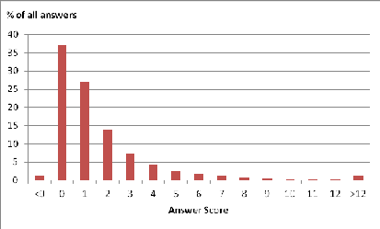
Figure 1. Distribution of answer scores on SO

4 We could alternatively use SO’s public data dump for selecting the sample, but the nondeterministic nature of the crawler ensured the randomness of the sample which was enough for this study. We used a lower threshold of 4 during our manual filtering to keep threads with answers containing real code, even with a lower score of 4 or more. We chose this lower threshold since we knew its appropriateness from the statistical analysis.
5 It can be found at http://ase.cpsc.ucalgary.ca/uploads/ICSM2012.zip.
  - Analysis
We started our analysis by open-coding questions/answers in a subset of our sample similar to the way it is done in grounded theory [4]. We chose this method because we did not have a priori knowledge what categories would be relevant, so we chose a methodology that supports developing categories from data. We coded interesting elements of questions/answers and tried to use the language of the users for our codes. The first 63 threads were gone through open-coding and after doing it for some of them we started to find higher level categories concurrently. After doing it for those threads we realized that we reached saturation (no more new categories did emerge), but we only saw some aspects of already found categories. So we decided to stop open-coding and continue with focused-coding. Some of the categories were adopted as theoretical concepts to help us create interpretive description of the data⁶.
Our main research question is what makes a good code example, so we have mainly focused on the answers being posted on SO that contain code examples. Our findings provide the attributes of those examples present within recognized answers. It was also observed that recognized answers do not just provide code. They usually provide some explanation besides the code. Therefore, another part of our findings deals with the structure and organization of the explanation element of recognized answers. Our first impression was that these two elements of an answer, namely code and prose accompanying it, are equally important and studying their attributes will help us understand what makes a good answer to a programming question. To make sure that these attributes actually make an answer a better one, we also compared the recognized answers to the low-vote ones based on these attributes. Answers do not live in the void. They are answers to some questions. Our analysis also resulted in a categorization of question types in our sample.
- Findings
We start with a categorization of the questions. These question types are important, since we found that some answer attributes are related to the question types. The main part of this section is dedicated to the presentation of our main findings about the attributes of recognized answers. Finally the common attributes of low-vote answers will be discussed.
- Question Types
The main goal of SO visitors is to find an answer for their programming questions. The first step is to formulate an appropriate question that provides enough information about the problem to the potential responders. The flexibility of the site enables a questioner to refine their question as the Q&A session unfolds. It is common for a question to be edited multiple times by the original poster or even by other site members. Our sample of edited questions shows that the wiki-like feature of the site makes it possible to improve the

6 Our coding summary is publicly available at http://ase.cpsc.ucalgary.ca/uploads/ICSM2012-Coding.zip.

question content based on the feedback from other site members if the question did not originally provide enough information or it was somewhat ambiguous.
SO question types can be described based on two different dimensions. The first dimension deals with the question topic: It shows the main technology or construct that the question revolves around and usually can be identified from the question tags. These types are API related questions, object-oriented programming/design questions, language basics questions, questions about migrating to a new language and comparing constructs of two languages, and questions asking for algorithms or how to improve the performance of an algorithm.
The second dimension is about the main concerns of the questioners and what they wanted to solve. The question types in this group are:
- Debug/Corrective: Dealing with problems in the code under development, such as run-time errors and unexpected behavior. It could also be about working code which is not satisfactory due to its current design or structure and thus seeking a better design.
- Need-To-Know: Questions regarding possibility or availability of (doing) something. These questions normally show the lack of knowledge or uncertainty about some aspects of the technology (e.g. the presence of a feature in an API or a language).
- How-To-Do-It: Providing a scenario and asking about how to implement it (sometimes with a given technology or API).
- Seeking-Different-Solution: The questioner has a working code yet is seeking a different approach for doing the job.
We did not find a meaningful relationship between the question types from the first dimension and the attributes of recognized answers, so hereby we just focus on the second dimension. Question types do not necessarily show separate sets, some of them actually overlap, i.e. a question might belong to more than one type. Fig. 2 shows the distribution of second dimension question types in our sample.
- Attributes of Recognized Answers
The responders are encouraged to provide code in their answers, since SO is dedicated to programming questions. But just providing code is not enough. The code usually is accompanied by some explanation. The analysis of recognized answers in our sample showed that they possess some attributes, either regarding the code or the explanation in the answer. Table I lists these attributes with a short description of each attribute and some examples. In the rest of this section we present the most important attributes of recognized answers in more details. For each attribute we also compared the recognized answers having it to the low- vote answers in the same thread to find out if that attribute is the distinguishing factor between them. Consider a recognized answer attribute, A. From these comparisons we found that A is a distinguishing factor if the only difference
between a recognized answer and a low-vote answer, is that the low-vote answer lacks A. On the other hand, just having some of these attributes is not enough to make an answer a recognized one. Having some other (negative) attributes such as lack of enough explanation, not providing any code when it is the main goal of the questioner, using unfamiliar context, and not using best practices can lead to a low score. In other words, a good answer needs to have some basic features such as explanation, code (if it was asked by the question), and it should be correct. Only when an answer has these basic attributes, having other recognized answer attributes, presented in the rest of this section, would be a distinguishing factor to make it a recognized one.
  - Concise Code
The code presented within answers is considered as concise if either it is shorter than similar code inside other answers to the same question, has less than 4 lines of code, being labeled as concise in the comments by the audience, or it is apparent that its complexity has been reduced; for instance, when it is clear that some parts of the implementation were removed to make the code simpler.
We found that many recognized answers in our sample provide the concise solution code: 48 Q&A threads have one or more recognized answers with this attribute. One way to make code concise is to leave unnecessary details out and show their absence with some place-holders (such as comments or ellipses) which usually transforms the code to a solution skeleton. This technique is used when the implementation details are considered irrelevant or readers are assumed to easily figure out how to put the missing details back there. In our sample we have 18 recognized answers using this technique. Most of them (15) use it to show the structure of the solution (e.g. a pattern or general usage scenario of an API) and imply that the structure is more important than the implementation details. However, some implementation tips could be included as comments to show the way of transforming the skeleton into full-fledged code.
For instance, the following code snippet shows how anonymous inner classes are used in Java as an idiom in place of function-pointers in other languages. The structure of the solution is the main point of the solution, and thus the implementation of the method body is considered irrelevant and left out:
Collections.sort(list, new Comparator<MyClass>(){ public int compare(MyClass a, MyClass b)
{
// compare objects
}
});
Sometimes one line of code is the complete answer for the question (it is called a one-liner by the site members). As an example consider the following method with a single line body.
public static byte[] toByteArray(String s) { return DatatypeConverter.parseHexBinary(s);
}
The API method call provides the functionality needed by the questioner, namely converting a string of hex values to a byte array.

TABLE I. Attributes of Recognized Answers

Attribute Name | What is it? | Explanation and Examples
Concise Code | Less complex and shorter code examples | - Eliminating implementation details  - Using place-holders
Using Question Context | Answer code can build on top of the question  code; either to correct it or improve it | - Usually results in more concise code  - Using question code closely, if possible; otherwise using identifiers from it
Highlighting  Important Elements | The answer starts with highlighting the key element of the solution | - The element name could be hyperlinked to external pages for further information  - Some examples of these elements: the cause of error in question code, the name of an API class, and the name of a pattern/best practice
Step-by-Step Solutions | The code divided to multiple chunks, each chunk is described separately | - Suitable for explaining facts to novices  - Can be used to explain how things work in detail (e.g. how code is executed)  - Suitable for solutions with code in multiple files
Links to Extra Resources | The answer has hyperlinks to other sources of information | - The external resource could show more complex code for almost similar scenarios, and/or more explanation  - The preferred resources could have an authoritative/official nature
Multiple Solutions | Answers in a Q&A thread could provide alternative solutions to a question | - Can be used as a refernce for people with similar questions  - Alternative solutions could use different classes from one API, different classes from different APIs, or different versions of an API
Inline Documentation | Comments can be used as an alternative way of explanation | - Using normal comments, Javadoc comment, or exception messages as a means of explaining the code or using comments as place-holders for implementation details  - Directly usable code with a mini-guide inside it
Solution Limitations | The answer explains the limitation of the  solution | - Could be initially part of the answer, or added later due to the comments  - Some examples: performance issues, usability of the solution, and security risks
API Limitations | Explicitly mentioning the shortcommings of the API used by the questioner | - It could be the lack of functionality, API design issues, or even a bug in the API  - Highlighted when it is the main source of the problem for the questioner  - A workaround solution is usually presnted

It is wrapped inside a method with a name reflecting the functionality mentioned in the question which makes it more relevant to the question’s vocabulary than the original method name.
Comparing the recognized answers having concise code to the low-vote ones based on the length of the code inside them revealed that for half of the low-vote answers the distinguishing factor is the code length. For the rest, we saw that even though the low-vote ones have a code with similar length, some other factors contributed to their low scores, such as lack of explanation, inefficiency of the code, using a complex domain, and not covering all cases.
  - Using Question Context
Providing code is not restricted to answers. Some questions also present code snippets as part of their problem description. It is very common for the Debug/Corrective questions to contain code, but it does not mean that only this type of questions presents code. 58% of questions in our sample provide some code snippets. Fig. 3 shows the distribution of questions with code among different question types.
When the question code has some flaws or is not working, the answer usually provides some corrective suggestions. We have 10 recognized answers that apply corrections to the question code and represent the corrected version. Since the answer code does not necessarily have to show the whole code, using the question code also results in more concise code (7 out of 10). For instance, if the question code can be fixed by adding some missing statements or changing some arguments, only those changes need to be represented, probably with a few other lines of code surrounding them. A good sample of this is the answer to a question regarding polymorphic CriteriaQuery in the Hibernate API. The question code has more than ten lines of
code, but the answer just suggests that the following line from the question code
Path<Object> path = from.join("idTag").get("code");
needs to be replaced with this one:
Path<Object> path = ((Path) from.join("idTag")
.as(RfIdTag.class)).get("code");
The unexpected behavior of the question code can be a result of questioner’s inaccurate knowledge of the API or language elements. Misleading documentations or misreading them can be blamed for questioner’s wrong conception, as one questioner puts it:
“the Javadoc is a bit confusing.”
Then the solution will show how to apply changes to the question code in order to use those misused elements correctly.
The answers that use the question code are not limited to those that just provide a working solution. Some of them also provide suggestions on how to improve the code, either by improving its readability or by applying best practices/patterns/idioms to the question code, regardless of this change being the main goal of the question. This type of improvements could also have some pedagogical benefits for questioners as they learn how to write better code.
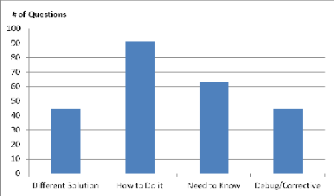
Figure 2. Distribution of question types in our sample

For instance a responder suggests the following as a best practice that the questioner should follow, even though it was not the source of the problem:
“You should also get used to define the type of the elements in the list.”
The extent to which the elements of the question code are used in the solution varies. The question code can be used closely if the amount of change for fixing the problem or improving the design is not considerable. In our sample, we observed that the question code has been used closely on occasions when adding or removing a few statements would fix the problem or some minor restructuring would improve the code. On the other hand, even if the solution is dramatically different in design and implementation from the question code, or when the question code is incomplete, some elements from the question (i.e. identifiers) can be used, probably to make it easier for the questioner to understand the solution. We observed that in the majority of these cases (7 out of 9) the questioner does not know how to do the task and this leads to an inadequate code snippet in the question. For instance, a questioner wants to get the integer values of enum members. His code shows an enum:
public enum TK{ ID,GROUP,DATA,FAIL;
}
Then it shows the questioner’s current solution of defining and getting those values. The accepted answer explains that this approach is against best practices, thus the solution has a completely different structure, but at least it uses the name of the enum type (TK) in the solution:
Map<TK,T> map = new EnumMap<TK,T>(TK.class); TK tk = ...;
T something = ...;
map.put(tk, something);
Comparing the recognized answers that use question context to the low-vote ones revealed that for almost half of the low-vote answers, not using the question context in the solution was in fact the distinguishing factor. For the rest, we found that even though the low-vote ones use the question context in their code, some other factors contributed to their low scores, such as lack of explanation, longer solutions, and not using best practices.
  - Highlighting Important Elements
A considerable number of recognized answers (43 answers, each belongs to one of 36 different questions) start the discussion of the answer with highlighting the most important element of the solution. For How-To-Do-It question, it is usually the name of the API element to be used in implementing the desired questioner’s scenario. The answer highlights that element, and sometimes links it to external resources like the Javadoc entry of the API element, followed by the solution using it. The highlighted element could also be a design pattern name to be used to improve the current design of the question code, when the questioner seeks to improve the current design of their code. The name of the pattern is mentioned first followed by the solution. For instance,
“This sounds like a good candidate for the Specification pattern.”
In 8 recognized answers to some Debug/Corrective questions, the answer starts with highlighting what causes
the problem for the questioner: The lack of knowledge on how to use an API method/class; e.g. not knowing how to use special characters when using the String.split method. Bad programming, wrong assumptions about what the questioner implemented, or not being familiar with a development tool are some other causes of problems present in our sample. For instance:
“You may have inadvertently selected Java Desktop Application.”
In 5 occasions the answer starts with highlighting a list of things (in contrast to only one element). These answers have the common property that their questions can be solved in multiple ways, each with its advantages/disadvantages. The answer first provides a list of pros/cons of these alternative solutions to justify the preferred solution that follows.
Comparing the recognized answers with highlighted elements to the low-vote ones revealed that for almost half of the low-vote answers, they do not highlight the element and that is the main difference between them and the recognized ones. For the rest, we found that even though the low-vote ones do the highlighting, some other factors contributed to their low scores, such as lack of explanation and lack of code to show how to implement the required functionality or fix the problem.
  - Step-by-Step Solution
As the name implies, these answers (32 answers in our sample, each belongs to one of 21 different questions) present the solution in a detailed and ordered fashion. They might divide the code into some chunks, describing each small piece of code separately. These informative answers are utilized for different reasons.
In 7 answers, when the questioner explicitly asks about some basic facts, or when it is clear from the question or problem that they are not aware of those basic facts, this format is used; e.g. explaining the benefits of getters/setters or the bridge methods in Java. In some of these questions, the questioner explicitly describes themselves as non- experts. Apart from the step-by-step format, the examples presented in these answers have the following interesting attributes: they are quite simple and use a familiar domain. They also explain to newcomers how things work.
A good example that shows the last attribute is a question asking about an infinite loop containing a strange x=x++ statement. Unlike normal Debug/Corrective questions, the main goal is not to find how to fix it (the fix is obvious), but rather to learn why it behaves like this. The accepted answer tries to explain how the code actually works by providing a simulation (a method that simulates the post- increment operator) and step-by-step using this method (by rewriting the original code) to explain what happens when the original code is run.
This format is also used for some How-To-Do-It questions (7 instances). The questioner is not usually a novice in these cases. For instance, they might be familiar with a construct in Java and want to know how to simulate it in C#. Since an answer to these questions normally involves multiple elements (some class and sub-class definitions, method implementations, and usage code), it seems a suitable format to use a step-by-step approach which

introduces and discusses these elements one by one and explains how they fit together: This format is used when the answer needs to provide multiple elements (sometimes in different places/files). We have 3 instances of step-by-step solutions that use this format due to the both previously mentioned reasons. They suggest using a design pattern or a best practice. Since a design pattern/best practice usually consists of multiple elements, to explain why it should be used/it is a good practice, a step-by-step format is used. But they also describe the philosophy of the design and how things work for non-experts.
Our Comparison of the recognized answers with step-by- step solutions to the low-vote ones revealed that for almost half of the low-vote answers, they do not use this format and that is the main difference. For the rest, even though the low- vote ones use this format, some other factors contributed to their low scores, such as less explanation and using a more complex code/context.
  - Providing Links to Extra Resources
The expected length of an answer, and the time window for answering, make short answers more appealing for responders (consider the high percentage of answers posted in the first hour of a thread’s life). We should mention that there are few really long recognized answers in our sample, but most of the recognized answers are relatively short. To keep the answer short, the responder can provide links to external web sites that contain longer/more complex examples, contain examples with slightly different scenarios, and/or provide more detailed explanation. It is encouraged to provide such links, however the answer should be self- contained by providing a summary of the external source contents. This self-containment will prevent the answers from becoming useless due to dead links. So, an answer is expected to actually answer the question, regardless of having links to other resources. This technique is quite common for answers to questions of the Need-To-Know category (19 recognized answers to 15 different questions use this technique).
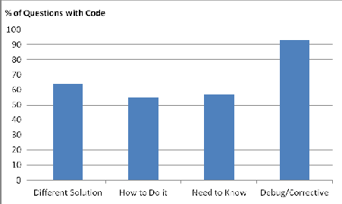
Let’s see what these sources have in common: In 6 instances the external resource presents information from some well-known and respected people in the community, and it is used to justify the appropriateness of the answer. Examples of these resources are a book by a well-known author about best practices in Java, an official book presenting the language specification, an interview with the creator of the C# language, and an online FAQ web site about the Java language constructs by a well-known instructor.
Another source of information that can be referred to is the documentation of the API or language. The standard Javadoc entries can be referenced when the questioner is unaware of a method or class to be used. The documentation can have the format of a tutorial/reference which provides more detailed explanation of the language/API elements and has more code samples.
- Common Attributes of Low-Vote Answers
As we discussed in the previous section, having some of the attributes of recognized answers does not necessarily translate into becoming a recognized answer. Therefore, we decided to study low-vote answers in general to see what attributes they have in common that might have led to their poor score. Lack of code, especially when the question asks for it explicitly or implicitly⁷ is one shared attribute of low- vote answers. Lack of explanation is another one, even if the explanation comes in the form of code comments, it would be better than similar solutions without any explanation on how the code works. Table II presents a summary of these attributes with some examples. A good answer is one without any of these attributes in the first place. Only then possessing the attributes shown in Table I would lead to a better solution more likely to be recognized by community.
- Recognized Answers without Code
In coding our sample we encountered a few recognized answers (32) that have one of the common attributes of the low-vote answers, i.e. they do not provide any code. This was strange, since we did not expect to see recognized answers without code due to the way we did our sampling. A further investigation clarified the situation. Half of the recognized answers without code actually refer to the code in the question and provide some explanation about that code (e.g. their dis/approval of the design of the code and the reason behind it). Three of these answers provide links to external web pages that provide code examples. The rest (except for 3 interesting cases) are answers to some high- level Kneed-To-Know questions regarding concepts, such as the pitfalls in the design of an API or comparing two API classes, which normally does not need any code to explain.
The 3 interesting answers in this group could have provided some code examples to the How-To-Do-It questions, but instead they just provide a link to a Javadoc of the API class/method or just describe the algorithm. From their comments we found that the responders might have assumed the questioners can go from this starting point and would be able to solve their problem, even without code examples. For instance, a question on how to compare two version strings has an accepted answer that just describes the scenario steps of doing the asked functionality, without showing any code. The questioner confirms in the comments that these steps are similar to “what I suspected I'd have to resort to. This also involves looping over the tokens in the shorter of the two version strings. Thanks for confirming.”

Figure 3. Percentage of questions containg code for each question type
7 How-To-Do-It is the major question type containing questions that ask for some code examples. In our sample 95% of their recognized answers provide code examples in the answer.

TABLE II. Common Attributes of Low-Vote Answers

Attribute | Explanation/Examples
Lack of code | Especially when a questioner asks for code  example (e.g. how to initialize a static map in Java?)
Lack of explanation | e.g. not mentioning solution limitations
Shortcomings of solution | Avoidable shortcomings (e.g. throwing exceptions) Not conforming to question constraints  Using an unfamiliar context  Long code examples when shorter solutions exist

- Discussion
Our study has several implications for providers of the support material for developers. It can show how the process of producing supportive materials can be enhanced and what kind of tools could be used during that process. We start with a summary of some of our findings that leads to those implications. Then we discuss the implications. Finally we discuss the limitations of our study.
Customized answers: We found that a main attribute of good answers is that they are normally customized to the questioner’s needs. Many answers are directly applicable to the problem, especially for the Debug/Corrective and How- To-Do-It questions. If the context of the problem is provided (either using code or in plain English), good answers would try to use it while presenting the solution. The familiar solution context makes it easier for the audience to understand and use the solution. It reduces the questioner’s intellectual effort needed to apply the solution to their problem and thus decreases the cognitive distance [15]. This very attribute is one that is absent from some other information sources (documentation, open source repositories, and code search engines).
Familiar context: Even when no context is provided for the question, the responder can choose a familiar one (at least familiar for most of the audience). In this case, the questioner does not have to ponder on the unfamiliar context before they are able to understand the solution. We saw that when the questioner is relatively novice, the answer can use a more detailed format (e.g. step-by-step) to ease the learning process. In other words, the responder would choose the proper presentation format based on the questioner’s expertise level. Another example is those accepted answers that just describe the solution very briefly, since they know the questioner is able to get started with this initial information and do the rest herself.
The impact of question type: The analysis of the distribution of attributes of recognized answers and their question types showed that those attributes are likely to be determined by the second group of question types (i.e. “what the questioner wants”) than by the technology or construct of the question. This relationship is shown in Table III. These attributes stand out for the shown question types (i.e. they are more common for these types); however, it does not mean that they are not used for other question types at all.
Although knowledge sharing sites like SO seem to replace traditional sources of support for developers (such as API documentation), our findings show that there is still a need for more thorough sources of information dedicated to a
specific API/language. The authority attribute of information sources originated from API/language designers makes them more dependable for users. Robillard had a similar finding that examples tied to API designers are more attractive for developers [23].
- Implications
Our findings have some implications on how the current state of tools, examples, and documentation can be improved. The main advantage of the online Q&A sites, namely customized answers to the questions, is hardly transferable to the mentioned sources of knowledge; however, some of the attributes of the recognized answers can be adopted by the information providers.
Retrieval Tools: Many tools use code repositories and apply different mining techniques to retrieve examples. As our findings show, the code itself is not useful enough in many occasions. Therefore, mining knowledge repositories, such as SO and developers’ forums, should be considered as an alternative for retrieving more useful examples accompanied with necessary explanation, and perhaps formatted in some ways to facilitate understanding.
Documentation: Documentations that just provide textual descriptions are not as useful as those sprinkled with several examples. To prepare such documentation, writers need to predict what kind of examples the audience would need and what questions they might have. Since nobody can anticipate each and every question, the documentation should evolve (as the API/language it describes does), not only to cover new features, but also to add examples and explanation for problems that API/language users are facing frequently which are absent from the current version of the documentation. To find out about these problems, the tools mentioned in the previous section can be handy. It is also possible to add a wiki-like capability to the online documentation, so that users’ contributions can be added to it, but in a way that is easily distinguished from the official segments.
Examples: Developers of an API/language should provide a comprehensive set of examples for the potential adopters of their product [23].

TABLE III. Relationship between Recognized Answer Attributes and Question Types

Question Types | Answer Attributes
Debug/Corrective | Highlighting Important Elements (e.g. cause of problem)  Using Question Code (to revise it)
Need-To-Know | Highlighting Important Elements Step-by-Step Solutions  Using Question Code  Link to External Resources
How-To-Do-It | Highlighting Important Elements (e.g. API class name)  Step-by-Step Solutions Using Question Code
Different Solution | Highlighting Important Elements (e.g. pattern name)  Step-by-Step Solutions Using Question Code

This set needs to evolve, as it is the case for the documentation. Therefore they can benefit from the same knowledge mining techniques. It is also important to provide different examples for audience with different levels of expertise.
- Limitations of the Study
Our criteria for building our sample might be regarded as too restrictive (focusing on Java Q&A and using threads containing code examples with relatively high score). However, we used it since these criteria serve our main goal of finding attributes of good code-based answers. There might be a lot of recognized answers without code, but would barely provide much insight into reaching our goal. Another limiting assumption of our study was the score of answers. We assumed that answers with higher scores generally mean better solutions; however, other factors such as answer posting time, the question topic, and the responder identity might affect these numbers. To alleviate the effects of these factors we chose a high score of 4 for answers in our sampling process to make sure that some niche questions that attracted fewer people would not be truncated. We also compared answers to the same question and not with answers to other questions.
The generalizability of our findings could be regarded as another limitation. However, our findings have some overlaps with some other studies [13, 23, 27] which suggests that our results could be generalized to some extent. At least our findings can be used as hypotheses to be examined in later studies.
Another concern would be the reproducibility of our findings. The coding of questions and answers were done by the first researcher. A second researcher then coded all the questions and 32 answers from 10 randomly selected Q&A threads. We computed Cohen’s kappa inter-rater reliability values [5] for different question types and answer attributes. This value is between 0.69 and 0.79 for the question types and between 0.68 and 1 for the answer attributes. This ensures that our results could be reproduced with a high probability by other researchers.
- Related Work
APIs play a major role in developing software (65% of the questions in our sample ask a question related to some API). There are some studies addressing issues in learning APIs. Ko et al. found six learning barriers that end-user programmers would face. They found that programmers can overcome some of these barriers by finding relevant examples. However, they might face some other barriers when trying to adapt these examples to their needs [14]. This is not often the case with examples on Q&A web sites, since the answer code is usually tailor-made to the questioner’s needs. Robillard’s findings based on a survey from professional developers show that API learning resources have a similar importance as the API design on the ease of learning for developers. He also found that developers want some well-structured and complete documentation and a comprehensive set of examples that show usage best practices for different scenarios [23]. A study of discussions
in a programming forum categorized three major types of questions (asking for a solution, using a wrong solution, and using a solution incorrectly) and found several obstacles imposed by the API for each category, for instance improper default solutions and hard to find elements [13]. Finding relevant Q&A threads could be a challenge, especially in large forums. Gottipati et al. developed a text classification method on different types of entries in software forums and showed that their tool would outperform normal search engines in recovering relevant answers to user queries [10].
Using the web as a main source for programmers to gather information has been the focus of some research studies. Programmers use the information available on the web for three main reasons: just-in-time learning, clarification, and remembering difficult things. They use different types of queries (natural language, code, or a mixture of both) based on their main objective [3]. Q&A web sites can be a good source to provide the needed information to programmers. An analysis on how programmers conduct Q&A on SO resulted in several question categories (how-to, review, error, conceptual, etc.) and that questions containing code are very common for review questions. Besides the question type, other factors, such as the question posting date and time, the identity of the questioner, the technology in the question, the length of the question, and the availability of code in the question affect receiving good answers [27]. The web can also provide alternative means of API documentation. A study showed that blogs cover 87.9% of a specific API’s methods and provide tutorials and personal usage experiences. They also found that these sources are the main way of support for some niche communities [20].
Using examples is a main source of help for both professional [24] and end-user programmers [29]. Both groups are trying to solve a problem by reusing those examples. For novice developers, having more knowledge about the architecture of a framework will be a major factor in adapting framework usage examples more efficiently, so it was suggested that learning a framework should start with teaching novices about the design of that framework [12].
There are also tools designed to extract code from source repositories to provide them as examples. Some of them use mining technique to locate features [17, 22]; others extract common API usage patterns [1, 2, 30]. These tools rely on queries consisting of keywords to find examples. Holmes et al. developed a tool that uses the current development context (i.e. types used in code under development) as the query to find similar code snippets that might be reused [11]. The extracted code by all of these tools does not necessarily have a familiar context and is not always accompanied with helpful explanation. To overcome some of these shortcomings, Stylos et al. developed a tool that extracts some common usage scenarios using web search (such as object creation) and injects them into the API documentation
[26]; albeit for very limited scenario types.
Documentation is also a main source of information for developers [23]. Dagenais and Robillard studied the creation and evolution of the documentation, and found that different types of documentation are more appropriate for libraries and

33

frameworks. They also found that mailing lists could be considered as bug reports and be used in the evolution of the documentation [7]. Dagenais and Ossher built a tool that helps developers to create light-weight documentation while using a framework by defining different steps of a task and adding elements to each step and thus creating a set of guides [5]. Nontrivial and infrequent knowledge about how to use elements of an API could be hidden under tons of API documentation text. Two studies defined different types of these hidden elements (called directives) [8, 18]. Dekel also built a tool integrated to an IDE to present these important elements to developers while they are using the API and showed that it improved the outcome of documentation reading for their study subjects [9].
- Conclusion and Future Work
Q&A web sites like SO are providing a new means for programmers to participate in social learning [28]. The shear amount of questions and answers posted on the site shows the popularity and success of this way of learning. This also provided us with a good source for studying the properties of well-received answers. We found that code examples and the accompanied explanation are two inseparable elements of recognized answers. We also found attributes of these two elements and techniques being used to shape these elements, such as making concise examples, shaping the explanation based on the questioner’s expertise level, and making use of the question context to decrease the cognitive distance. These findings can be used by documentation and example developers to create more usable artifacts for potential users.
We are going to combine these findings with our previous study [19] to apply some of these findings on automated tests and study their effects on developers learning experience.
References
- M. Acharya, T. Xie, J. Pei, and J. Xu, “Mining API Patterns as Partial Orders from Source Code: From Usage Scenarios to Specifications,” in Proceedings of ESEC/FSM 2007, New York, NY, USA, 2007, pp. 25–34.
- S. K. Bajracharya, J. Ossher, and C. V. Lopes, “Leveraging Usage Similarity for Effective Retrieval of Examples in Code Repositories,” in Proceedings of FSE 2010, New York, NY, USA, 2010, pp. 157– 166.
- J. Brandt, P. J. Guo, J. Lewenstein, M. Dontcheva, and S. R. Klemmer, “Two Studies of Opportunistic Programming: Interleaving Web Foraging, Learning, and Writing Code,” in Proceedings of CHI 2009, New York, NY, USA, 2009, pp. 1589–1598.
- K. C. Charmaz, Constructing Grounded Theory: A Practical Guide through Qualitative Analysis. Sage Publications Ltd, 2006.
- J. Cohen, “A Coefficient of Agreement for Nominal Scales,” Educational and Psychological Measurement, vol. 20, no. 1, pp. 37– 46, Apr. 1960.
- B. Dagenais and H. Ossher, “Automatically Locating Framework Extension Examples,” in Proceedings of FSE 2008, New York, NY, USA, 2008, pp. 203–213.
- B. Dagenais and M. P. Robillard, “Creating and Evolving Developer Documentation: Understanding the Decisions of Open Source Contributors,” in Proceedings of FSE 2010, New York, NY, USA, 2010, pp. 127–136.
- U. Dekel and J. D. Herbsleb, “Improving API Documentation Usability with Knowledge Pushing,” in Proceedings of ICSE 2009, Washington, DC, USA, 2009, pp. 320–330.
- U. Dekel and J. D. Herbsleb, “Reading the Documentation of Invoked API Functions in Program Comprehension,” in Proceedings of ICPC 2009, 2009, pp. 168–177.
- S. Gottipati, D. Lo, and J. Jiang, “Finding Relevant Answers in Software Forums,” in Proceedings of ASE 2011, 2011, pp. 323–332.
- R. Holmes, R. J. Walker, and G. C. Murphy, “Strathcona Example Recommendation Tool,” in ACM SIGSOFT Software Engineering Notes, New York, NY, USA, 2005, pp. 237–240.
- D. Hou, “Investigating the effects of framework design knowledge in example-based framework learning,” in Proceedings of ICSM 2008, 2008, pp. 37 –46.
- D. Hou and L. Li, “Obstacles in Using Frameworks and APIs: An Exploratory Study of Programmers’ Newsgroup Discussions,” in Proceedings of ICPC 2011, 2011, pp. 91–100.
- A. J. Ko, B. A. Myers, and H. H. Aung, “Six Learning Barriers in End-User Programming Systems,” in Proceedings of VL/HCC 2004, Washington, DC, USA, 2004, pp. 199–206.
- C. W. Krueger, “Software Reuse,” ACM Comput. Surv., vol. 24, no. 2, pp. 131–183, Jun. 1992.
- L. Mamykina, B. Manoim, M. Mittal, G. Hripcsak, and B. Hartmann, “Design Lessons from the Fastest Q&A Site in the West,” in Proceedings of the 2011 annual conference on Human factors in computing systems, New York, NY, USA, 2011, pp. 2857–2866.
- C. McMillan, M. Grechanik, D. Poshyvanyk, Q. Xie, and C. Fu, “Portfolio: A Search Engine for Finding Functions and Their Usages,” in Proceedings of ICSE 2011, 2011, pp. 1043–1045.
- M. Monperrus, M. Eichberg, E. Tekes, and M. Mezini, “What Should Developers be Aware of? An Empirical Study on the Directives of API Documentation,” Empirical Software Engineering, Dec. 2011.
- S. M. Nasehi and F. Maurer, “Unit Tests as API Usage Examples,” in Proceedings of ICSM 2010, 2010, pp. 1–10.
- C. Parnin and C. Treude, “Measuring API Documentation on the Web,” in Proceedings of Web2SE 2011, New York, NY, USA, 2011,
pp. 25–30.
- J. L. Plass, R. Moreno, and R. Brünken, Cognitive Load Theory, 1st ed. Cambridge University Press, 2010.
- M. Revelle, B. Dit, and D. Poshyvanyk, “Using Data Fusion and Web Mining to Support Feature Location in Software,” in Proceedings of ICPC 2010, 2010, pp. 14–23.
- M. P. Robillard, “What Makes APIs Hard to Learn? Answers from Developers,” IEEE Softw., vol. 26, pp. 27–34, Nov. 2009.
- M. B. Rosson and J. M. Carroll, “The Reuse of Uses in Smalltalk Programming,” ACM Trans. Comput.-Hum. Interact., vol. 3, no. 3,
pp. 219–253, Sep. 1996.
- C. B. Seaman, “The Information Gathering Strategies of Software Maintainers,” in Proceedings of ICSM 2002, 2002, pp. 141 – 149.
- J. Stylos, A. Faulring, Z. Yang, and B. A. Myers, “Improving API Documentation Using API Usage Information,” in Proceedings of VL/HCC 2009, Washington, DC, USA, 2009, pp. 119–126.
- C. Treude, O. Barzilay, and M.-A. Storey, “How Do Programmers Ask and Answer Questions on the Web?” in Proceedings of ICSE 2011, New York, NY, USA, 2011, pp. 804–807.
- J. Vassileva, “Toward Social Learning Environments,” IEEE Transactions on Learning Technologies, vol. 1, no. 4, pp. 199–214, Dec. 2008.
- S. Wiedenbeck, “Facilitators and Inhibitors of End-User Development by Teachers in a School,” in Proceedings of VL/HCC 2005, 2005, pp. 215– 222.
- T. Xie and J. Pei, “MAPO: Mining API Usages from Open Source Repositories,” in Proceedings of MSR 2006, New York, NY, USA, 2006, pp. 54–57.

34

Start of PDF Naman_Omar 4

2023 IEEE International Symposium on Mixed and Augmented Reality Adjunct (ISMAR-Adjunct)

Cardiac Visualisation Along the RV-Continuum - A High-Fidelity Pilot Study
2023 IEEE International Symposium on Mixed and Augmented Reality Adjunct (ISMAR-Adjunct) | 979-8-3503-2891-2/23/$31.00 ©2023 IEEE | DOI: 10.1109/ISMAR-Adjunct60411.2023.00145

David Aigner*
University of Applied Sciences Upper Austria
Nanjia Wang†
University of Applied Sciences Upper Austria
University of Calgary
David Kielmayer‡
Keplerklinikum Linz
Ju¨ rgen Steiner§
Keplerklinikum Linz

Julian Hochpo¨ chler¶
Keplerklinikum Linz
Christoph Heinzl||
University of Passau
Daniel Roth**
Technical University of Munich Klinikum rechts der Isar
Christoph Anthes‡‡
Frank Maurer††
University of Calgary

University of Applied Sciences Upper Austria
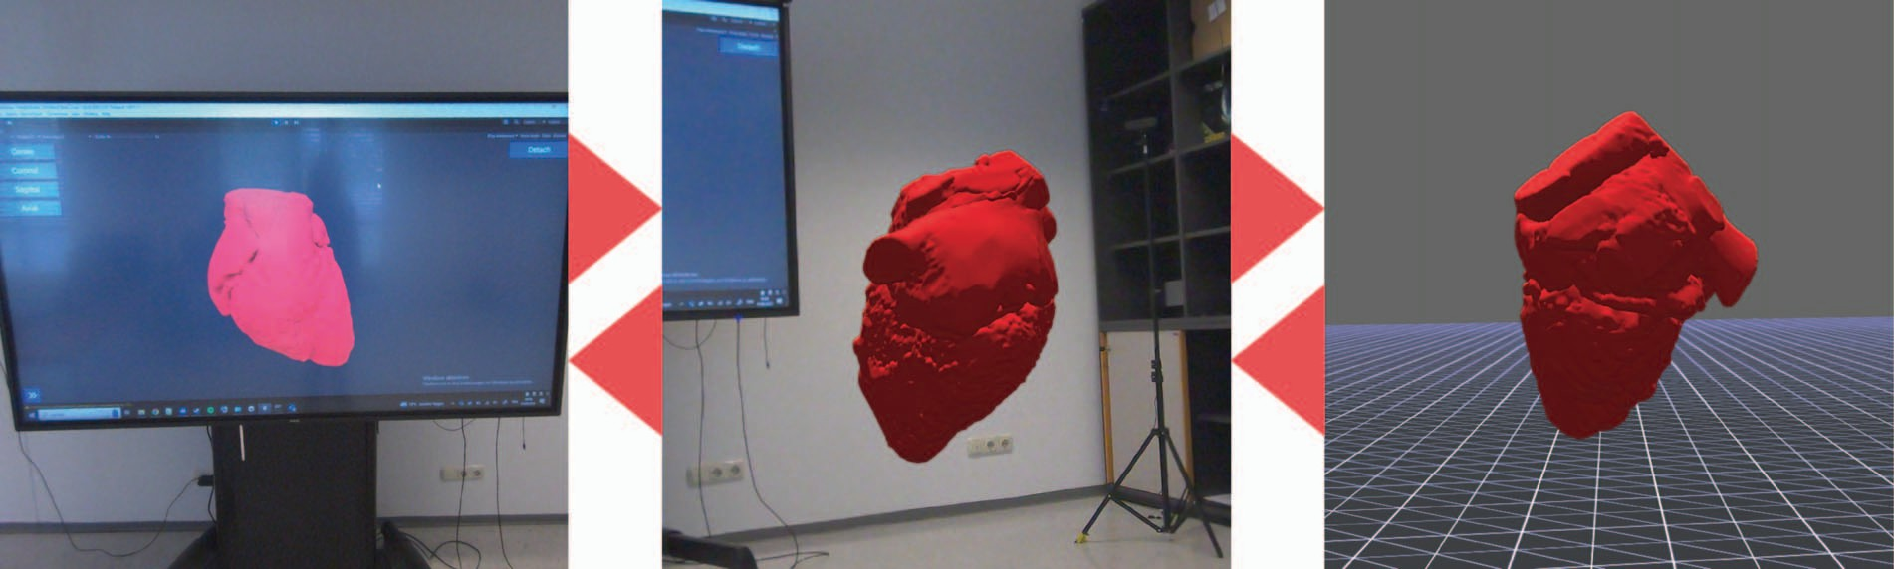

Figure 1: The different stages of the RVC as used in our prototype. 3D visualisation on a planar touch display (left), data set representation in AR space (center) and in virtual space (right). The users are able to move freely and seamlessly between these stages with the help of transitions.

Abstract

The different stages along the Reality-Virtuality Continuum (RVC) come with individual challenges and benefits for visualisation. While visualisation at these stages has been explored extensively over the past decades, a combination including all stages is yet to be investigated. In this publication we introduce an early prototype from the area of cardiac surgery planning connecting the different RVC stages and allowing the user to move between real, augmented and virtual environment within a single application. An overview of the implemented concepts and the functionality is presented and a pilot study gathering data about the potential use of such a system for operation planning was executed.
Index Terms: Human-centered computing—Visualization—Visu- alization techniques—; Human-centered computing—Visualiza- tion—Visualization design and evaluation methods

*e-mail: david.aigner@fh-hagenberg.at
†e-mail: nanjia.wang1@ucalgary.ca
‡e-mail: david.kielmayer@kepleruniklinikum.at
§e-mail: juergen.steiner@kepleruniklinikum.at
¶e-mail: julian.hochpoechler@kepleruniklinikum.at
||e-mail: christoph.heinzl@uni-passau.de
**e-mail: d.roth@fau.de
††e-mail: fmaurer@ucalgary.ca
‡‡e-mail: christoph.anthes@fh-hagenberg.at
1 Introduction
In the recent years, technologies along Milgram’s Reality-Virtuality Continuum (RVC) [16] like Augmented Reality (AR) and Virtual Reality (VR) have been used extensively for visualisation pur- poses [9, 14]. The term immersive analytics (IA) was introduced to describe and discuss such types of visualisations. IA offers a larger design space [17]. It allows the choice of an arbitrary viewpoint without controller navigation [4], and facilitates to investigate re- gions not expected to be of interest without penalty [3]. Thus a better insight into three-dimensional structures maybe provided. But yet, a variety of challenges in IA still exist [7]. One of these challenges is found in the transitions between standard monitor device (SMD), AR, and VR.
Interconnecting the different stages (e.g. SMD, AR, VR) along the RVC has been partially investigated (e.g., between real environ- ments and AR [23], real environments and VR [22] and AR and VR [5]). Moving seamlessly between these stages has become fea- sible just recently due to technological advancements in the design of Head-Mounted Displays (HMDs) [10]. Both Varjo XR3 and Ap- ple Vision Pro devices have the potential to support the transition of virtual objects and environments along the RVC. IA along the RVC, also known as Cross-Reality (CR) or Cross-Virtuality Ana- lytics (XVA), can open up new possibilities for data visualisation and mitigate the problems of the individual stages of the RVC by fluently transitioning between them [27].
One application domain which makes already extensive use of Mixed Reality (MR) technologies is the area of medicine. Here, the individual stages of the RVC have been explored in prototypes or applications for presurgery planning [15], patient education [25, 26] and training [30]. We designed and implemented such a prototype in the area of child cardiology (see Figure 1).

2771-1110/23/$31.00 ©2023 IEEE
DOI 10.1109/ISMAR-Adjunct60411.2023.00145
675

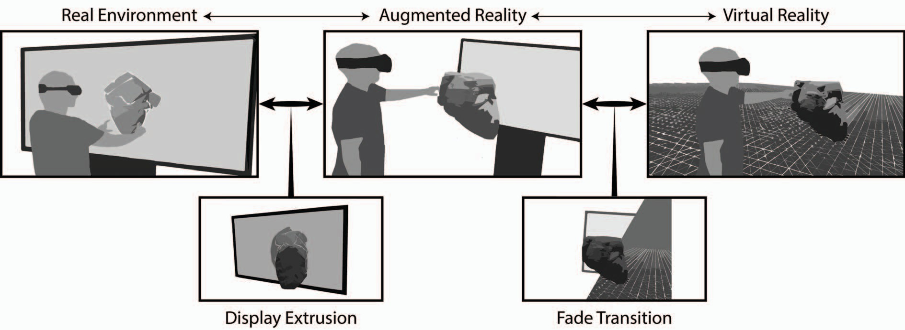

Figure 2: The different stages of the RVC (real environment, AR and VR - on top) are interconnected with the help of their individual transitions (display extrusion from 2D display into AR space as well as the fade transition from AR space into VR space- at bottom) allow users to move between different visualisation approaches. The interaction is kept consistently hand based and uses touch and spatial gestures for application control and data manipulation.

One in a hundred children is affected by a congenital heart disease (CHD). Due to their sparsity and high variability with every case be- ing different, it is difficult to collect single-centre experience in this field [29]. Conventional demonstration modalities for operative plan- ning include echocardiology, magnetic resonance imaging (MRI), X-ray, and computed tomography (CT). Limitinig three-dimensional structures to two-dimensional representations, however has the dis- advantage of loosing realism and depth perception. VR and AR can overcome these disadvantages. Respective and allow for real-time interaction with patient-specific 3D heart models leading to better anatomical understanding, improving presurgery planning, reducing unexpected and adverse events, intra- and postoperative complica- tion as well as operative room time and potentially hospitalisation expenses [18].
In this publication, we investigate the requirements and desired features for a workflow along the RVC in the area of presurgery planning in cardiac child medicine. We designed a high-fidelity CR prototype demonstrating the benefits of interconnecting MR tech- nologies and moving seamlessly between the stages of the RVC. The preseneted visualisation techniques are early prototypical implemen- tations focusing on transitioning between the different stages of the RVC. We propose an generic setup for CR and point out potential challenges in the areas of interaction and visualisation which are unique to cross-virtuality applications.
Our main contributions are:
- Designed and implemented a prototype which allows a data transition from a SMD through AR space and a transition of the user and data between AR and VR spaces.
- Conducted a pilot study investigating the potential use of such a system for child cardiology.
- Related Work
In this section, we present examples from cross-virtuality and medi- cal applications dealing with visualisation at different stages of the RVC.
  - Previous Work in Cross-Virtuality
The concept of moving along the RVC was originally initated by Billinghurst et al. already in 2001 with the Magic Book prototype [2]. Due to the availability and quality of current video-based see-through HMDs it has become feasible to integrate this concept into current
applications. A recent survey investigated and structured the variety of previous publications in the different areas of CR [10]. For our prototype and the presented pilot study two aspects are crucial. The extension of displays in the AR space and the transitioning between real and virtual environments.
The extension of displays and specifically moving data dynami- cally out of planar surfaces has been previously implemented in a variety of prototypes. For example Mergereality [28] uses gestures to move user created content like sketches or CAD data from a tablet or desktop system into space with the help of an optical see-through HMD. Graphs have been extruded from a large scale planar display into space to use the advantages of 2D as well as 3D layout in a single system [24]. The focus in this work lies on the transition of data to keep a coherent mental image of the dataset.
Full transitions between AR and VR have been explored recently by Pointecker et al. [19], while transitions between different environ- ments in VR have been investigated by Husung and Langbehn [13] and Feld et al. [8].

  - Medical Visualisation Using MR Technology
In the domain of medicine a vast amount of publications exist, which investigate the application of MR technology to improve, enhance and also replace existing workflows. Specifically, in the area of data visualisation, MR technologies have shown to be a useful tool. A variety of publications describe the use of HMDs (AR or VR) for educational purposes in the medical domain [30].
Focusing on cardiology, Huang et al. developed a hybrid VR and desktop system for surgery planning and education [12]. They also describe the demand for a combination of traditional desktop visual- isation with VR representation of the data sets. Deng et al. created a VR system for planning complex cardiac surgery [6]. A similar approach was chosen by Sadeghi et al. [20], who also investigated the feasibility of VR for complex adult cardiac surgery planning.

- Concept and Design
To support application areas in cardiac medicine, we believe that all stages of the RVC can provide advantages and disadvantages. Being able to make use of all stages and move seamlessly between them can be beneficial for a variety of use-cases including presurgery planning. Figure 2 illustrates the conceptual design of our prototype. The stages of the RVC (on top) between which users are able to move forth and back with the help of transitions (below) are shown.

  - Transitioning Between the RVC Stages
We implemented two kinds of transitions: one between real and augmented environment and one between augmented and virtual environment. The users are able to freely move forth and back along the RVC.
For the transition between real and augmented environment the data is initially represented as a 3D data set on a planar large scale touch display. Here, the user can manipulate the data on the display with touch gestures. By performing a grab gesture (forming a fist with the hand) in close proximity to the touch display the extrusion of the data into AR space is initiated. Based on the finding by Schwajda et al. [24], we opted for moving the data along the translation of the user’s hands. They propose user-controlled data extrusion along the translation of an input device for short task completion times. Additionally, the delta rotation of the user’s wrist, which is grabbing the data is applied to the data set. This gives the user an intuitive interaction with a real-world object. During the actual transition, parts of the data are displayed on the screen as well as in AR space. When the transition is complete the visualisation is removed from the touch display.
From the AR environment it is possible to move into VR space for even deeper immersion and increased layout space. Based on the findings by Pointecker et al. [19], we have chosen Fade as a transition technique, which is the most promising technique in work environments due to low transition time and support of spatial orientation. The transition (forth and back) is triggered by a gesture button press located on the left arm of the user.

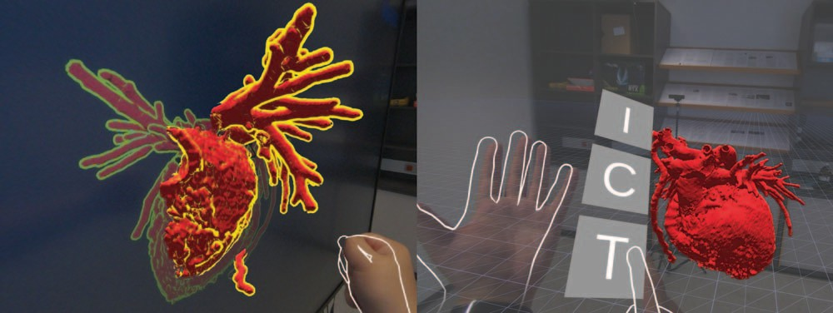

Figure 3: The extrusion transition from real to AR space (left) can be triggered by a grab gesture in close proximity to the screen. The fade transition from AR to VR space (right) can be triggered by pressing a button in the menu attached to the left hand.

Figure 3 illustrates the intermediate state in the transitions be- tween real and AR (left) and AR and VR (right). The stages in which interaction with the data takes place are shown in Figure 1.

  - Interaction Design
For interaction, we opted for touch interfaces, hand tracking and gesture recognition to allow the natural manipulation and use of applications on the 2D screen without having the hands carrying a controller. To provide coherent interaction within the AR and VR stage, the interface in these modes also utilises gestures.
On the large scale 2D multi-touch display, a regular touch with additional finger motion can be used to rotate the data set around its origin while pinch gestures can be applied to scale the data set. Using two or more fingers on the touch display rotates the data set around the perpendicular axis of the screen and moves it, as the interacting fingers are being dragged over the display. Once a data set becomes selected by tapping on the display using fingers for interaction, its outline is highlighted.
The spatial interaction allows manipulation of the data with ges- tures, by grabbing the model. The delta movement of the user’s
grabbing wrist in order to rotate the model around makes it appear like the user is holding a real world object in his hand.
While interacting in AR or VR, clipping can be enabled to per- ceive the inside of the data set. This is realised with a scaleable clip- ping box. The clipping box provides the user with control points to manipulate the the cubic volume, within which models are cropped. The control points in the middle of each face can be pinched in order to move the entire clipping box. The control points on each corner can be used to resize the clipping box. Pixels of the model’s mesh that are inside the clipping box are not being rendered (see Figure 4
- left side).
One common problem with mid-air gestures is arm fatigue, also known as the gorilla arm [11]. To avoid this, often controllers or smart devices are used, which allow operations on datasets without stretching the arm. For our use case ideal solutions could be tracked pens supporting spatial interaction on planar displays or surfaces as already suggested by Schmalstieg et al. [21]. Future hardware like the Logitech VR-Ink¹ might be a reasonable interaction device.
    - Interface Design
Two groups of interface elements were designed and implemented. They were chosen to be placed both body-stabilised (to avoid oc- clusion in the viewport) and world-stabilised (to support spatial orientation and provide a clear points of reference) [1].
The prototype uses a 2D touch menu on the planar screen. Several menu elements are integrated, in order to load and save data as well as setting standard orientations of the dataset like coronal, sagital and axial. The transformations on the screen (either chosen by menu or performed on the surface of the display via touch gestures) can be applied to the model representation on screen or they can be linked to the AR representation. With a grab gesture executed next to the touch display the data set in close proximity to the users hands the extrusion transition into AR space is initiated.
The second group of interface elements is displayed on the right side of the users left arm (see Figure 4 - right side), once the arm is rotated in a way that the user sees the palm. Here, the user is able to select three options by intersecting an interface element with the right index finger. The introduction button (I) shows an overview presenting the gestures for reference, the clipping box button (C) enables or disables the clipping box and the transition button (T) triggers the transition to VR space and vice versa to AR space.
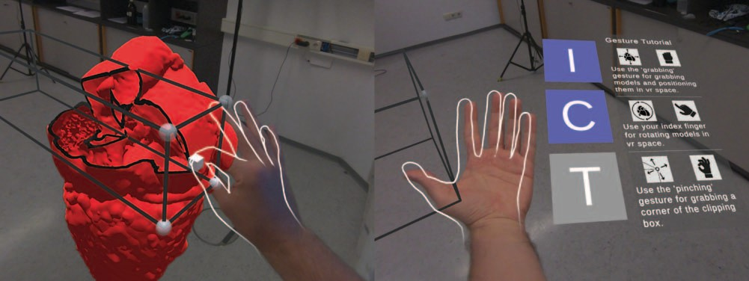

Figure 4: Manipulation of the clipping box (left) performed with a pinch gestures on a corner or a centre of a face and the menu next to the left hand (right) showing an explanation of available gestures, allowing to toggle the clipping box and allowing to transition from AR to VR or vice versa.

- Prototype
The general workflow of preoperative planning for CHD involves a group of approximately twenty cardiologists and surgeons to gather in front of a large-scale display and discuss cardiac images of up- coming patients. In order to reconstruct this workflow, we have

interacting wrist is applied to the model in order to provide the abil-
ity of repositioning via hand motion. Using the delta rotation of the 1https://www.logitech.com/en-us/promo/vr-ink.html

implemented a client-server approach as depicted in Figure 5. Our implementation was developed in Unity (2021.3.2f1)². The touch display is connected to a system acting as a server, while the system to which the HMD is connected acts as a client. The server provides a desktop interface, with which the user can interact with a 3D rep- resentation of the data on screen via touch display. It additionally manages data. The client integrates the AR and VR stages of the RVC with which the user can interact with a 3D representation of the data via hand gestures. In order to realise this network-based architecture, we use Unity Netcode³. As an HMD, we use the Varjo XR3⁴ due to the resolution requirements for interacting in video- based see-through mode on the 2D display in combination with a comparably large FOV and to allow for transitioning into VR space. The tracking is performed by lighthouse tracking, where both HMD as well as touch display are co-registered in the same tracking space. The touch display is tracked with an Vive Tracker.
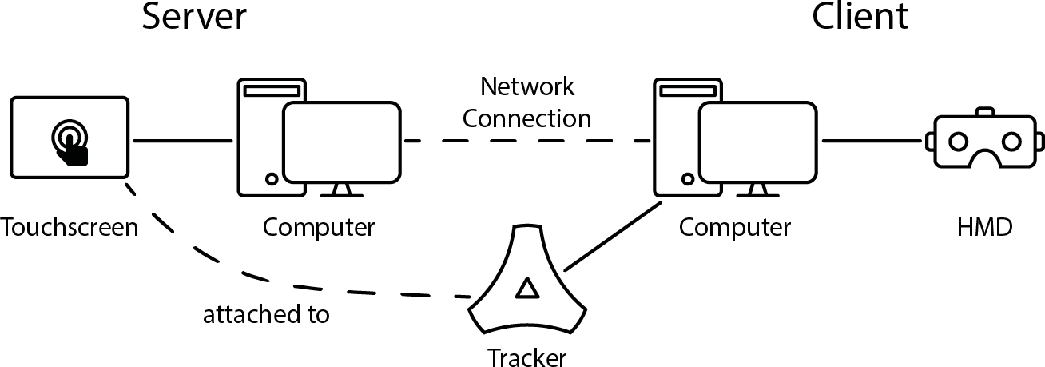

Figure 5: The architecture is client-server based and registers the 2D touch display and the HMD in the same tracking space. This is required for perspective correction, the grabbing gesture and display extrusion.

Interaction on the touch display is realised with the touch API sup- port provided by Unity. On the AR and VR side, gesture recognition and hand tracking is implemented with Ultraleap Hand Tracking for Unity⁵. With this package, different detectors can be configured to track the user’s hands for specific gesture poses. If a hand performs such a pose, then the detector triggers the associated code fragments. In order to implement the clipping feature, a material shader was created that receives the boundaries of the clipping box cuboid as a parameter. During the rendering process, the shader only renders the part of the mesh that is outside the clipping box boundaries. The clipping box can be moved using a pinching gesture on the centre of
one of it’s faces.

- Pilot Study
In order to refine the prototype and improve its applicability and user experience, a pilot study was conducted to collect feedback from cardiologists who regularly participate in preoperative planning for CHD. Due to the limited time availability of clinicians, four cardi- ologists participated in the study. The study focuses on collecting qualitative data.
  - Apparatus
The CR prototype participants interacted with was described in the previous sections. The tutorial and exploring session during which participants used the prototype were video and audio recorded through the Varjo XR3 build-in camera via the Varjo Base soft- ware and a 1080p Logitech webcam mounted on a tripod. The semi-structured interview was audio recorded via a Razer Seiren X microphone and was video recorded via a Razer Kiyo webcam.

2https://unity.com/
3https://unity.com/de/products/netcode 4https://varjo.com/products/xr-3/
5https://developer.leapmotion.com/unity
  - Procedure
At the beginning of the study, participants were informed of the purpose of the study. Then, participants were tasked to fill out a questionnaire regarding their age, gender, experience in congenital heart defects treatment, and previous experience with computers, HMD, and interaction techniques. They were instructed on how to interact with our prototype. Next, they were guided to sit in front of the laptop and fitted with the HMD. We guided our participants through multiple stages of our prototype, including interacting with 3D heart visualisation on laptops and large multi-touch displays, transitioning 3D heart visualisation from the large display to AR space, and transitioning the environment from AR to VR space. Af- ter the tutorial session, the participants were given time to interact with our prototype independently. The prototype showed an iso- surface 3D heart model with congenital heart disease constructed from CT scan data. They were asked to simulate planning surgical procedures in complex CHD and were informed that they could ask any clarification questions during the exploration session. Par- ticipants wore the HMD during the entire tutorial and exploration session. Lastly, a semi-structured interview was conducted to gather feedback and comments on our prototype.
  - Closing Interview
To gather details on the participants’ thoughts and feelings about using our CR prototype, the participants sat together with investiga- tors for a semi-structured interview after finishing the self-exploring session. During the interview, ten main questions were asked to gain information regarding whether our prototype is intuitive to use, what aspects of our prototype cardiologists can benefit from, and how our prototype can be improved to better support presurgery decision-making. Depending on the answer of participants, addi- tional follow-up questions were asked to elicit clarification and gain additional insights.
  - Interview Data Processing
The semi-structured interview was audio and video recorded to convert participants’ feedback to text for further analysis. Investi- gators manually listened through all interview data and transcribed it into text word by word. Then, the key points were extracted and organised from the text data.
- Result and Discussion
In this section, we summarise and discuss the benefits, limitations, and potential of our CR prototype based on the result we collected from the survey and semi-structured interview.
  - Participants Demographics
Four cardiologists volunteered to participate in the pilot study, two of whom were within the age of 40-49 years, with the remaining other participants being in the age group of 50 and above. One participant is an co-investigator of this study. All participants use mixed reality devices rarely. Three out of four participants have used MR devices a few times, while one has never used MR devices before the study. No participant has experienced motion sickness. Three participants used a computer with a mouse and keyboard for less than three hours daily, while one did not use a computer daily. All participants use a smartphone or a tablet with multi-touch interaction daily. Three of four participants only interact with those devices for less than one hour daily.
Three out of four participants have experience related to CHD treatment for more than 20 years, while one participant has related experience for 14 years. All participants are familiar with using 2D medical images for planning surgeries such as single ventricle palliation, biventricular repair, and shunt and anastomosis of the pulmonary veins or arteries.

In order to maintain anonymity, all participants were assigned a unique identification number. In this section, each participant is referred to by the letter P followed by their identification number. For example, participant number one is referred to as P1.
  - User Experience Feedback and Observation
All participants reported that interacting with our prototype, such as transitioning a 3D heart visualisation from a standard monitor to AR, transitioning the environment from AR to VR, and manipulating 3D heart visualisation in 3D space, is effortless and intuitive. Since no participants were experienced with interacting with MR HMD, we planned a 15-minute tutorial session to walk them through all functionalities of the prototype. On average, it took participants ten minutes and 43 seconds to familiarise themselves with all func- tionalities. They were then ready to work on analysing a 3D heart visualisation with CHD on their own. Two participants explicitly claim they ”can get used to it rather rapidly” (P1) and understand how the prototype works in ”ten minutes” (P1, P4). We observed that we only need to show participants the way of interaction once with all tasks, and they can use that interaction later in the self ex- ploration session without asking for help from investigators. All participants interacted with our prototype while wearing an HMD for over 25 minutes. None of them report motion sickness and physical or mental fatigue.
  - Overall Benefits of CR and Our Prototype
When prompted for what aspect of the CR prototype they felt was most beneficial for their day-to-day work, including preoperative planning, participants primarily mentioned the transition of the 3D heart visualisation from the standard monitor to MR space whenever needed to view it in the actual three dimensions. All participants agreed that although MR has many benefits supporting preoperative planning on complex CHD cases, it would not replace the con- ventional 2D medical image visualisation tools, since cardiologists ”have been using those CT and those MRI pictures for thirty years and are used to work on tasks using the ”established” traditional tools. In addition, P1 mentioned that CT and MRI can provide enough information for simple CHD cases. Thus there is no need for a transition of a 3D heart visualisation to the MR space for every case. Participants also think, it is beneficial to be able to see inside the heart using a clipping box to cut the visualisation from different angles, which is not available by viewing CT, MRI, or angiogram data on a standard monitor (P1, P3, P4). P2 and P4 mentioned that manipulating a 3D heart visualisation, such as moving or rotating by dragging the hand or turning the wrist while grabbing the visu- alisation, is as intuitive as manipulating real objects in the physical world. This is beneficial for analysing tasks since it ”reflects the reality” (P2). P3 also mentioned that cardiologists can usually only view 2D medical images from ”one angle.” However, with the CR prototype, ”(heart visualisations) feel real while standing inside the heart and see information (unavailable from medical images shown on the standard monitor).”
  - CR Prototype’s Adoption Potential
All participants responded positively to using our prototype or CR application for presurgery planning. Participants described the over- all experience as ”great” (P2, P3), ”impressive” (P4), ”fantastic” (P4), ”intuitive” (P1, P2), ”simple/easy to use” (P1, P3, P4), ”user- friendly” (P2), ”comfortable” (P1), and ”useful” (P1, P2, P4). All participants think that our prototype and CR application will pos- itively impact tasks related to CHD surgery planning. P2, as a surgeon, interacted with the prototype for over 45 minutes and stated that the prototype is beneficial for meetings on preoperative planning and supports individual analysis work. P2 stated, ”Yesterday... it would have been fine if I had this...We have one case next week... It would be very fine to have (the prototype)”. P4, as another surgeon,
described the condition of a heart with complex CHD within ten minutes of analysing using the CR prototype on their own. P4 stated, ”I just want to have it. It is a really fine thing.”
Despite the positive attitude to adopting the CR application for CHD surgery planning, a concern was voiced by P3 regarding the free space required for using the CR application. Current surgery meetings are held in a conference room with tables, chairs, and other equipment. At the same time, three out of four participants stated they wanted to transition the 3D heart visualisation to MR spaces and do the analysis work while standing. Thus, the hospital might need a free space dedicated to meetings involving CR applications. However, P1 and P4 stated they prefer working with CR application while sitting since ”normally we have our surgical conferences while we are sitting” and ”it is not necessary to stand and have (the 3D visualisation) very big” since being able to rotate a 3D visualisation using a hand intuitively is adequate.
  - Suggested Improvements and Additional Functional- ity
P2 reported the drawback that all interactions need to be done in front of the MR HMD so that the camera can recognise them, which was inconvenient sometimes. P3 reported that the mid-air gesture ”Grab” that triggers the transition could be refined to improve user experience. Beyond addressing these issues and some technical refinement, participants suggested adding improvements and func- tionalities to enhance the CR prototype further. The most commonly proposed feature is collaboration. All participants mentioned that CHD presurgery planning is a collaborative task with around 20 participants. It is important that cardiologists that use standard mon- itor devices can collaborate with those who wear an HMD. For example, P1 stated that after one cardiologist transitions from 3D heart visualisation to MR space, other cardiologists should still be able to share the presenter’s view. P3 proposes an improvement on using a standard monitor to display a world in miniature of the room that shows the position of the user and visualisation, which could enhance the navigation.
- Conclusion and Future Work
Our pilot study sought to reveal the potential benefits CR can offer cardiologists in analysing cardiac data compared to conventional 2D visualisation or immersive analytics using the HMD approaches. Cardiologists gain benefits such as naturally navigating around the 3D heart visualisation by walking, looking into the heart using a clipping box to gain more depth cues, and intuitively manipulating heart models using hand gestures which greatly support the analysis work of complex CHD presurgery planning. However, conventional 2D visualisation applications should not be replaced since they are established and provide adequate information for decision-making of simple CHD cases. The study results indicate that our CR prototype is on the right track, bridging multiple systems along the RVC to preserve the benefits brought by those systems and allows users to intuitively and seamlessly transition between those systems. All participants have used the MR HMDs for over 30 minutes and reported that they did not experience any motion sickness and did not feel either physical or mental fatigue.
Despite the overwhelmingly positive feedback from participants, some improvements need to be made to the prototype and study. First, interaction design needs to be improved, including the transi- tion of virtual objects, the transition between environments along the RVC, and interaction with different systems, such as desktops, large touch-display, and MR HMDs. In order to offer users a seamless transition experience, we intend to introduce colour correction for the transition between real and AR space, as the model’s appearance depends on the calibrations of the touch display and the HMD’s screen and camera. Additionally, we plan to introduce geometrical corrections to improve the spatial alignment of the model’s differ-

ent representations. Collaboration features will also be added on request of all participants, since applications will be used in both individual and collaborative scenarios for surgery planning purposes. Challenges our prototype needs to overcome include asymmetric interaction between users using different systems along the RVC and sharing users’ perceptions at different levels of immersion. A formal user study will be designed based on feedback from the pilot study and conducted with more participants to gather quantitative and qualitative results to investigate the eligibility of CR in CHD presurgery planning.
Acknowledgments
This publication is a part of the X-PRO project. The project X- PRO is financed by research subsidies granted by the government of Upper Austria.
References
- M. Billinghurst and H. Kato. Collaborative Mixed Reality. In Y. Ohta and H. Tamura, eds., International Symposium on Mixed Reality (ISMR ’99), pp. 261–284. Springer Berlin Heidelberg, Berlin, Heidelberg, 1999.
- M. Billinghurst, H. Kato, and I. Poupyrev. MagicBook: Transitioning between reality and virtuality. In ACM Conference on Human Factors in Computing Systems (CHI) - Extended Abstracts. ACM Press, 2001.
- S. Bryson. Virtual reality in scientific visualization. Communications of the ACM, 39(5):62–71, May 1996.
- W. Bu¨ schel, J. Chen, R. Dachselt, S. M. Drucker, T. Dwyer, C. Go¨ rg,
T. Isenberg, A. Kerren, C. North, and W. Stuerzlinger. Interaction for immersive analytics. In Immersive Analytics, 2018.
- D. Clergeaud, J. S. Roo, M. Hachet, and P. Guitton. Towards seamless interaction between physical and virtual locations for asymmetric col- laboration. In Symposium on Virtual Reality Software and Technology (VRST), VRST ’17, pp. 1–4. ACM, New York, NY, USA, 2017.
- S. Deng, G. Wheeler, N. Toussaint, L. Munroe, S. Bhattacharya,
G. Sajith, E. Lin, E. Singh, K. Y. K. Chu, S. Kabir, K. Pushparajah, J. M. Simpson, J. A. Schnabel, and A. Gomez. A Virtual Reality System for Improved Image-Based Planning of Complex Cardiac Procedures. Journal of Imaging, 7(8):151, Aug. 2021.
- B. Ens, B. Bach, M. Cordeil, U. Engelke, M. Serrano, W. Willett,
A. Prouzeau, C. Anthes, W. Bu¨ schel, C. Dunne, T. Dwyer, J. Gru- bert, J. H. Haga, N. Kirschenbaum, D. Kobayashi, T. Lin, M. Olaose- bikan, F. Pointecker, D. Saffo, N. Saquib, D. Schmalsteig, D. A. Szafir,
M. Whitlock, and Y. Yang. Grand Challenges in Immersive Analyt- ics. In CHI ’21: Proceedings of the 2021 CHI Conference on Human Factors in Computing Systems. ACM, Yokohama, Japan, May 2021.
- N. Feld, P. Bimberg, B. Weyers, and D. Zielasko. Keep it simple? Evaluation of Transitions in Virtual Reality. In Extended Abstracts of the 2023 CHI Conference on Human Factors in Computing Systems,
pp. 1–7. ACM, Hamburg Germany, Apr. 2023.
- A. Fonnet and Y. Prie. Survey of Immersive Analytics. IEEE Trans- actions on Visualization and Computer Graphics, 27(3):2101–2122, 2021.
- B. Fro¨hler, C. Anthes, F. Pointecker, J. Friedl, D. Schwajda, A. Riegler,
S. Tripathi, C. Holzmann, M. Brunner, H. Jodlbauer, H.-C. Jetter, and
C. Heinzl. A Survey on Cross-Virtuality Analytics. Computer Graphics Forum, 41(1):465–494, 2022.
- J. D. Hincapie´-Ramos, X. Guo, P. Moghadasian, and P. Irani. Con- sumed endurance: A metric to quantify arm fatigue of mid-air interac- tions. In Proceedings of the SIGCHI Conference on Human Factors in Computing Systems, CHI ’14, p. 1063–1072. Association for Comput- ing Machinery, New York, NY, USA, 2014.
- J. Huang, J. D. Plasencia, D. M. Bardo, N. C. Huber, E. G. Ellsworth,
S. D. Zangwill, and C. Bryan. Phoenix Virtual Heart: A Hybrid VR-Desktop Visualization System for Cardiac Surgery Planning and Education. In 2021 IEEE Workshop on Visual Analytics in Healthcare (VAHC), pp. 36–40. IEEE, New Orleans, LA, USA, Oct. 2021.
- M. Husung and E. Langbehn. Of Portals and Orbs: An Evaluation of Scene Transition Techniques for Virtual Reality. In Mensch und Computer (MuC), pp. 245–254. ACM, Hamburg Germany, Sept. 2019.
- M. Kraus, J. Fuchs, B. Sommer, K. Klein, U. Engelke, D. Keim, and
F. Schreiber. Immersive Analytics with Abstract 3D Visualizations: A Survey. Computer Graphics Forum, 41(1):201–229, 2022.
- L. Lan, R. Q. Mao, R. Y. Qiu, J. Kay, and D. de Sa. Immersive Vir- tual Reality for Patient-Specific Preoperative Planning: A Systematic Review. Surgical Innovation, 30(1):109–122, Feb. 2023.
- P. Milgram, H. Takemura, A. Utsumi, and F. Kishino. Augmented reality: A class of displays on the reality-virtuality continuum. In
H. Das, ed., Photonics for Industrial Applications, pp. 282–292. Boston, MA, 1995.
- A. Nishimoto and A. E. Johnson. Extending Virtual Reality Display Wall Environments Using Augmented Reality. In Symposium on Spatial User Interaction, pp. 1–5. Association for Computing Machinery, New York, NY, USA, 2019.
- C. S. Ong, A. Krishnan, C. Y. Huang, P. Spevak, L. Vricella, N. Hibino,
J. R. Garcia, and L. Gaur. Role of virtual reality in congenital heart disease. Congenital Heart Disease, 13(3):357–361, 2018.
- F. Pointecker, J. Friedl, D. Schwajda, H.-C. Jetter, and C. Anthes. Bridging the Gap Across Realities: Visual Transitions Between Virtual and Augmented Reality. In 2022 IEEE International Symposium on Mixed and Augmented Reality (ISMAR), pp. 827–836. IEEE, Singapore, Singapore, Oct. 2022.
- A. H. Sadeghi, W. Bakhuis, F. Van Schaagen, F. B. S. Oei, J. A. Bekkers,
A. P. W. M. Maat, E. A. F. Mahtab, A. J. J. C. Bogers, and Y. J. H. J. Taverne. Immersive 3D virtual reality imaging in planning minimally invasive and complex adult cardiac surgery. European Heart Journal - Digital Health, 1(1):62–70, Nov. 2020.
- D. Schmalstieg, A. Fuhrmann, G. Hesina, Z. Szalava´ri, L. M. Encarnac¸a˜o, M. Gervautz, and W. Purgathofer. The Studierstube Augmented Reality Project. Presence: Teleoperators and Virtual Environments, 11(1):33–54, Feb. 2002.
- G. Schubert, C. Anthes, D. Kranzlmu¨ller, and F. Petzold. From physi- cal to virtual: Real-time immersive visualisations from an architect’s working model. pp. 417–426. Taipeh, Taiwan, 2012.
- G. Schubert, D. Schattel, M. To¨nnis, G. Klinker, and F. Petzold. Tangi- ble Mixed Reality On-Site: Interactive Augmented Visualisations from Architectural Working Models in Urban Design. In G. Celani, D. M. Sperling, and J. M. S. Franco, eds., Computer-Aided Architectural Design Futures. The Next City - New Technologies and the Future of the Built Environment, vol. 527, pp. 55–74. Springer Berlin Heidelberg, Berlin, Heidelberg, 2015.
- D. Schwajda, J. Friedl, F. Pointecker, H.-C. Jetter, and C. Anthes. Trans- forming graph data visualisations from 2D displays into augmented reality 3D space: A quantitative study. Frontiers in Virtual Reality, 4:1155628, Mar. 2023.
- J. Urlings, S. Sezer, M. ter Laan, R. Bartels, T. Maal, J. Boogaarts, and
D. Henssen. The role and effectiveness of augmented reality in patient education: A systematic review of the literature. Patient Education and Counseling, 105(7):1917–1927, July 2022.
- S. R. van der Kruk, R. Zielinski, H. MacDougall, D. Hughes-Barton, and K. M. Gunn. Virtual reality as a patient education tool in healthcare: A scoping review. Patient Education and Counseling, 105(7):1928– 1942, July 2022.
- N. Wang and F. Maurer. A design space for single-user cross-reality applications. In Proceedings of the 2022 International Conference on Advanced Visual Interfaces, AVI 2022. Association for Comput- ing Machinery, New York, NY, USA, 2022. doi: 10.1145/3531073. 3531116
- S. Wu, D. Byrne, and M. W. Steenson. ”Mergereality”: Leverag- ing Physical Affordances for Multi-Device Gestural Interaction in Augmented Reality. In Conference on Human Factors in Computing Systems (CHI) - Extended Abstracts, CHI EA ’20, pp. 1–4. ACM, Honolulu, HI, USA, Apr. 2020.
- J.-J. Xu, Y.-J. Luo, J.-H. Wang, W.-Z. Xu, Z. Shi, J.-Z. Fu, and Q. Shu.
Patient-specific three-dimensional printed heart models benefit preop- erative planning for complex congenital heart disease. World Journal of Pediatrics, 15(3):246–254, Jun 2019.
- X. Xu, E. Mangina, and A. G. Campbell. HMD-Based Virtual and Aug- mented Reality in Medical Education: A Systematic Review. Frontiers in Virtual Reality, 2:692103, July 2021.

Start of PDF Naman_Omar 5


User Preferences for Interactive 3D Object Transitions in Cross Reality - An Elicitation Study

Nanjia Wang University of Calgary Canada nanjia.wang1@ucalgary.ca
Daniel Zielasko University of Trier Germany
daniel.zielasko@rwth-aachen.de
Frank Maurer University of Calgary Canada frank.maurer@ucalgary.ca

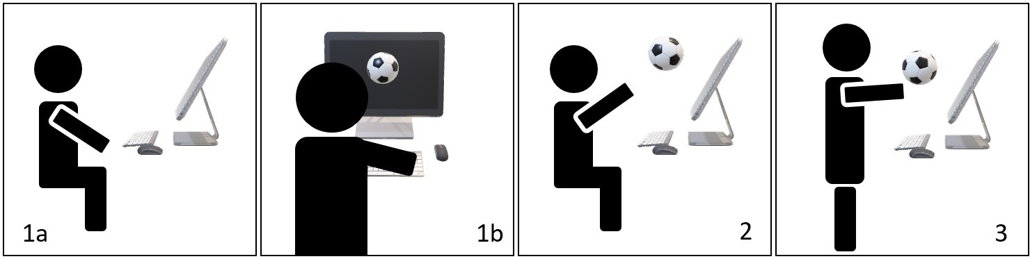

Figure 1: The wizard-of-oz approach is used in this study to create the illusion that Cross-Reality virtual object transition is triggered by interaction proposed by participants. This figure shows the task of a user transitioning a 3D virtual object from a computer monitor to AR space while sitting (1a and 2) or standing (1b and 3). 1a and 1b show the initial state of the task where a 3D virtual object is shown on the computer monitor. 2 and 3 show the ending state where a virtual object disappears from the computer monitor and is shown in AR space in front of the user.

ABSTRACT
The paper investigates how users want to transfer 3D virtual objects between a standard desktop monitor and an augmented reality head-mounted display setup during a Cross Reality session. An elicitation study with 20 participants was conducted to gather their preferred interactions and input modalities to select 3D virtual objects and trigger the transition. Participants were allowed to propose interactions belonging to various input modalities or a combination of interactions that utilize multiple input modalities. We labeled the observed data and analyzed the resulting 1200 input observations to derive a set of recommended interactions. We found that mid-air hand gestures Drag, Tap, and Grab were the most commonly proposed interactions and should be considered as the primary interaction for CR virtual objects transition assisted with other interactions and input modalities as the supplementary base on different user scenarios.

Permission to make digital or hard copies of all or part of this work for personal or classroom use is granted without fee provided that copies are not made or distributed for profit or commercial advantage and that copies bear this notice and the full citation on the first page. Copyrights for components of this work owned by others than the author(s) must be honored. Abstracting with credit is permitted. To copy otherwise, or republish, to post on servers or to redistribute to lists, requires prior specific permission and/or a fee. Request permissions from permissions@acm.org.
AVI 2024, June 03–07, 2024, Arenzano, Genoa, Italy
© 2024 Copyright held by the owner/author(s). Publication rights licensed to ACM.
ACM ISBN 979-8-4007-1764-2/24/06
https://doi.org/10.1145/3656650.3656698

CCS CONCEPTS
- Human-centered computing → User interface design; User centered design; Gestural input; Empirical studies in HCI; Mixed / augmented reality; Interaction techniques; User stud- ies.

KEYWORDS
Cross Reality, Elicitation Study, Augmented Reality, Mixed Reality
ACM Reference Format:
Nanjia Wang, Daniel Zielasko, and Frank Maurer. 2024. User Preferences for Interactive 3D Object Transitions in Cross Reality - An Elicitation Study. In International Conference on Advanced Visual Interfaces 2024 (AVI 2024), June 03–07, 2024, Arenzano, Genoa, Italy. ACM, New York, NY, USA, 9 pages. https://doi.org/10.1145/3656650.3656698

INTRODUCTION
In recent years an increasing number of researchers have started using benefits brought by systems that connect multiple stages on the reality-virtuality continuum (RVC) by design [22]. Cross Reality (CR) is a technology that seamlessly connects different stages on the RVC and is defined as a technology that supports transition between or concurrent usage of multiple systems on the RVC. CR is, for example, beneficial in data analysis, when part of the analysis workflow is more productive and effective with a standard monitor device (SMD), due to higher readability and increased ergonomics than in currently commercially available HMDs [29]. In addition, users can interact with SMD using input modalities they are famil- iar with, such as mouse, keyboard, and touchscreen. However, the

AVI 2024, June 03–07, 2024, Arenzano, Genoa, Italy Wang, et al.

SMD lacks stereoscopic presentation, leading to lower immersion and fewer depth cues [12, 32], are less engaging, and less intuitive when interacting with 3D virtual objects [28], all characteristics that might be beneficial in other steps of the analysis workflow. This is the reason why DeskVR was conceptualized [47], a scenario in which the display device had to be switched during the workflow. Modern video pass-through displays now enable an even smoother integration of different stages along the continuum. Next to the user transitioning between different stages of the RVC [13, 31], a central challenge of CR applications to be productive is finding effortless interactions for the transition of context and virtual objects be- tween stages [43]. Although researchers have been utilizing novel interaction techniques, such as head and body gesture interaction, eye gaze interaction, voice interaction, non-verbal vocal input, and brain-computer interfaces, Jankowski et al. state that novel input modalities will not replace the mouse, keyboards, and touchscreens as the major input modality for interacting with standard monitor devices [9, 17, 37, 46]. On the other hand, a review of interaction techniques for immersive environments done by Spittle et al. states that freehand interaction, gaze-based input, hardware-based input, and speech interaction occur most frequently in research using HMDs [38]. Although VR and AR HMDs both focus on providing natural and intuitive interaction, the most prevalent input modality varies slightly for those two stages. Anthes et al. state that con- trollers are the most widely utilized input devices for VR HMDs, followed by navigation and tracking technology [2]. Hand gesture interaction enabled by an optical hand tracker is the most common input modality for AR HMDs. When users are working with a CR application that support virtual object transition, they will interact with devices and interfaces that belong to at least two points along the RVC. Given the heterogeneity of devices and interaction, as pointed out above, picking the right subset is not a trivial task. The available CR transitions, for instance, are mostly based on technol- ogy capabilities, not user preference. Researchers and developers may utilize the input modality most commonly implemented in a space on the RVC to trigger the transition of the virtual object be- tween that space to another due to the easiness of implementation and other practical reasons. However, this may sacrifice usability and reduce user experience since previous elicitation studies point out that researchers and developers often have different concep- tual models than users. With this work, we aim to address this challenge in the context of object transitions in CR and raise the research question: How do users want to transfer 3D virtual objects between a standard monitor and an augmented re- ality head-mounted display during a Cross Reality session? We accomplish this by conducting wizard-of-oz elicitation studies inspired by Chopra et al. [8]. All participants sat or stood in front of a computer monitor during the study wearing Microsoft Hololens 2 (Figure 1). They could see the visual effect of virtual objects tran- sitioning between the computer monitor and Hololens 2 while the investigator was explaining the task. Participants also saw the vi- sual effect of transitioning while they made the proposal. However, the visual effect of transition is controlled by the investigator. Sec- tion 2 provides an overview of the existing studies and literature on the CR transition of virtual objects. Section 3 introduces the study’s design, including participants’ demographics, referents, and procedures. Section 4 presents the result of the study with an initial
analysis of the result. Finally, Section 5 further analyzes the result and discusses the insights we have found.

RELATED WORK
Elicitation studies are conducted to gain insights that contribute to user-centered design [5, 7, 8, 21]. They are a qualitative research method aimed at uncovering and documenting user experiences, perceptions, emotions, and opinions pertaining to VR/AR tech- nologies, applications, or content. They involve structured data collection techniques to elicit valuable insights from participants. These studies typically involve various data collection techniques such as interviews, surveys, observations, or think-aloud protocols. Current prototypes that support the transition of virtual objects from one reality to another are based on designers’ intuition. No elicitation study has been conducted to gather empirical data on users’ preferences for selecting and transitioning virtual objects along the RVC.

Cross Reality Transition of Virtual Objects
Researchers had the idea to bridge different points along the RVC to overcome the limitation of technologies at each point for decades. With the advancement of network and display technologies, there is an increased number of publications investigating the capability of CR. CR is the technology focusing on the transition between or concurrent usage of technologies on different points along the RVC. Wang et al. propose a design space for single-user CR applications stating that the transition of environment and transition of virtual objects are two essential subfields of CR [43].
The research idea of moving virtual objects from one point to another along the RVC was initially proposed and explored by Ki- jima and Ojika [19]. They built a prototype supporting the CAD model transition from an SMD workstation to a Projective Head Mounted Display (PHMD). Many researchers also investigate using AR devices to extend content displayed on SMD [20]. Riegler et al. and Wang et al. suggest that a user can benefit from CR applica- tions that support the transition of virtual objects [32, 42]. Roo et al. proposed OneReality, a six-level CR system in which the user can progressively transition from the physical space to the virtual space by incrementally increasing the immersion level [33]. The system focuses on the transition of environment, while the virtual objects in the system are created to associate with the real physi- cal object the user is interacting with at Level 0. The transition of the virtual object happens simultaneously with the transition of the environment’s immersion level. However, the paper does not cover the interactions that trigger the transition. Schwajda et al. proposed transformation initialization using mid-air hand gesture, target layout in 3D space, and transformation parameters as three influential areas to be considered to seamlessly transition infor- mation from a 2D display to AR [36]. In that study, when the user selects a visualization and pulls the controller away from the 2D display, a copy of the visualization will first spawn in AR space in a 2D form that aligns with the 2D visualization shown in the 2D display. Then the 2D visualization in AR space will transform into a 3D visualization. Benko et al. look into the transition of virtual content between standard monitor devices and HMDs. The tran- sition of virtual objects was triggered by multi-model interaction

combined with mid-air and on-screen gestures. In their system, those gestures were captured by a multi-touch surface and data gloves [6]. Cools proposed a CR prototype framework that allows users to transition virtual objects from desktop to AR space using bimanual and batched techniques. Both techniques utilize a mouse to select virtual objects on the desktop and hand gestures to mark position in AR space to trigger the transition of virtual objects from desktop to AR space. On the contrary, when transitioning virtual objects from AR space to the desktop, the user needs to use hand gestures to select the virtual object and then use the mouse to select a position on the desktop [10].

User Elicitation Studies
Many studies have investigated how end-users would prefer to interact with devices along the RVC using a single form of input modalities, such as a mouse and keyboard, on-screen or mid-air hand gestures, full body gestures, eye gazing, and brain-computer interface [7, 34]. Our study aims to elicit the user’s preference for transitioning 3D virtual objects between SMD and HMD with input modalities they can imagine. Multi-model refers to multiple input modalities users use to interact with computer systems. The wizard- of-oz technique is commonly utilized in multi-model elicitation studies [5, 21, 27]. A wizard-of-oz study is a research method where the experimenter simulates the functionality of a technology or system behind the scenes to create the illusion that an automated system is functioning as intended. This approach is commonly used to gather user feedback and test user interactions with a system before it is fully developed or automated.
Peshkova conducted an elicitation study on how users want to control UAVs using voice commands and gestures using a com- bination of wizard-of-oz study, online survey, and interview [30]. They use online surveys, video interviews, and in-person elicitation studies to conclude a set of gesture and voice interactions to control UVAs. Some multi-model elicitation studies collect the number of occurrences of users’ inputs as a result. Morris ran a wizard-of-oz elicitation on gesture and voice interaction to controlled TVs for web browsing [23]. He found that participants considered both ges- ture and voice to be effective for accomplishing the task. However, very few participants proposed multimodal interactions. Nebeling et al. reproduce the study designed by Morris and test the set of interactions concluded from the elicitation study results with a mul- timodal web browser they designed to compare the difference [27]. They found this method could be used to obtain reproducible and implementable user-defined interaction sets. Many multi-model elicitation studies use two ways of interaction and aim to find the way of interaction by asking users to pick which method they want to use for each referent [16, 30]. However, Chopra et al. looked into the overall preference between gestures and voice commands on all tasks [8]. Studies should include an extra step to check preference by asking users which input modalities they prefer. Kettebekov et al. conducted gestural elicitation but discussed the emergence of speech and multi-modal interaction [18]. Williams et al. investi- gated how users preferred manipulating virtual objects while wear- ing AR HMD using gesture and speech [44]. Tsandilas reviewed methods commonly used to assess consensus among proposals in gesture elicitation [39]. The agreement rate equation visited in
the review that is proposed by Findlater et al. was used to find consensus among proposals in this elicitation study [3, 4, 14, 15]. Villarreal-Narvaez et al. also conducted a systematic review of gesture elicitation studies and found that the average number of participants is 25 and the average number of referents is 20. The re- view also states that 51% of elicitation studies report the agreement rate proposed by Findlater et al [41].

ELICITATION STUDY
To answer our research question, how users prefer transitioning 3D virtual objects between an SMD and AR HMDs, an elicitation study was conducted. Our elicitation study is inspired by Wobbrock et al.’s elicitation methodology and Wizard of Oz experiments [11, 45]. Since there is no adequate evidence on which interaction techniques are more intuitive and effortless for CR virtual objects transition, our study participants could propose any interactions associated with any input modalities they could think of. Participants were encouraged to propose a combination of interactions associated with multiple input modalities if the proposals were considered intuitive and effortless.

Apparatus
Since the study investigates how users want to transition 3D virtual objects between the SMD and AR devices, we include an Acer T231H computer monitor as the SMD and a Microsoft Hololens 2 to display holographic contents in AR space. Holographic contents are virtual, graphical components that users can only see through the HMD. This study used twelve low-poly 3D virtual objects. All virtual objects are fully opaque and similar in size, but each one is different in shape and color. We used the wizard-of-oz approach to remove the gulf of execution so that the system accepts all inputs from participants no matter what input modality or combination of input modalities participants use to create the interaction inputs [11]. Each front-end component on the screen-based and holographic GUI was mapped to either the keyboard key or clickable button so that the researcher could use a mouse and keyboard to trigger the transition. Every time the user proposed an interaction for virtual objects transition, we manually triggered the transition so that it gave participants an illusion that the interaction they proposed triggered the transition successfully. The participants’ interactions and semi-structured interviews were video and audio-captured by two 1080p Logitech StreamCam mounted on two tripods from different angles.

Referents and Rounds
We derived a list of five scenarios based on prototypes proposed in previous studies and considered to be frequently implemented in CR applications that support virtual object transition, as listed in Table 1 [1, 32, 35, 36]. It is important to note that twenty combinations of tasks are derived since we want to investigate what interaction users prefer to perform for each scenario while they are sitting or standing and while they are transitioning one 3D virtual object from a group of 3D virtual objects or transitioning multiple 3D virtual objects within a group of 3D virtual objects. While the user’s posture is not at the center of our research questions, we do acknowledge

Table 1: All possible 20 combinations of tasks.

Referent # | Scenario | Body Position | # of Virtual Object Being Transitioned
1 | Move 3D virtual object(s) from standard monitor to AR space at a fixed position | Sitting   OR  Standing   |     1 out of 12 Virtual Object OR 3 out of 12 Virtual Object
2 | Move 3D virtual object(s) from standard monitor to AR space at a customized position
3 | Duplicate virtual object(s) from standard monitor to AR space
4 | Move 3D virtual object(s) from AR space back to standard monitor at a fixed position
5 | Move 3D virtual object(s) from AR space back to standard monitor at a customized position

that it potentially has a significant impact on how users interact [47]. Therefore, we put the participants in both scenarios.

Procedure
At the beginning of each session, participants were informed of the purpose of the study. Then, participants were primed with a short introduction to commercially available input modalities and technologies. The introduction included input modalities includ- ing but not limited to mouse and keyboard, voice, hand and body gesture, motion controller, and eye gaze. A list of input devices such as a mouse, keyboard, game controller, VR controller, voice capture device, and gesture capture device was also shown to in- crease affordance in front of the participants. Participants were taught how to use the devices. Those input devices remained in front of participants during the study for affordance. Participants were informed that they could design special input devices using the rubber, stylus, or any input devices shown on the desk. Par- ticipants were encouraged to propose interactions based on input modalities introduced by the researcher or any input modalities they could imagine as long as the interaction they proposed was convenient and effective. They were also informed that they could propose interactions that combine multiple input modalities. Fi- nally, they also were encouraged to propose any interaction they could imagine or had seen in science fiction movies.
Participants were fitted with the headset to ensure they were comfortable and that all 3D virtual objects were visible. Participants were told they were working with 3D virtual objects on the stan- dard monitor using a mouse and keyboard. Participants were then presented with a list of five referents shown in Table 1 with four different combinations of conditions. Participants first worked on referent one, and the rest were done in random order for all condi- tions since referent one is considered the base case. Four referents are followed by the referent one, and the permutation equals 24 (Table 1). Thus, each participant proposed tasks two to four in all conditions in a unique order.
At the beginning of each referent, the investigator describes the details of the scenario with a demonstration of the transition. After participants proposed three interactions for each referent, they were asked to rank their proposals based on their preferences. We asked participants to propose three interactions for each referent because it is a typical number used by elicitation studies when applying the production techniques to reduce legacy bias [25]. Participants were allowed to ask any clarification questions. After completing all 20 tasks, we conducted semi-structured interviews to collect feedback on participants’ experiences and potential use cases. At the end of the study, participants were asked to fill out a questionnaire regard- ing their age, educational/occupational background, and previous experience with computers, HMD, and interaction techniques.

Participants
Twenty-four volunteers participated in the main study based on the permutation of referent order. Four participants were dropped due to technical and recording issues. Ten participants were female, 9 participants were male, and 1 participant classified themselves as non-binary. Participants were recruited using website advertise- ments, email lists, word of mouth, and snowball sampling. Twelve participants were in the age range of 18 to 25, 3 participants were in the age range of 26 to 30, 4 participants were in the age range from 31 to 35, and 1 participant was in the age range above 40. Ten participants came from a Computer Science or Software Engineer- ing background, and others from Chemical Engineering, Petroleum Engineering, Health Science, and Business. All participants use a computer with a traditional mouse and keyboard daily, and 16 out of 20 participants spend 5 to 10 hours daily interacting with com- puters. The majority of participants have some level of experience with game controllers, VR/AR devices, multi-touch interaction, and voice interaction. However more than half of the participants have no experience with mid-air gesture interaction, and most have no experience with eye gaze input. 75 percent of participants have experience with game controllers, and 80 percent have experience in VR.

RESULT AND ANALYSIS

Analysis
Proposals made by 20 participants were recorded, and each partici- pant was asked to propose three interactions for each referent. As a result, we collected 1200 interactions (20 participants x 20 referents x 3 proposals). All 1200 interaction inputs with participants’ voice descriptions were recorded on video. We used open coding inspired by grounded theory to create labels for input modalities and inter- actions by watching the video and audio recordings several times [26]. We identified key recurring behaviors. We developed two sets of codes, one focusing on input modalities and the other focusing on interactions in one input modality or combination of multiple input modalities.
For each proposal made by participants, we record every unique atomic interaction to remove the side effects caused by an atomic in- teraction being used multiple times within a single proposal. A final set of atomic interactions was generated that contains all unique atomic interactions that may or may not be repeated. The number of occurrences of each unique atomic interaction was also recorded. A set of input modalities was also generated using a similar approach by adding and counting each unique input modality proposed by each participant for a single referent. For example, a participant was asked to transition three virtual objects from the computer monitor to AR space. The participant "used the index finger of the

right hand to tap on three virtual objects one by one and then drag them to the AR space." The unique atomic interactions extracted from the proposal are Tap and Drag. Although Tap was used three times in the proposal, the occurrences of both Tap and Drag in the proposed interaction were one.
The study aims to find the consensus between users or con- sistency among the interaction method users proposed on each referent. After counting the number of occurrences of each elicited interaction for all referents, the overall agreement rate among all proposals of a referent was calculated using the equation proposed by Vatavu and Wobbrock to determine the level of consensus among proposals (Equation 1) [40]. In this equation, P is the set of all atomic interactions being proposed for referent r, |𝑃 | is the size of the set,
𝑃𝑖 is subsets of identical atomic interactions from P, and |𝑃𝑖 | is the size of the subset. Compared with the agreement rate used by Chen et al. and Chopra et al., this modified agreement rate determines the consensus among all proposed atomic interactions and input modalities instead of the one proposed by most participants. This agreement calculation method also accounts for the possibility of 0 agreement, where no one agrees with others.

∑︁ 1 |𝑃𝑖 | (|𝑃𝑖 | − 1)
Table 3: Result table of the top-ranked consensus atomic interaction set, top-ranked consensus input modality set, and overall agreement rate for all referents. This table only contains atomic interactions from the proposal ranked first by each participant for each referent.

Referent # | Top | Ranked Interaction | Top Ranked | Input Modality | Scenario
 | Overall AR | Consensus Set | Overall AR | Consensus Set
1 | 0.298 | Grab, Drag | 0.495 | HG | 
2 | 0.235 | Drag, Grab, Tap | 0.597 | HG
3 | 0.106 | Tap, Grab, Drag | 0.364 | HG
4 | 0.189 | Grab, Throw, Voice | 0.584 | HG
5 | 0.276 | Drag, Grab, Tap | 0.662 | HG
6 | 0.168 | Tap, Voice, Drag, Grab | 0.426 | HG, VE | 
7 | 0.206 | Drag, Grab, Tap, Voice | 0.503 | HG
8 | 0.196 | Tap, Voice, Grab | 0.46 | HG, VE
9 | 0.119 | Throw, Grab, Swipe | 0.642 | HG
10 | 0.221 | Drag, Grab, Tap | 0.617 | HG
11 | 0.155 | Tap, Drag, Voice | 0.429 | HG | 
12 | 0.195 | Drag, Grab, Tap | 0.561 | HG
13 | 0.113 | Tap, Voice, Select, Press button | 0.295 | HG
14 | 0.117 | Grab, Throw, Voice, Swipe | 0.424 | HG
15 | 0.175 | Drag, Grab, Tap | 0.733 | HG
16 | 0.204 | Tap, Voice, Grab | 0.526 | HG | 
17 | 0.203 | Drag, Grab, Tap | 0.547 | HG
18 | 0.131 | Voice, Tap, Drag, Circle | 0.356 | HG, VE
19 | 0.133 | Throw, Grab, Tap, Voice | 0.395 | HG
20 | 0.194 | Drag, Grab, Tap | 0.819 | HG

Table 2: Result table of consensus atomic interaction set, consensus input modality set, and overall agreement rate for

2
𝑃 ⫅𝑃
(1)
all referents. Both input modalities and input modalities are

AR =
𝑖
1 |𝑃 | (|𝑃 | − 1)
2
ranked by the frequency they are proposed in descending order. Most frequently proposed are bold. (Note: HG: Hand gesture, VE: Voice, MC: Motion controller)

Another essential goal of this study is establishing a consen- sus interaction set. In this study, the interactions that pass the consensus threshold were also identified and could be considered supplemental interactions. Morris et al. initially proposed The term consensus threshold when they introduced the consensus-distinct ratio to calculate the percent of the distinct proposals made for each referent [24]. To determine the set of consensus atomic interactions for each referent, we redefine the consensus threshold to be the av- erage occurrence of each distinct atomic interaction in the final set (Equation 2). In this equation, P is the set of all atomic interactions for referent r, |𝑃 | is the size of the set, 𝑈 is the set of unique atomic interactions for referent r, and |𝑈 | is the size of the set.
Referent # |  | Interaction | Input | Modality | Scenario
 | Overall AR | Consensus Set | Overall AR | Consensus Set
1 | 0.136 | Drag, Grab, Select, Tap | 0.305 | HG | 
2 | 0.176 | Drag, Grab, Select, Tap | 0.289 | HG
3 | 0.141 | Tap, Select, Press button, Grab, Drag | 0.31 | HG
4 | 0.112 | Grab, Throw, Tap, Select, Voice, Drag | 0.372 | HG
5 | 0.16 | Drag, Grab, Tap, Select | 0.346 | HG
6 | 0.158 | Tap, Drag, Select, Grab, Voice | 0.379 | HG | 
7 | 0.159 | Drag, Grab, Tap, Select, Voice | 0.375 | HG
8 | 0.155 | Tap, Voice, Grab, Select, Drag | 0.377 | HG, VE
9 | 0.109 | Throw, Grab, Tap, Voice, Select, Drag, Swipe | 0.405 | HG
10 | 0.17 | Drag, Grab, Select, Tap | 0.378 | HG, MC
11 | 0.125 | Drag, Tap, Select, Voice, Grab | 0.301 | HG | 
12 | 0.174 | Drag, Tap, Grab, Select | 0.357 | HG
13 | 0.12 | Tap, Voice, Select, Press button, Drag, Circle, Grab | 0.31 | HG, VE
14 | 0.105 | Grab, Throw, Voice, Tap | 0.402 | HG
15 | 0.153 | Drag, Grab, Tap, Select, Voice | 0.39 | HG
16 | 0.146 | Tap, Voice, Drag, Grab, Select | 0.337 | HG, VE | 
17 | 0.177 | Drag, Grab, Tap, Voice, Circle, Select | 0.491 | HG
18 | 0.121 | Tap, Voice, Select, Press button, Drag, Circle | 0.333 | HG, VE
19 | 0.133 | Throw, Grab, Voice, Tap, Swipe | 0.424 | HG, VE
20 | 0.16 | Drag, Tap, Grab, Select, Voice | 0.479 | HG

Result
𝐶𝑜𝑛𝑠𝑒𝑛𝑠𝑢𝑠𝑇ℎ𝑟𝑒𝑠ℎ𝑜𝑙𝑑 = |𝑈 |
|𝑃 |

(2)
We also analyzed the atomic interactions and input modalities ranked top by each participant on each referent using the same method. Based on the margin proposed by Vatavu and Webbrock, The participants have a medium overall agreement rate on top-

Vatavu and Webbrock recalculated the agreement rate using Equa- tion 1 on 18 previous studies and defined margins for interpreting the magnitude of the overall agreement [40]. The margin proposed by Vatavu and Webbrock indicates that in our study, participants have a medium overall agreement on proposed atomic interactions and a medium to a high overall agreement on proposed input modal- ities for each referent (Table 2). The analysis resulted in overall agreement rates that were high enough to conclude an atomic inter- action set. We created a table containing sets of consensus atomic interactions, input modality, and over-agreement rate for all 20 referents. All atomic interactions and input modalities that passed the consensus threshold were recorded in the table.
ranked favorite interactions and high to very high agreement on top-ranked input modalities for all referents (Table 3) [40].

DISCUSSION AND DESIGN RECOMMENDATIONS
The CR transition of virtual objects usually involves selecting the virtual object and triggering the transition. Thus, participants usu- ally need to make a proposal consisting of multiple atomic interac- tions to accomplish the task. In addition, the overall agreement rate of an open elicitation study tends to be lower since participants do not have any constraints on the proposal they make. Due to these two reasons, we decided to record all atomic interactions that pass

AVI 2024, June 03–07, 2024, Arenzano, Genoa, Italy Wang, et al.

the consensus threshold in the consensus set even though the over- all agreement rate of proposed atomic interaction and top-ranked atomic interaction falls into the medium agreement interval (Table 2 and 3).

Primary Input Modality
Based on the analysis results, we can conclude that hand gesture is the most natural and effective input modality for transitioning 3D virtual objects between computer monitors and XR spaces since it is the most proposed input modality for all referents with very high agreement on average. This finding aligns with the CR prototype proposed by David et al., where hand gesture is used to transition heart visualization from a large multi-touch display to AR space [1]. Based on the feedback we collected during the study, users prefer to use hand gestures in most cases. As commented by one participant," I like using hand gesture [over controller] since it’s convenient and intuitive." Another participant commented, "...if originally working with mouse and keyboard, I don’t want to pick up another device, I just want to make my hand stay free." Across all referents, we observed that most participants (60% to 96%) proposed hand gesture interaction first among all three proposals, indicating that hand gestures are an intuitive input modality for the CR virtual object transition. Since 80 percent of participants have experienced VR technologies, legacy bias could potentially influence the result. However, over half of the participants have never experienced mid- air hand gestures, indicating limited influence on consensus input modality from legacy bias. Based on data analysis and observation, we suggest hand gestures should be considered the primary input modality for CR applications supporting the transition of 3D virtual objects.
Inspired by the prototype proposed by Cools et al., we thought the Traditional Controller, such as mouse and keyboard, could be used as a supplementary input modality. Since all participants use the mouse and keyboard daily for five to ten hours, we thought this legacy bias might make participants who sat in front of the monitor with a keyboard and mouse within arm’s reach tend to include them as part of the proposal. Surprisingly, the Traditional Controller did not pass the consensus threshold for any referents, even those referents while participants sat.

Primary Atomic Interaction Set
Drag, Tap, and Grab are the three most commonly seen atomic interactions in Table 2 and Table 3 across all referents. Tap and Grab are two hand gestures that were frequently used to select the virtual object at the initial stage of the CR transition. However, Tap could also terminate the CR transition. For example, when participants were asked to transition the virtual object from AR space to a customized position on the standard monitor, some par- ticipants terminated the transition by tapping a specific position on the monitor. Drag is the highest occurrence interaction overall since Drag is an interaction belonging to input modalities such as hand gesture, traditional controller, and motion controller input modality. The hand gesture Drag was usually used after partici- pants selected the virtual object using Grab or Tap to move the virtual object and execute the CR transition. Since Drag, Tap, and Grab are most commonly proposed and always ranked top among
atomic interactions, we suggest Drag combined with Tap or Grab should be considered as the primary interaction for CR applications supporting the transition of 3D virtual objects.
The importance of supplemental atomic interactions is not neg- ligible. From Table 2, we can see many atomic interactions other than primary atomic interactions, such as Select, Throw, Voice, Circle, Swipe, and Press Button. These atomic interactions can be combined with three primary atomic interactions discussed in the paragraph in specific postures or scenarios to make the transition of 3D virtual objects between SMD and AR spaces more efficient and effective.

Interaction for Sitting and Standing
Voice was more frequently proposed when participants stood away from the monitor. Voice was included in the consensus atomic in- teraction set in 9 out of 10 referents where participants stood. From observation and interview, we found that participants tend to select 3D virtual objects using Voice by calling the name of virtual objects since they consider it more convenient and precise than using a motion controller or hand gesture. However, some participants were concerned about the extra effort to remember all names or codes of virtual objects that stored in the system to select virtual objects using voice commands. In most proposals that involve using voice commands to select virtual objects, a keyword such as "select" and the name of the virtual objects are always included. Typical examples are "Select A, B, C" or "A, B, C," where "A," "B," and "C" represent the names of the virtual objects. Some participants also mentioned that triggering transition while standing using Voice is more effortless since the user would not need to hold any devices or walk toward the monitor. However, Voice was proposed to trigger the transition to a fixed position on SMD or AR spaces because participants thought "it is very hard to use voice to define a cus- tomized position." For referents that ask participants to transition the virtual object(s) from the standard monitor to a fixed position in AR space, the keyword "out" occurs most frequently. For referents that ask participants to transition the virtual object(s) from the AR space to a fixed position on the standard monitor, voice command has a low level of convergence. Participants used "Back," "Return," "Clear," "Go," "Put," "Monitor," "Screen," and "Inside" as part of their voice commands.
Select is defined as using a cursor or pointer aiming at a 3D virtual object, then pressing the button or pulling the trigger to choose it. Most Select was done on the motion controller (17 out of 20) instead of the traditional controller, such as a mouse or game controller with the joystick. While standing, the occurrence of the motion controller is higher than the traditional controller in all ten referents. While sitting, participants picked the traditional controller over the motion controller only in 3 referents (referents 3, 11, and 13). This indicates that Select using a motion controller could be considered a supplemental interaction whether the user is sitting or standing. We expected more participants to propose Select using the mouse while they sat close to the monitor since all participants interacted with a PC or laptop daily for 5 to 10 hours. We think the fact that 80 percent of participants have experienced VR, in which motion controllers are most commonly used, might have offset the influence of daily computer usage.

We suggest in the tasks where the user stands away from com- puter monitors, developers could combine voice commands or mo- tion controllers with hand gesture Drag to transition 3D virtual objects between SMD and AR space. The developer could also uti- lize voice commands to trigger transition while the user sits in front of the monitor, either combining with voice commands, Grab, or Tap for object selection.

Transitioning 3D virtual objects to monitor
The hand gesture Throw is the most proposed atomic interaction and the most proposed favorite atomic interaction for Referents 4, 9, 14, and 19, which covers all tasks that asked participants to select 1 or 3 out of 12 virtual objects and transition them from AR space to the standard monitor at a fixed position while standing. No matter what interaction participants used, the virtual object(s) always disappeared from AR spaces and appeared on the monitor at a fixed position. This means participants would not need to define the ending position precisely. In addition, "Throw" is included in the list of supplemental atomic interaction and supplemental atomic top-ranked interaction for tasks 4 and 14, which were tasks that asked participants to select 1 or 3 out of 12 virtual objects and transition them from AR space to the standard monitor at a fixed position while sitting. This evidence suggests that Throw should be considered part of the primary interaction for transitioning virtual objects from HMD to the monitor to a fixed position. Using Throw is intuitive since the user could refer to actions such as throwing objects into bins in the physical world. It is also effortless since the user would not need to approach the monitor or point at a position on it using the peripheral device or virtual assistance such as a computer-generated ray pointer. Since Throw is the gesture that only triggers the transition, it needs to be combined with either Grab or Tap to be a complete interaction for CR virtual object transition.
Like Throw, Swipe is a hand gesture included in the list of sup- plemental atomic interactions and top-ranked atomic interactions for tasks 9 and 19, where participants were asked to transition a group of 3D virtual objects from AR space to SMD. Although Swipe was not proposed as frequently compared with Throw, some partic- ipants found this hand gesture intuitive to transition virtual objects back to the monitor. One participant thought, Swipe is similar to wiping the board, and I think all virtual object(s) in front of me will be cleared [in AR space] and go back to the monitor if I swipe once." Throw is a hand gesture that needs to be combined with Tap or Grab. When multiple virtual objects need to be transitioned from the AR space to the monitor, the user could select all of them and Throw once or Throw virtual objects back to the monitor individually. In comparison, some participants consider Swipe to be a hand gesture that reset the AR space. Thus, Swipe could be used specifically to transition all virtual objects to monitor at once since this single hand gesture is more effortless compared with performing Tap or Grab with Throw multiple times.

Grouping
A grouping method could make the whole process more efficient when transitioning a group of 3D virtual objects between SMD and AR space. Although Swipe discussed in the previous paragraph is
a good example, it only applies to a very specific scenario. Most participants proposed atomic interactions such as Tap, Grab, Voice, and Select to highlight 3D virtual objects one by one as the method of grouping before triggering the transition. Circle is within atomic interaction consensus set for only 3 out of 10 referents involving grouping. However, we suggest that the developer consider using Circle as a mid-air or on-screen gesture when grouping is needed since it groups multiple virtual objects by performing the gesture only once, which we think is more efficient.

Duplication
Duplication is another type of task that might need special supple- mental atomic interaction since the user may be unable to refer to intuitive and natural interaction to duplicate in the physical world. Thus, participants propose interaction based on their previ- ous experience making duplicates in other computing systems. As a result, the traditional controller became the only input modality that passed the consensus threshold for Referent 3. In addition, Select and Press Button passed the consensus threshold as a supplemental atomic interaction for Referents 3, 8, 13, and 18. These referents re- quired participants to duplicate virtual object(s) from the standard monitor to the AR space. Participants made proposals while sitting for Referents 3 and 13 and standing for Referents 8 and 18. It is also essential to note that more participants proposed the traditional controller than the motion controller for Referents 3 and 13. Con- cluding from the data and observation, the combination of Select and Press Button with mouse and keyboard could be considered as supplemental interaction for duplication while sitting in front of the monitor. While sitting close to the monitor, Select is achieved using the mouse cursor, while Press Button could be achieved by pressing a virtual button on GUI utilizing the mouse or pressing physical keyboard buttons as a shortcut. In contrast, while users are standing, which is further away from the monitor, Select and Press Button should be considered as supplemental interaction with the motion controller, such as the VR controller. Select is achieved by pointing the ray pointer of the controller to the virtual object(s) and pulling the trigger. While Press Button could be achieved by using the VR controller to select a virtual button on a GUI in AR space or pressing a physical button designated for duplication on the controller. We observed that sometimes, when participants use the motion controller to duplicate the virtual object(s), the order of proposing Select and Press Button is reversed. Some participants chose to Press Button and enter the "Duplication Mode" and then Select virtual object(s). Those participants expect virtual object(s) to be selected after entering the duplication mode automatically duplicated, and the duplicate would appear in the AR space.
Voice could also be used in duplication tasks. Voice could be used solely for completing duplication of 3D virtual objects from monitor to AR space. The developer could use the voice command mentioned previously for object selection with a voice command that triggers the transition. For referents that ask participants to duplicate the virtual object(s) from the standard monitor to the AR space, the keywords "copy," "duplicate," and "clone" were proposed frequently. Since those three words share a similar meaning, the designer could use those as a part of a supplemental interaction for CR duplication.

Monomodality or Multimodality Interaction
From the data, we observed that 1.7% to 25% of proposals included interactions belonging to more than one input modality for each referent. An average of 11.3% of proposals had interactions with more than one input modality for each referent, with a standard deviation of 6.3%. The data indicate that the majority of participants prefer transitioning virtual objects between the standard monitor and AR space using interactions belonging to one input modality. Although at the beginning of the study, participants were informed that they were allowed to make proposals containing atomic inter- actions belonging to multiple input modalities, participants might forget multimodal interaction as an available option since some participants explicitly asked during the study if they were allowed to combine interactions from more than one input modality.
More monomodal interactions were proposed for simple tran- sition tasks, such as the transition of one virtual object between SMD and AR space. However, more participants proposed multi- modal interaction when they stood or were asked to transition multiple virtual objects. Some participants were concerned about the accuracy of hand gestures and motion controllers when they selected the virtual objects or a specific position on the SMD and suggested that voice could make the selection more reliable from a distance. However, many participants who proposed voice found it hard to define a customized position in the AR space. These feedbacks indicate that utilizing multimodal interaction in some CR transition scenarios has promising potential since it can offset drawbacks brought by monomodal interactions and offer users a more seamless transition.

LIMITATION
Our study has some limitations. First, participants were asked to propose three interactions for each referent, which generated addi- tional disagreement and potentially led to a low overall agreement rate using Equation 1. This indicates the consensus we found among participants is conservative. In addition, we focused on collecting quantitative data, which was then used for data analysis. Although quantitative data provides strong evidence to support our results, collecting more qualitative data, such as why participants prefer one interaction over the other when ranking them, is valuable. Some participants shared their reasoning on ranking preference, which was helpful supplementary evidence and can be used with data and observation to justify our findings and discussion.
Legacy bias may introduce a significant effect on elicitation results[7]. In this study, we utilized two of Morris et al.’s proposed techniques to reduce legacy bias: priming and production [25]. The technique we opted out of is pairing. Pairing is a technique that encourages multiple participants to collaborate on proposing interactions together. This could decrease the probability that par- ticipants make a proposal only based on their unique experiences. However, if one participant in the pairing group dominates the con- version, the proposals can also be biased toward the understanding of the dominant participant. Another drawback of pairing is it will significantly increase the time for each proposal since participants need to discuss and convince each other before proposing.

CONCLUSION
In this elicitation study, we defined five key tasks of single-user CR transition of virtual objects and derived 20 referents. A study was conducted with 20 participants who were video and audio captured while they proposed interactions for each task. Partici- pants were generally excited about the work and expected to try more CR prototypes in the near future. The elicitation data was analyzed through an open-coding approach. A quantitative analy- sis was performed on atomic interaction participants proposed for each referent to measure user preference. An agreement rate was calculated for each referent on the most proposed interaction, the most proposed input modality, the most proposed favorite interac- tion, and the most proposed favorite input modality. The consensus threshold was also calculated to define each referent’s supplemen- tal interaction and input modality. Finally, the quantitative results were further discussed to derive a set of guidelines for designing interaction to execute the virtual object(s) transition between the standard monitor and AR HMDs. The guideline also applies to CR applications transitioning between the standard monitor and VR HMDs supporting video pass-through.

REFERENCES
- David Aigner, Nanjia Wang, David Kielmayer, Jurgen Steiner, Julian Hochpochler, Christoph Heinzl, Daniel Roth, Frank Maurer, and Christoph Anthes. 2023. Car- diac Visualisation Along the RV-Continuum – A High-Fidelity Pilot Study. In 1st Joint Workshop on Cross Reality at IEEE International Symposium on Mixed and Augmented Reality (ISMAR).
- Christoph Anthes, Rubén Jesús García-Hernández, Markus Wiedemann, and Dieter Kranzlmüller. 2016. State of the art of virtual reality technology. In 2016 IEEE Aerospace Conference. 1–19. https://doi.org/10.1109/AERO.2016.7500674
- Christopher R. Austin, Barrett Ens, Kadek Ananta Satriadi, and Bernhard Jenny. 2020. Elicitation study investigating hand and foot gesture interaction for im- mersive maps in augmented reality. Cartography and Geographic Information Science 47, 3 (2020), 214–228. https://doi.org/10.1080/15230406.2019.1696232
arXiv:https://doi.org/10.1080/15230406.2019.1696232
- Patrick Bader, Huy Viet Le, Julian Strotzer, and Niels Henze. 2017. Exploring Interactions with Smart Windows for Sunlight Control (CHI EA ’17). Association for Computing Machinery, New York, NY, USA, 2373–2380. https://doi.org/10. 1145/3027063.3053242
- Ceylan Beşevli, Oğuz Turan Buruk, Merve Erkaya, and Oğuzhan Özcan. 2018. Investigating the Effects of Legacy Bias: User Elicited Gestures from the End Users Perspective (DIS ’18 Companion). Association for Computing Machinery,
New York, NY, USA, 277–281. https://doi.org/10.1145/3197391.3205449
- H. Benko, E.W. Ishak, and S. Feiner. 2005. Cross-dimensional gestural interaction techniques for hybrid immersive environments. In IEEE Proceedings. VR 2005.
Virtual Reality, 2005. 209–216. https://doi.org/10.1109/VR.2005.1492776
- Edwin Chan, Teddy Seyed, Wolfgang Stuerzlinger, Xing-Dong Yang, and Frank Maurer. 2016. User Elicitation on Single-Hand Microgestures. In Proceedings of the 2016 CHI Conference on Human Factors in Computing Systems (San Jose, California, USA) (CHI ’16). Association for Computing Machinery, New York, NY,
USA, 3403–3414. https://doi.org/10.1145/2858036.2858589
- Shreya Chopra and Frank Maurer. 2020. Evaluating User Preferences for Aug- mented Reality Interactions with the Internet of Things. In Proceedings of the International Conference on Advanced Visual Interfaces (Salerno, Italy) (AVI ’20). Association for Computing Machinery, New York, NY, USA, Article 20, 9 pages. https://doi.org/10.1145/3399715.3399716
- Leigh Clark, Philip Doyle, Diego Garaialde, Emer Gilmartin, Stephan Schlögl, Jens Edlund, Matthew Aylett, João Cabral, Cosmin Munteanu, Justin Ed- wards, and Benjamin R Cowan. 2019. The State of Speech in HCI: Trends, Themes and Challenges. Interacting with Computers 31, 4 (09 2019), 349–371. https://doi.org/10.1093/iwc/iwz016 arXiv:https://academic.oup.com/iwc/article- pdf/31/4/349/33525046/iwz016.pdf
- Robbe Cools, Matt Gottsacker, Adalberto Simeone, Gerd Bruder, Greg Welch, and Steven Feiner. 2022. Towards a Desktop-AR Prototyping Framework: Prototyping Cross-Reality Between Desktops and Augmented Reality. In 2022 IEEE Interna- tional Symposium on Mixed and Augmented Reality Adjunct (ISMAR-Adjunct). 175–182. https://doi.org/10.1109/ISMAR-Adjunct57072.2022.00040
- Nils Dahlbäck, Arne Jönsson, and Lars Ahrenberg. 1993. Wizard of Oz studies: why and how. In Proceedings of the 1st international conference on Intelligent user

interfaces. 193–200.
- Niklas Elmqvist, Andrew Vande Moere, Hans-Christian Jetter, Daniel Cernea, Harald Reiterer, and TJ Jankun-Kelly. 2011. Fluid interaction for information visualization. Information Visualization 10, 4 (2011), 327–340. https://doi.org/10. 1177/1473871611413180 arXiv:https://doi.org/10.1177/1473871611413180
- Nico Feld, Pauline Bimberg, Benjamin Weyers, and Daniel Zielasko. 2023. Keep it simple? Evaluation of Transitions in Virtual Reality. Proc. of ACM CHI Conference Extended Abstracts on Human Factors in Computing Systems (2023). https://doi. org/10.1145/3544549.3585811
- Leah Findlater, Ben Lee, and Jacob Wobbrock. 2012. Beyond QWERTY: Augment- ing Touch Screen Keyboards with Multi-Touch Gestures for Non-Alphanumeric Input. In Proceedings of the SIGCHI Conference on Human Factors in Computing Systems (Austin, Texas, USA) (CHI ’12). Association for Computing Machinery,
New York, NY, USA, 2679–2682. https://doi.org/10.1145/2207676.2208660
- Glebys Gonzalez, Naveen Madapana, Rahul Taneja, Lingsong Zhang, Richard Rodgers, and Juan P. Wachs. 2018. Looking Beyond the Gesture: Vocabulary Acceptability Criteria for Gesture Elicitation Studies. Proceedings of the Human Factors and Ergonomics Society Annual Meeting 62, 1 (2018), 997–1001. https://doi. org/10.1177/1541931218621230 arXiv:https://doi.org/10.1177/1541931218621230
- A. G. Hauptmann. 1989. Speech and Gestures for Graphic Image Manipulation.
SIGCHI Bull. 20, SI (mar 1989), 241–245. https://doi.org/10.1145/67450.67496
- Jacek Jankowski and Martin Hachet. 2013. A Survey of Interaction Techniques for Interactive 3D Environments. In Eurographics 2013 - State of the Art Reports,
M. Sbert and L. Szirmay-Kalos (Eds.). The Eurographics Association. https:
//doi.org/10.2312/conf/EG2013/stars/065-093
- Sanshzar Kettebekov and Rajeev Sharma. 2001. Toward Natural Gesture/Speech Control of a Large Display. In Proceedings of the 8th IFIP International Confer- ence on Engineering for Human-Computer Interaction (EHCI ’01). Springer-Verlag, Berlin, Heidelberg, 221–234.
- Ryugo Kijima and Takeo Ojika. 1997. Transition between virtual environment and workstation environment with projective head mounted display. Proceedings of IEEE 1997 Annual International Symposium on Virtual Reality (1997), 130–137.
- Ricardo Langner, Marc Satkowski, Wolfgang Büschel, and Raimund Dachselt. 2021. MARVIS: Combining Mobile Devices and Augmented Reality for Visual Data Analysis. In Proceedings of the 2021 ACM Conference on Human Factors in Computing Systems (Yokohama, Japan). ACM, New York, NY, USA, 17 pages. https://doi.org/10.1145/3411764.3445593
- Sang-Su Lee, Jeonghun Chae, Hyunjeong Kim, Youn-kyung Lim, and Kun-pyo Lee. 2013. Towards More Natural Digital Content Manipulation via User Freehand Ges- tural Interaction in a Living Room (UbiComp ’13). Association for Computing Ma- chinery, New York, NY, USA, 617–626. https://doi.org/10.1145/2493432.2493480
- Paul Milgram, Haruo Takemura, Akira Utsumi, and Fumio Kishino. 1994. Aug- mented reality: A class of displays on the reality-virtuality continuum. Telema- nipulator and Telepresence Technologies 2351 (January 1994). https://doi.org/10. 1117/12.197321
- Meredith Ringel Morris. 2012. Web on the Wall: Insights from a Multimodal Interaction Elicitation Study. In Proceedings of the 2012 ACM International Con- ference on Interactive Tabletops and Surfaces (Cambridge, Massachusetts, USA) (ITS ’12). Association for Computing Machinery, New York, NY, USA, 95–104. https://doi.org/10.1145/2396636.2396651
- Meredith Ringel Morris. 2012. Web on the Wall: Insights from a Multimodal Interaction Elicitation Study. In Proceedings of the 2012 ACM International Con- ference on Interactive Tabletops and Surfaces (Cambridge, Massachusetts, USA) (ITS ’12). Association for Computing Machinery, New York, NY, USA, 95–104. https://doi.org/10.1145/2396636.2396651
- Meredith Ringel Morris, Andreea Danielescu, Steven Drucker, Danyel Fisher, Bongshin Lee, m. c. schraefel, and Jacob O. Wobbrock. 2014. Reducing Legacy Bias in Gesture Elicitation Studies. Interactions 21, 3 (may 2014), 40–45. https:
//doi.org/10.1145/2591689
- Michael Muller. 2012. Grounded Theory Methods. https://mixed-news.com/en/ how-bad-is-the-video-passthrough-on-the-quest-pro/
- Michael Nebeling, Alexander Huber, David Ott, and Moira C. Norrie. 2014. Web on the Wall Reloaded: Implementation, Replication and Refinement of User-Defined Interaction Sets. In Proceedings of the Ninth ACM International Conference on Interactive Tabletops and Surfaces (Dresden, Germany) (ITS ’14). Association for Computing Machinery, New York, NY, USA, 15–24. https://doi.org/10.1145/ 2669485.2669497
- Tao Ni, G.S. Schmidt, O.G. Staadt, M.A. Livingston, R. Ball, and R. May. 2006. A Survey of Large High-Resolution Display Technologies, Techniques, and Applications. In IEEE Virtual Reality Conference (VR 2006). 223–236. https:
//doi.org/10.1109/VR.2006.20
- Leonardo Pavanatto, Chris North, Doug A. Bowman, Carmen Badea, and Richard Stoakley. 2021. Do we still need physical monitors? An evaluation of the usability of AR virtual monitors for productivity work. In 2021 IEEE Virtual Reality and 3D User Interfaces (VR). 759–767. https://doi.org/10.1109/VR50410.2021.00103
- Ekaterina Peshkova, Martin Hitz, and David Ahlström. 2017. Exploring User- Defined Gestures and Voice Commands to Control an Unmanned Aerial Vehicle. In Intelligent Technologies for Interactive Entertainment, Vol. 178. Springer. https:
//doi.org/10.1007/978-3-319-49616-0_5
- Fabian Pointecker, Judith Friedl, Daniel Schwajda, Hans-Christian Jetter, and Christoph Anthes. 2022. Bridging the Gap Across Realities: Visual Transitions Between Virtual and Augmented Reality. In 2022 IEEE International Symposium on Mixed and Augmented Reality (ISMAR). 827–836. https://doi.org/10.1109/ ISMAR55827.2022.00101
- Andreas Riegler, Christoph Anthes, Hans-Christian Jetter, Christoph Heinzl, Clemens Holzmann, Herbert Jodlbauer, Manuel Brunner, Stefan Auer, Judith Friedl, Bernhard Fröhler, Christina Leitner, Fabian Pointecker, Daniel Schwajda, and Shailesh Tripathi. 2020. Cross-Virtuality Visualization, Interaction and Collaboration. In Proceedings of the 1st ACM International Workshop on Cross- Reality Interaction (Lisbon, Portugal). ACM.
- Joan Sol Roo and Martin Hachet. 2017. One Reality: Augmenting How the Physical World is Experienced by Combining Multiple Mixed Reality Modalities (UIST ’17). Association for Computing Machinery, New York, NY, USA, 787–795. https://doi.org/10.1145/3126594.3126638
- Jaime Ruiz, Yang Li, and Edward Lank. 2011. User-Defined Motion Gestures for Mobile Interaction (CHI ’11). Association for Computing Machinery, New York,
NY, USA, 197–206. https://doi.org/10.1145/1978942.1978971
- Daniel Schwajda, Judith Friedl, Fabian Pointecker, Hans-Christian Jetter, and Christoph Anthes. 2023. Transforming graph data visualisations from 2D displays into augmented reality 3D space: A quantitative study. Frontiers in Virtual Reality 4 (2023). https://doi.org/10.3389/frvir.2023.1155628
- Daniel Schwajda, Fabian Pointecker, Leopold Böss, and Christoph Anthes. 2021. Transforming Graph-based Data Visualisations from Planar Displays into Aug- mented Reality 3D Space. In ISS’21 Workshop Proceedings: "Transitional Inter- faces in Mixed and Cross-Reality: A new frontier?", Hans-Christian Jetter, Jan- Henrik Schröder, Jan Gugenheimer, Mark Billinghurst, Christoph Anthes, Mo- hamed Khamis, and Tiare Feuchtner (Eds.). https://doi.org/10.18148/kops/352-2- 1kugqssauin8a2
- Mara G. Silva and Doug A. Bowman. 2009. Body-Based Interaction for Desktop Games. In CHI ’09 Extended Abstracts on Human Factors in Computing Systems (Boston, MA, USA) (CHI EA ’09). Association for Computing Machinery, New York, NY, USA, 4249–4254. https://doi.org/10.1145/1520340.1520648
- Becky Spittle, Maite Frutos-Pascual, Chris Creed, and Ian Williams. 2022. A Review of Interaction Techniques for Immersive Environments. IEEE Transactions on Visualization and Computer Graphics (2022), 1–1. https://doi.org/10.1109/ TVCG.2022.3174805
- Theophanis Tsandilas. 2018. Fallacies of Agreement: A Critical Review of Con- sensus Assessment Methods for Gesture Elicitation. ACM Trans. Comput.-Hum.
Interact. 25, 3, Article 18 (jun 2018), 49 pages. https://doi.org/10.1145/3182168
- Radu-Daniel Vatavu and Jacob O. Wobbrock. 2015. Formalizing Agreement Anal- ysis for Elicitation Studies: New Measures, Significance Test, and Toolkit. In Proceedings of the 33rd Annual ACM Conference on Human Factors in Computing Systems (Seoul, Republic of Korea) (CHI ’15). Association for Computing Machin- ery, New York, NY, USA, 1325–1334. https://doi.org/10.1145/2702123.2702223
- Santiago Villarreal-Narvaez, Jean Vanderdonckt, Radu-Daniel Vatavu, and Ja- cob O. Wobbrock. 2020. A Systematic Review of Gesture Elicitation Studies: What Can We Learn from 216 Studies?. In Proceedings of the 2020 ACM De- signing Interactive Systems Conference (Eindhoven, Netherlands) (DIS ’20). As- sociation for Computing Machinery, New York, NY, USA, 855–872. https:
//doi.org/10.1145/3357236.3395511
- Nanjia Wang, A. Aminbeidokhti, and F. Maurer. 2020. Individual and Collab- orative Cross-reality Immersive Analytics - Initial Ideas. In Proceedings of the 1st ACM International Workshop on Cross-Reality Interaction (Lisbon, Portugal). ACM.
- Nanjia Wang and Frank Maurer. 2022. A Design Space for Single-User Cross- Reality Applications. In Proceedings of the 2022 International Conference on Ad- vanced Visual Interfaces (Frascati, Rome, Italy) (AVI 2022). Association for Com- puting Machinery, New York, NY, USA, Article 31, 5 pages. https://doi.org/10. 1145/3531073.3531116
- Adam S. Williams, Jason Garcia, and Francisco Ortega. 2020. Understanding Multimodal User Gesture and Speech Behavior for Object Manipulation in Aug- mented Reality Using Elicitation. IEEE Transactions on Visualization and Computer Graphics 26, 12 (2020), 3479–3489. https://doi.org/10.1109/TVCG.2020.3023566
- Jacob O. Wobbrock, Meredith Ringel Morris, and Andrew D. Wilson. 2009. User- Defined Gestures for Surface Computing. In Proceedings of the SIGCHI Conference on Human Factors in Computing Systems (Boston, MA, USA) (CHI ’09). Association for Computing Machinery, New York, NY, USA, 1083–1092. https://doi.org/10. 1145/1518701.1518866
- Daniel Zielasko, Neha Neha, Benjamin Weyers, and Torsten W. Kuhlen. 2017. A Reliable Non-Verbal Vocal Input Metaphor for Clicking. In Proc. of IEEE 3D User Interfaces (2017), 40–49. https://doi.org/10.1109/3DUI.2017.7893316
- Daniel Zielasko, Benjamin Weyers, Martin Bellgardt, Sebastian Pick, Alexander Meißner, Tom Vierjahn, and Torsten W. Kuhlen. 2017. Remain Seated: Towards Fully-Immersive Desktop VR. In Proc. of IEEE 3rd Workshop on Everyday Virtual Reality. 1–6. https://doi.org/10.1109/WEVR.2017.7957707

