**Computer Vision Assignment -4-**

Naman Kumar Andrew Id : namank

Q1.

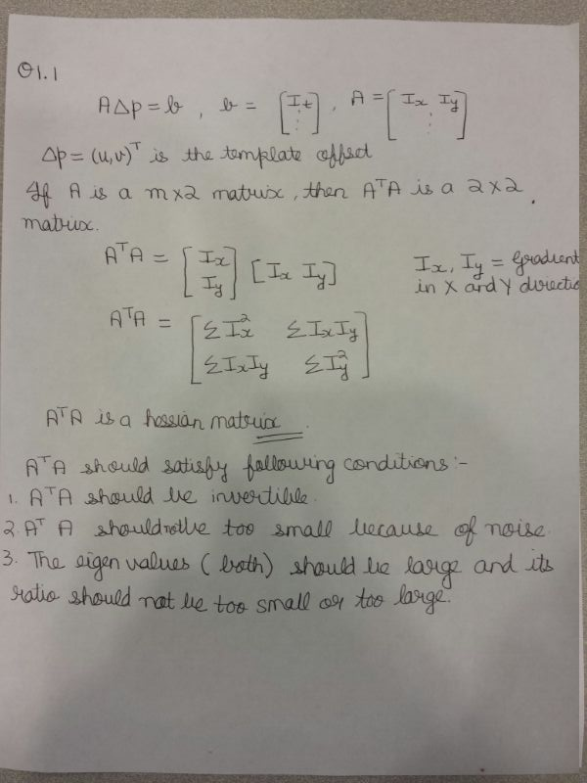

Q1.2

In this question, I implemented Lucas Kanade to track the car and to overcome the fractional movement, I am using interp2. Also, there is a need to run many iterations till change in (u,v) becomes less than a threshold.

Frame 20:

Frame 50: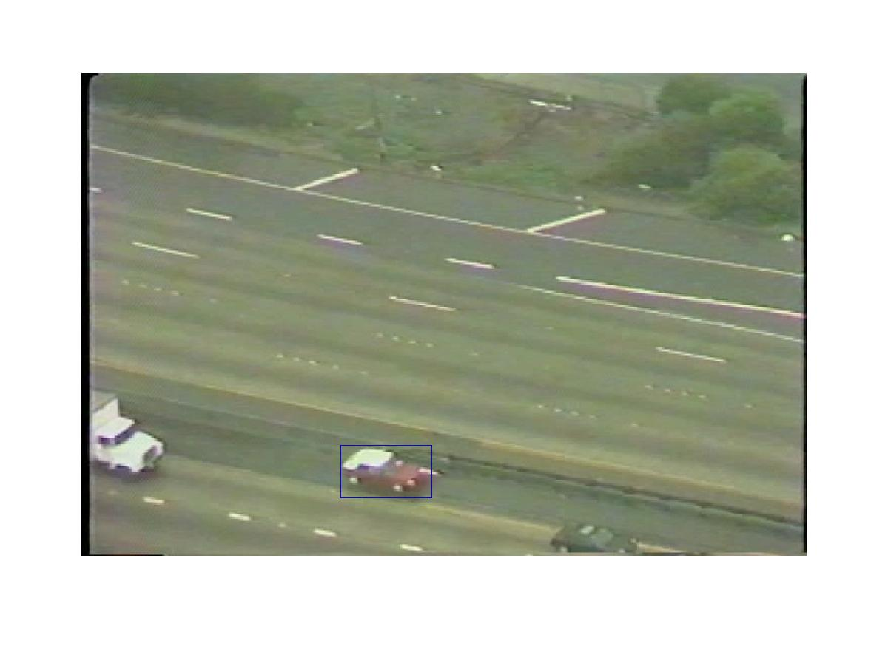

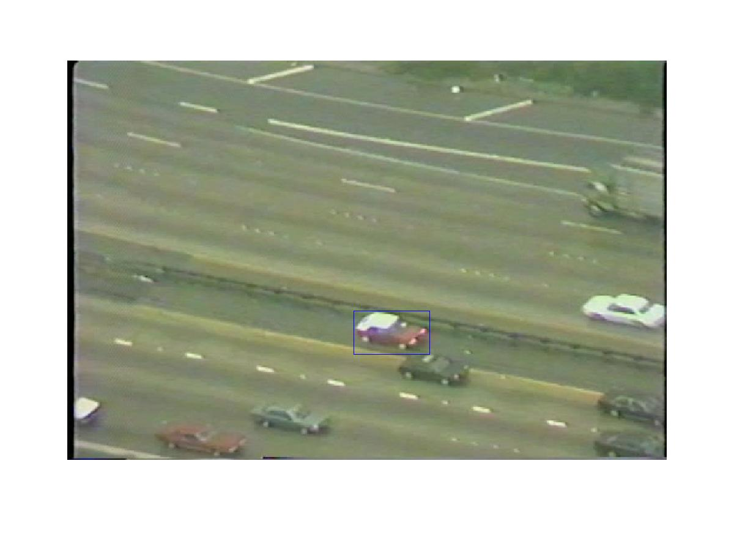

Frame 100: