Q4.
i) Here, we have to find H value using ComputeH function. For that I wrote A matrix using
A = [A;p2(:,i)' [0,0,0] -p1(1,i)*p2(:,i)'; [0,0,0] p2(:,i)' -p1(2,i)*p2(:,i)'];
Then A*h = 0. To find H, I found the eigen vector corresponding to the minimum eigen value of (A'*A) and then reshape it to 3*3 Matrix to get H.

ii) Here, before applying ComputeH, we have to normalize input set of points that is make centroid as [0,0] and average distance to origin as sqrt(2).
For that, I used a tranformation matrix :
Hnorm2 = [ S2 0 -S2*centx2; 0 S2 -S2*centy2; 0 0 1]; where S is the scaling factor.
I used 2 transformation matrices for 2 different set of points.
After normalization, run computeH using normalized set of points to get Hnorm and then go back to H because we will be working on images which are not normalized.

Q5. i) Here we will be finding Hnorm and H using P and Pcorrupt (noise is added). Then I found two corresponding set of points (1000 points) for ptest:
a) Set of points by multipying with H.
b) Set of points by multiplying with Hnorm.

ii) After that, I plotted ptestH and ptestHnorm.

iii) The I found out the covariance and standard deviation. The standard deviation ratio (unnormalized/normalized) is very large. After running normCompare 100 times, the average value of standard deviation ratio came out to be around 80.

All the ptest points corresponding to Hnorm are very close to each other and look almost like a dot on the plot which shows that ptest is homogaphed to almost the same point everytime and noise does not have much effect on it whereas in case where we have H which is not normalized, all the corresponding ptest points are scattered which shows that ptest gets homographed to a different point every time depending on the noise and is largely affected by the noise. So, clearly it is better to normalize the points before computing H, so computeH_norm (Normalized) algorithm is better because it is not affected by noise.

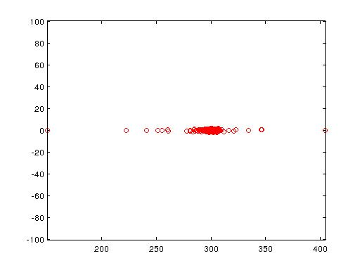

iv) After running it for 1000 times, the average value of standard deviation ratio came out to be around 80. Also, Standard deviation for the normalized case remains almost constant whereas standard deviation for the un-normalized case keeps on varying by a huge amount. This shows that normalized case is not affected by noise whereas the un-normalized case is greatly affected by noise which is not a good thing. Therefore normalized case algorithm is better.

Q6 i) H2to1 = T1\(Hnorm*T2);
Now warp Image2 using warpH.m
Output =
1.
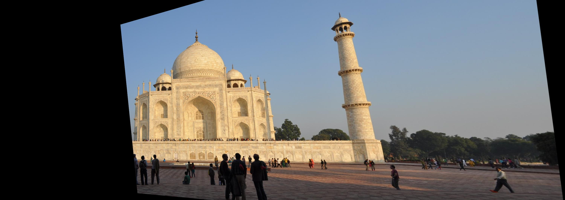
2. Common Part
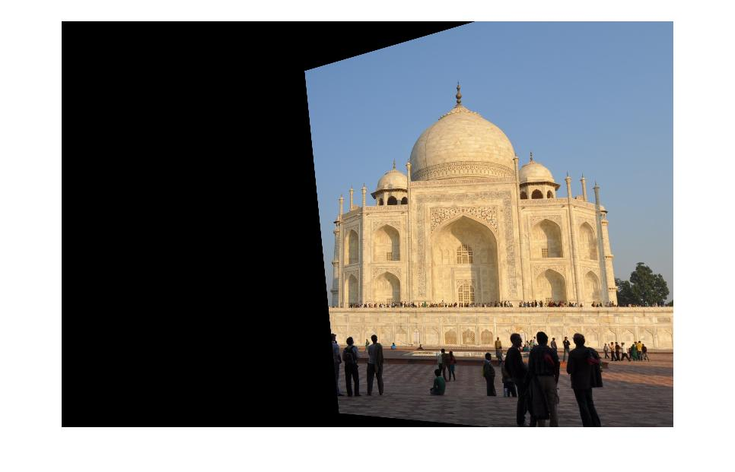
Then form the Panorma image:

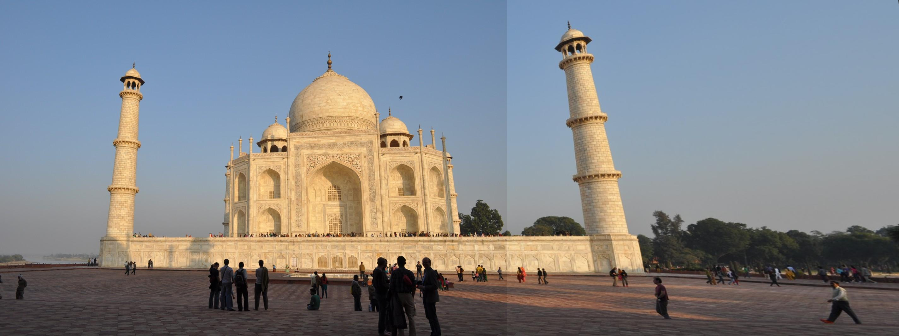

ii) First, find out the H matrix using corresponding points of 2 images.
Then, form a Transformation matrix which takes into consideration Scaling and translation. Let it be S. It is done by first finding the homographed vertices of the 4 vertices of the original image 2 and then finding the scaling value using those vertices and then do the translation to fit the warped image 2 properly.
Now use S to get warped image 1 and use S*H2to1 to get warped image 2.
After that, add warped image 1 to warped image 2 to get the final mosaic image.

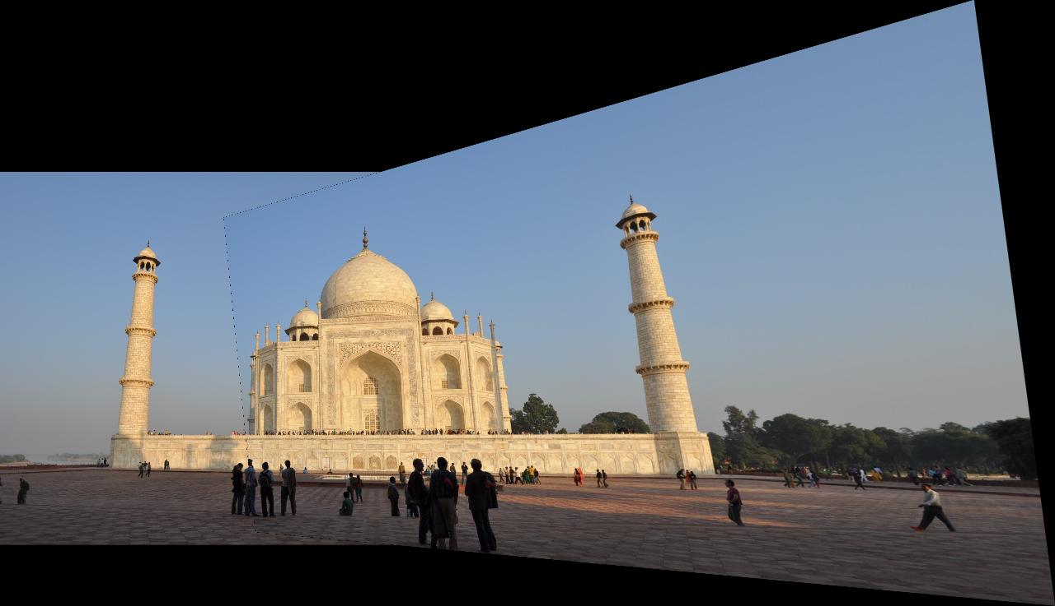

Q7. I used cpselect to find the correspondent points between two images. Then saved those points as ecpts.mat andthen found panorma from 2 input images ec1.jpg and ec2.jpg. I saved the result as ec_pan.jpg and the script as ec.m

Final Panorma Image



