**Statement of the Problem**

We are expected to evaluate the function f(x) = x3 – 3x2 + 3x – 1 and analyse its zero at x = 1

**Algorithm**

We create a vector according to the given conditions and scatter the plot for f(x).

**Results**

The results presented by the program are as follows:

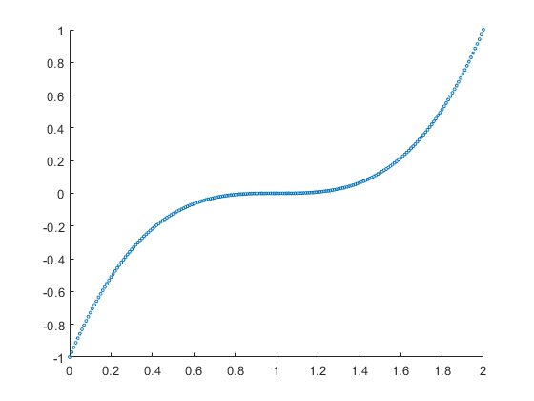

**Figure 1**

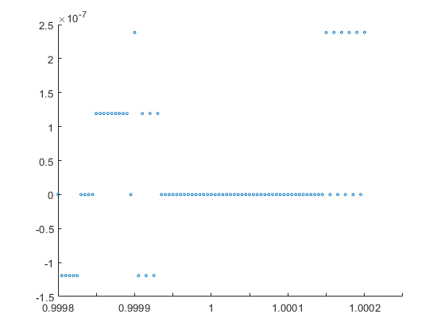

**Figure 2**

**Comments**

1. The function is a perfect cube and has all 3 roots at x = 1.
2. In the first figure the plot is smooth and has no discontinuities.
3. In the second figure, the interval between different points is much smaller (i.e., not much greater than the machine precision), and the fact that we are cubing and squaring every point, adds up the error and thus we can see that there are discontinuities and we get the answer as 0 for many values of x other than 1.
4. Trying to plot the second figure using double instead of single precision, shows us that indeed it is due to the intervals being comparable to the machine precision which causes this issue. Using double, we get a smooth curve like figure 1.