**Statement of the Problem**

We are expected to find the roots of the function f(x) = x6 – 15x + 3 and analyse bisection method and Newton’s method for the same.

**Algorithm**

**Bisection Method:-**

* Check if root lies between the 2 initial points.
* If it does then halve the domain to check, similar to binary search
* Keep repeating the process till the points converge within the convergence criterion

**Newton’s Method:-**

* Check if derivative is non-trivial at the initial and subsequent points.
* If it is not trivial then find the next point using the tangent to the function at the current point.
* Repeat the process till points converge within the convergence criterion

**Results**

The results presented by the program are as follows:

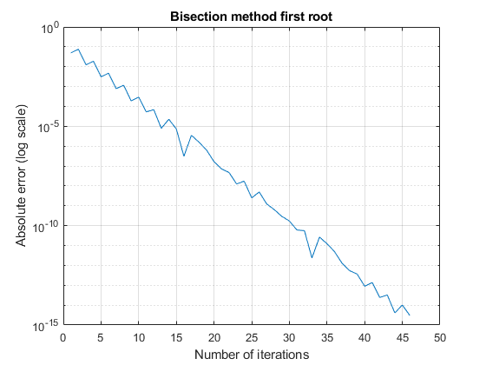

**Figure 1**

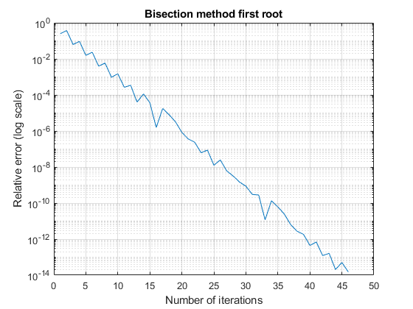

**Figure 2**

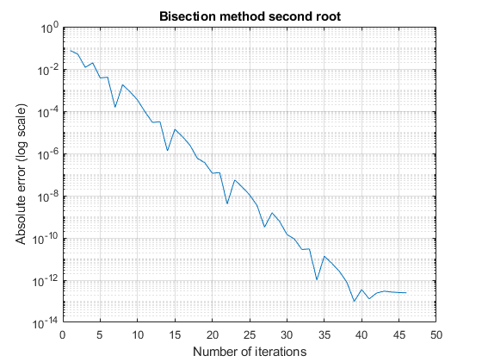

**Figure 3**

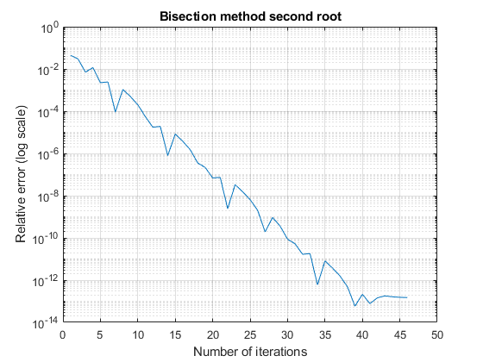

**Figure 4**

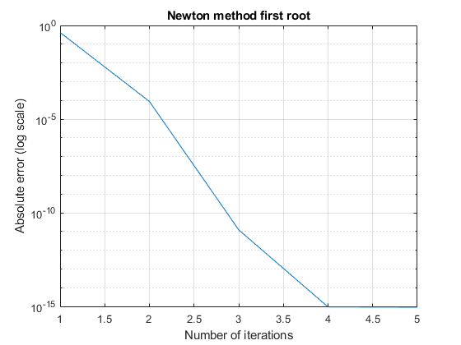

**Figure 5**

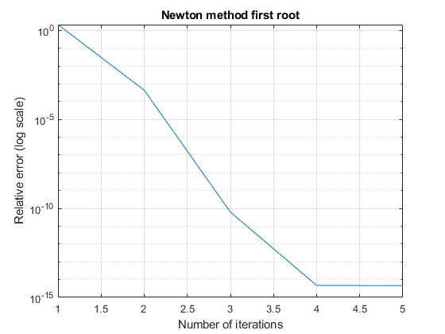

**Figure 6**

**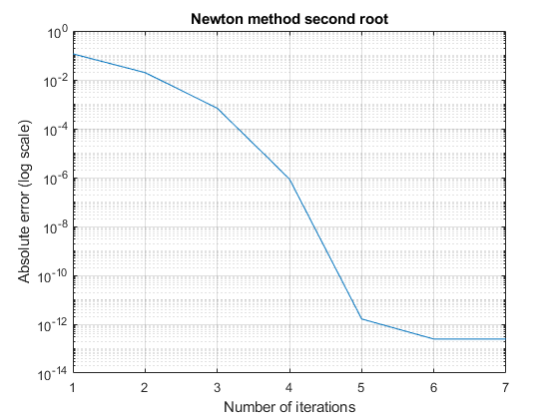  
Figure 7**

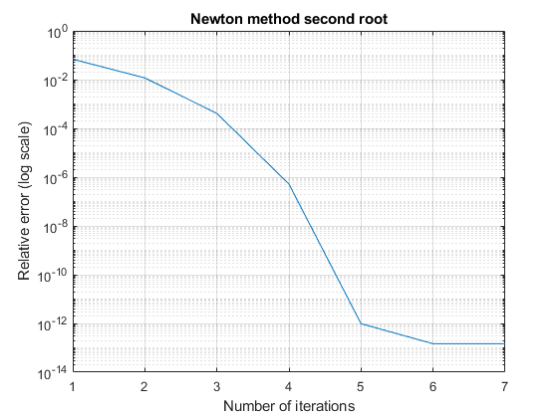

**Figure 8**

**Comments**

1. The function has roots at x = 0.200042.
2. In the first 2 figures the plot is linear and converges after more than 45 iterations.
3. In the 3rd and 4th figure, the plot converges quadratically and very fast, we can see it converges for both roots in under 10 iterations.
4. Newtons method is much faster, which can be seen by the results.