**Statement of the Problem**

We are expected to find the roots of the functions:

F(x) = x3 – 3x2 + 3x – 1

F(x) = x4 – 3x3 + 20x2 + 44x + 54

**Algorithm**

**Muller’s Method:-**

* Construct parabola which passes through the given 3 points.
* Use the roots of the parabola to get a new point for the algorithm
* Replace the first point with this new point and repeat the process till the points converge within the convergence criterion

**Newton’s Method:-**

* Check if derivative is non-trivial at the initial and subsequent points.
* If it is not trivial then find the next point using the tangent to the function at the current point.
* Repeat the process till points converge within the convergence criterion

**Results**

The results presented by the program are as follows:

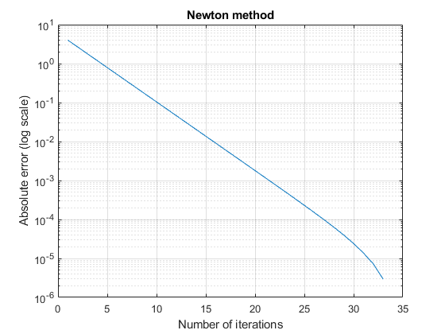

**Figure 1**

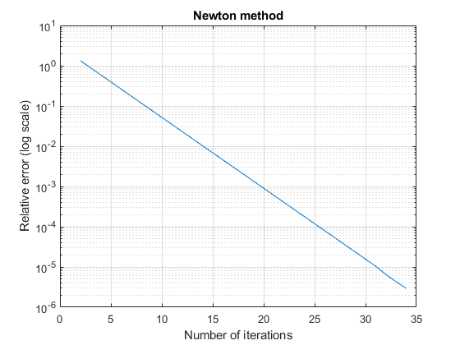

**Figure 2**

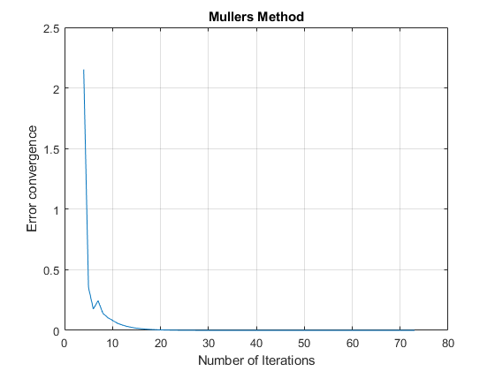

**Figure 3**

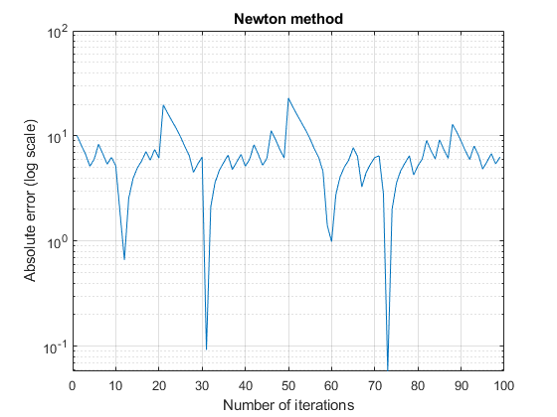

**Figure 4 (Function2)**

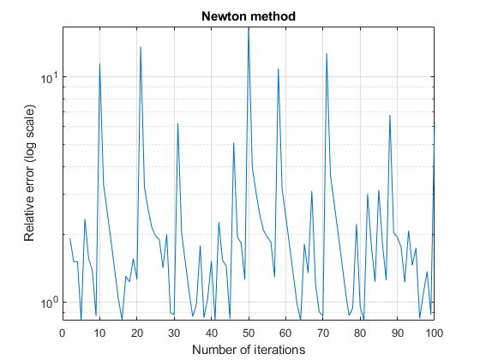

**Figure 5 (Function2)**

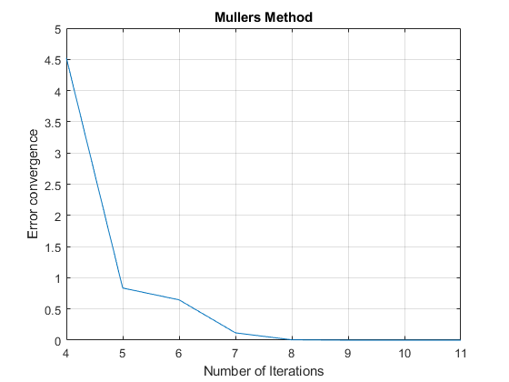

**Figure 6 (Function2)**

**Comments**

1. Function 1 has all 3 roots at x = 1
2. Function 2 has imaginary roots at
   * X = -0.97064 ± 1.00581i
   * X = 2.4706 ± 4.6405i
3. We can see that for function 1, which has real roots, Newton’s Method converges faster than Muller’s Method.
4. Newtons method is faster, However it cannot calculate for imaginary roots, which can be seen from function 2, as Newtons method is unable to get to a root, however Muller’s Method can find both the roots fairly quickly