**Statement of the Problem**

We are expected to solve the system of nonlinear functions:

F1(x) = x2 + y2 – 4 = 0

F1(x) = x2 – y2 – 1 = 0

**Algorithm**

**Newton’s Method:-**

* Define Jacobian and Function vector at every iteration
* Find the delta vector at every iteration
* Using the delta vector update the variable to next iteration

**Results**

The results presented by the program are as follows:

* *Iterations = 4*
* *X_next = [ 1.581138830084190 ; 1.224744891391589]*
* *Sqrt(2.5) = 1.581138830084190*
* *Sqrt(1.5) = 1.224744871391589*

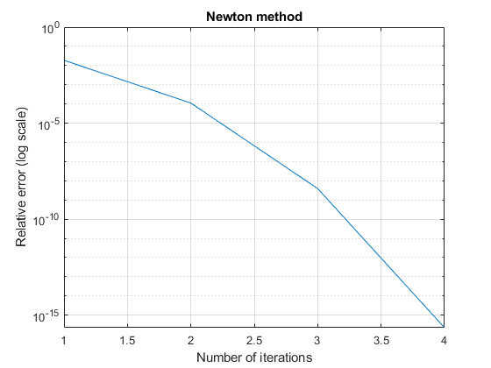

***Figure 1***

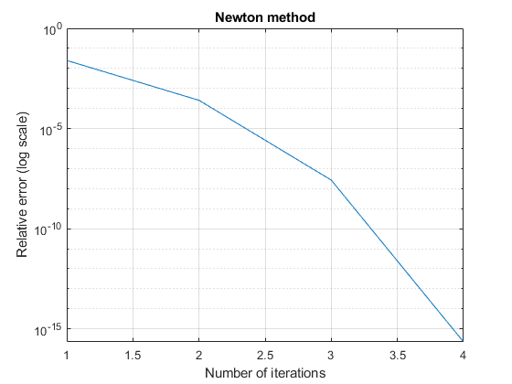

***Figure 2***

**Comments**

1. ***Roots converge in 4 iterations.***
2. ***The roots are very accurate compared to the actual roots***
3. ***The speed of convergence is fairly quick and can be used for large cases as well.***