**Statement of the Problem**

We are expected to find the eigenvalues of the A matrix as defined in the problem statement by the Jacobi Method.

**Algorithm**

**Jacobi Method**

* We do consecutive orthogonal similarity transformations on the A matrix, to convert it more and more diagonal
* As the matrix converts more and more diagonal, we see that the diagonal elements become the eigenvalues themselves.
* Only used for symmetric matrices.

**Results**

The results presented by the program are as follows:

**eigenval =**

**0.000711909483248**

**0.011545325881776**

**0.082975188938587**

**0.100983067319276**

**0.218617864814489**

**0.292537662269235**

**0.300560521934562**

**0.360968459358827**

**realEigenVal =**

**0.000711909483248**

**0.011545325881776**

**0.082975188938587**

**0.100983067319276**

**0.218617864814489**

**0.292537662269235**

**0.300560521934563**

**0.360968459358826**

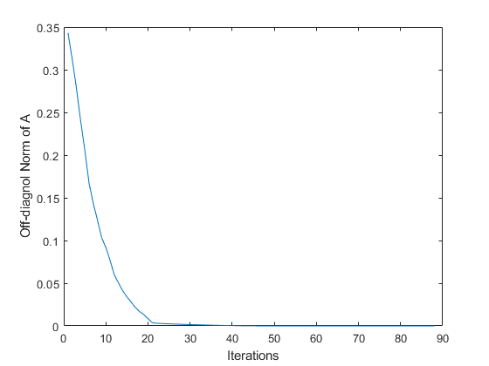

**Comments**

1. ***The program is quite fast and finishes execution in under 0.1 seconds. This is very fast for such highly accurate results and calculations.***
2. ***The off-diagonal norm converges to 0, because we know that Jacobi method converts the coefficient matrix slowly into a diagonal matrix through similarity transformation.***
3. ***Jacobi method is highly accurate, and gives convergence upto 14 digits of accuracy for eigenvalues, using the inbuilt method for finding eigenvalues we only get slightly different results, that wont matter in real world applications.***