**Cyber Biscuits:**

CyberCell organizes its flagship event VishwaCTF every year. We have hoodies and stickers as our merchandises, this year we’re going to launch our Cyber-biscuits. We hope you’ll like taste of it, visit the below website to know more about our CTF.

**Website will display:**

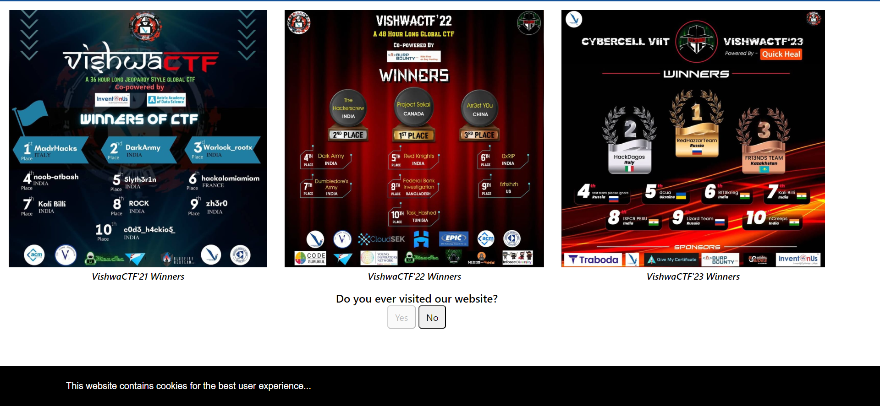

* Right click is disabled on the website, so user must open the developer tools with shortcut like

CRTL+SHIFT+I

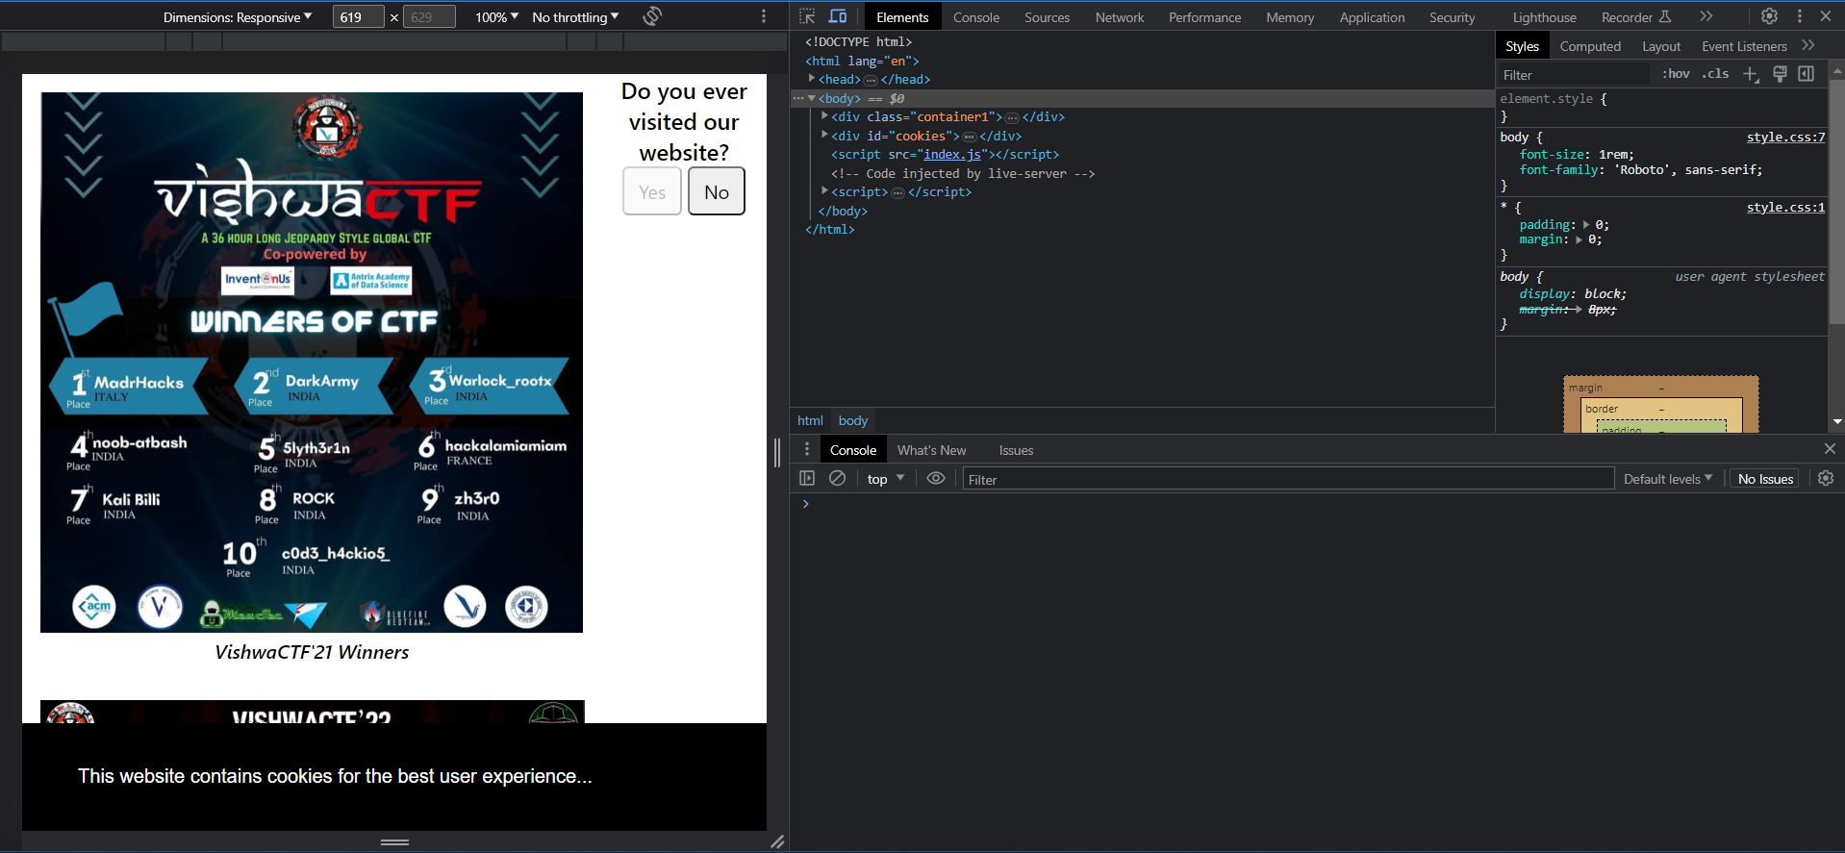

* “Yes” button is also disabled so user have to enable it.

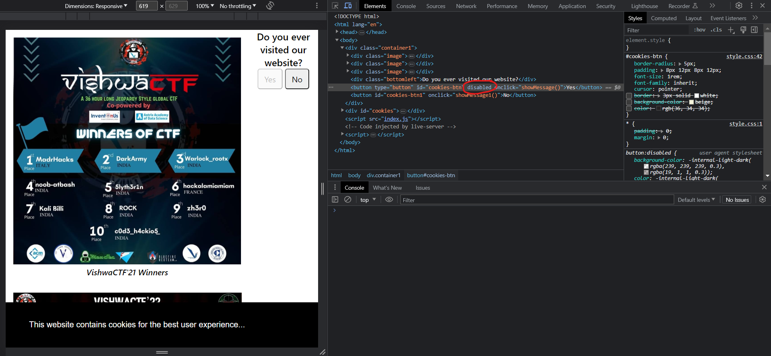

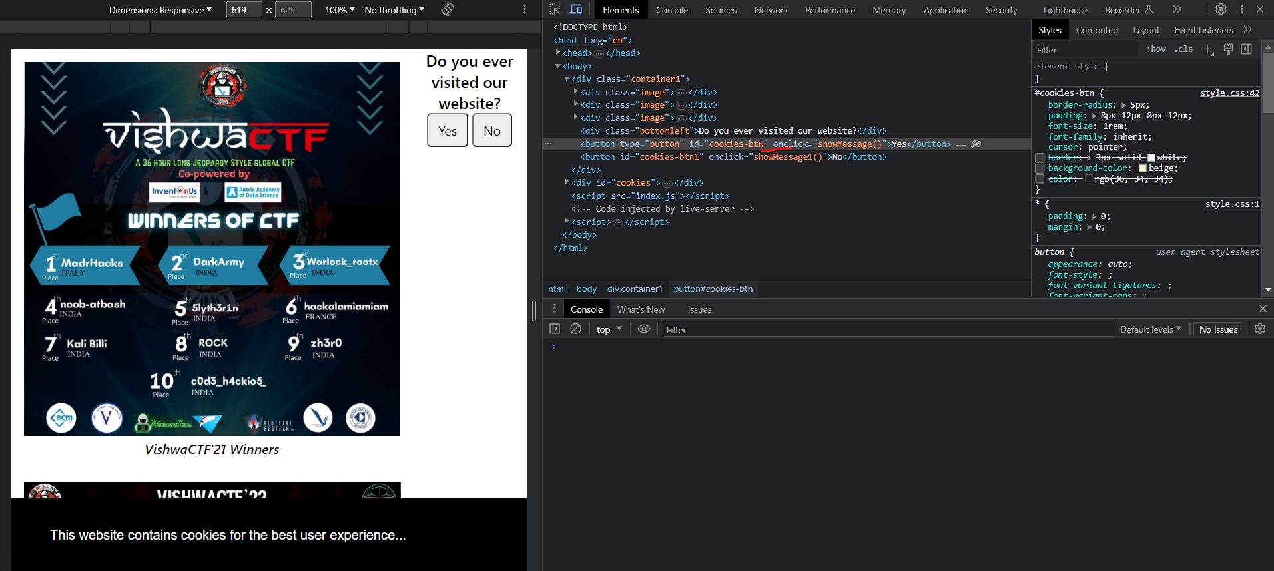

* After enabling and clicking the Yes button a pop-up window will be displayed showing user that He/ She is close to the flag
* We’ve already given hint in the question by mentioning biscuits and on the website by saying this website contains cookies
* So, when user checks cookies logs following will be shown:

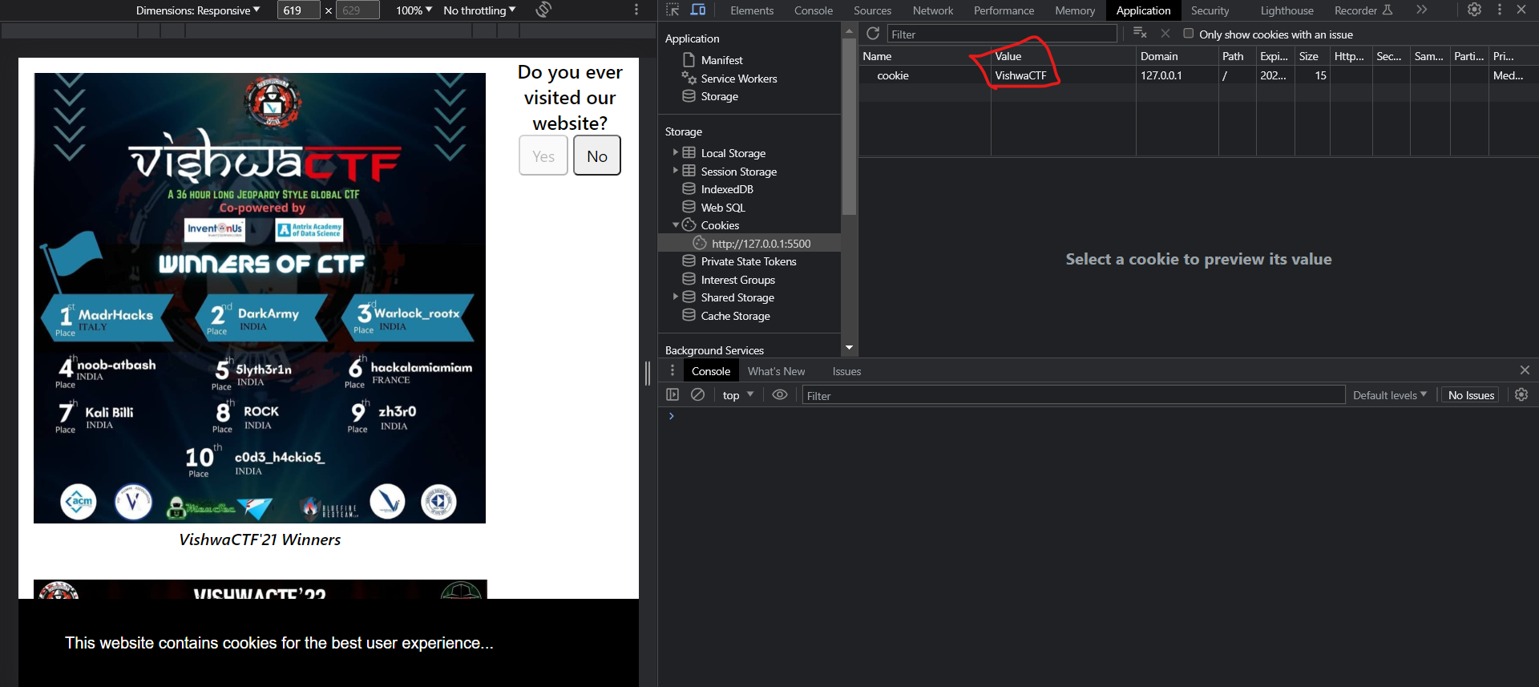

* The value container will contain the flag