

**📄 Intern Information**

**Name :** Naman Dangi

**Age : 19**

**Course :** B.Tech in Artificial Intelligence & Data Science

**Internship Role :** Prompt Engineering Intern

**Large Language Model (LLM) / AI Used :** ChatGPT based on GPT 5

**Institute :** HMR Institute of Technology & Management

**University :** Guru Gobind Singh Indraprastha University , Delhi

**Date :** 13 September 2025

**Total Hours for Task 1 :** 6 – 8 hours (Minimum)

**Mentor/Supervisor :**  N/A (Self - Paced Internship , guided by SkillCraft Instructions)

**Task 01 – Writing Better Prompts**

**📝 Task Description**

Learn the basics of prompt engineering by experimenting with clarity, specificity, and tone. You’ll take 3 vague or ineffective prompts and rewrite them into improved versions. Compare and analyze the outputs to understand how prompt design affects LLM behavior.

**️ Prompts Used**

Original Prompt: ...  
Improved Prompt: ...

**💻 Outputs (Examples)**

Input 1 → Output  
Input 2 → Output  
Input 3 → Output

**📊 Analysis / Comparison**

Comparison here...

**🔄 Reflection**

Reflection here...

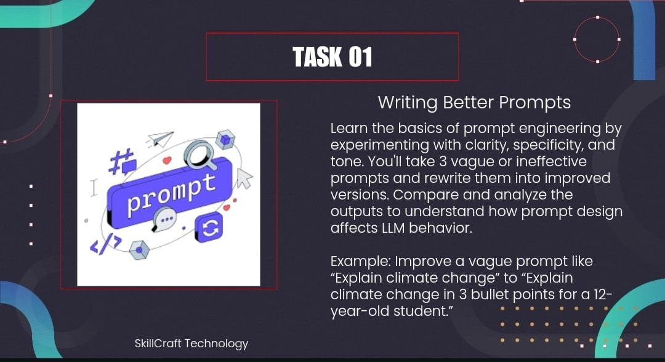

**SOLUTION**

**VAGUE / INEFFECTIVE PROMPTS**

* EXAMPLE PROMPT :

Explain climate change ?

* PROMPT 1 :

What is Engineering ?

* PROMPT 2 :

Describe Prompt Engineering ?

* PROMPT 3 :

Explain Internship ?

OUTPUT

* EXAMPLE PROMPT

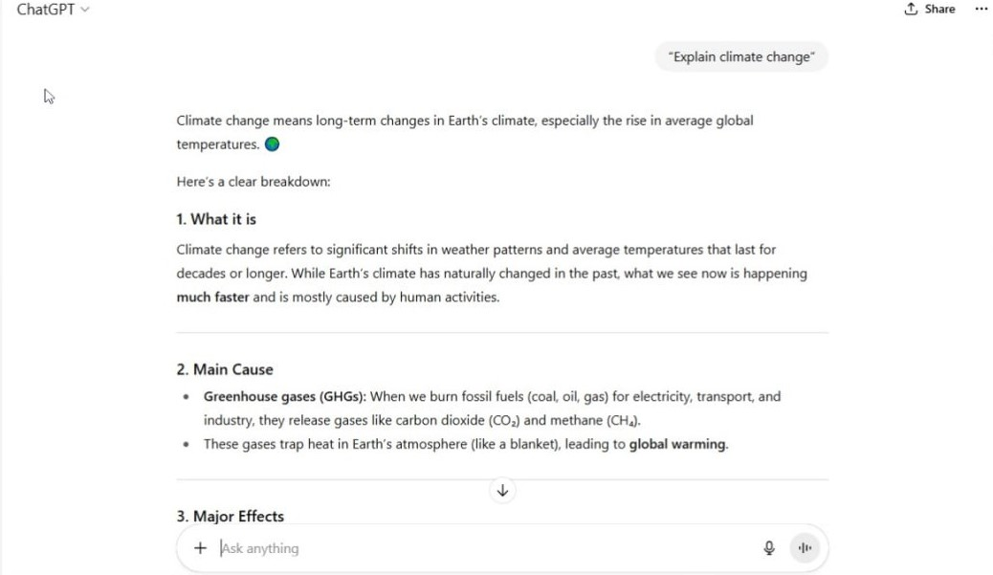

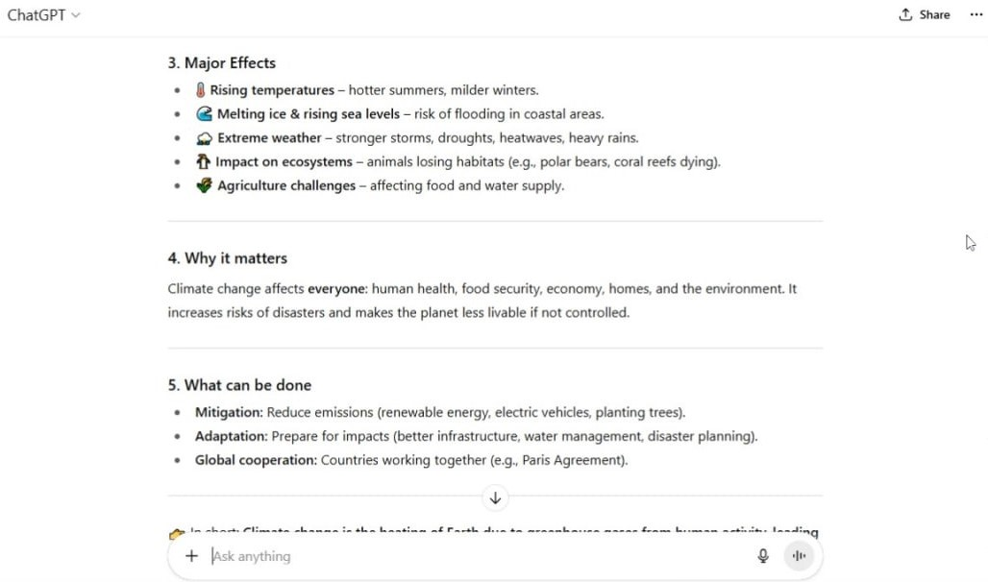

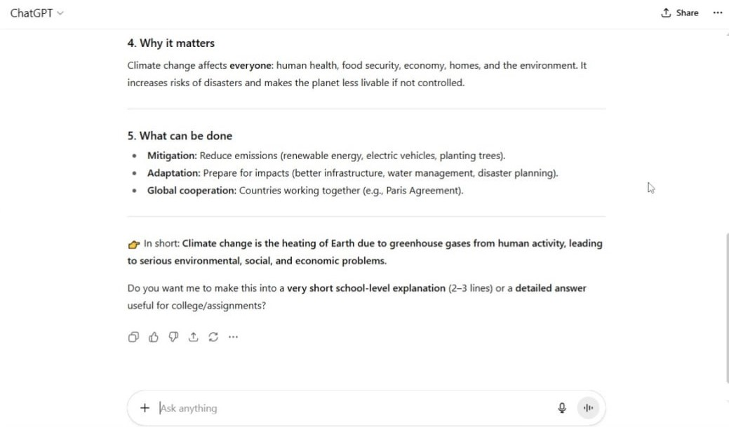

* PROMPT 1

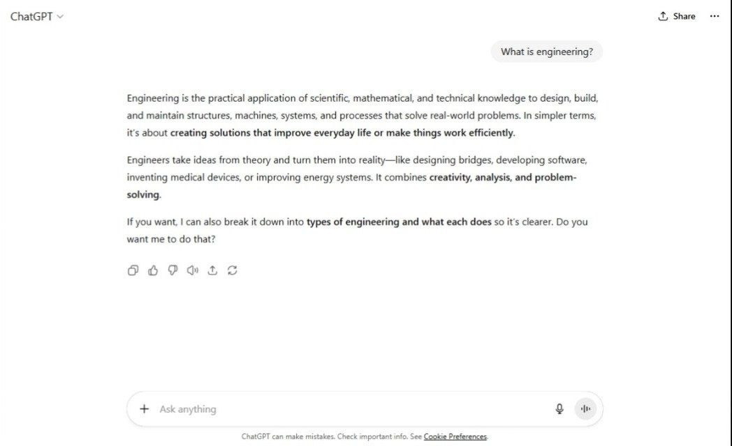

* PROMPT 2

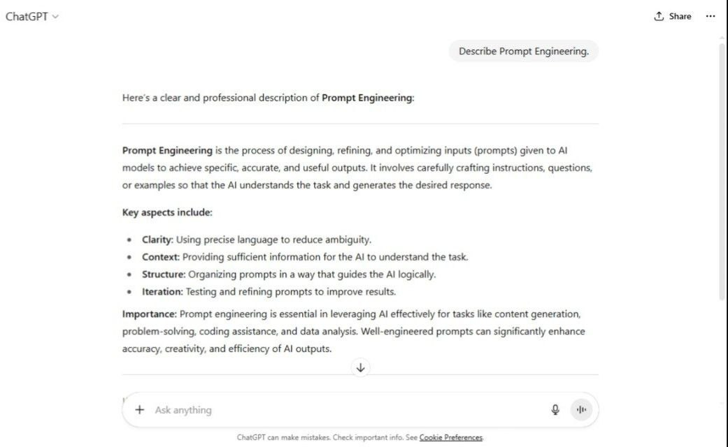

* PROMPT 3

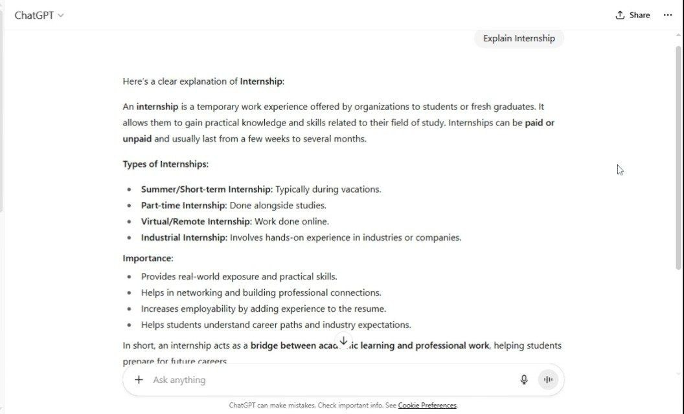

**IMPROVED PROMPTS**

* EXAMPLE PROMPT :

Explain climate change in 3 bullet points for a 12 year-old student ?

* PROMPT 1 :

Provide a brief explanation of engineering in about 50 words. Present the advantages and disadvantages in separate bullet points to ensure clarity and easy understanding ?

* PROMPT 2 :

Write a clear and concise note (80-100 words) on Prompt Engineering. Highlight its role in modern life and explain its significance in the field of Artificial Intelligence, using simple and professional language ?

* PROMPT 3 :

Define an internship and explain its types, importance, and role in a student's life. Present the response in a structured format with headings. Use bullet points to list its advantages, pros, and cons. Additionally, include a simple flowchart that illustrates the internship process (application learning gaining experience) ?

OUTPUT

* EXAMPLE PROMPT

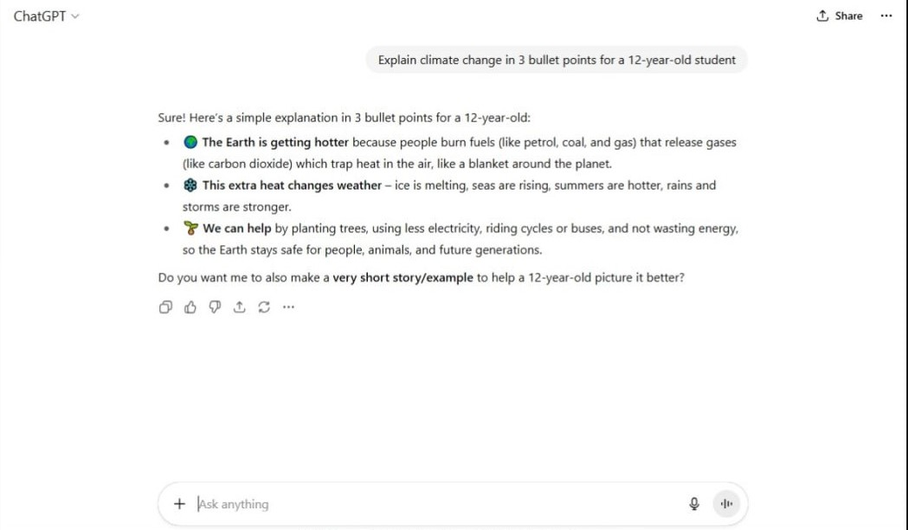

* PROMPT 1

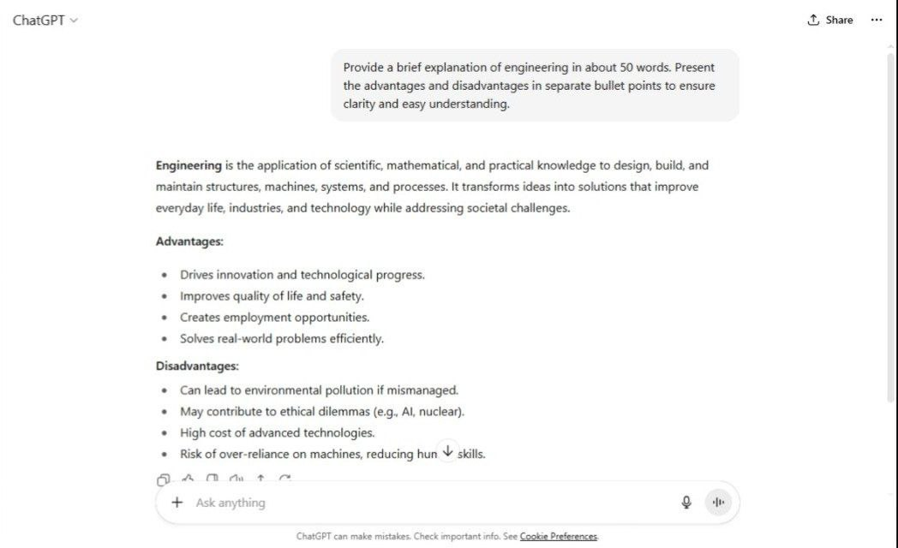

* PROMPT 2

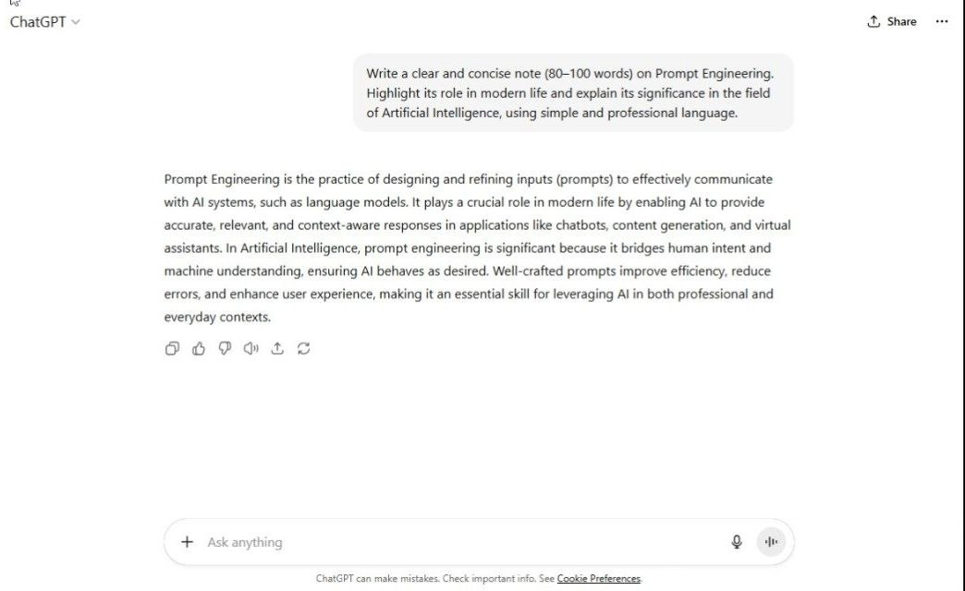

* PROMPT 3

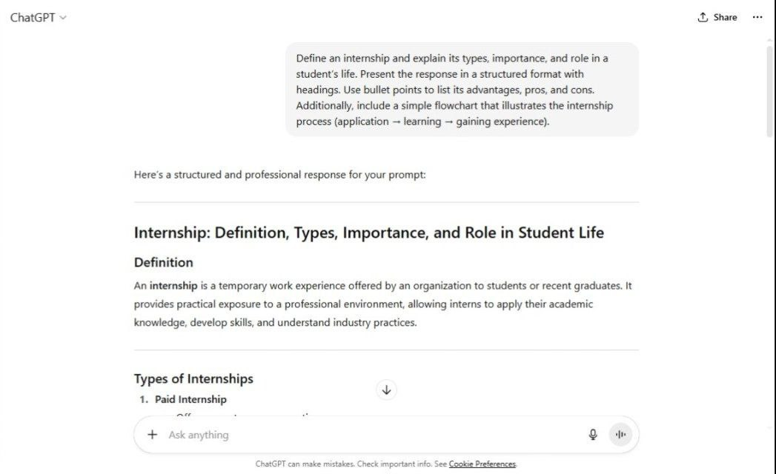

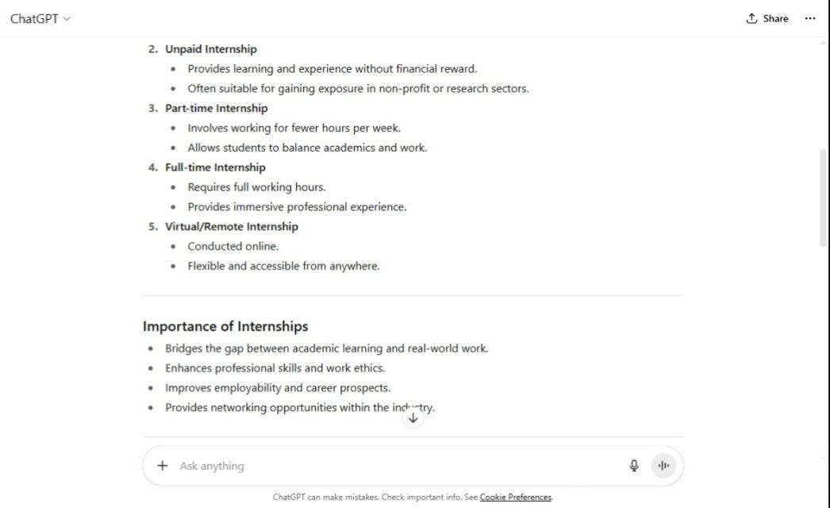

**Analysis / Comparison:**

PROMPT 1

* The vague prompt gave a simple one-line definition of engineering. The improved prompt, however, gave a more detailed explanation in bullet points, making it easier for a non-engineering student to understand.

PROMPT 2

* The vague prompt only gave a short technical definition of prompt engineering. It lacked clarity and context. The improved prompt, however, explained the concept in simple language, included its importance in AI, and made it suitable even for beginners. The improved version was more engaging and easier to understand.

PROMPT 3

* The vague prompt gave only a one-line definition of internship, which was too brief. The improved prompt produced a detailed answer with definition, types, importance, role in student life. This made the output much richer and more useful for academic or professional purposes.

**Reflection:**

PROMPT 1

* From this task, I understood that adding details like “in simple words” or “explain in 5 points” helps generate answers that are more structured and tailored to the audience.

PROMPT 2

* From this task, I realized that the same topic can be explained at different difficulty levels depending on the prompt. By specifying the target audience (like “young learner” or “beginner”), the AI gives responses that are simpler and more relatable. This shows how prompt engineering helps control both the content and tone of AI responses.

PROMPT 3

* From this task, I learned that prompts can guide the AI to include structure (like bullet points & more) and cover multiple aspects of a topic. A well-designed prompt ensures that the output is not only informative but also visually clear and easy to follow. This shows the real power of prompt engineering in organizing knowledge effectively.

C**onclusion:**

Task 01, “Writing Better Prompts”, helped me understand the importance of clarity, structure, and specificity in prompt engineering. By transforming vague prompts into improved versions, I learned how even small changes in wording can significantly impact the quality of AI-generated responses.

This activity enhanced my ability to:

* Frame well-structured prompts.
* Guide AI tools toward more accurate and meaningful outputs.
* Appreciate the role of prompt engineering in real-world applications of Artificial Intelligence.

Overall, this task provided me with valuable insights into effective communication with AI systems, which will be helpful in both my internship journey and future learning.