# C:\Users\pc\Downloads\SkillCraft Technology.png

**📄 Intern Information**

**Name :** Naman Dangi

**Age : 19**

**Course :** B.Tech in Artificial Intelligence & Data Science

**Internship Role :** Prompt Engineering Intern

**Large Language Model (LLM) / AI Used :** ChatGPT based on GPT 5

**Institute :** HMR Institute of Technology & Management

**University :** Guru Gobind Singh Indraprastha University , Delhi

**Date :** 13 September 2025

**Total Hours for Task 1 :** 5 – 7 hours (Minimum)

**Mentor/Supervisor :**  N/A (Self - Paced Internship , guided by SkillCraft Instructions)

**Task 2 – Prompting for Creativity**

**📝 Task Description**

You'll design a prompt that generates creative outputs (e.g, startup ideas, story snippets, ad copy), run multiple variants of your prompt, and compare the results for tone, creativity, and detail....

**️ Prompts Used**

Original Prompt: ...  
Improved Prompt: ...

**💻 Outputs (Examples)**

Input 1 → Output  
Input 2 → Output  
Input 3 → Output

**📊 Analysis / Comparison**

Comparison here...

**🔄 Reflection**

Reflection here...

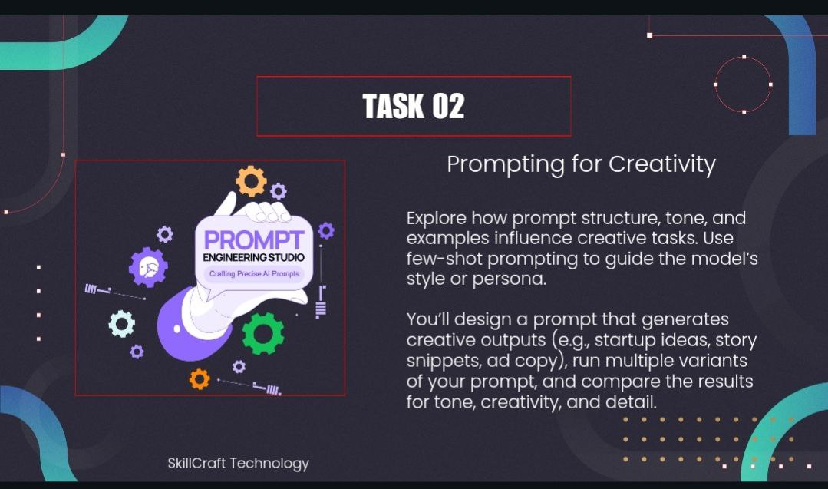

**SOLUTION**

**REQUIRED PROMPT**

**-** Define 3 Startup Ideas to start with ?

**VARIANT 1 : (Basic Prompt)**

* Suggest 3 innovative startup ideas in the education sector. Each idea should be explained in 2–3 sentences.

**VARIANT 2 : (Fun Prompt)**

* Imagine you are a creative entrepreneur. Give me 3 fun and quirky startup ideas in education that would excite teenagers.

**VARIANT 3 : (Investor Prompt)**

* Give me 3 professional startup ideas in education that would attract investors. Provide each idea with a one-line pitch.

OUTPUT

**REQUIRED PROMPT**

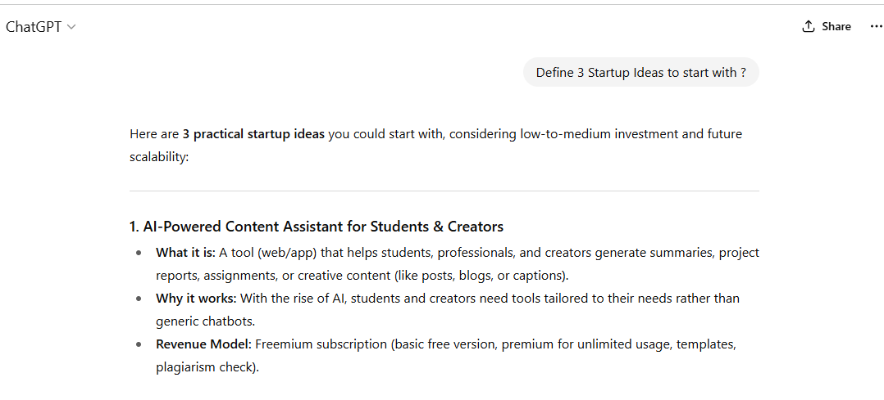

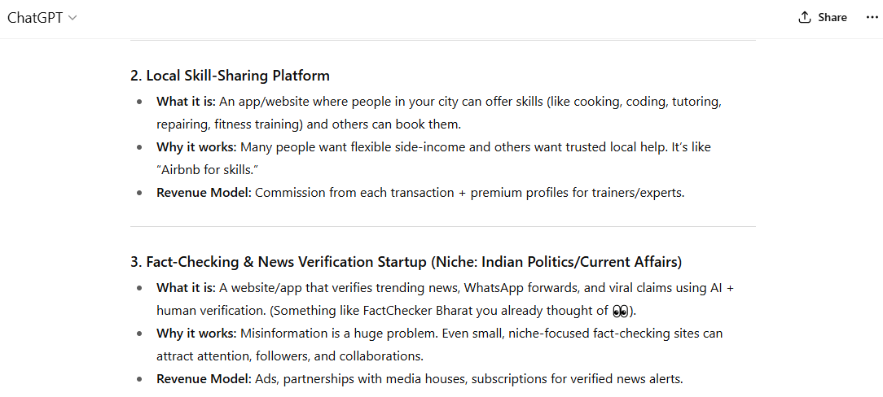

**VARIANT 1**

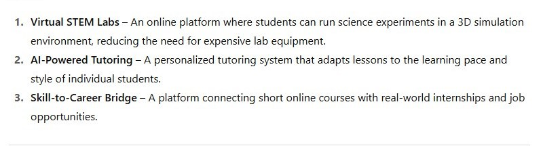

**VARIANT 2**

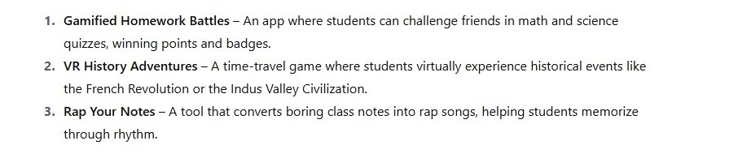

**VARIANT 3**

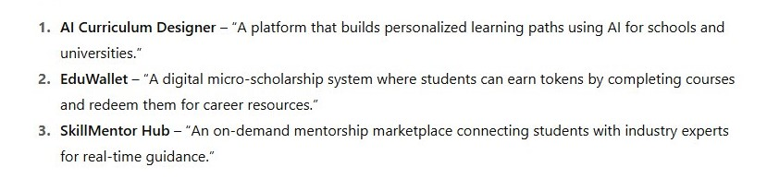

**Analysis / Comparison:**

By experimenting with four different prompts, I observed clear differences in the outputs:

1. **Required Prompt** → The results in this were not very specific. The ideas were an overview.
2. **Basic Professional Prompt** → The results were balanced and safe. The ideas were useful but not very creative.
3. **Fun & Quirky Prompt** → The outputs became playful, imaginative, and more appealing to teenagers (e.g., gamified apps, rap-style learning).
4. **Investor-Friendly Prompt** → The outputs were structured like business pitches, focusing on scalability and market value

**Reflection :**

By changing the **tone of the prompt**, the results varied a lot:

* The **basic prompt** gave balanced and safe ideas.
* The **fun prompt** encouraged playful and youth-focused ideas.
* The **investor prompt** generated more professional and business-ready concepts.

**Conclusion :**

Through this task, I learned how the wording and tone of a prompt can significantly influence the style, creativity, and usefulness of AI outputs. A professional prompt produced safe and structured ideas, a fun prompt encouraged playful and imaginative results, and an investor-focused prompt gave concise, business-oriented pitches. This exercise highlighted the importance of carefully designing prompts to match the audience and purpose.