MODULE – 2

SE – HTML & CSS

* Define the terms: Website, Webpage, Web browser, Web server, HTML, CSS

1 ) Website

* A group of world wide wed pages usually containing link to each other and made available online by an individual, company or organization.

2 ) Webpages

* A webpage is a hypertext document on the world wide web.
* Webpages are delivered by a web server to the user and displayed in a web browser.

3 ) Web browser

* A web browser is an application for accessing websites.
* When a user requests a web page from a particular website, the browser retrieves its files from a web server and then display the pages on the user’s screen.

4 ) Web Server

* Web server is software and hardware that uses HTTP and other protocols to respond to client requested made over the world wide web.

5 ) HTML

* HTML stands for Hyper Text Markup Language.
* HTML is the standard markup language for web pages.

6 ) CSS

* CSS stands for Cascading Style Sheets.
* It is a style sheet language which is used to described the look and formatting of a document written in markup language.
* Create a webpage to show “This is my first HTML page”

<!DOCTYPE html>

<html lang="en">

<head>

    <meta charset="UTF-8">

    <meta http-equiv="X-UA-Compatible" content="IE=edge">

    <meta name="viewport" content="width=device-width, initial-scale=1.0">

    <title>This is my Web-Page</title>

</head>

<body>

    <h1>This Is My Home-Page</h1>

</body>

</html>

OUTPUT

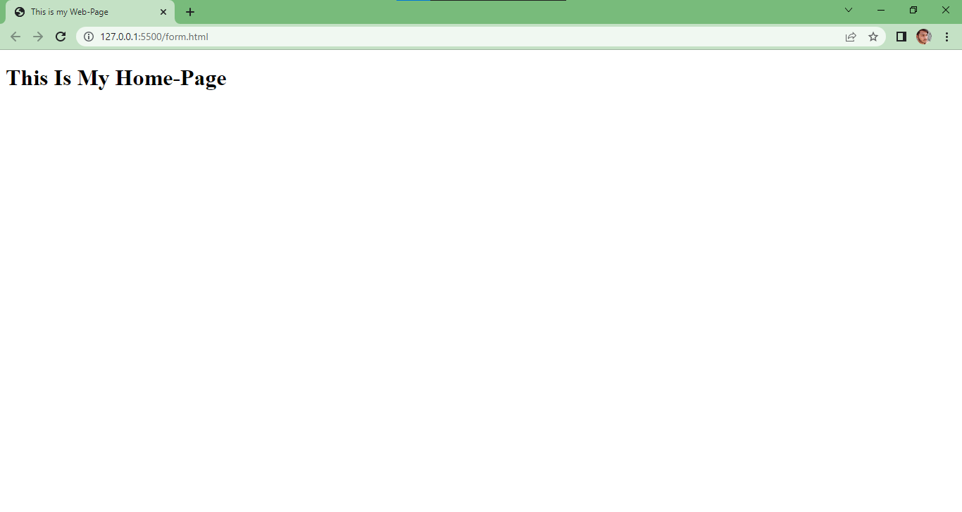

* Display top 10 IT companies list in html webpage

<!DOCTYPE html>

<html lang="en">

<head>

    <meta charset="UTF-8">

    <meta http-equiv="X-UA-Compatible" content="IE=edge">

    <meta name="viewport" content="width=device-width, initial-scale=1.0">

    <title>IT Company</title>

</head>

<body>

    <h2>Tops Technologies</h2>

    <h2>Openxcell</h2>

    <h2>Tridhya Tech</h2>

    <h2>TatvaSoft</h2>

    <h2>Qrious Tech</h2>

    <h2>Hupp Technologies</h2>

    <h2>Simform Solution</h2>

    <h2>Bancancy Technologies</h2>

    <h2>Hyperlink Infosystem</h2>

    <h2>RadixWeb</h2>

</body>

</html>

OTPUT

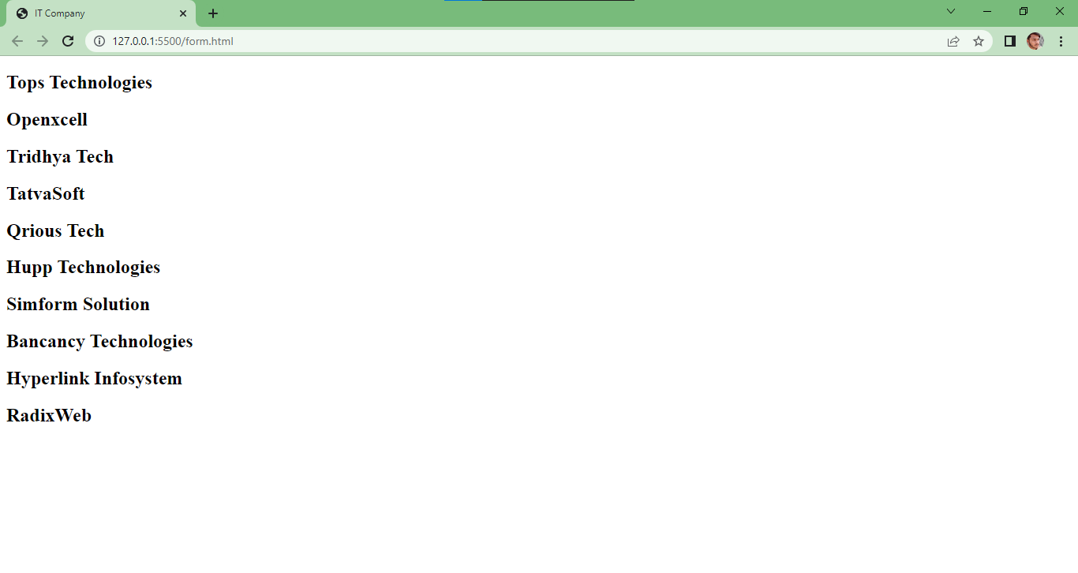

* Create a dropdown list

<!DOCTYPE html>

<html lang="en">

<head>

    <meta charset="UTF-8">

    <meta http-equiv="X-UA-Compatible" content="IE=edge">

    <meta name="viewport" content="width=device-width, initial-scale=1.0">

    <title>IT Company</title>

</head>

<body>

    <select >

        <option disabled selected>It company</option>

        <option >Tops Technologies</option>

        <option>Openxcell</option>

        <option>TatvaSoft</option>

        <option>Qrious Tech</option>

    </select>

</body>

</html>

OUTPUT

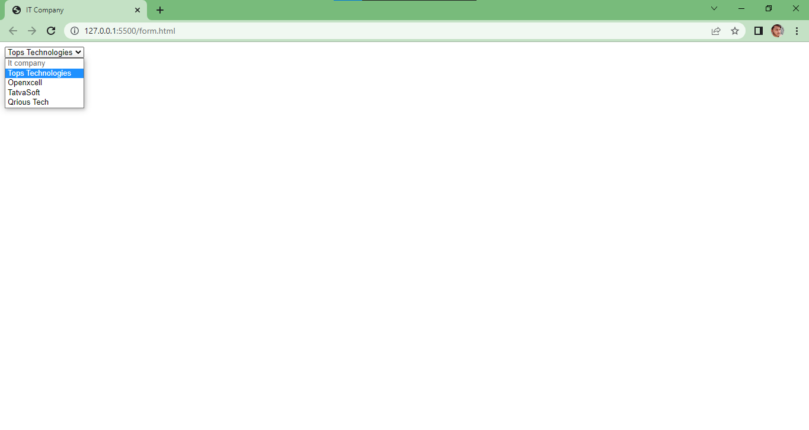

* Create a Table Of college Management system using row span & col span.

<!DOCTYPE html>

<html lang="en">

<head>

    <meta charset="UTF-8">

    <meta http-equiv="X-UA-Compatible" content="IE=edge">

    <meta name="viewport" content="width=device-width, initial-scale=1.0">

    <title>Document</title>

</head>

<body>

    <table border="1">

        <tr align="center">

            <td colspan="6">Time Table</td>

        </tr>

        <tr>

            <th rowspan="6">hours</th>

            <th>mon</th>

            <th>tue</th>

            <th>wed</th>

            <th>thu</th>

            <th>fir</th>

            <tr><td>math</td>

                <td>math</td>

                <td>math</td>

                <td>math</td>

                <td>math</td>

            </tr>

            <tr><td>math</td>

                <td>math</td>

                <td>math</td>

                <td>math</td>

                <td>math</td>

            </tr >

            <tr align="center"><td colspan="6">Lunch</td>

            </tr>

            <tr><td>math</td>

                <td>math</td>

                <td>math</td>

                <td rowspan="2" colspan="2" align="center">project</td>

            </tr>

            <tr><td>math</td>

                <td>math</td>

                <td>math</td>

            </tr>

        </tr>

      </table>

</body>

</html>

OUTPUT

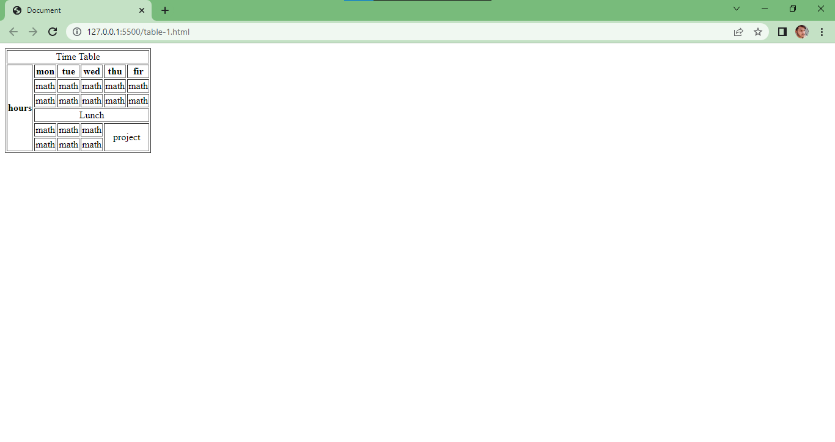

* Create below table using HTML table tags.

<!DOCTYPE html>

<html lang="en">

<head>

    <meta charset="UTF-8">

    <meta http-equiv="X-UA-Compatible" content="IE=edge">

    <meta name="viewport" content="width=device-width, initial-scale=1.0">

    <title>Document</title>

</head>

<body>

    <table border="1" bgcolor="green">

        <th rowspan="8">0</th>

        <tr>

            <td bgcolor="red"><font color="white">3</font></td>

            <td bgcolor="black"><font color="white">6</font></td>

            <td bgcolor="red"><font color="white">9</font></td>

            <td bgcolor="red"><font color="white">12</font></td>

            <td bgcolor="black"><font color="white">15</font></td>

            <td bgcolor="red"><font color="white">18</font></td>

            <td bgcolor="red"><font color="white">21</font></td>

            <td bgcolor="black"><font color="white">24</font></td>

            <td bgcolor="red"><font color="white">27</font></td>

            <td bgcolor="red"><font color="white">30</font></td>

            <td bgcolor="black"><font color="white">33</font></td>

            <td bgcolor="red"><font color="white">36</font></td>

            <td bgcolor="red"><font color="white">2to1</font></td>

        </tr>

        <tr>

            <td bgcolor="black"><font color="white">2</font></td>

            <td bgcolor="red"><font color="white">5</font></td>

            <td bgcolor="black"><font color="white">8</font></td>

            <td bgcolor="black"><font color="white">11</font></td>

            <td bgcolor="red"><font color="white">14</font></td>

            <td bgcolor="black"><font color="white">17</font></td>

            <td bgcolor="black"><font color="white">20</font></td>

            <td bgcolor="red"><font color="white">23</font></td>

            <td bgcolor="black"><font color="white">26</font></td>

            <td bgcolor="black"><font color="white">29</font></td>

            <td bgcolor="red"><font color="white">32</font></td>

            <td bgcolor="black"><font color="white">35</font></td>

            <td bgcolor="black"><font color="white">2to1</font></td>

        </tr>

        <tr>

            <td bgcolor="red"><font color="white">1</font></td>

            <td bgcolor="black"><font color="white">4</font></td>

            <td bgcolor="red"><font color="white">7</font></td>

            <td bgcolor="black"><font color="white">10</font></td>

            <td bgcolor="black"><font color="white">13</font></td>

            <td bgcolor="red"><font color="white">16</font></td>

            <td bgcolor="red"><font color="white">19</font></td>

            <td bgcolor="black"><font color="white">22</font></td>

            <td bgcolor="red"><font color="white">25</font></td>

            <td bgcolor="black"><font color="white">28</font></td>

            <td bgcolor="black"><font color="white">31</font></td>

            <td bgcolor="red"><font color="white">34</font></td>

            <td bgcolor="red"><font color="white">3</font></td>

        </tr>

        <tr>

            <td colspan="4"><font color="white">1st12</font></td>

            <td colspan="4"><font color="white">2nd12</font></td>

            <td colspan="4"><font color="white">3rd12</font></td>

            <td rowspan="2"></td>

        </tr>

        <tr>

            <td colspan="2" bgcolor="black"><font color="white">1to18</font></td>

            <td colspan="2"><font color="white">EVEN</font></td>

            <td colspan="2" bgcolor="red"></td>

            <td colspan="2" bgcolor="black"></td>

            <td colspan="2"><font color="white">ODD</font></td>

            <td colspan="2"><font collor="white">19to36</font></td>

        </tr>

    </table>

</body>

</html>

OUTPUT

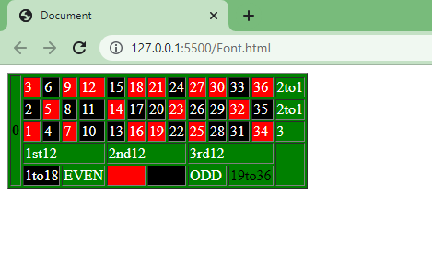

* Create Registration form using HTML, CSS.
* <!DOCTYPE html>
* <html>
* <head>
* <meta name="viewport" content="width=device-width, initial-scale=1">
* <title>Register Form</title>
* <style>
* body {
* font-family: Arial, Helvetica, sans-serif;
* background-color: black;
* }
* * {
* box-sizing: border-box;
* }
* /* Add padding to containers */
* .container {
* padding: 16px;
* background-color: white;
* }
* /* Full-width input fields */
* input[type=text], input[type=password] {
* width: 100%;
* padding: 15px;
* margin: 5px 0 22px 0;
* display: inline-block;
* border: none;
* background: #f1f1f1;
* }
* input[type=text]:focus, input[type=password]:focus {
* background-color: #ddd;
* outline: none;
* }
* /* Overwrite default styles of hr */
* hr {
* border: 1px solid #f1f1f1;
* margin-bottom: 25px;
* }
* /* Set a style for the submit button */
* .registerbtn {
* background-color: #04AA6D;
* color: white;
* padding: 16px 20px;
* margin: 8px 0;
* border: none;
* cursor: pointer;
* width: 100%;
* opacity: 0.9;
* }
* .registerbtn:hover {
* opacity: 1;
* }
* /* Add a blue text color to links */
* a {
* color: dodgerblue;
* }
* /* Set a grey background color and center the text of the "sign in" section */
* .signin {
* background-color: #f1f1f1;
* text-align: center;
* }
* </style>
* </head>
* <body>
* <form action="/action_page.php">
* <div class="container">
* <h1>Register</h1>
* <p>Please fill in this form to create an account.</p>
* <hr>
* <label for="email"><b>Email</b></label>
* <input type="text" placeholder="Enter Email" name="email" id="email" required>
* <label for="psw"><b>Password</b></label>
* <input type="password" placeholder="Enter Password" name="psw" id="psw" required>
* <label for="psw-repeat"><b>Repeat Password</b></label>
* <input type="password" placeholder="Repeat Password" name="psw-repeat" id="psw-repeat" required>
* <hr>
* <p>By creating an account you agree to our <a href="#">Terms & Privacy</a>.</p>
* <button type="submit" class="registerbtn">Register</button>
* </div>
* <div class="container signin">
* <p>Already have an account? <a href="#">Sign in</a>.</p>
* </div>
* </form>
* </body>
* </html>

OTPUT

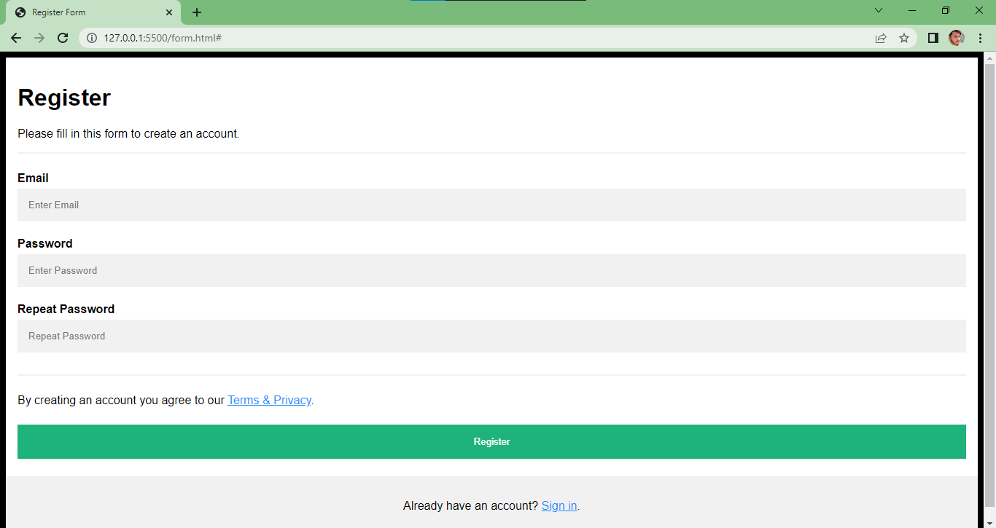

* In how many ways can a CSS be integrated as a web page?

CSS can be added to HTML document in 3 Ways :

* Inline : By using the style attribute inside HTML element.
* Internal : By using a <style> element in the <head>
* External : By using a <link> element to link to an external CSS file.
* Create simple three pages using External CSS, Internal CSS, and Inline CSS.

1 ) Using External CSS

HTML PAGE

<!DOCTYPE html>

<html>

<head>

<link rel="stylesheet" href="mystyle.css">

<title>External CSS</title>

</head>

<body>

<h1>This is a External Css Page</h1>

<p>This is a paragraph.</p>

</body>

</html>

CSS PAGE

body {

  background-color: lightblue;

}

h1 {

  color: navy;

  margin-left: 20px;

}

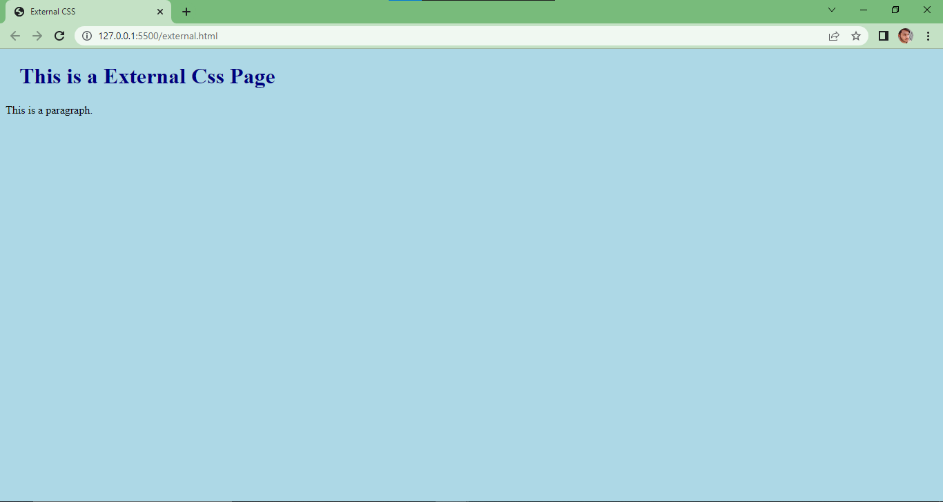 OUTPUT

2 ) Internal CSS

<!DOCTYPE html>

<html>

<head>

<style>

body {

  background-color: linen;

}

h1 {

  color: maroon;

  margin-left: 40px;

}

</style>

<title>Internal CSS</title>

</head>

<body>

<h1>This is a heading</h1>

<p>This is a paragraph.</p>

</body>

</html>

OUTPUT

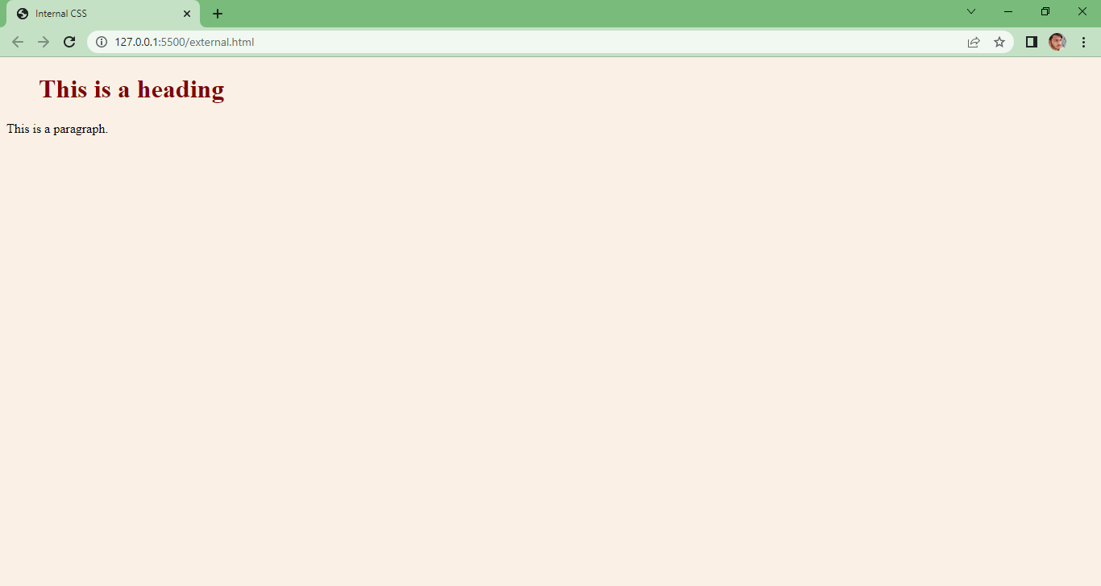

3 ) Inline CSS

<!DOCTYPE html>

<html>

<body>

<h1 style="color:blue;text-align:center;">This is a heading</h1>

<p style="color:red;">This is a paragraph.</p>

<title>Inline CSS</title>

</body>

</html>

OUTPUT

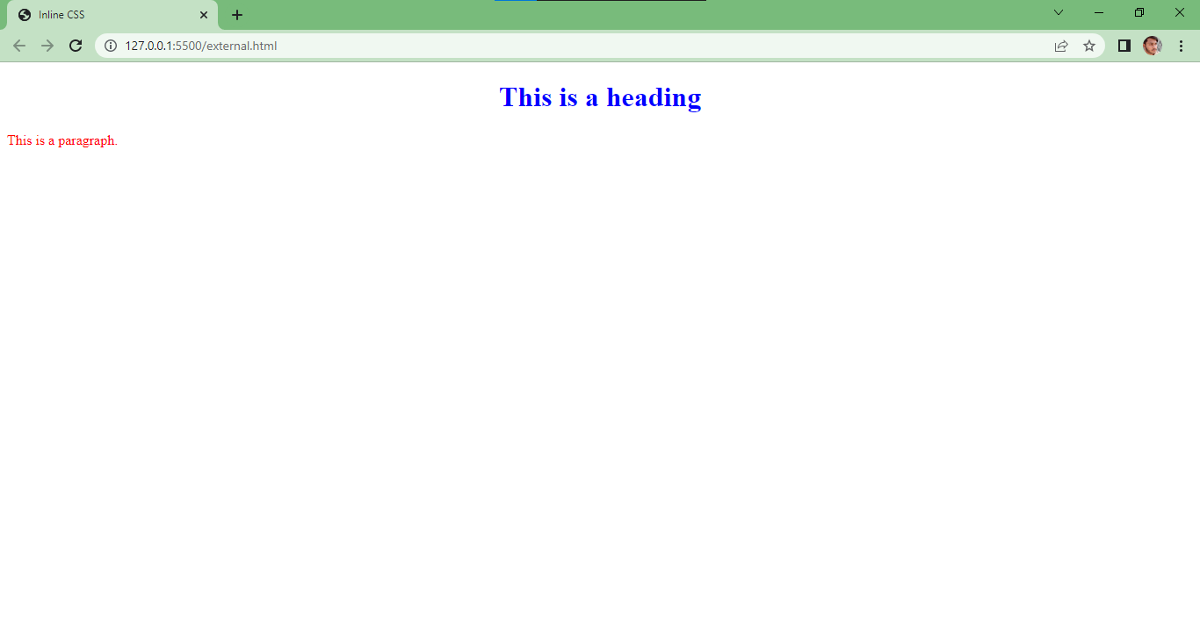

* Create link-pseudo classes using external css, to format links on the page.

<!DOCTYPE html>

<html>

<head>

<style>

/* unvisited link */

a:link {

  color: red;

}

/* visited link */

a:visited {

  color: green;

}

/* mouse over link */

a:hover {

  color: hotpink;

}

/* selected link */

a:active {

  color: blue;

}

</style>

</head>

<body>

<h2>Styling a link depending on state</h2>

<p><b><a href="default.asp" target="_blank">This is a link</a></b></p>

</body>

</html>

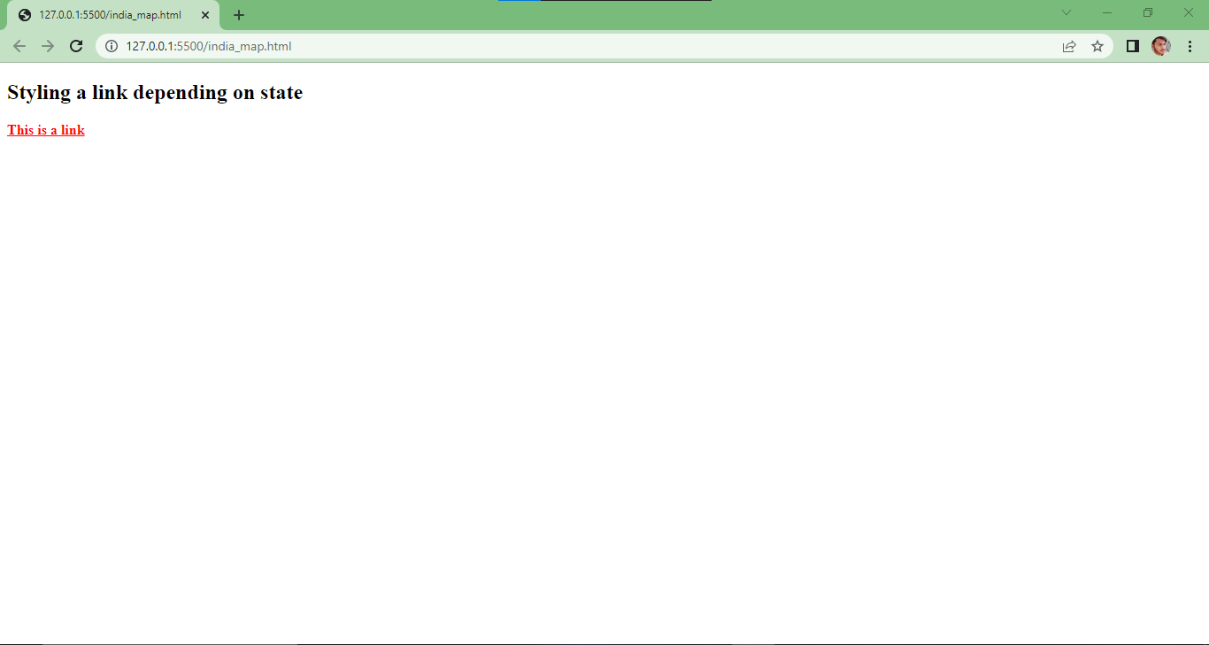OUTPUT

* Create a dynamic pseudo class using HTML, CSS.

<!DOCTYPE html>

<html>

<head>

<style>

/* unvisited link */

a:link {

  color: red;

}

/* visited link */

a:visited {

  color: green;

}

/* mouse over link */

a:hover {

  color: hotpink;

  background-color: aquamarine;

}

/* selected link */

a:active {

  color: blue;

}

</style>

</head>

<body>

<h2>Styling a link depending on state</h2>

<p><b><a href="default.asp" target="_blank">This is a link</a></b></p>

</body>

</html>

OUTPUT

