
Technical Coding Research Innovation, Navi Mumbai,
Maharashtra, India-410206

(ORIGANO-Online Food Ordering Website)

A Case-Study Submitted for the requirement of
Technical Coding Research Innovation

For the Internship Project work done during
FRONT-END WEB DEVELOPMENTP INTERNSHIP PROGRAM

by
MILIND UDBHAV(TCRIA6R162)
NAMAN JAIN(TCRIA6R72)
KAPIL NAIK(TCRIA6R83)
SAKSHI DESHMUKH(TCRIA6R216)

Date: 13 SEP 2022
Grade: 3 YEAR CE

Rutuja Doiphode
CO-FOUNDER &CEO
TCR innovation.

About Organization

TCR Innovation stands for Technical Coding & Research Innovation, is a best institute for industrial training and internship programs and believes in "bridging the gap between students and their knowledge in the industrial field & bringing them a step closer to their Dream. TCR Innovation focus on industrial training and offer Internship Programs where you can learn the in-demand professional skills to advance your career in Artificial Intelligence, Machine Learning, Deep Learning, Python with Automation, Computer Vision, Data Science, Digital Marketing, Python Programming, Software development, Database and more.

TCR INNOVATION was founded in Feb 2020 by Rutuja Doiphode and Saheel Ramji. Their Internship Programs are specially designed so Interns can learn new skills or enhance their skills in the most efficient way. Interns are First trained by the Mentors in their applied Domain through Live Lectures. Comprehensive Notes & Study

Materials are provided along with Intensive Training in the domain. After the Training Period is Complete, Interns are given the Opportunity to work on an Industrial-Level Project which will be the Project Phase and one of the most

Important Phase of their Internship. The Training completion certificate along
with the Internships Certificate are awarded after the Successful Completion of your Project with Letter of Recommendation.

Email of TCR Innovation is tcrinnovation@tcrinnovation.co.in and their website is https://tcrinnovation.co.in/ The current status of TCR Innovation is active

ABSTRACT

The main purpose of Online Food Ordering Website was to switch customer from manual system to the technical ground by the help of some of the application. It is designed for increase the user experience so that the new user can easily get familiar to online sites.

In this website the features are Fresh and Organic box in this all the fresh and organic vegetables as well as the fruits are there. We have different types of fruits and vegetables along with the price and as well as the review from our purchased customer. Another feature is Free Delivery in this all the details regarding the delivery process the timing and other required details are there. The last feature of our website is Easy Payments in this feature the details is provided regarding our payment partners as well as the

successful review. The objective is to manage the details of Food Item,

Payment, Delivery process. This project describes how to manage for good performance and better services for the customers.

Introduction

A front-end developer works on desktop or mobile websites, by which users interact. Specifically, a front-end developer spends time on the side of technology that the user touches and sees.
The front end is referred as the client side.

What makes a great front-end developer?

“A strong and effective front-end developer shows a determined focus and obsession on what users and customers need and want.

Jobs and Common Skills Needed

Here are the top four attributes:
- Strong technical skills in web programming;
- Advanced skills with HTML and CSS;
- An understanding of JavaScript (and/or PHP, ASP.NET, or Ruby on Rails);

- An understanding of security and best development practices.

Tools and Technology used during our internship training. Some of them are listed below:

- HTML5

HTML stands for Hyper Text Mark-up Language. Hypertext mainly tell the link between webpages. Markup language is used for text which shows the structure of web pages. HTML5 is referred as fifth as it is the fifth version of Html.

• Basic HTML (tags, element, attributes, paragraphs, headings, line breaks, lists, table, color codes, font, text linking, email, images, background, comments, media, charset)
• HTML Forms (input, text fields, password, checkbox, combo-box, radio box, text areas, files, buttons)

- Paragraph Tag
In HTML, tag has an opener and a closer. To format a paragraph tag is:
<p>This is a new paragraph. </p>
- Header Tag
Header tags is one of the important tags as it used to search the current document on search engines easily. The <h1> tags, which is the highest among all. Then comes <h2>, <h3> and sometimes even <h4> tags. Mostly, the subheads in your articles will be <h2> and <h3> tags.
<h1>Title of Article</h1>
<p>Introduction. </p>
<h2>Sub header</h2>
- Image Tag
The <img> tag does not require a closing tag.
<img style=”margin: 10px; float: left;” alt=”keyword” src=”images/path/image-name.jpg” />
- HREF Tag
This tag is used to created links in Html document.
<a href=” http://www.URL.com”>Linked Text Here</a>

Features
- Html is easy to understand and can be modified.
- Html has tags which make effective presentations.
- The links can easily be added in the web page where needed which make it informative.
- Html is platform independent means can be open in Linux mac windows.
- Flexible using Html you can style CSS.
- Audio and Video Support in Html you can stream audio and video

- CSS

Cascading Style Sheets, is a designed language which is used for making web pages presentable. There are three types of CSS:
- Inline CSS
- Internal CSS
- External CSS

The main difference between CSS and HTML is that html show the structural way the web page whereas CSS add the style and make it attractive. It can style more than one page at a time

Applications of CSS
There are three ways of HTML accessing CSS:
- Inline CSS - An inline style sheet is only done with the tag itself. Inline CSS is important as if we want small change or want to try the style then it is used. If we want to small change then it can be done in Inline CSS.
- Internal CSS - The internal is used when we want small changes in a single tag. This is because inline only affects the one tag that is contained within it, whereas the internal styling is always on the head of HTML document. It is simple to debug and easy to understand.
- External CSS - External stylesheets are used to make changes according to the web page. This CSS can have more than one stylesheet for the same document. The style sheet has advantage that if there is any changes in external sheet then it won’t affect rest parent sheets it is linked to.
Advantages of CSS:
- CSS is device Compatibility
- CSS is easy to maintain
- Ability to re-position
- It increases capabilities to crawl the web pages

Uses of CSS
- CSS can add unique styles to old documents of HTML.
- It can change the design of the website by using some CSS code .
- We can use cascading style sheet with JavaScript and HTML to the websites to develop user experience.
Features of CSS
- Website Design: CSS, have various styles, such as the text color, the font style, column size and layout, background color and images, many other effects as well.
- Web Control: CSS has controlling power on documents of HTML, so it is easy to learn and understand.
- Different Languages: Along with CSS and HTML, other technologies like Angular, PHP, and JavaScript are become clearer to understand.

- JavaScript

JavaScript is a interpreted scripting language. It is known for development of web pages. It is also used for Client-side developments as well as Server-side developments.

Features

- JavaScript is one of the most popular languages now a days. JavaScript server with Node.js and other frameworks..
- In JS functions are called objects. It can be passed as arguments in other functions.
- JS has feature to handle date and time.
- JavaScript doesn’t require compiler like. getDate().
- JS is platform independent it can run on Windows, Mac, Linux.
- JavaScript can generate dynamically HTML content for the web. It allows to add text, links, images, tables, etc after an event occurrence.

- Bootstrap

- Grid System
- Typography
- Tables, forms, buttons, images
- Dropdown, button group
- Navigation element
- Bootstrap plug-ins (Transition, Modal, Dropdown, Tab, tooltip, Alert, Button)

Features

- Ease of availability.
- It is one the loved choice of front-end developers.
- Currently Bootstrap is on high demand in IT sector.
- Bootstrap is easy to understand and has complete consistent performance

Application

- Most popular framework when it comes to creating web layouts.
- Highly user-friendly and easily available.
- The structure is easy to understand as well as the style is very responsive.

Outputs:

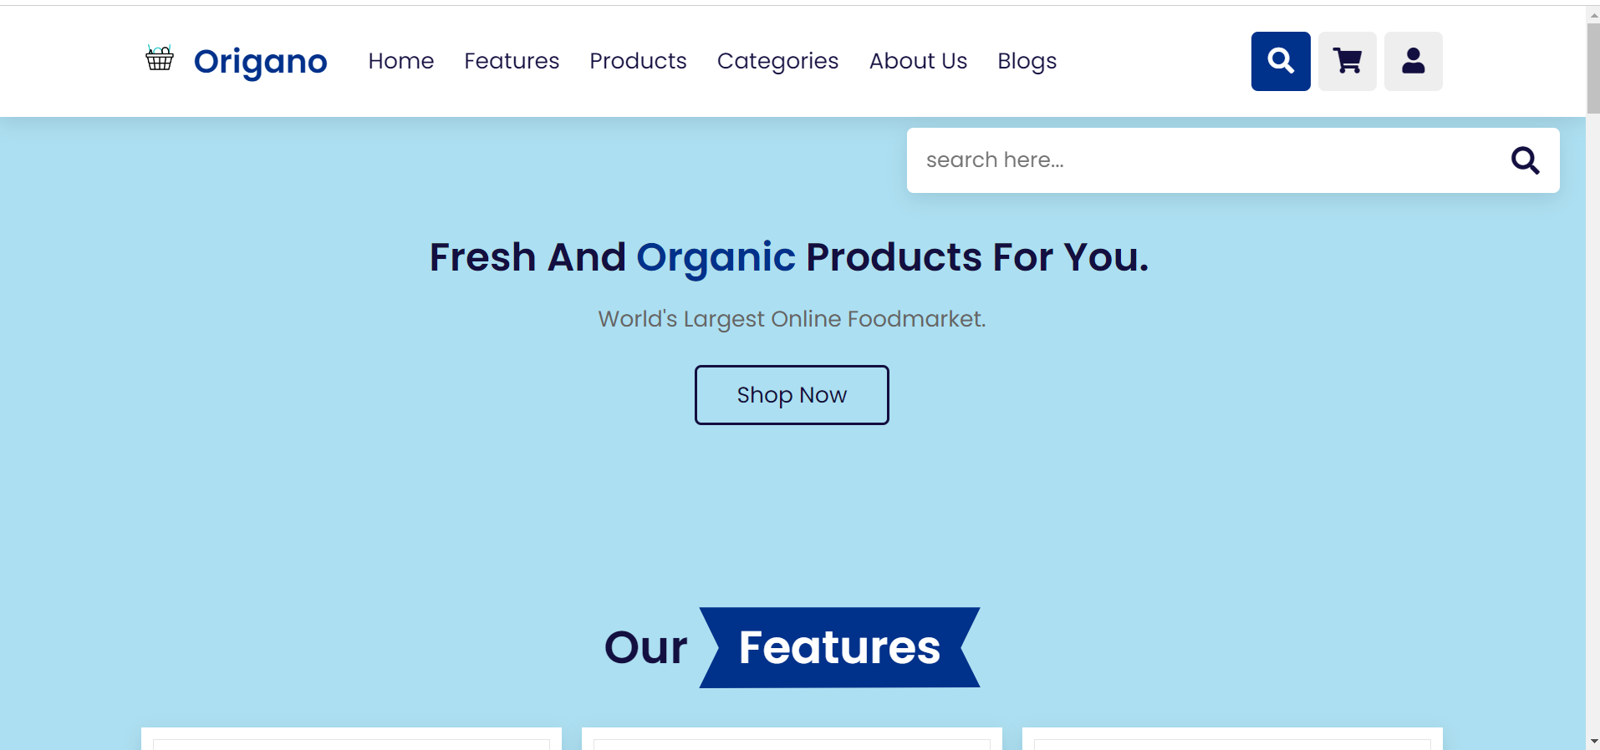

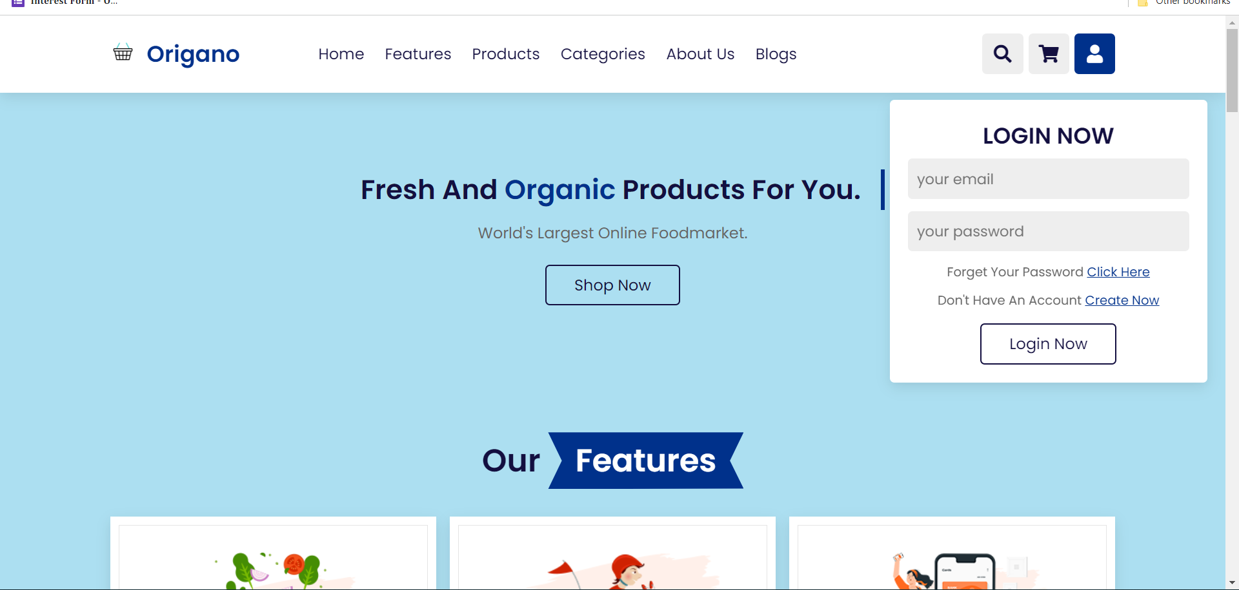

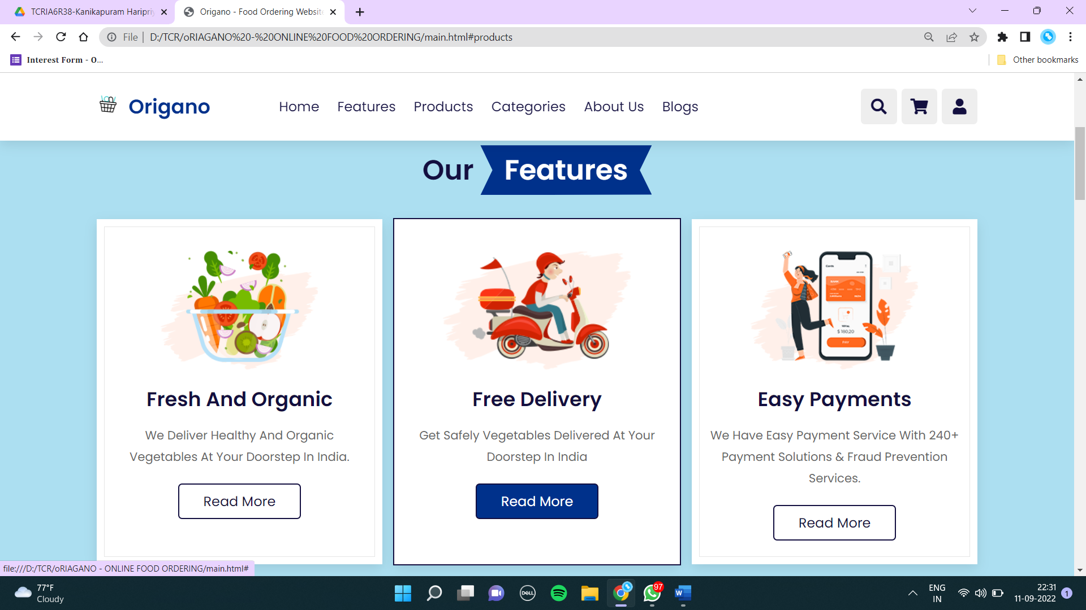

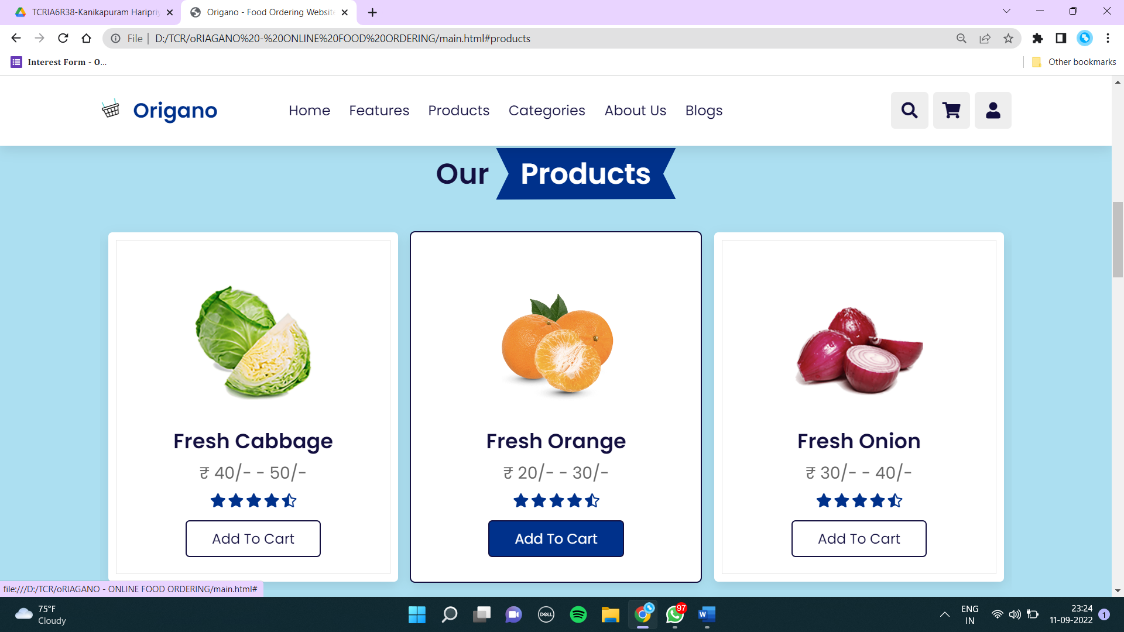

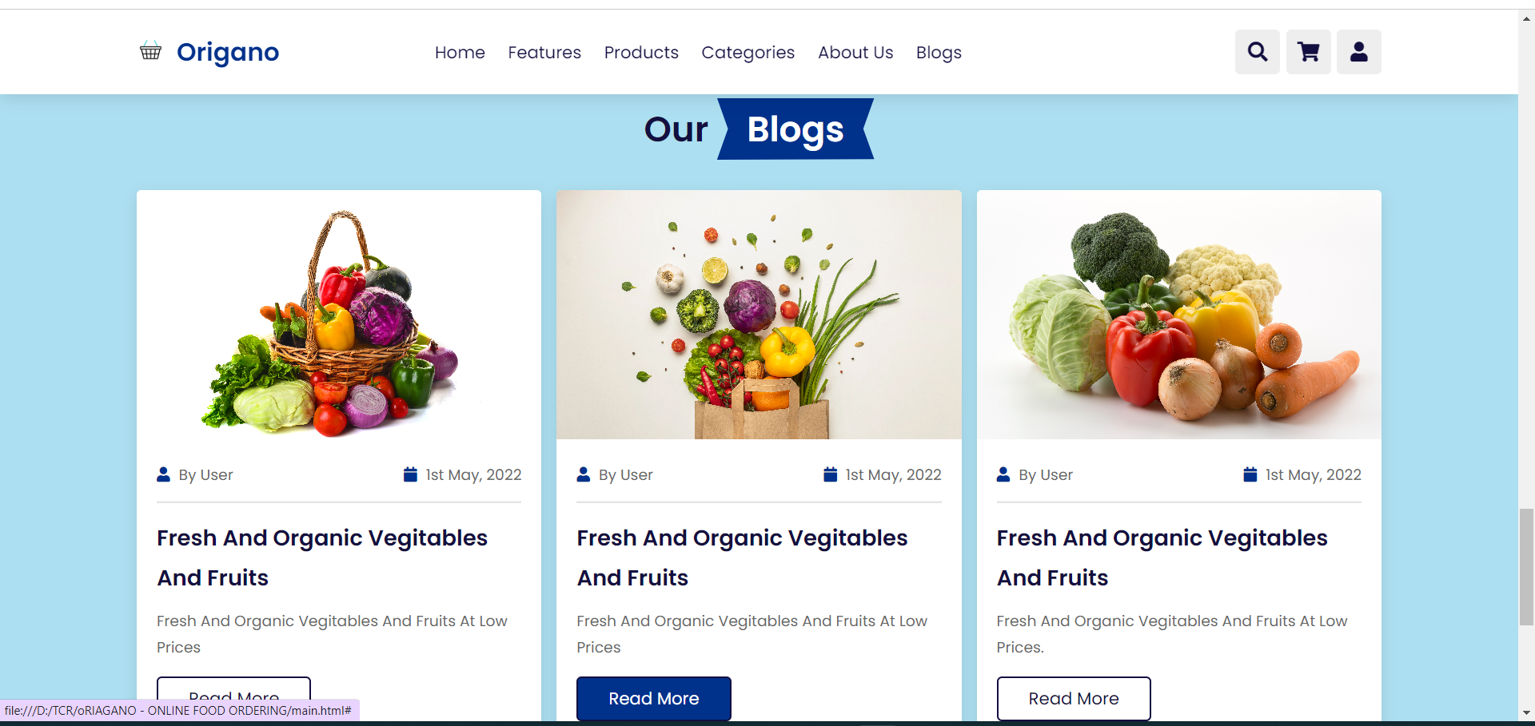

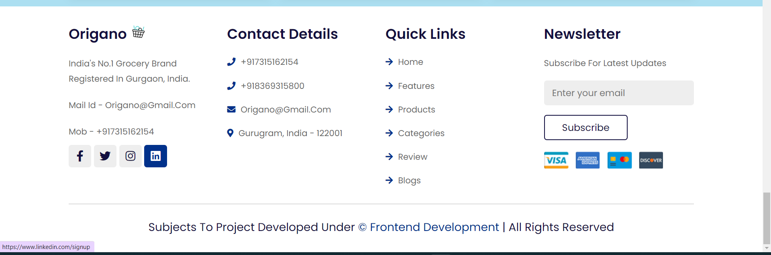

Conclusion

The objective of the website designing is to create a user friendly and enhance its experience. The website is designed by using many technologies which keeps track of information about the whole website. This internship helped us to gain skills and knowledge and provided us essential skills as well as knowledge those are required in the Front-End Development field. We have used HTML, CSS and JavaScript to build this project. During this internship we got stuck in between later we figured it out and resolved the problem. We have learnt a lot while doing this project as well as it was a excellent experience. We get the field work experience and the training was provided by the experienced faculty. It enhanced our knowledge in Website designing as got to know about the languages to be used in website design.

In conclusion, I can say that this internship was a great experience. Thanks to this project, we acquired deeper knowledge concerning our technical skills.

