1. Show all the customers whose creditLimit is greater than 20000.

1. Show the employees who report to VP Sales.

1. Find all the customers who have set their state while filling the forms and Lives in USA and credit limit is between 100000 and 200000.

1. Find all the employees who report to Sales Managers of all types.

1. Find the average credit limit of customers of each country.

1. Find the total no. of orders for each date and customer. Show only dates with total number of orders greater than 10 for date and customer.

1. Find the name of the supervisor, job title of supervisor and total no. of supervisee using subquery. (With out using Join operation)

1. Find the name of the supervisor, job title of supervisor and total no. of supervisee using subquery. (With using Join operation)

1. Find all customers with a credit limit greater than average credit credit limit using WITH Clause. A screenshot of a computer

   AI-generated content may be incorrect.
2. Find the rank of customer. [Customer with highest credit limit have 1 rank and Customer with lowest credit limit have highest rank]. Then, find the customer with the third highest credit limit.

1. Generate a report that shows total no. of employees working in each office.

1. Generate a report that shows total no. of customers visited each office.

1. Generate a report that shows total payment received by each office using payment tables and essential tables. The report should show the office name, state and country, along with total payments made

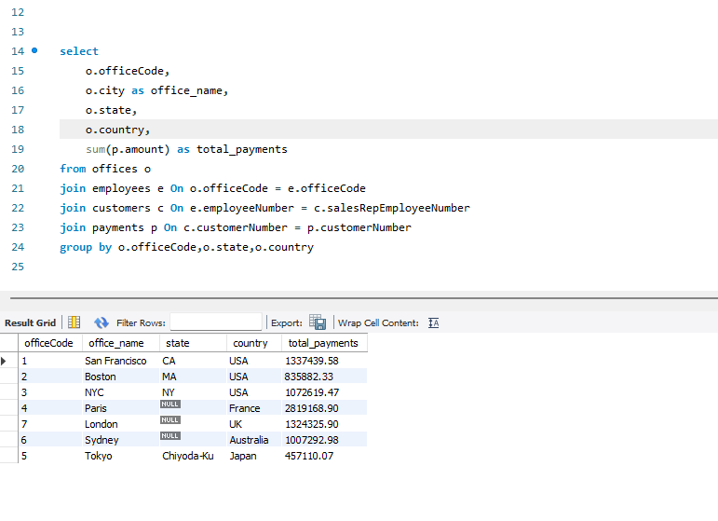

1. Generate a report that shows total sales (in amount) by each office using order details table and other essential tables.

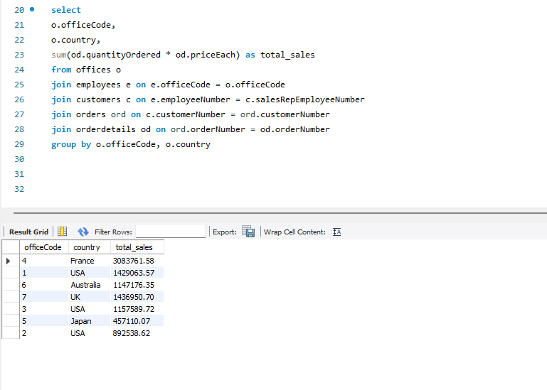

1. Generate a report that shows total payment pending for each office.

1. Find the creditLimit of each person, proportion of creditLimit of each person in each country. [Proportion of person in USA = creditLimit of that person / sum(creditLimit of all person in USA].

1. Create a view showing the customer name, complete address, and their total number of orders.

1. Update the country of a customer (use any one record).

1. Delete all payments below 20,000.

1. Add new payments manually for an existing customer.

