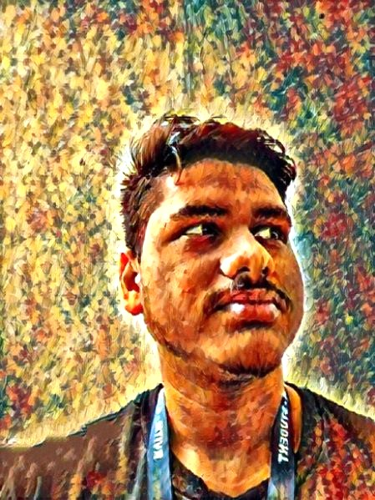
Naman Bagdiya +91-9300681625
Pursuing Bachelors in Engineering namanbagdiya@outlook.com in Computer Science and Engineering GitHub
RV Institute of Technology and Management, Bangalore LinkedIn Portfolio

Summary
Greetings, I am a Computer Science student at RV Institute of Technology, Bangalore. A tech enthusiast with a passion for music, specializing in diverse projects showcased on GitHub.

EDucation

Degree | Institute | Board / University | CGPA/Percentage | Year
B.Tech CSE | RV Institute of Technology and Management,  Bangalore | RVITM Bangalore | —- | 2022-2027
Senior Secondary | Ryan International, Raipur | CBSE | 88.88% | 2020-2022
Matriculation | The Daly College, Indore | CBSE | 79.97% | 2017-2020
Schooling | Rajkumar College, Raipur | ICSE | 82% | 2008-2017
Experience
- Bharat Intern December 2023 - January 2024
Web Developer Intern Remote
  - Netflix Landing Page
  - Portfolio Website
- Viral Fission June 2023 - Current
Youth Ambassador Virtual Internship
  - Brand Management
  - Brand Promotion

Projects
- Portfolio September 2023
Self Made Portfolio
- Netflix Landing Page December 2023 - January 2024
Internship at Bharat Intern Github
  - Netflix Landing Page
- Windows 11 Clone December 2023
Self Made Github
  - Runs on your browser (Preferably desktop or PC)
  - Working apps like Excel, Calculator, etc

Technical Skills
- Programming Languages: C/C++ | Python | HTML | CSS | JavaScript | ReactJs | AngularJs
- Tools and Frameworks: Visual Studio Code | Figma | Canva | Photoshop
- Operating Systems: Windows | Mac

Key courses taken
- Computer Science and Engineering: Introduction to C/C++, Object Oriented Programming in C++, Data Structures and Algorithms, Operating System, Database Management System, Numerical Methods

certifications
- C Programming for Beginners by Udemy
- Create a Virtual Private Cloud (VPC) Using AWS by Coursera
- ChatGPT for Startups by Udemy
- Digital Transformation with Google Cloud by Udemy

