# Project - Virtual Key for your Repositories

##### Contents of this document are as follows-

###### [Project and developer details](#_Project and developer details_1)

###### [Sprints planned and the tasks achieved in them](#_Sprints planned and the tasks achieved in them_1)

###### [Algorithms, Core Concepts used and flowcharts of the application](#_Algorithms and flowcharts of the application_1)

###### [Your conclusion on enhancing the application and defining the USPs (Unique Selling Points)](#_Conclusion on enhancing the application)

---------------------------------------------------------------------------------------------------------------------------------------

##### Project and developer details

****Project objective:****

In this Project we have to develop a console-based application which can perform various tasks such as ->

1. Retrieve all files from a directory.
2. Add, Delete or Search any file from that directory.
3. To be able to exit from the application.

Project code is hosted at Github -

[https:/github.com/NamanUp/Virtual-Key-for-Your-Repositories](https://github.com/NamanUp/Virtual-Key-for-Your-Repositories)

****Developer Details:****

The developer of this application Naman Uppal.

##### Sprints planned and the tasks achieved in them

Project is planned to be completed within 1 Sprint, including Flow Chart and Specification Document.

Tasks to be completed in the Sprint are -

1. Analysis and Creating the flow of the application.
2. Creating a Git Repository and Tracking Progress of the Development
3. Developing and Testing each functionality of the application one by one.
4. Push the code in the Master Branch.
5. Creating Specification Document of the Project.

##### Algorithms, Core Concepts and flowcharts of the application

**Core Java concepts** - File Handling, Exception Handling.

**Algorithms** - Sorting, Recursion.

**FlowChart of the application -**

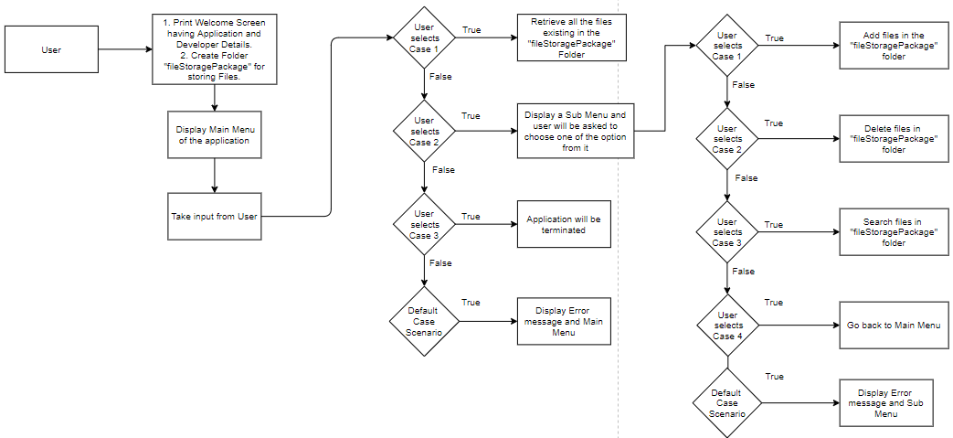

File - I have used Draw.io app for creating the FlowChart (<https://app.diagrams.net/>)



##### Conclusion on enhancing the application

For Further enhancement of the application we can include below functionalities -

1. Writing content in the files.
2. Allowing user to add, delete or search files in different directories.
3. Adding sorting based on size, last modified etc.