# Project - Virtual Key for your Repositories

##### Attaching Screenshots for various operations performed by the Application-

I have created a folder named fileStoragePackage under the Project directory and we are going to retrieve, add, delete or search files from this folder.

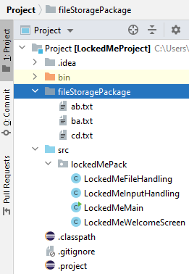

###### Welcome Screen and Main Menu-

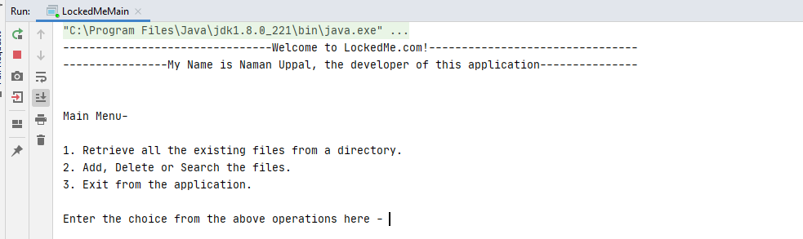

Choosing option 1- Retrieve all the files.

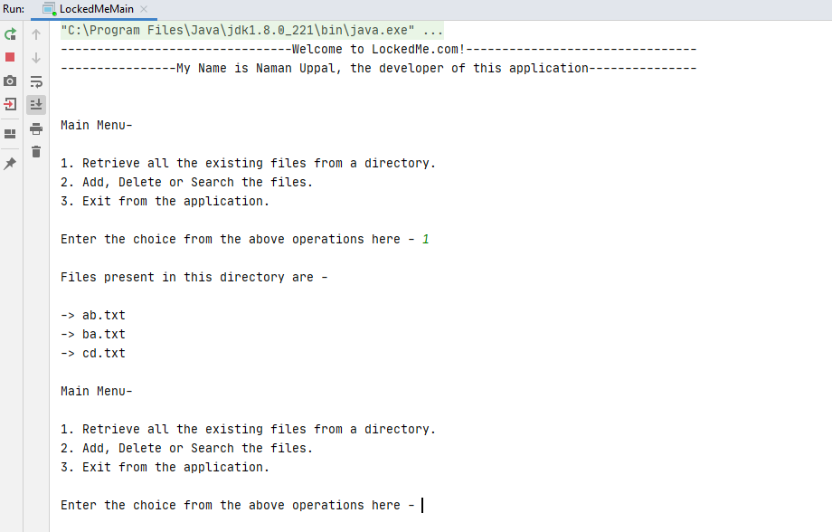

Option 2 is discussed under Sub Menu

Choosing option 3 - To Terminate the Application.

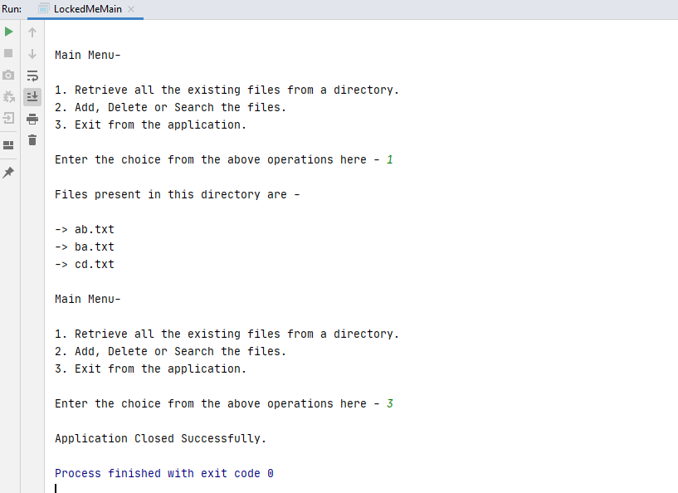

Giving an invalid input -

1. An integer value other than 1,2 or 3 -

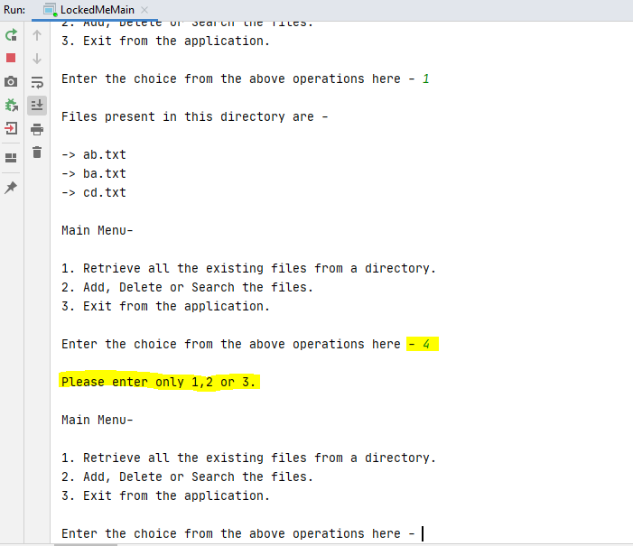

1. A character -

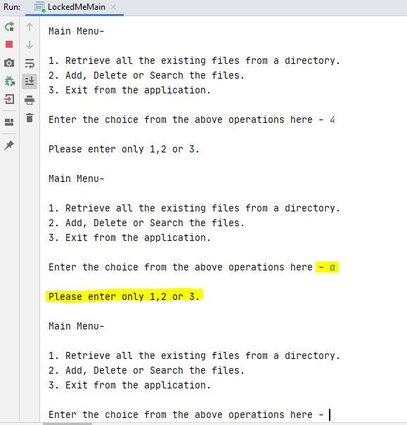

###### 

###### Sub Menu-

Choosing option 2 from Main Menu -

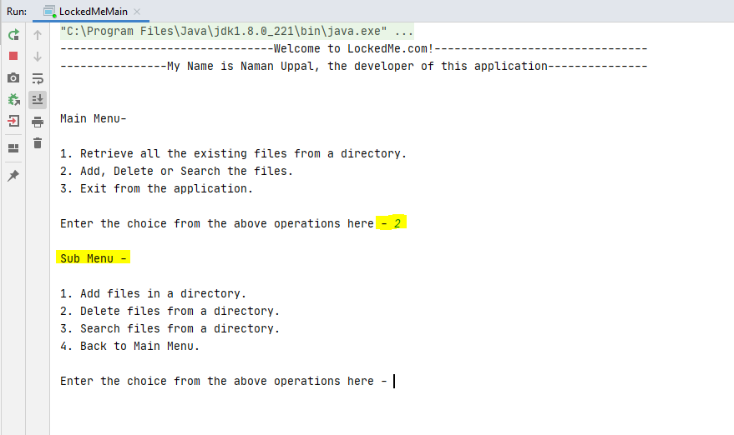

###### Add Files -

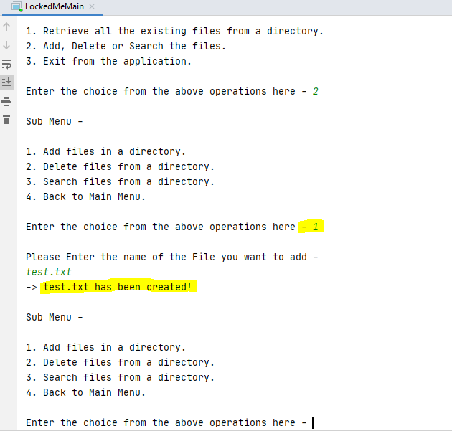

Check in the Directory -

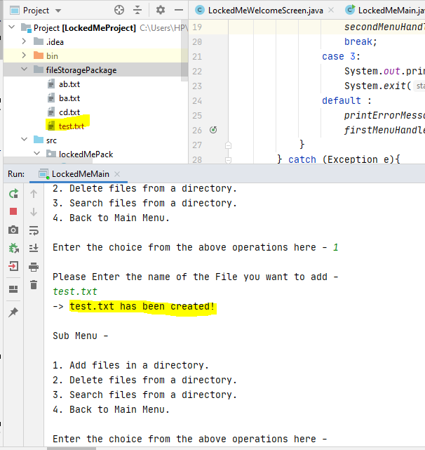

###### Delete Files -

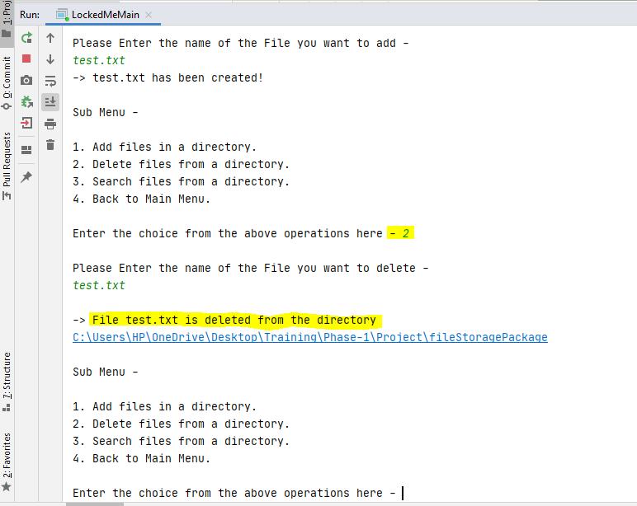

Check in the directory -

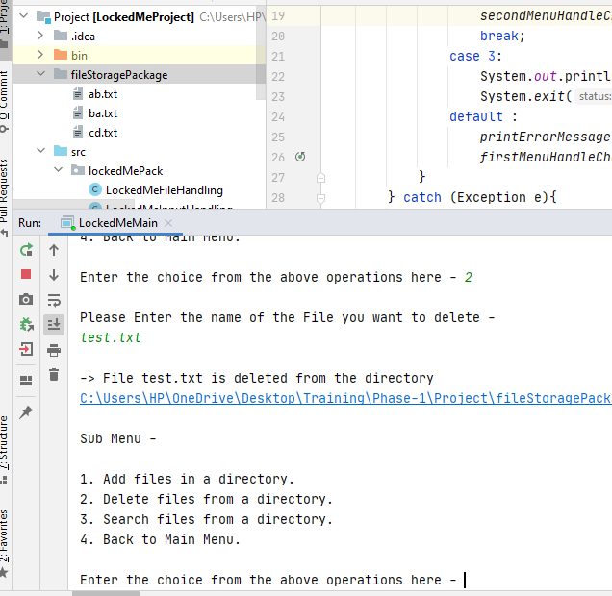

Deleting a file which is not present in the Directory -

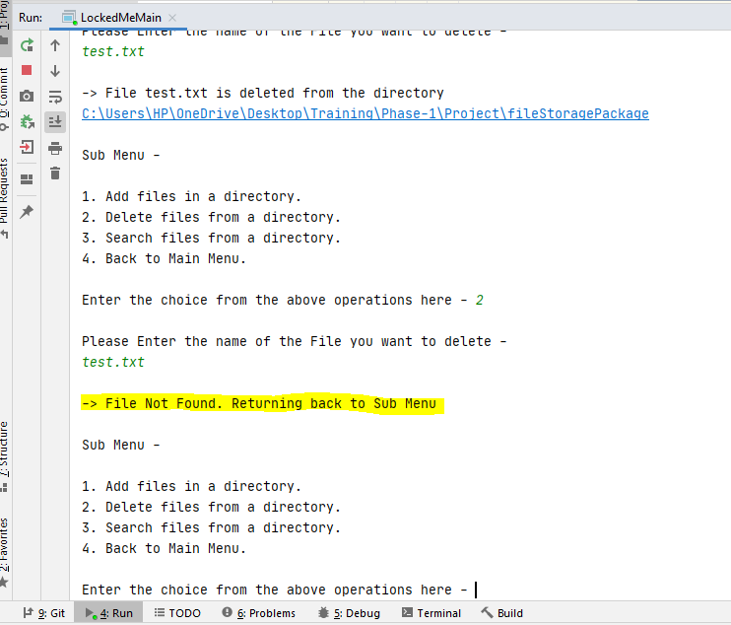

###### Search Files -

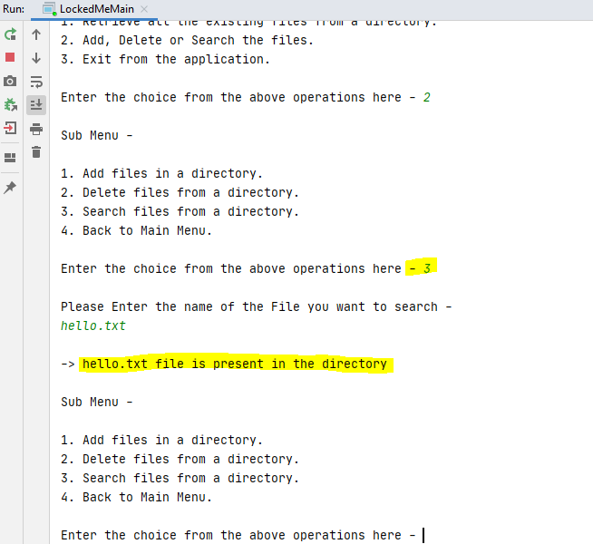

Searching a file which is not there in the Folder -

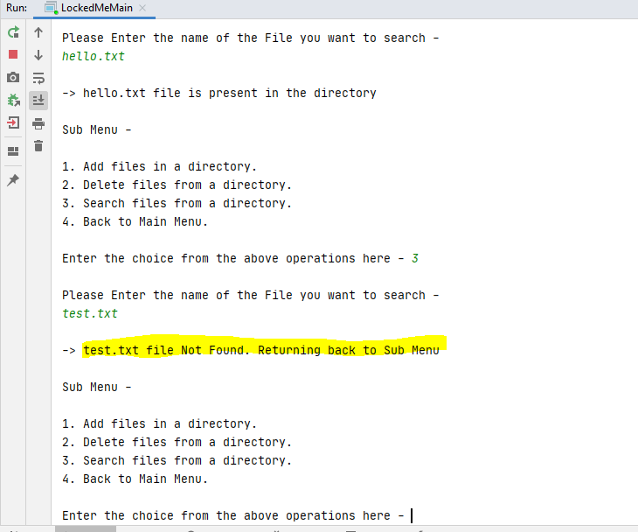

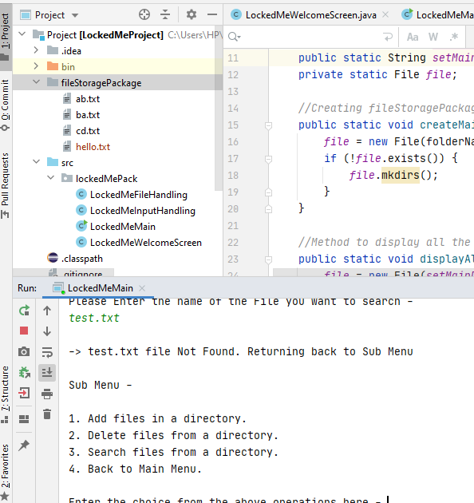

###### Go Back to the Main Menu-

###### 

Case - If Directory is deleted

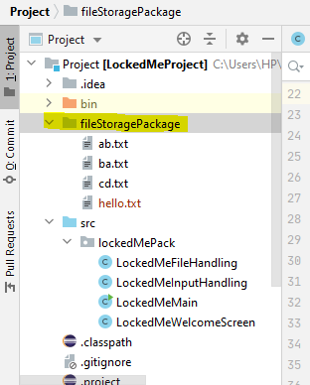

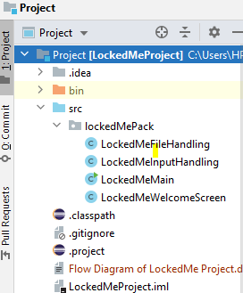

Then Directory will be created again ->

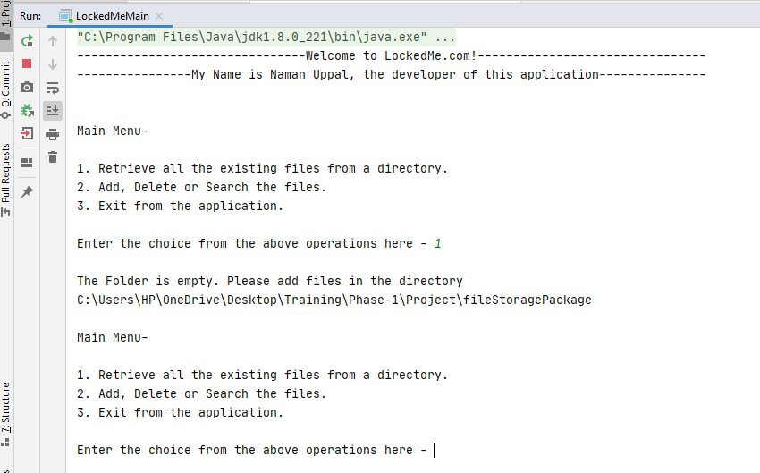

Empty Folder will be created ->

