ProjectMemristor Documentation

ProjectMemristor Documentation

Overview
This project implements the HP TiO2 memristor model (Strukov et al., 2008) with a Joglekar window function to keep the ion-drift boundary behavior physical. The primary implementation is `src/memristor/hp.py` which provides the `HPMemristor` class.

Governing equations
- Memristance (linear interpolation between ON and OFF resistances):

$$M(x) = R_{on}\,x + R_{off}\,(1 - x)$$

- Current (Ohm's law using the instantaneous memristance):

$$i(t) = \frac{v(t)}{M(x(t))}$$

- Joglekar window function (to bound state evolution near edges):

$$f(x; p) = 1 - (2x - 1)^{2p}$$

- State derivative (ion-drift rule with windowing):

Let

$$k = \frac{\mu_v\,R_{on}}{D^2}$$

then

$$\frac{dx}{dt} = k\,i(t)\,f(x; p)$$

where:
- $R_{on}$: low resistance state (Ω)
- $R_{off}$: high resistance state (Ω)
- $D$: device thickness (m)
- $\mu_v$: ion mobility (m^2 / (V·s))
- $x\in[0,1]$: normalized state variable indicating fraction of doped region
- $p$: window sharpness parameter

Implementation notes
- `HPMemristor` methods:
- `current(voltage)` — returns instantaneous current given `voltage` and current `x`.
- `dxdt(voltage)` / `dxdt_from_current(i)` — compute state derivative.
- `update_state(voltage, dt)` — integrate state forward using Euler step and clip to [0,1].
- `apply_voltage(voltage, dt)` — compute current at start of step, integrate state, and return the pre-update current.

How to reproduce plots
A script `tests/hp_simulations.py` is provided to run three different input parameter sets and save plots:
- V-I hysteresis (voltage vs current)
- State variable vs time (x vs t)
- Memristance vs time (R vs t)

Run the script from the project root after activating the virtualenv:

source .venv/bin/activate
python tests/hp_simulations.py

The script saves PNG files into the project root named:
- `hp_vi_set1.png`, `hp_x_set1.png`, `hp_r_set1.png` (and likewise for `set2`, `set3`).

Parameters used in examples
Three example parameter sets used in the simulation script (each runs a sinusoidal voltage):

- Set 1: A = 1.5 V, f = 0.5 Hz, dt = 1e-4 s
- Set 2: A = 2.5 V, f = 1.0 Hz, dt = 5e-5 s
- Set 3: A = 0.8 V, f = 0.2 Hz, dt = 2e-4 s

You can customize amplitude `A`, frequency `f`, simulation time `T`, and initial `x0` by editing `tests/hp_simulations.py`.

Figures included
The simulation script generates the figures and saves them as PNGs. See the project root (or `tests` output) after running the script.

References
- Strukov, D. B., Snider, G. S., Stewart, D. R., & Williams, R. S. (2008). The missing memristor found. Nature, 453(7191), 80–83.

---

Generated by tooling in the repository to illustrate the HP memristor model and example outputs.

hp_vi_set1.png
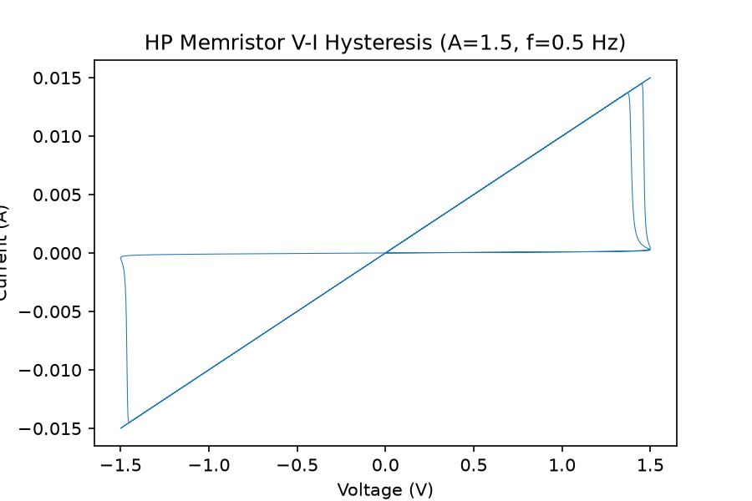
Figure: hp_vi_set1.png

hp_x_set1.png
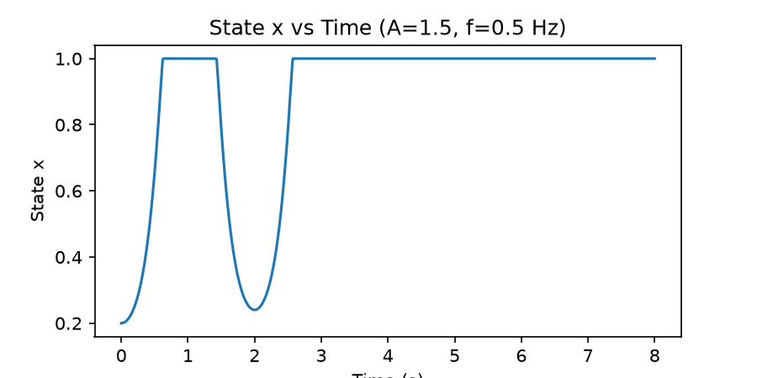
Figure: hp_x_set1.png

hp_r_set1.png
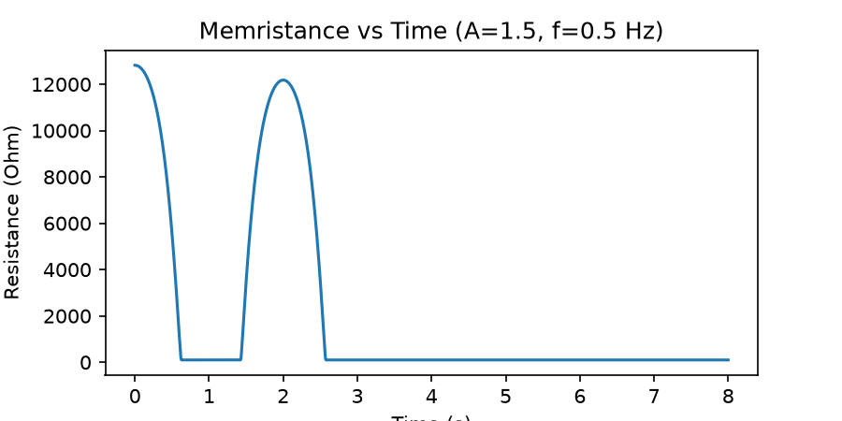
Figure: hp_r_set1.png

hp_vi_set2.png
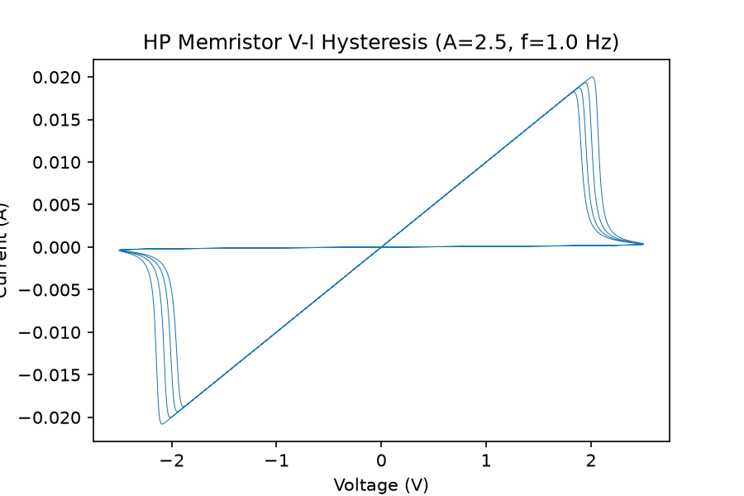
Figure: hp_vi_set2.png

hp_x_set2.png
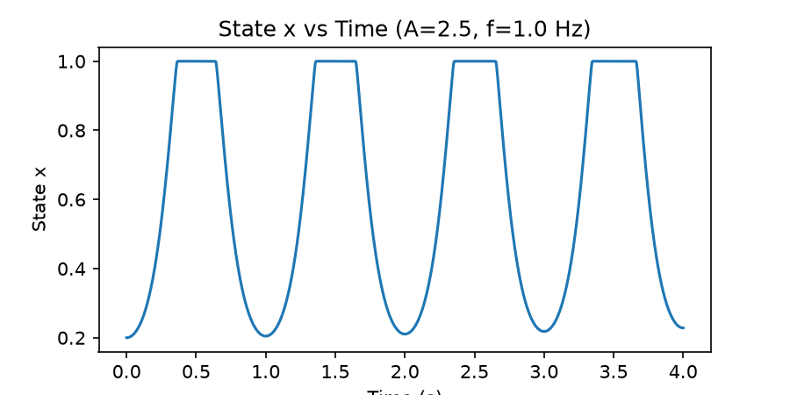
Figure: hp_x_set2.png

hp_r_set2.png
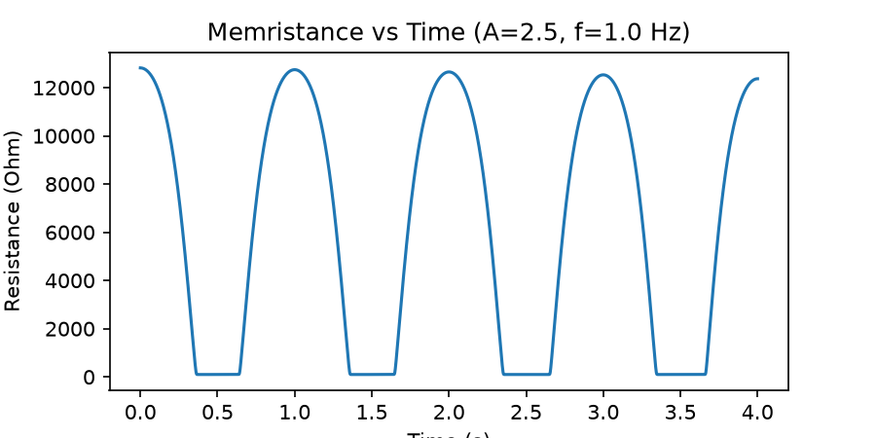
Figure: hp_r_set2.png

hp_vi_set3.png
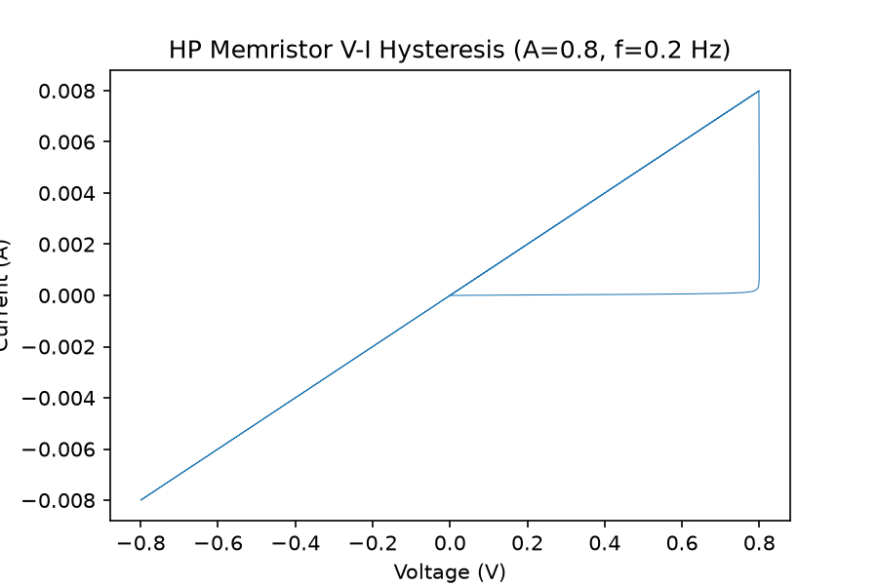
Figure: hp_vi_set3.png

hp_x_set3.png
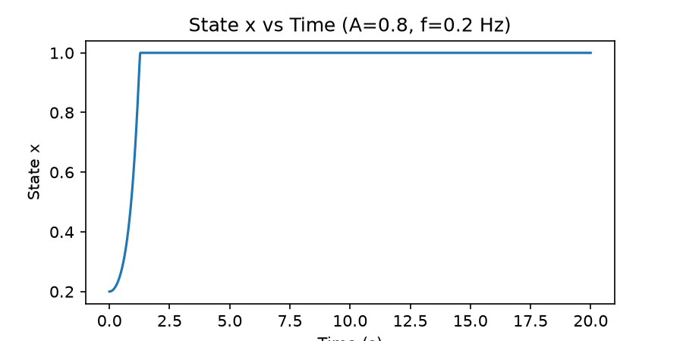
Figure: hp_x_set3.png

hp_r_set3.png
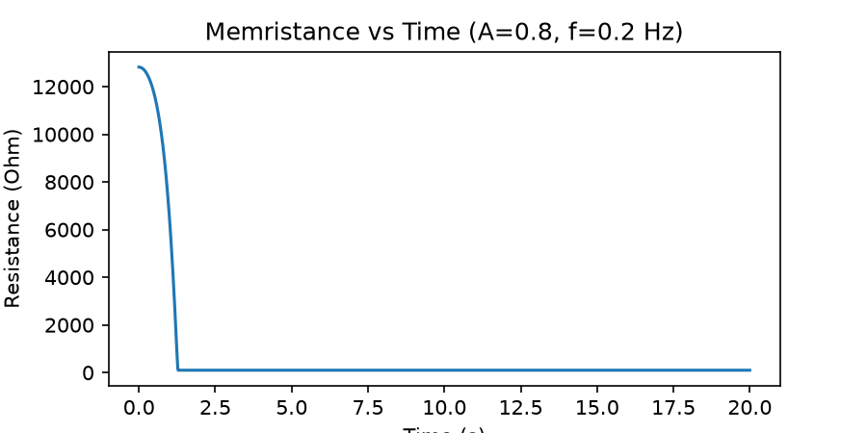
Figure: hp_r_set3.png

