ProjectMemristor Documentation

ProjectMemristor Documentation

Overview
This project implements the HP TiO2 memristor model (Strukov et al., 2008) with a Joglekar window function to keep the ion-drift boundary behavior physical. The primary implementation is `src/memristor/hp.py` which provides the `HPMemristor` class.

Governing equations

1. Memristance Equation
M(x)=Ron​x+Roff​(1−x)
This says:
The resistance depends on the internal state x.
Here,
- Ron​ = minimum resistance (device fully ON)
- Roff​ = maximum resistance (device fully OFF)
- x = fraction of the conducting (doped) region
Since 0≤x≤1,
If
- x=1
then
M=Ron​
meaning completely ON.
If
- x=0
then
M=Roff​
meaning completely OFF.
If
x=0.5
then
M=2Ron​+Roff​​
So this equation is simply linear interpolation between the two resistance states.

2. Current Equation
i(t)=M(x(t))v(t)​
This is simply Ohm's Law.
Voltage is applied.
Resistance depends on the state.
Therefore current becomes
I=RV​
Nothing special here except that R is changing continuously, so current changes even if voltage is constant.

3. Window Function
f(x;p)=1−(2x−1)2p
This is called the Joglekar Window Function.
Its purpose is to slow down the movement of ions near the boundaries.
Without this function,
the state variable may become
x>1
or
x<0
which is physically impossible.
Let's see:
If
x=0
then
f=0
If
x=1
then
f=0
If
x=0.5
then
f=1
So,
the ions move fastest in the middle and almost stop near the edges.
Changing p:
- small p: gentle slowing
- large p: sharp slowing near the boundaries

4. Constant
k=D2μv​Ron​​
This combines several physical constants.
Where
- μv​ = mobility of oxygen vacancies
- Ron​ = ON resistance
- D = oxide thickness
It tells how quickly the state changes.
Large mobility →
large k
→ faster switching.
Larger device thickness →
smaller k
→ slower switching.

5. State Equation
dtdx​=ki(t)f(x;p)
This is the heart of the memristor model.
It says
The internal state changes according to the current flowing through the device.
Breaking it down:
- More current → faster change.
- Larger mobility → faster change.
- Near the boundaries → the window function slows the change.
- Zero current → no state change.
This equation tells you how the conductive region grows or shrinks over time.

Implementation notes
- `HPMemristor` methods:
- `current(voltage)` — returns instantaneous current given `voltage` and current `x`.
- `dxdt(voltage)` / `dxdt_from_current(i)` — compute state derivative.
- `update_state(voltage, dt)` — integrate state forward using Euler step and clip to [0,1].
- `apply_voltage(voltage, dt)` — compute current at start of step, integrate state, and return the pre-update current.

How to reproduce plots
A script `tests/hp_simulations.py` is provided to run three different input parameter sets and save plots:
- V-I hysteresis (voltage vs current)
- State variable vs time (x vs t)
- Memristance vs time (R vs t)

Run the script from the project root after activating the virtualenv:

source .venv/bin/activate
python tests/hp_simulations.py

The script saves PNG files into the project root named:
- `hp_vi_set1.png`, `hp_x_set1.png`, `hp_r_set1.png` (and likewise for `set2`, `set3`).

Parameters used in examples
Three example parameter sets used in the simulation script (each runs a sinusoidal voltage):

- Set 1: A = 1.5 V, f = 0.5 Hz, dt = 1e-4 s
- Set 2: A = 2.5 V, f = 1.0 Hz, dt = 5e-5 s
- Set 3: A = 0.8 V, f = 0.2 Hz, dt = 2e-4 s

You can customize amplitude `A`, frequency `f`, simulation time `T`, and initial `x0` by editing `tests/hp_simulations.py`.

Figures included
The simulation script generates the figures and saves them as PNGs. See the project root (or `tests` output) after running the script.

References
- Strukov, D. B., Snider, G. S., Stewart, D. R., & Williams, R. S. (2008). The missing memristor found. Nature, 453(7191), 80–83.

---

Generated by tooling in the repository to illustrate the HP memristor model and example outputs.

hp_vi_set1.png
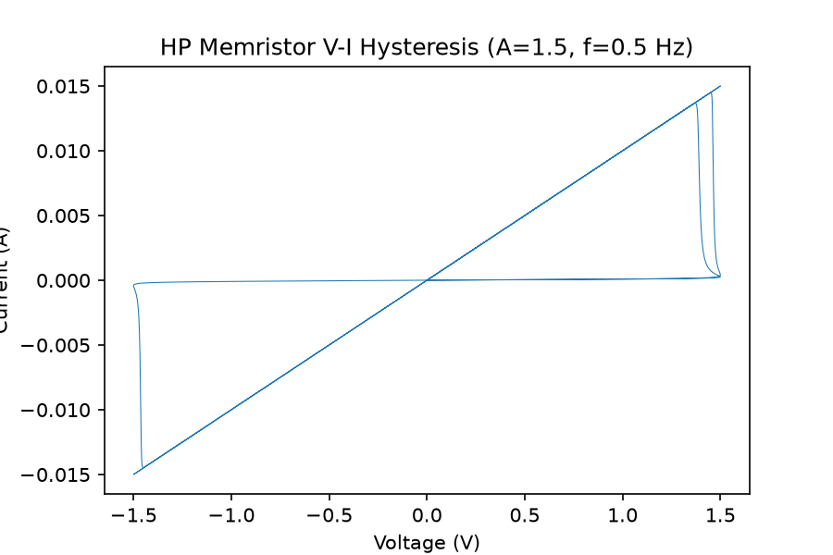
Figure: hp_vi_set1.png

hp_x_set1.png
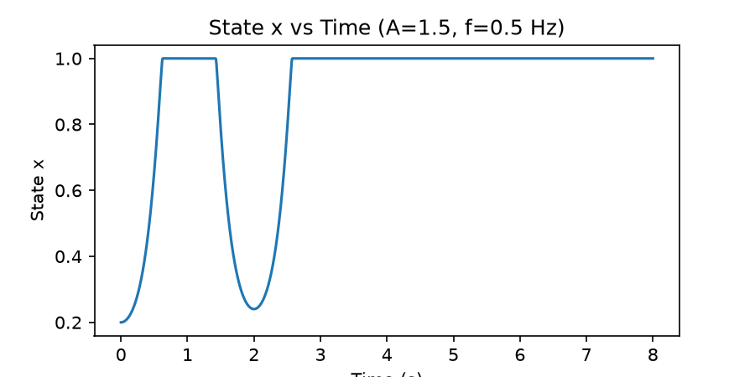
Figure: hp_x_set1.png

hp_r_set1.png
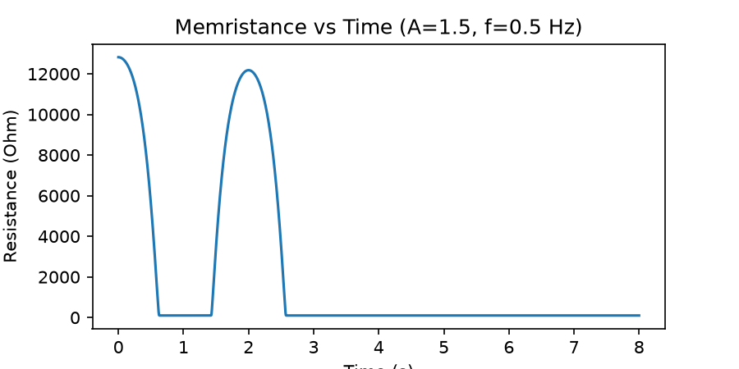
Figure: hp_r_set1.png

hp_vi_set2.png
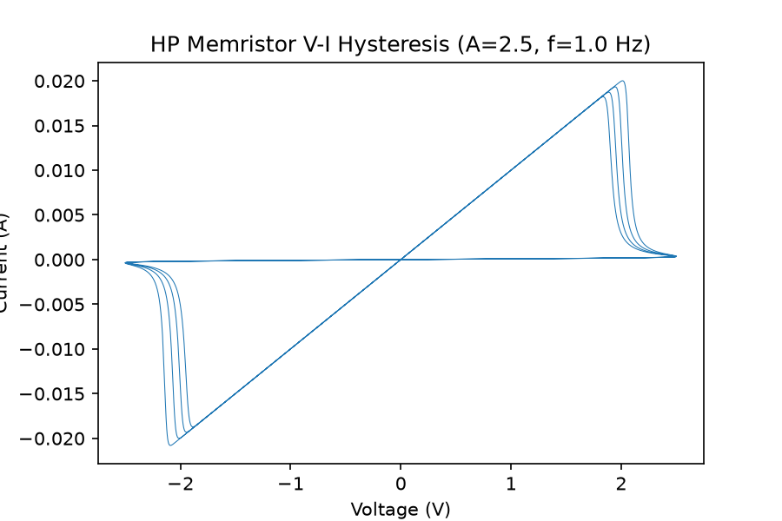
Figure: hp_vi_set2.png

hp_x_set2.png
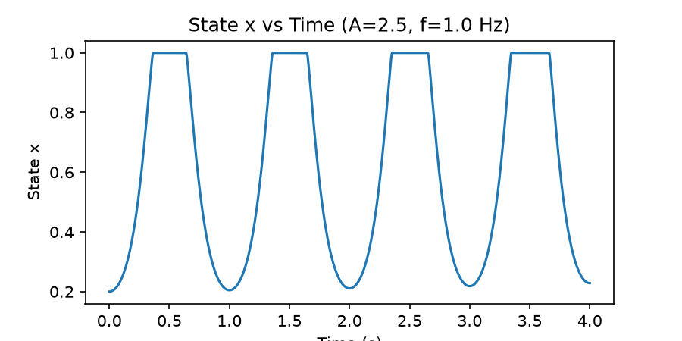
Figure: hp_x_set2.png

hp_r_set2.png
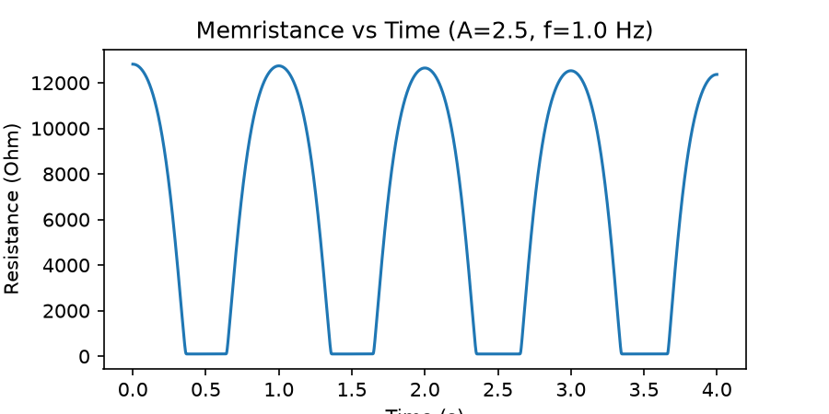
Figure: hp_r_set2.png

hp_vi_set3.png
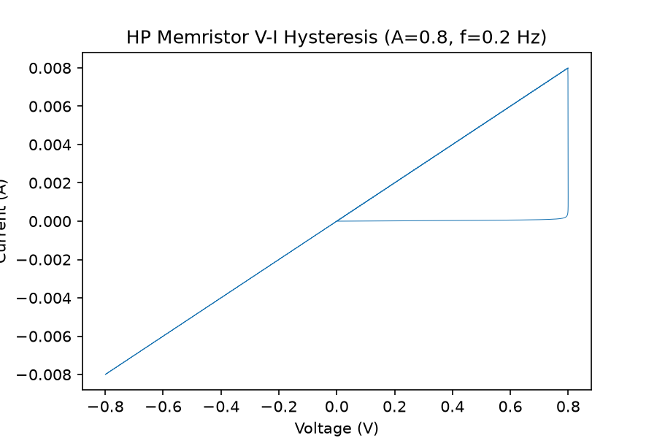
Figure: hp_vi_set3.png

hp_x_set3.png
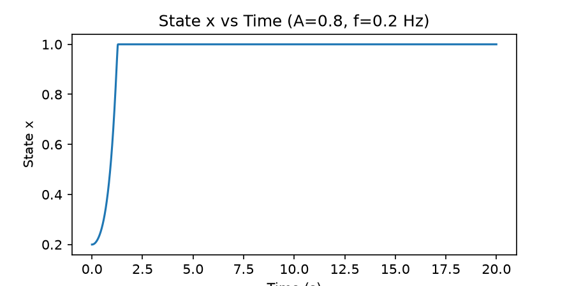
Figure: hp_x_set3.png

hp_r_set3.png
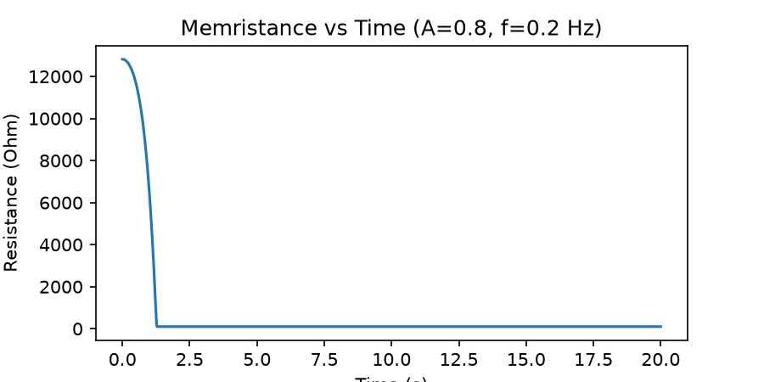
Figure: hp_r_set3.png

