**Amendment made in 2020 Juvenile Justice Act**

* The new amendment lays down the eligibility for the appointment of members of the Child Welfare Committees.
* The definition of children in need of care and protection will be modified.
* It will include those children who have been victims of trafficking or drug abuse or child labour.
* Will also include children who have been abandoned by their guardians.

The district magistrate and the additional district magistrate will have increased powers to monitor the functions of agencies responsible for implementation of the Act. For example:

* The district child protection unit will function under the district magistrate.
* Before registration of a child care institution, the district magistrate will conduct its capacity and background check, and make recommendations to the state government.
* The district magistrate will now be able to independently evaluate a specialised Child Welfare Committee, juvenile police unit and other registered institutions.

The amendment will add one more category of crime to the “Serious offences” list.

It will include offences where the sentence is more than 7 years but no minimum sentence is prescribed; or a minimum sentence of less than 7 years is provided.

**DICKINSONIA FOSSILS:**

* About 550 million years ago, animals were restricted to the seas.
* The continents were volcanic and barren.
* Microbes and larger multicellular organisms covered much of the seafloor in an organic mat (similar to pond floor).
* On top of this, settled the world’s first animals.

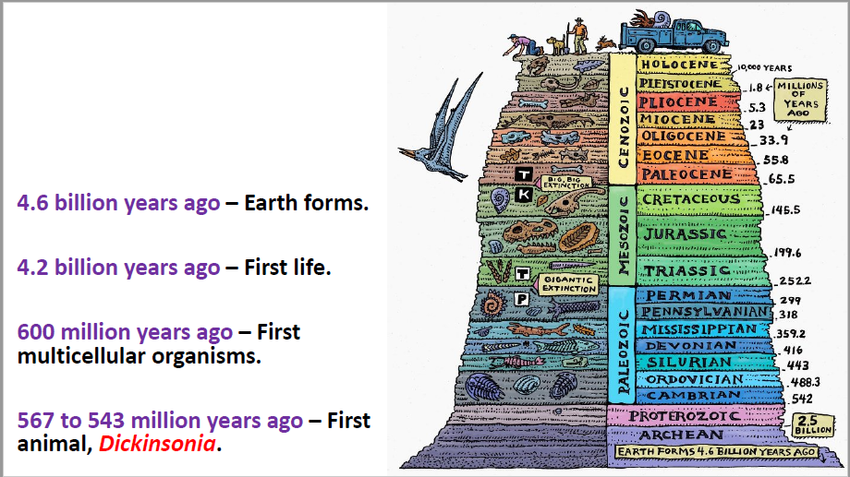

* Dickinsonia fossils were first found in Australia, in 1947.
* Later specimens were also found in China, Ukraine and Russia.
* Pancake shaped fossils of a metre in length.
* The early fossils in Australia were found solely as two-dimensional imprints in sandstone.
* Equivalent to judging the structure of our modern world if human beings had only two footprints.
* Debate raged on what Dickinsonia was – early form of jellyfish, or annelid worms, or mushrooms, or enormously oversized lichens or single-celled organisms

***In 2018, a study finally confirmed Dickinsonia as an animal – with the discovery of cholesterol molecules in the fossils.***

***Cholesterol in cell membranes is a hallmark of animals.***

* Trackways left behind by the Dickinsonia fossils, exhibit movement in a preferred direction.
* This suggests an organism moving under its own power and moving in a direction related to its internal biology.
* With this, researchers have concluded that *Dickinsonia* fed in one spot on the seafloor's organic carpet and then actively sought a fresh food source.
* This movement in search for food lasted for hours or days.
* Dickinsonia belonged to the Ediacaran period (635 million years ago to 541 million years ago).
* The living creatures of the era called vendobionts.
* This was also the time when the earliest multicellular organisms, or metazoans emerged.

At the end of the Ediacaran period (and beginning of the Cambrian), an evolutionary uprising occurred.

* It overturned the simple ecosystems and set the stage for our modern world.
* Known as the Cambrian explosion.
* It produced animals with familiar anatomies and behaviors, such as creatures with shells, spines, thrashing limbs and tooth-rimmed jaws that could trap and devour prey.
* The first Indian fossils of Dickinsonia, were discovered in the roof of the auditorium cave in Bhimbetka Rock Shelters, part of the Vindhyan super group of rocks.
* The age of fossil rock is determined using isotopes.
* Zircon dating of the youngest Maihar sandstone in Madhya Pradesh puts its age at 548 Ma (Ediacaran Period).
* The limestones of lower Bhander group in the Son and Chambal valleys range from 978 Ma to 1073 Ma (older Tonian period).
* The age profiles of the Dickinsonia fossils in the Maihar sandstone of Bhimbetka, have been found to be about 555 Ma.
* Timescale comparable to its fossils from Russia’s White Sea region.
* The Bhimbetka fossils are also comparable to *Dickinsonia tenuis* and *Dickinsonia costata* fossils in South Australia, estimated to be from 550 Ma.
* Dickinsonia fossils from India were found by the scientists to be identical to the Rawnsley Quartzite in South Australia.
* Studies of the rock characteristics in and around Bhimbetka show that they shared several characteristics with rocks in Australia, including “old elephant skin” texture.
* There is also evidence of a trace fossil, *Prasinema gracile* (fungi or plant).

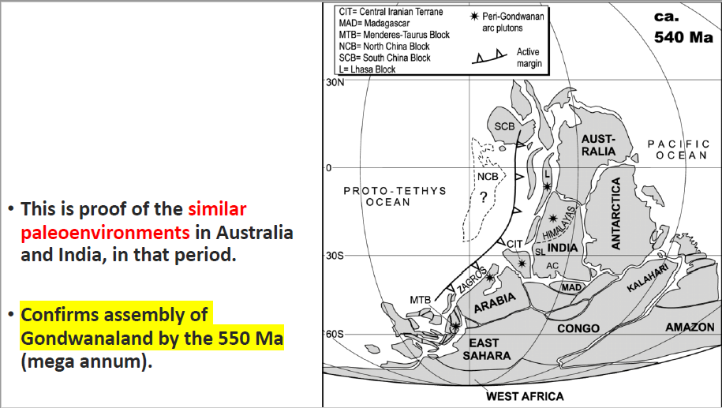

* This proves the proximity of the two land masses – India and Australia – in Gondwanaland in that era.
* The evidence however did not support reconstructions adjusted for the polar wander phenomenon.
* Polar wanderer phenomenon involves motion of continents over geologic time and its impacts.

**CCI – ON STEEL COMPANY CARTELIZATION**

**CCI is India’s anti-trust regulator.**

* **Statutory body of the Government of India.**
* **Responsible for enforcing the Competition Act, 2002, throughout India.**
* **Prevents activities that have an adverse effect on market competition.**
* **1 chairman + 5 other members.**
* **Replaced the Monopolies and Restrictive Trade Practices Commission.**
* **In June 2020, the CCI had held Tata Steel and three other companies on charges of cartelisation in the domestic industrial and automotive bearings market between 2009 to 2014.**
* **However, back then, the companies were let off with only a warning.**
* **No penalty imposed – the companies were just asked to cease cartel behaviour in the future.**

The steel companies’ defence

* Steel companies have blamed the rise in the raw material cost.
* They have pointed out that iron ore prices have surged by 135% in the last one year.
* Steel tycoons have defended themselves by saying that even now, domestic steel prices are still less than the costs of imported steel.
* Imported steel from China has become 80% costlier, and that of the US 119% more expensive.
* The RoCE (Return on capital employed) in the steel industry is as low as 14-15 percent (as their input is iron ore and if there is no iron oreyou can’t produce steel).
* Steel companies say, that this low RoCE does not enable them to reinvest.

*The Union Minister of Road Transport has called on CCI to check the rising prices of steel. In January 2021, he had pointed out that every steel company has*

*its own iron ore mines and there has been no increase in labour and power costs, yet they are increasing rates.*

The Reply from User Industries

• The government has waived the anti-dumping duty on a few (imported) steel products till September 2021.

• It has also halved the Customs duty to 7.5% on import of semis, flat and long products of non-alloy, alloy and stainless steel.

• Industries that buy steel as raw material, have questioned the logic of the steel companies comparing domestic prices with landed cost of imports.

*China is still ranked 1st with a production of 996 million tonnes in 2019. India produced 111 MT in 2019.*

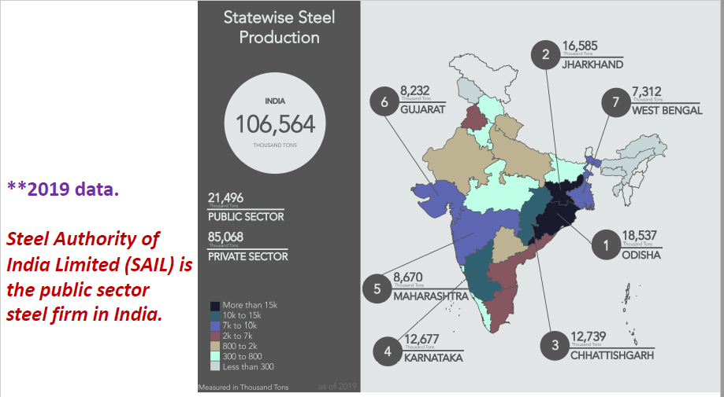

SAIL’s 5 major plants are at – Bhilai, Bokaro, Durgapur, Burnpur (IISCO), and Rourkela.

• SAIL announced doubling of its at 5 of its steel plants capacity in September 2020.

• Ministry of Steel plans to invest US$ 70 million in the eastern region of the country through accelerated development of the sector.

• The production capacity of SAIL is expected to increase from 13 MTPA to 50 MTPA in 2025 with total investment of US$ 24.88 billion.

Steel companies by the production capacity of their Indian units:

1. SAIL = 21 Million Tonnes (MT) per annum.

2. Tata Steel = 19.4 MT per annum (overseas capacity 14.6 MT pa; hence Tata Steel is the biggest Indian steel company by revenue).

3. JSW Steel Limited = 18 MT per annum.

4. Essar Steel India Limited = 10 MT per annum.

5. Jindal Steel and Power Limited = 8.6 MT pa (capacity in Oman =2.4 MT pa).

**ENVIRONMENTAL IMPACT ASSESSMENT ON DAM**

• It was approved just a day before the Uttarakhand avalanche tragedy, of February 2021.

• Experts say, the obstruction offered by hydro-projects to the river on its mountain course, amplified the flood.

• There is a fear that because the Lakhwar project has a huge reservoir dam, it will kill the flow of river Yamuna downstream.

This can affect agriculture in UP and Haryana.

• The project was allowed to go ahead without any scientific studies or proper environment impact assessments (EIA).

• It had been exempted from assessment, because of questionable interpretation of the law, which states that the project was proposed before the EIA Act of 2006.

• Experts argue that it was done at a time when the level of environment consciousness was different and the report only talked about the loss of trees and the diverted forest land but not of its direct or indirect impacts.

* There is no community impact assessment, no disaster impact assessment.
* The Lakhwar-Vyasi hydroelectric project in Uttarakhand is almost the size of the Tehri hydroelectric project.
* Environmentalists say that this means that an EIA should be conducted.
* 2015 – Petition filed in NGT, pointing out –
* Lakhwar HEP is planned just 120 km from Yamuna's origin at Yamunotri.
* As a result of the 40 km long reservoir, the free flowing stretch of the river Yamuna would be reduced to just 75-80 km.
* It will convert the entire river into something similar to a lake.

• The site is downstream of where the Aglar river meets the Yamuna, a stretch which is rich in mahseer fish and will impact its movement and population.

• The project site is also located in an earthquake-prone zone making it vulnerable to disasters.

*The draft EIA 2020 exempts the public consultation process (required for approving projects under EIA 2006), for irrigation, construction and area development projects, etc.*

1. **Solar power is a far cheaper alternative today. It has less environmental impact on human lives and livelihoods. So is it time to switch from Hydro-electricity to solar energy?**
2. **Do you think Ease of Doing Business should be chased by the policymakers at the cost of disaster vulnerability?**

**PATHARUGHAT UPRISING IN BRITISH COLONALISATION:**

1826 – East India Company’s annexation of Assam.

* Surveys of the vast lands of the state begin.
* On the basis of such surveys, the Company Raj begins to impose land taxes, much to the resentment of the farmers.
* Peasants would pay taxes in kind or provide a service in lieu of cash.

1893 – The British government decides to increase agricultural land tax by 70- 80 per cent.

* Throughout Assam, peasants begin protesting the move by organising Raij Mels(kisan, or peaceful peoples’ conventions (Although INC was formed during this period but there was no involvement of them in Assam at that time).
* These gatherings were democratic and mostly nonviolent.
* The British perceived them as breeding grounds for sedition, and started brutal crackdowns upon Raij Mels.

1894 – On January 28th, when the British officers were refusing to listen to the farmers’ grievances, things heated up.

* There was a lathi charge, followed by an open firing which killed many of the peasants present.
* Official sources place at casualties at 15 killed and 37 wounded.
* Unofficial sources claim it was a much higher number (approx. 150).

Though it is one of most tragic and inspiring episodes of the Indian freedom movement, recorded history mentions little detail about it today.

* For the Assamese community, the Patharughat massacre comes second only to the Battle of Saraighat (when the Ahoms defeated the Mughals in 1671).
* It is often mistakenly refered to as the “Patharughat Ron” or the “Battle of Patharughat”.
* However, it was a peaceful protest, and a precursor to the Civil Disobedience movement.
* In the pre-Congress pre-organised-independence-struggle era, it is one of the few instances, when the masses organised themselves to resist the autocratic designs of the British.

28th January, 2001 – A martyrs column was erected at the site by the Army and unveiled by SK Sinha, former Governor of Assam.

* Every year on January 28, the government and local people pay respects to the martyrs of the incident.
* Krishak Swahid Diwas is held as an official function.

**WORLD SOLAR BANK(WSB):**

*At the COP 26 at Glasgow, the India led ISA plans to launch:*

* Green Grid Initiative–a joint effort of ISA and Climate Parliament to encourage all member countries to emulate India’s GEC and integrate them to OSOWOG.
* Sun Charter
* World Solar Bank

Companies creating the road map for the global grid OSOWOG

AETS – France

Energy and Resource Institute (Teri) - India

France’s govt owned power utility firm EDF

World Solar Bank (WSB)

* The proposed financing agency is aimed to pool resources from across the globe and use them to fund solar power projects in ISA member countries.
* The proposed capital size of the World Solar Bank would be $10 billion.
* ISA officials said the country that would request to host the headquarters of the bank would have to contribute 30 % of the proposed capital.
* The development of a World Solar Bank is crucial because financing for green energy projects will be the priority topic at the upcoming COP26 (Conference of Parties) Summit at Glasgow

COP26 coincides with the US joining the 2015 Paris Climate Accord.

The founding of ISA was proposed by India at the COP21 (where the Paris Accord also came up.)

*The President of COP26 –British Cabinet Minister Alok Sharma –visited India on 15thFebruary 2021, and met:*

➢PM Modi,

➢Environment Minister Prakash Javadekar,

➢External Affairs Minister S. Jaishankar,

➢MNRE Minister Raj Kumar Singh, and

➢G20 and G7 Sherpa Suresh Prabhu.

On 18thFebruary 2021, UN Secretary-General Antonio Guterres called on world governments to follow the new scientific report published by UNEP to help save the planet.

The report also urges governments to look beyond economic growth as an indicator of performance and take account of the value of preserving ecosystems.

National Solar Mission:

•Generation Based Incentives were introduced for small grid solar projects below 33 kW. •GBIs are for bridging the gap between a base tariff of ₹5.5 and the tariff put in place by the Central Electricity Regulatory Commission (CERC) as a fiscal incentive.

**SOCIAL MEDIA REGULATIONS:**

2021 has been marked by pivotal political moments across the world.

These events have been united by a controversial feature of modern communication.

* In January, right-wing extremist groups of the United States successfully radicalised, organised and militarised on social media, managing to invade the seat of the US Congress.
* *This resulted in Twitter banning Donald Trump and some other right wing groups. They feared that such regulation can be misused by tech companies and governments to stop legitimate protests in the future.*

*Trump can turn to his press team or fox news to spread his message, but Black, Brown, and LGBTQ activists who have been censored by social media will not have that luxury*

Facebook’s own research revealed that 64 percent of the time a person joins an extremist Facebook Group, they do so because the platform recommended it.

* *In US, Section 230 of the Communications Decency Act (1996), shields social media platforms from lawsuits over much of the content posted by users.*

*But now Democrats are looking to amend that, in order to act against platforms that spread* disinformation *content fuelling the Capitol riots.*

* Until recently, only a few countries –like Germany –actively pushed for regulations on speech in social media
* The rest followed the US policy –“free speech is the best approach.”
* Under this policy, whatever restrictions were needed, would be provided by users coming together to volunteer to flag negative content.

German regulators had a clearly articulated red line for the kind of content that the social networking sites could permit.

* Because of the potentially large German market, the sites listened.
* Looking at the German example, world governments started an attempt to regulate social media.

In November 2020, the European Parliament introduced three new bills to regulate how tech companies operate.

* If passed in the Parliament, Europe’s new Digital Services Act will require platforms to disclose "hate speech" and counterfeit produce to European regulators and remove it.
* Digital Market Act will seek to curb "unfair behaviour" by internet giants, thereby benefiting "many small and middle sized companies".
* Tech giants would be required to disclose their algorithms (mathematical formulas) used to recommend online content.

**Opposing of Mexico Bill:**

The Latin American Internet Association (ALAI), has warned that the reform will violate "the free and open nature of the internet" by creating a supervisory authority.

* It will treat a global phenomenon from a national standpoint.
* Critics also say that the EU laws have concentrated on data protection and protecting users from being manipulated by fake news, bots and smear campaigns.
* The Mexican bills focused on the question of who should decide whether to block an account.
* Activists fear the IFT also risks becoming bogged down by political tasks.
* The bill has picked out only certain elements, such as the spreading of fake news, hate speech or the violation of certain personal rights, as reasons for closing accounts.
* Bots and false user accounts would not be motives for shutting down accounts.
* As a result, critics have accused the government of letting in professional manipulators in through the back door.

*The tech industry’s lobby groups say that the bill would breach the United States-Mexico-Canada Agreement (USMCA) and create unjustified trade barriers.*

* The USMCA (drafted in 2018, effective in 2020) replaced the North American Free Trade Area(NAFTA).
* The legislation would require social media networks, like Facebook and Twitter, to “request authorization” from the IFT, in order to continue operating in the country.
* That creates discriminatory treatment of social media companies under Chapter 19 of USMCA, because the United States and Canada are not requiring the same authorization

•Senator Ricardo Monreal who introduced the bill proposal said the reform would not violate USMCA, because it is intended to regulate the actions of the social media platforms “with regard to content related to freedom of expression, which does not mean invading the sphere of free trade.”

***Do you think we are heading to an era of increased spying on the people?***