1. **What lies ahead for Afghanistan after U.S. exit?**

**Context:**

* 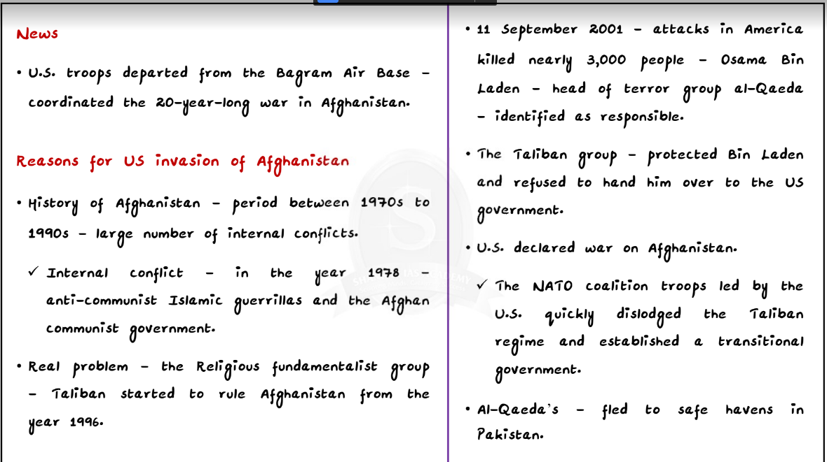As part of the U.S.’s plan to withdraw its troops from Afghanistan by September 11, the U.S. troops departed from the Bagram Air Base that had helped coordinate its long drawn war in Afghanistan. This effectively marks the end of their military operations in the country.

**Background:**

* The U.S.-Taliban deal: The deal signed between the U.S. and the Taliban in Doha

•The deal dealt with four aspects of the conflict — violence, foreign troops, intra- Afghan peace talks and the use of Afghan soil by terrorist groups such as al-Qaeda and the Islamic State.

•While the Taliban promised to reduce violence, join intra-Afghan peace talks and cut all ties with foreign terrorist groups, the U.S. Pledged to withdraw all its troops.

* The U.S. went into Afghanistan in October 2001, a few weeks after the 9/11 terror attacks, with the goals of defeating terrorists and rebuilding and stabilizing Afghanistan.
* In 19 years of the war, the Afghan war is estimated to have cost $2-trillion, with more than 3,500 American and coalition soldiers killed. Afghanistan lost hundreds of thousands of people, both civilians and soldiers.
* In spite of the best efforts, the Taliban is at its strongest moment since the U.S. launched the war. The insurgents control or contest the government control in almost half of Afghanistan.

**Details:**

* The U.S. seeks to exit Afghanistan with assurances from the Taliban that the insurgents will not allow Afghan soil to be used by transnational terrorist groups such as al-Qaeda and that they would engage the Kabul government directly to find a lasting solution to the civil war.

**Concerns:**

Exclusion of the Afghan government in negotiations:

* The fundamental issue with the U.S.’s Taliban engagement is that it deliberately excluded the Afghan government in the negotiations.
* The Taliban insurgents do not see the elected government as legitimate rulers. By giving in to the Taliban’s demand, the U.S. has practically called into question the legitimacy of the elected government of Afghanistan.

One-sided agreement:

* The U.S. has made several concessions to the Taliban in the agreement. The Taliban got what it wanted in the form of the withdrawal of foreign troops, without making any major concession.
  + The Taliban was not pressed enough to declare a ceasefire.
  + The Taliban, whose previous rule is known for strict religious laws, banishing women from public life, shutting down schools and unleashing systemic discrimination on religious and ethnic minorities, has not made any promises on whether it would respect civil liberties or accept the Afghan Constitution.

Weakening the elected government:

* The U.S. withdrawal from Afghanistan will invariably weaken the Kabul government, altering the balance of power both on the battlefield and at the negotiating table of the intra-Afghan talks.
* The Taliban already controls or contests half the country’s territory and the American and [NATO](https://byjus.com/free-ias-prep/north-atlantic-treaty-organization/) withdrawal will help it expand its territorial base at the expense of the government’s poorly trained forces.
* A weakened government will have to talk with a resurgent Taliban.

The threat of violence:

* The deal, though sets the stage for America to wind down the longest war in its history, leaves the Afghan people at the mercy of violent, tribal Islamists.

One-sided agreement:

* The U.S. has made several concessions to the Taliban in the agreement. The Taliban got what it wanted in the form of the withdrawal of foreign troops, without making any major concession.
  + The Taliban was not pressed enough to declare a ceasefire.
  + The Taliban, whose previous rule is known for strict religious laws, banishing women from public life, shutting down schools and unleashing systemic discrimination on religious and ethnic minorities, has not made any promises on whether it would respect civil liberties or accept the Afghan Constitution.

Weakening the elected government:

* The U.S. withdrawal from Afghanistan will invariably weaken the Kabul government, altering the balance of power both on the battlefield and at the negotiating table of the intra-Afghan talks.
* The Taliban already controls or contests half the country’s territory and the American and [NATO](https://byjus.com/free-ias-prep/north-atlantic-treaty-organization/) withdrawal will help it expand its territorial base at the expense of the government’s poorly trained forces.
* A weakened government will have to talk with a resurgent Taliban.

The threat of violence:

* The deal, though sets the stage for America to wind down the longest war in its history, leaves the Afghan people at the mercy of violent, tribal Islamists.

Intra-Afghan fighting:

* The U.S.-Taliban agreement may end up paving the way for further intra-Afghan fighting because it leaves the most important issue, namely, the future relationship between the Afghan government and the Taliban, unresolved.
* Given the political instability in Afghanistan with President Ashraf Ghani (belongs to the largest ethnic group of Pashtuns) and his primary challenger Chief Executive Abdullah Abdullah (belongs to the second largest ethnic group of Tajiks) threatening to set up parallel governments, the intra-Afghan talks will likely fan ethnic tensions in the country. Consequently, ethnic fissures may descend into open conflict.
* Similarly, the Taliban, despite appearances to the contrary, is not a well-knit force. It is composed of various regional and tribal groups acting semi-autonomously.
* The agreement may not bring lasting peace to the region.

Increasing Taliban influence:

* Ever since the U.S. troops began pulling out on May 1, the Taliban have made rapid territorial advances. The number of districts under its control has increased.
* The American withdrawal has turned the balance of power in the battleground in favour of the Taliban.
* As per the American intelligence community has concluded, Kabul could fall within six months to the Taliban

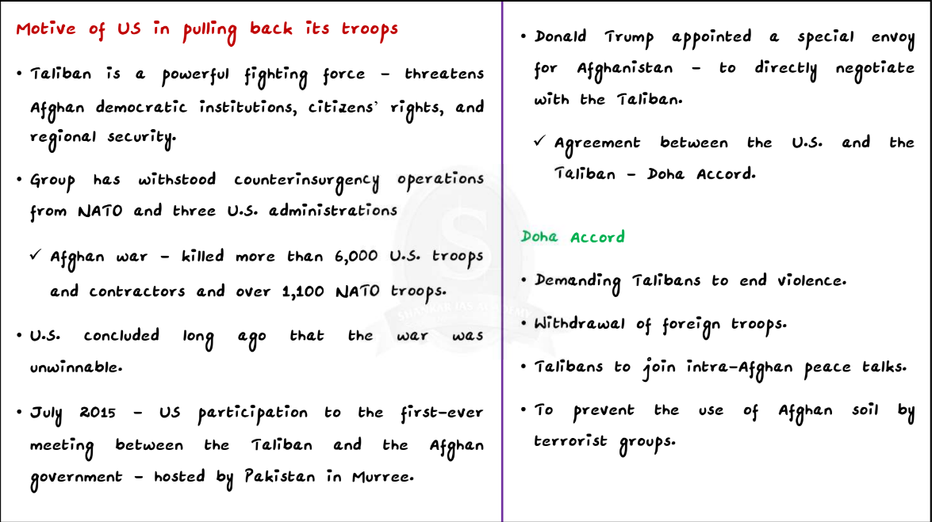

**Indian concerns:**

* Given the fact that India has invested considerable resources in Afghanistan’s development, India has a major stake in the stability of Afghanistan.
* India has always considered the elected government as a strategic asset against Pakistan and has a major stake in the continuation in power of the elected government. An increased political and military role for the Taliban and the expansion of its territorial control should be of great concern to India since the Taliban is widely believed to be close to Pakistan.
* The three areas of interest in engaging with the Taliban include:
  + Protecting India’s investments in Afghanistan
  + Preventing a future Taliban regime from being used by Pakistan to suppress India’s strategic reach in Afghanistan
  + To thwart the threat of Pakistan-backed anti-India terrorist groups getting support from the Taliban

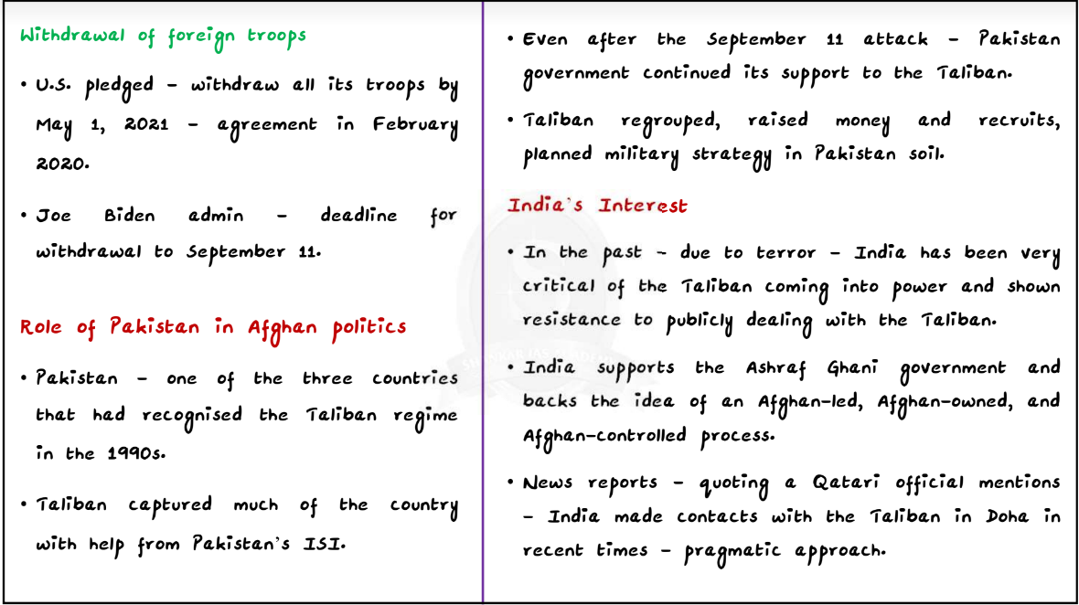

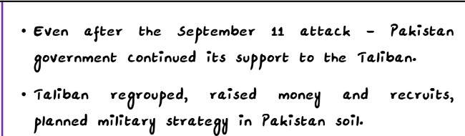

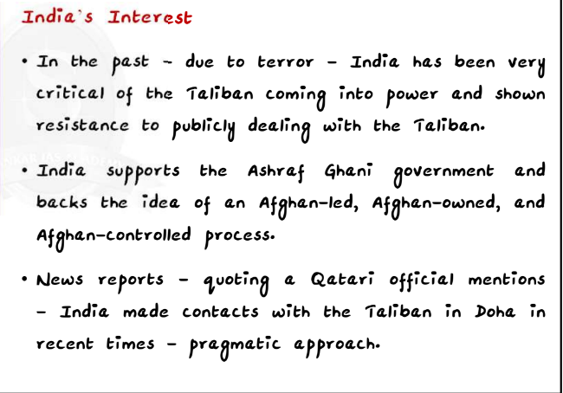

**What are the future possibilities?**

So, there could be three scenarios, according to experts.

* One, there could be a political settlement in which the Taliban and the government agree to some power-sharing mechanism and jointly shape the future of Afghanistan. As of now, this looks like a remote possibility.
* Two, an all-out civil war may be possible, in which the government, economically backed and militarily trained by the West, holds on to its positions in key cities and the Taliban expand its reach in the countryside, while other ethnic militias fight for their fiefs. This is already unfolding.
* A third scenario would be of the Taliban taking over the country. Any nation planning to deal with Afghanistan should be prepared for all three scenarios.

**EU’s ‘Green Passport’**

**Context:**

* EU Digital COVID Certificate (EUDCC) or the “Green Passport” system proposed by the European Union.

**What is ‘Green pass’?**

* The EU Digital Covid Certificate, or the “green pass” has been created to restore freedom of travel for the public and remove the barriers on entry placed due to the pandemic.
* The new vaccine passport system would come into effect across the EU from July 1, 2021.
* The document is valid across all EU countries.
* Before the pandemic, Schengen visa allowed the holders to move around freely. As part of the Schengen agreement, 26 European countries had abolished border control of any type, beginning in 1985.
* There are three ways to obtain a green pass:
  + Get fully vaccinated with one of the EMA approved vaccines
  + Show a recovery report less than 11 days after testing positive for COVID-19.
  + Show a negative test report, or an antibodies test.
* The EUDCC, or the Green Passport which would basically be a digital QR code, would attest a person as being vaccinated against COVID-19. It also attests if the person has had a recent negative test and/or is considered immune having previously contracted the illness and having recovered.
* This EUDCC has been recognised by all 27 EU countries, as well as Switzerland, Liechtenstein, Iceland and Norway for intra-EU travel.
  + Although not members of the EU, countries like Norway, Iceland, Switzerland and Lichtenstein are also part of what is referred to as the Schengen zone.
    - 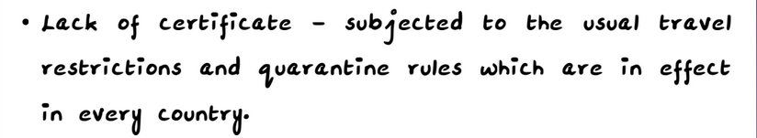Schengen Areasignifies a zone where 26 European countries, abolished their internal borders, for the free and unrestricted movement of people, in harmony with common rules for controlling external borders.

**Issue:**

* The European Medicines Agency (EMA) has not approved the India-produced Astrazeneca vaccine Covishield for the green pass despite approving its United Kingdom-made counterpart Vaxzevria.
* None of the three vaccines which have been approved for use in India till date — Covishield, Covaxin and Sputnik V — feature on the list.
* Currently, Covishield is the only WHO-approved vaccine available to Indians.
* The EMA’s decision to exclude Covishield from the list has enraged many who have availed of the vaccine as it was WHO approved.

**EMA’s response:**

* European Medicines Agency (EMA) has said that application has not been made for both Covishield and Covaxin to be included in the EMA list.
* 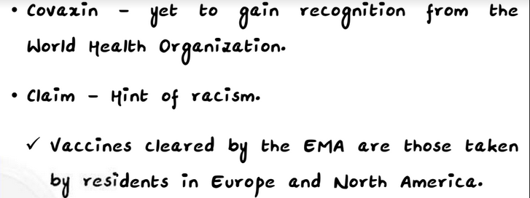It has made it clear that even if the vaccine is the same, different manufacturers of the same product need to submit separate applications for approval from EMA. This is because the EMA takes into consideration local manufacturing facilities.

**India’s stand on ‘vaccine passports’:**

* Vaccine passport has given rise to larger concerns over **intrusion, privacy and a curb on the right to free movement.**
* Though the EU has made it clear that the green pass will not be compulsory, the issue has given rise to a larger debate on **concerns around privacy and ethics.**
* In a recent development, government sources have warned that India will introduce a **reciprocal policy** only **allowing ease of** **travel for those European countries that recognise Indian vaccines Covishield and Covaxin.**
* The Indian government has warned that India would initiate reciprocal harsh quarantine measures against countries that discriminated against Indians.
* 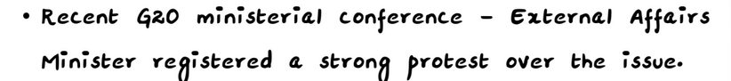India has suggested that all Indian-approved vaccines should be given recognition worldwide, and has recommended certifying of such passengers via the Co-WIN website.

The [African Union](https://byjus.com/free-ias-prep/african-union-au/) had also issued a letter of protest over the EU proposal saying that it promoted **inequality for those from lower-income countries** for whom the **Covishield vaccine was the backbone of the international COVAX alliance programme.**

**WHO’s stand:**

* In the recently published ‘Policy considerations for implementing a risk-based approach to travel in the context of COVID-19’, the WHO categorically states that vaccine passports should not be made mandatory for travel and should be optional.

**Recent developments:**

* Following India’s criticism, some nations have agreed to accept Indian vaccines also.
* **Nine European countries** have given **recognition to the Covishield vaccine produced by the Serum Institute of India (SII).**
* The nine countries’ move is a national move by them and not by the EU, headquartered in Brussels.
* The EU member-states that have recognised Covishield include Austria, Germany, Slovenia, Greece, Iceland, Ireland and Spain.
* Estonia has authorised all vaccines approved by GoI.
* Switzerland (Non-EU member) has also approved Covishield.

**China goes malaria-free with multi-pronged health strategy**

**Context:**

* In the context of the [World Health Organization (WHO)](https://byjus.com/free-ias-prep/world-health-organisation-who/) **declaring China “malaria-free”,** the article analyses China’s health strategy vis-à-vis malaria and the lessons it can offer India’s own efforts against malaria.
  + The “malaria-free” certification from the WHO requires four consecutive years of reporting no local cases.
  + China is the first country in the Western Pacific region to be declared malaria-free in more than 30 years.

**Malaria:**

* Malaria is a mosquito-borne disease caused by a parasite.
  + It is typically transmitted through the bite of an infected Anopheles mosquito. Infected mosquitoes carry the Plasmodium parasite (Plasmodium vivax) When this mosquito bites a human, the parasite is released into the bloodstream.
  + Malaria is a life-threatening disease caused by parasites that are transmitted to people through the bites of infected female Anopheles mosquitoes. It is preventable and curable.
  + Malaria is caused by Plasmodium parasites.
  + The parasites are spread to people through the bites of infected female Anopheles mosquitoes, called “malaria vectors.”
  + Symptoms of malaria:
    - Fever, Headache, Chills
    - Severe malaria can cause severe anaemia, respiratory distress in relation to metabolic acidosis, or cerebral malaria.
    - In adults, multi-organ failure is also frequent.
  + If untreated, malaria can be fatal.
* Malaria is typically found in tropical and subtropical climates where the parasites can live. It is most prevalent in Africa, followed by Asia and Latin America. It also affects people in the Middle East and Europe albeit to a much smaller degree.
* The number of malaria cases worldwide in 2019 was around 229 million, according to the World Malaria Report in 2020, with 409,000 lives lost to the mosquito-borne disease.
* The 2020 report said the majority of cases were reported in Africa, while India and Southeast Asia recorded a significant drop. Cases in India fell from approximately 20 million to 6 million, according to the report.

**About the World Malaria Report:**

* The World Malaria Report gives the estimated cases for malaria across the world, based on mathematical projections.
* It provides a comprehensive update on global and regional malaria data and trends.
* The report tracks investments in malaria programmes and research as well as progress across all intervention areas: prevention, diagnosis, treatment and surveillance.
* It also includes dedicated chapters on malaria elimination and on key threats in the fight against malaria.
* The report is based on information received from national malaria control programmes and other partners in endemic countries.
* It is published by WHO annually.

**Malaria in India – Background**

* Malaria has been a problem for India since centuries.
* During the latter parts of the nineteenth and early twentieth centuries, nearly one-fourth of India’s population suffered from malaria, particularly in the states like Punjab and Bengal.
* The economic losses were also enormous due to malaria.
* The National Malaria Control Programme was first launched in 1953.
  + This was a successful programme which helped to reduce the number of malaria cases significantly by 1958.
* In 1958, the ambitious National Malaria Eradication Programme was launched.
  + This programme suffered many setbacks and cases surged in the country.
* In more recent times, the National Framework for Malaria Elimination (NFME) was launched in 2016 by the Health Ministry.
* Based on the NFME’s framework, the [National Strategic Plan for Elimination of Malaria](https://byjus.com/free-ias-prep/national-strategic-plan-for-elimination-of-malaria/) was launched in 2017.
  + This plan lays down the strategies for 2017 to 2022.
* Malaria has been made notifiable in 31 states/UTs of India.
* The states with a high burden of the disease are West Bengal, Jharkhand, Madhya Pradesh and Chhattisgarh.

**High Burden to High Impact**

* WHO launched the High Burden to High Impact approach as a targeted response to malaria.
* The approach is currently being driven by the 11 countries that carry a high burden of the disease (Burkina Faso, Cameroon, Democratic Republic of the Congo, Ghana, India, Mali, Mozambique, Niger, Nigeria, Uganda and United Republic of Tanzania).
* Key elements include:
  + political will to reduce the toll of malaria;
  + strategic information to drive impact;
  + better guidance, policies and strategies; and
  + a coordinated national malaria response.

**Details:**

* China followed a multi-pronged health strategy that was able to entirely eliminate indigenous cases of malaria that once a major public health problem in China with millions of cases reported annually.
* Some of the major aspects of this strategy involved the following:

Mosquito control:

* Targeting mosquito breeding grounds and using of insecticide spraying have been a major aspects of China’s mosquito control efforts.

Robust surveillance:

* The WHO has attributed a lot of credit to China’s ‘1-3-7 strategy’ for its success in tackling malaria.
  + “1-3-7 strategy” refers to a one-day deadline to report a malaria diagnosis, confirming a case and determining the spread by the third day, and measures taken to stop the spread by the seventh day, along with continued surveillance in high-risk areas.
* China has also strengthened its laboratory networks with quality laboratory equipment, which has let it detect cases of malaria in a fast and effective manner.
* This approach has allowed China to detect cases early and prevent its spread.

Robust public health system:

* Strong political commitment to strengthen the national health systems has been a major factor of strength in the fight against the disease.
* China’s public health system offering free of charge diagnosis and treatment of malaria has played a major role in bringing down cases drastically.

Anti-malarial medicines:

* The discovery of artemisinin under “the 523 project” and its use in artemisinin-based combination therapies has provided one of the most effective antimalarial drugs.

Human resources:

* With assistance from the Global Fund to Fight AIDS, Tuberculosis and Malaria starting in 2003, China stepped up training, staffing to deal with the handling of the malaria disease. This has ensured the required human resources for the fight against Malaria.

Other interventions:

* China has been using insecticide-treated nets widely and distributed them free of cost to people living in vulnerable areas.

**Can reducing cess levies ease high fuel prices?**

**Context:**

* Ratings agency ICRA recently suggested cut cess levies on retail prices of petrol and diesel to ease price pressure on the fuels.

**Historic high of retail prices of fuels:**

* Though the base price of fuels have decreased over the years, the share of taxes on the retail price has increased at a very high pace. This has resulted in a scenario of historic high of retail prices of petrol and diesel.
* Experts attribute the current high fuel prices to higher cesses being imposed by the Centre and an increase in Value Added Tax (VAT) rates by more than three-fourths of the State governments.
* Four factors influencing rise in prices:

1. Crude oil, freight and processing charges to the dealer.
2. Excise duty charged by the government.
3. Dealer commission to the gas station.
4. Value Added Tax levied by the state government.

**Details:**

* The ICRA anticipates an increase in the mobility of the population and economic recovery after the easing of curbs. It forecasts the consumption of petrol and diesel to grow in the financial year 2021-22. This it argues will help ensure sufficient revenues for the government pegged at about ₹3.6 lakh crore, about ₹40,000 crore more than in the last financial year.
* ICRA: government may cut cess levies on retail prices of petrol and diesel to ease prices.
* Petrol consumption is estimated to grow 14% and diesel 10% year-on-year in FY22.

1. Reason: Recovering economic activities and mobility - easing of curbs and accelerating Covid19 vaccinations.

* Higher consumption of fuels - support a rise in the indirect taxes levied on them.
* Growth in consumption would result in Rs. 40,000 crore of extra cess collections.
* Existing fuel price can be cut by ₹4.50 per litre for petrol and diesel.

The Central taxes on Petrol and Diesel include **Basic Excise Duty, Special Additional Excise Duty, Road and Infrastructure Cess and Agriculture Infrastructure and Development Cess.** This comes to be around Rs 32.9 per litre of petrol and Rs 31.8 per litre of diesel. Apart from these central taxes, even the state governments impose their own tax in the form of VAT. Hence, there is a high incidence of Central and State taxes on Petrol and Diesel. These taxes alone account for almost around 60% of the cost of the petrol and diesel.

**Government's Tax policy towards Petroleum Products**

Whenever there is decline in the international crude oil prices, the Central Government usually increases the tax rates.  That is why, in spite of decline in the international crude oil prices, we end up paying almost the same price for petrol and diesel in India. We do not get the benefit of decline in the prices of crude oil. Rather, it is the government which gets the benefit in terms of higher tax revenue. Such a government’s policy has a number of advantages

* + The Higher Excise duty on Petrol and Diesel acts as an implicit carbon tax and nudges the economy to move towards greener fuels.
  + Enables the Government to earn more revenue, which can be used later as buffer, in event of increase in crude oil prices.
  + Enables the Government to raise revenue to undertake higher expenditure towards green energy projects.

**Significance:**

**Cool inflation level:**

* Lower fuel prices will likely help cool inflation levels.
* Retail inflation based on the consumer price index (CPI) has been persistently higher than the RBI’s medium-term target of 4%. **For May 2021, the provisional inflation reading was 6.3%,** owing to persistent price pressures in the transport and communication category, which includes the automotive fuels of petrol and diesel.
* Petrol and Diesel are considered to be important inputs in our economy. They are not only used for the purpose of transportation, but they are also used as raw materials in number of Industries. Hence, increase in their prices would inevitably lead to increase in the rate of Inflation.

**Allow RBI balance growth and inflation levels in the economy:**

* The lower fuel prices will help ease retail inflation and thus allow the RBI to maintain a growth-supportive stance. It will allow the RBI to **retain its accommodative monetary stance** that includes **keeping benchmark borrowing interest rates substantially low**. This would incentivize demand for credit to both consume and invest in new business activity, thus spurring economic growth.

**Counter arguments:**

* A reduction in fuel cesses could **adversely affect the government’s ability to pay interest and principal on oil bonds** issued to public oil marketing companies (OMCs) as compensation for subsidies.
* Oil bonds are special types of bonds that were issued to oil marketing companies (OMCs) like Indian Oil, Hindustan Petroleum and Bharat Petroleum. These companies received oil bonds from the government in place of cash subsidies.
  + OMCs were earlier receiving cash subsidies, as earlier these companies were not free to fix their own prices for petrol (before 2010) and diesel (before 2015). This meant that OMCs were often selling fuel far below the international market price, often at significant expenditure to themselves.
* The Oil bonds are interest-bearing, having a fixed coupon rate and paid on a half-yearly basis.

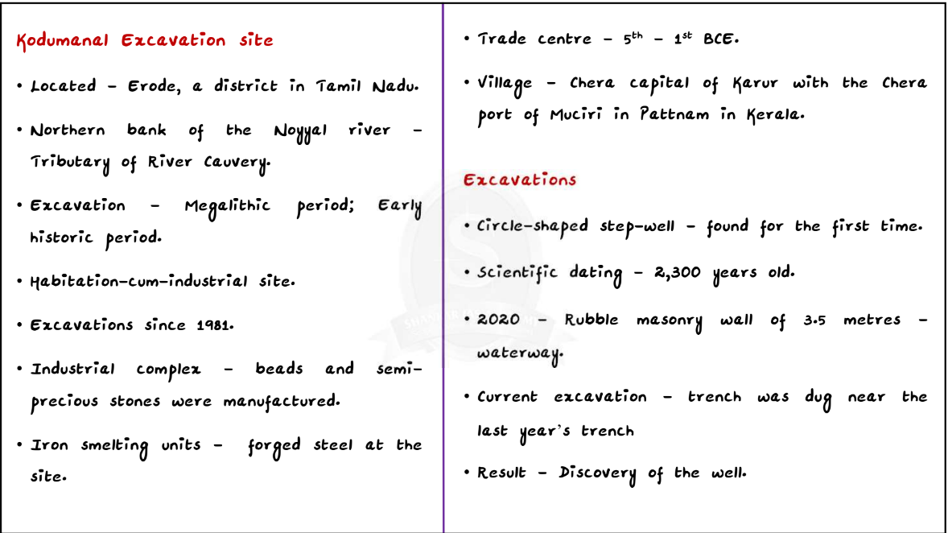**2300 years old stepwell**

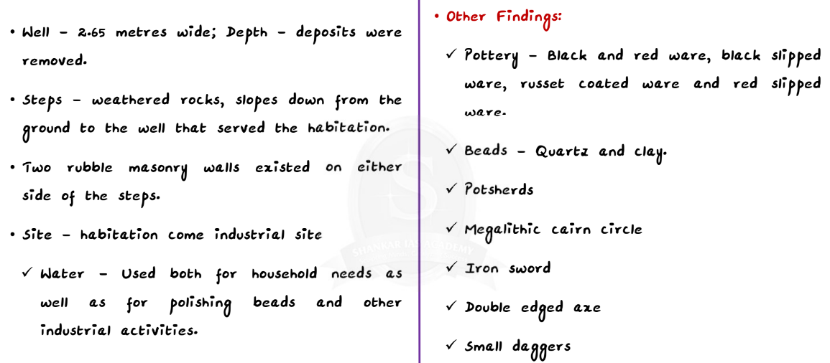**Suniksha Kerlam**

* To attain self-sufficiency in agriculture and food security
* Fallow lands are brought into cultivation
* Government and other organs function together

**New source of gravitational waves detected**

**Context:**

* Scientists have for the first time detected gravitational waves produced by the collision of a neutron star and a black hole.

**Background:**

**Neutron star:**

* A neutron star is the collapsed core of a massive supergiant star. They result from the supernova explosion of a massive star, combined with gravitational collapse.
* Neutron star, are thought to be composed primarily of neutrons.
* Apart for black holes, neutron stars are the smallest and densest currently known class of stellar objects. Despite their small diameters—about 12.5 miles neutron stars boast nearly 1.5 times the mass of our sun, and are thus incredibly dense.
* Once formed, they no longer actively generate heat, and cool over time; however, they may still evolve further through collision or accretion.

**Details:**

* The bursts of energy from the collisions were discovered when detectors on Earth spotted the mergers’ gravitational waves, cosmic energetic ripples soaring through space and time as first theorized by Albert Einstein.
  + The reverberations from the happening was picked up from the LIGO network of gravitational wave detectors.
* While astronomers had seen gravitational waves from two black holes colliding with each other and two neutron stars colliding with each other, this is the first time they saw one of each crashing together.

Significance:

* The study of the neutron star-black-hole systems would help answer many questions about star formation and calculating the expansion rate of our universe.