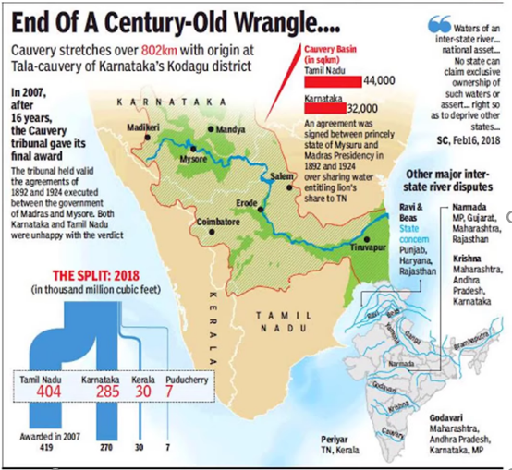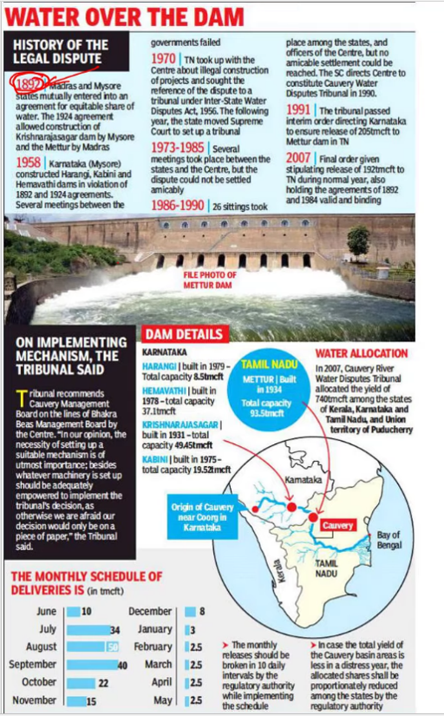**Cauvery and the row over Mekedatu project**

**Context:**

Differences between the states of Karnataka and Tamil Nadu over the proposed **Mekedatu project.**

**Background:**

**Mekedatu project:**

* The Karnataka state government has proposed the Mekedatu dam project in the **Cauvery Basin.**
* Mekedatu is a deep gorge situated at the **confluence of the rivers Cauvery and its tributary Arkavathi.**
  + Originally proposed as a **hydropower project**, the revised Mekedatu dam project apart from **catering to the drinking water needs of the Bengaluru Metropolitan City and surrounding areas** will also **help regulate the flow to Tamil Nadu** on a monthly basis, as stipulated by the Tribunal and the Supreme Court.
    - The Cauvery Water Disputes Tribunal, and the subsequent Supreme Court Judgement have made allocations of Cauvery waters to all the riparian States — Karnataka, Kerala and Tamil Nadu, apart from the Union Territory of Puducherry. It has also stipulated “tentative monthly deliveries during a normal year” to be made available by Karnataka to Tamil Nadu.

**Recommendations:**

* The Cauvery river water sharing has become an emotive and political issue over the years and any future interventions must be guided by pragmatism.
  + A possible solution to this new development would be to get **both states to agree to the idea of a joint execution, operation and maintenance of the project** or through a third party’s participation.
  + The project if it it is agreed to must be implemented after **addressing relevant environmental concerns.**