MSE-1 SUBMISSION
Naman Jadiya
202401100200208

GitHub repository URL- https://github.com/Namannn1869/github-skills-challenge
Pull request URL used to validate the workflows - https://github.com/Namannn1869/github-skills-challenge/pulls

Screenshot showing the GitHub Actions workflows
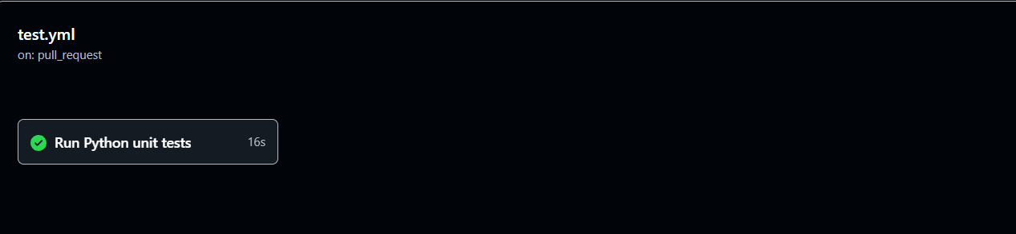
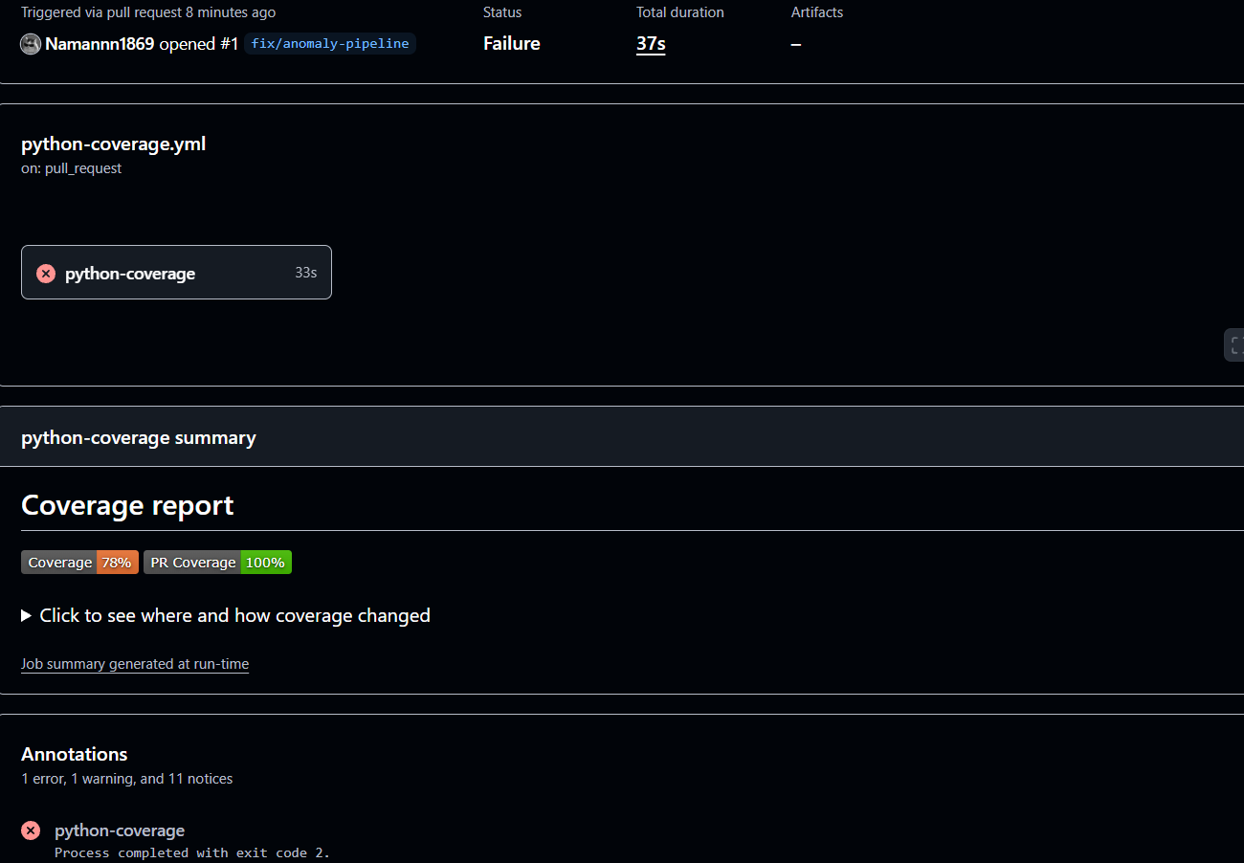

Screenshot showing a successful test workflow execution-
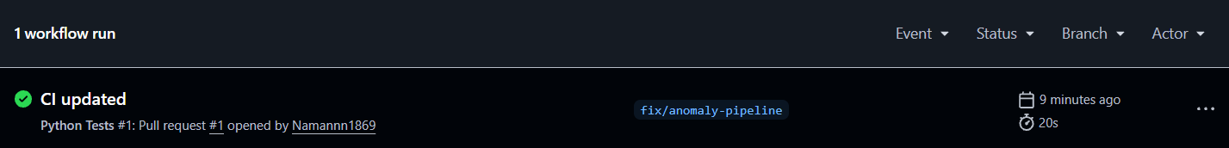
Screenshot showing the coverage result/comment on the pull request
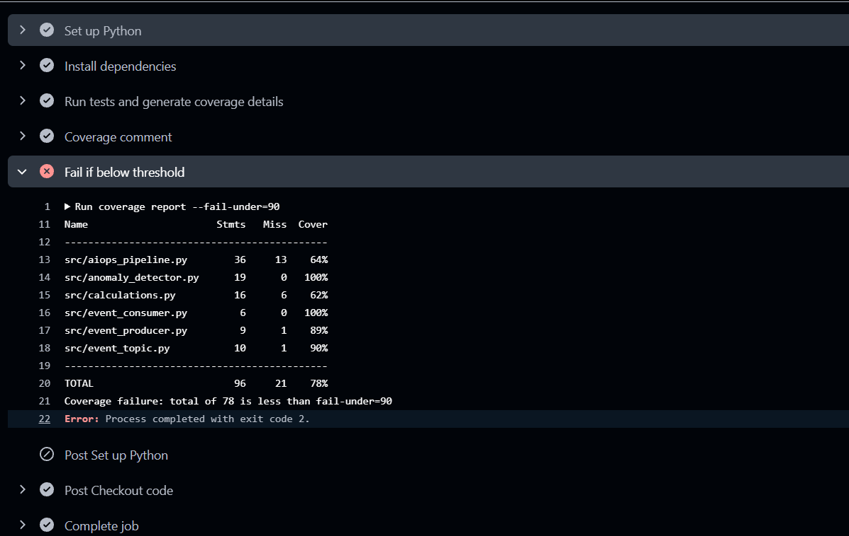

Screenshot showing the final repository/workflow files

