MSE-I SUBMISSION
Naman Jadiya
202401100200208

Github URL - https://github.com/Namannn1869/github-skills-challenge
PR URL - https://github.com/DebbieAUG/github-skills-challenge/pull/115

Workflow-
- test.yml
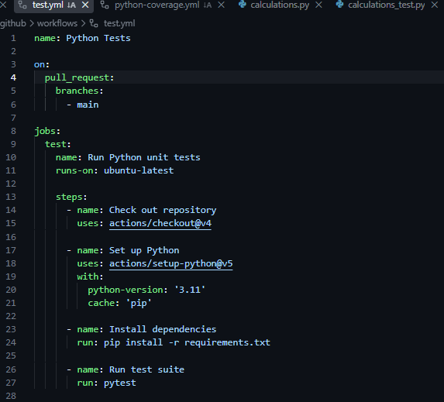

2.python-coverage.yml
