**CSE3039 – CN Experiment  
Namansh Singh Maurya  
22MIA1034**

**Screenshots:**

1. **Whole Configuration**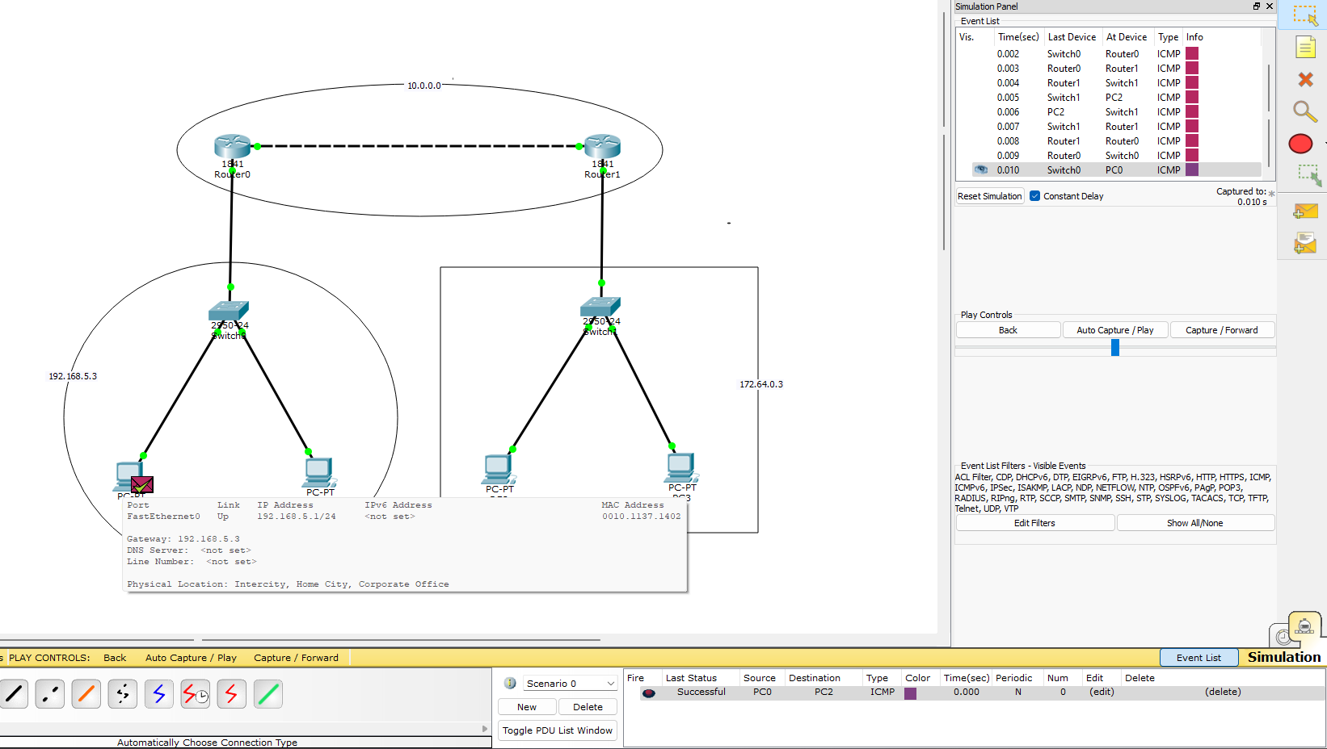
2. **Host IP Address**

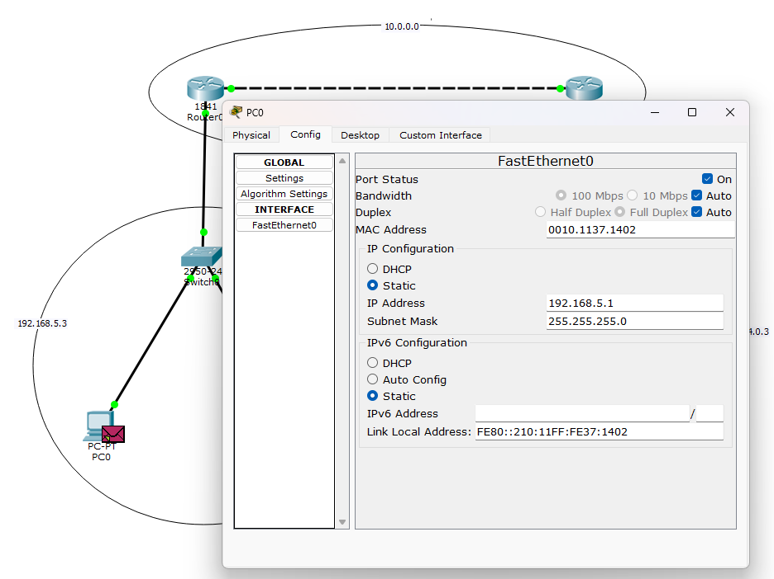

1. **Host Gateway ID**

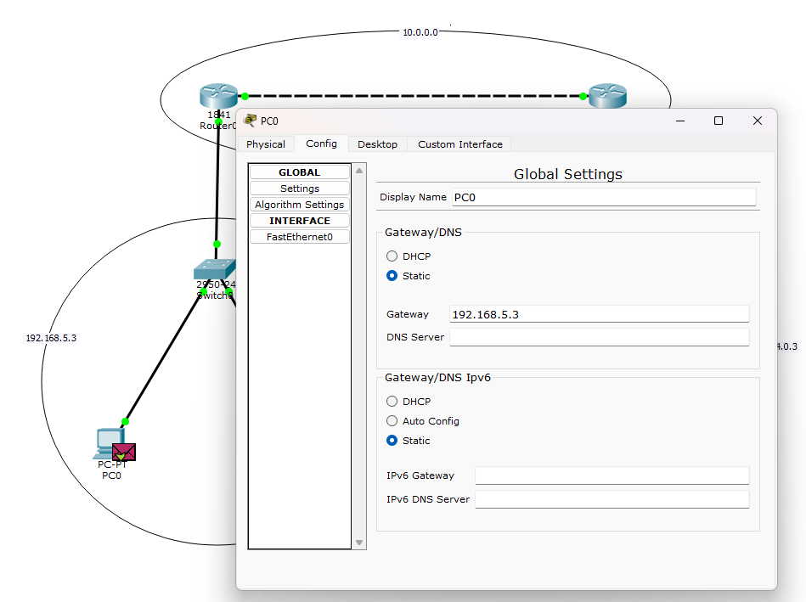

1. **Router0 RIP Routing**

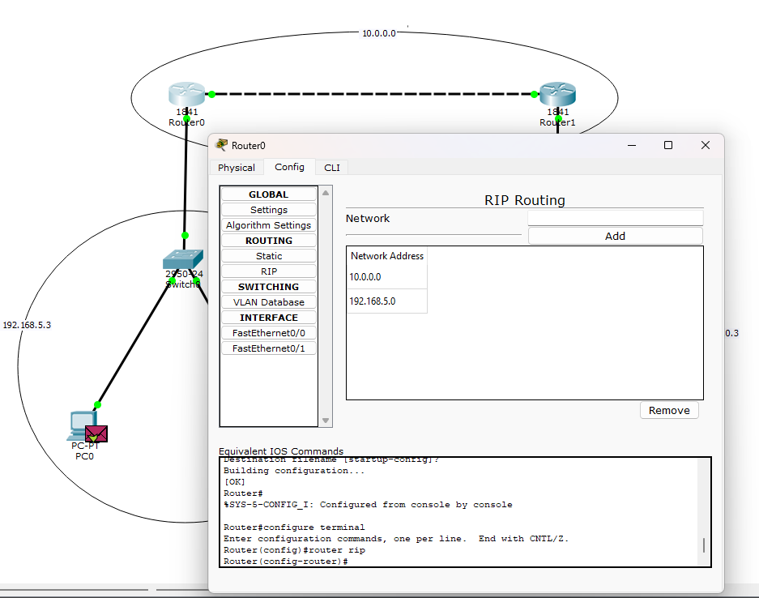

1. **Router1 - RIP Routing**

