SELECT EMP_CITY,COUNT(*) AS CNT FROM EMPLOYEES GROUP BY EMP_CITY
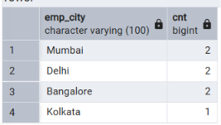

SELECT EMP_CITY, COUNT(EMP_ID) AS CNT FROM EMPLOYEES
GROUP BY EMP_CITY

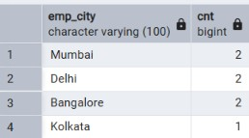

SELECT EMP_CITY, SUM (CASE WHEN EMP_SALARY>=90000 THEN 1 ELSE 0 END) AS CNT FROM EMPLOYEES
GROUP BY EMP_CITY

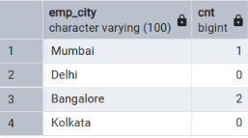

SELECT EMP_CITY,SUM(CASE WHEN EMP_SALARY>=90000 THEN 1 ELSE 0 END) AS CNT FROM EMPLOYEES
GROUP BY EMP_CITY
ORDER BY EMP_CITY DESC

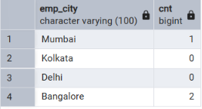

SELECT EMP_CITY,SUM(CASE WHEN EMP_SALARY>=90000 THEN 1 ELSE 0 END) AS CNT FROM EMPLOYEES
GROUP BY EMP_CITY
ORDER BY CNT DESC,EMP_CITY DESC

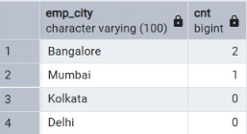

SELECT EMP_CITY AS CNT FROM EMPLOYEES
GROUP BY EMP_CITY
HAVING COUNT(EMP_ID)>=2

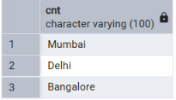

SELECT DISTINCT EMP_CITY
FROM EMPLOYEES
