CASE STUDY
IoT-Based Emergency Department Patient Triage Queue Manager
using ESP32, Dynamic Priority Linked List, and Persistent Audit Logging
Hardware + algorithm case study · Patient Queue Manager v2.0
Course / document type | Case Study Report
Project title | IoT-Based Emergency Department Patient Triage Queue Manager using ESP32
Team members | [Team Member 1] [Team Member 2] [Team Member 3] [Team Member 4]
GitHub repository | [To be added — paste your repository URL here]
Platform | ESP32 + Arduino framework (firmware v2.0)
Date | 28 October 2026

1. Title
IoT-Based Emergency Department Patient Triage Queue Manager using ESP32, Dynamic Priority Linked List, Auto-Escalation, and LittleFS Persistent Logging.
2. Team Members
Replace the placeholders below with official names, roll numbers, and roles before submission.
- [Team Member 1] — Role: Firmware / data structures
- [Team Member 2] — Role: Hardware integration (keypad, LCD, LEDs, buzzer)
- [Team Member 3] — Role: UX state machine and KPI dashboard
- [Team Member 4] — Role: Persistent log / Serial nurse-station report
3. GitHub Link
[To be added — paste the public or classroom GitHub repository URL here, for example https://github.com/<org>/<repo>]. The repository should contain the Arduino/ESP32 sketch, pin mapping notes, and this case-study document.
4. Project Scope
This case study covers a bench-scale emergency-department (ED) triage workstation: a nurse enters a two-digit patient identifier and a clinical urgency (P1 Emergency, P2 Urgent, P3 Normal) on a 4×4 keypad. The ESP32 maintains an in-memory priority queue as a dynamically allocated singly linked list, shows the next patient and live wait time on a 16×2 I2C LCD, drives colour-coded LEDs and buzzer tones, and appends every served encounter to onboard flash so the treatment log survives reset and power loss.
In scope:
- Priority-stable insertion (urgency first, then arrival order).
- Serve (dequeue) with individual and aggregate wait-time metrics.
- Time-based auto-escalation to reduce P3/P2 starvation.
- Queue browser, three-page KPI dashboard, and Serial audit reprint.
- LittleFS CSV log of served patients.
Out of scope:
- Hospital Information System (HIS/EMR) integration, HL7/FHIR, or multi-ward networking.
- True clinical scoring (ESI, NEWS2, Manchester) or clinician decision support.
- Machine learning, deep learning, NLP, or computer vision.
- HIPAA/GDPR production security; IDs in this prototype are two-digit lab tokens, not real MRNs.
5. Objective
The objective is to design, implement, and demonstrate an embedded triage queue that is fairer than plain FIFO, safer than an unbounded memory array, and more auditable than an in-RAM-only demo. Concretely, the firmware must:
- Accept nurse input (ID + priority) with duplicate-ID rejection and cancel (*).
- Always present the highest-urgency waiting patient as NEXT on the LCD.
- Measure wait time from arrival (millis()) through serve, and expose Avg / Max / Done / Escalated KPIs.
- Automatically promote patients who wait longer than a configured threshold (30 s in the lab build).
- Persist served encounters to LittleFS and reprint a nurse-station treatment table over Serial.
- Use only on-device algorithms and commodity hardware suitable for a student lab.
6. Already Existing Related Work
6.1 Clinical triage scales
Emergency departments internationally use structured scales such as the Emergency Severity Index (ESI), the Manchester Triage System, and the Canadian Triage and Acuity Scale. Those systems encode clinical risk into a small number of levels so scarce clinician time is allocated first to life-threatening cases. This project does not replace those scales; it implements the downstream queueing problem that appears once a priority label already exists.
6.2 Hospital software queues
Commercial ED track-boards and HIS modules (Epic, Cerner, and similar) already provide digital waiting lists, timestamps, and colour-coded acuity. They are networked, authenticated, and tightly coupled to the medical record. They are also expensive, closed, and unsuitable as a first-year/second-year embedded-systems teaching artefact. Our work is a transparent microcontroller counterpart, not a HIS competitor.
6.3 Academic and maker queue projects
A large body of Arduino/ESP32 “token display” and “hospital queue” projects uses a fixed-size array and FIFO (first-in, first-out) serving. FIFO is simple but clinically wrong: a later-arriving trauma case should not wait behind a minor complaint. Other student projects store a static MAX_PATIENTS array and lose history on reset. A smaller set of papers and lab reports discuss priority queues in software (heaps, linked lists) without closing the loop to LCD/keypad hardware or wait-time analytics.
6.4 Gap this case study addresses
The gap is an end-to-end, inspectable lab system that (i) uses a dynamic linked list instead of a hard-coded array, (ii) keeps FIFO stability inside the same priority band, (iii) measures wait time continuously, (iv) auto-escalates starved low-priority patients, and (v) writes an audit log that survives power loss. Those five properties together are uncommon in hobby FIFO token machines and are the focus of firmware v2.0.
7. Your Idea
The idea is to treat the nurse station as a real-time priority queue with a fairness overlay. Each arriving patient is a heap-allocated node carrying ID, priority, display name, and arrival timestamp. Insertion is an O(n) ordered walk that places P1 before P2 before P3, and appends behind existing patients of the same priority so two P2 patients are served in arrival order.
Waiting is not invisible. The home screen refreshes once per second so staff see how long the current NEXT patient has already waited. Serving (key B) records that duration into running totals (sum, count, maximum). If a P3 or P2 patient remains beyond 30 seconds in the test configuration, auto-escalation detaches the node, drops the numeric priority by one, and re-inserts it — a simple starvation-control policy inspired by operating-system aging.
Finally, every successful serve is appended as a CSV row (id, priority, wait_ms, timestamp_ms) on LittleFS. Key * reprints a formatted “Nurse Station — Patient Treatment Log” on the serial console even after a reboot, which is the difference between a RAM demo and an audit trail.
8. Implementation: Algorithm, Tools, and Method
8.1 Tools and method
- Firmware: Arduino IDE / ESP32 Arduino core, C++ sketch with a finite state machine.
- Libraries: Keypad, LiquidCrystal_I2C, Wire, FS, LittleFS.
- Instrumentation: USB Serial at 115200 for the nurse-desk report and debug traces.
- Workflow: Direct code-to-hardware iteration (keypad flows, LCD strings, LED/buzzer cues).
8.2 Core algorithms
Priority insertion sort on a singly linked list. For a new node with priority p, if the list is empty or p is strictly more urgent than head, the node becomes the new head. Otherwise the walk continues while next->priority <= p, which both preserves urgency order and FIFO among equals.
Dequeue is O(1) at the head: copy the node, compute wait = millis() − arrivalTime, update KPI accumulators, free the node, decrement queueSize.
Auto-escalation scans the list each loop(). Eligible nodes (priority > EMERGENCY and wait ≥ 30 s) are promoted by one level, unlinked, and re-inserted with the same insertion rule. After a structural change the scan restarts from head to keep the walk safe.
The keypad is a state machine: IDLE, ADD_ENTER_ID, ADD_ENTER_PRIORITY, DASHBOARD, VIEW_QUEUE. Global * cancels a multi-step add. Duplicate IDs are rejected by linear search. Memory allocation failure surfaces as MEMORY FULL on the LCD.
8.3 Architecture diagram
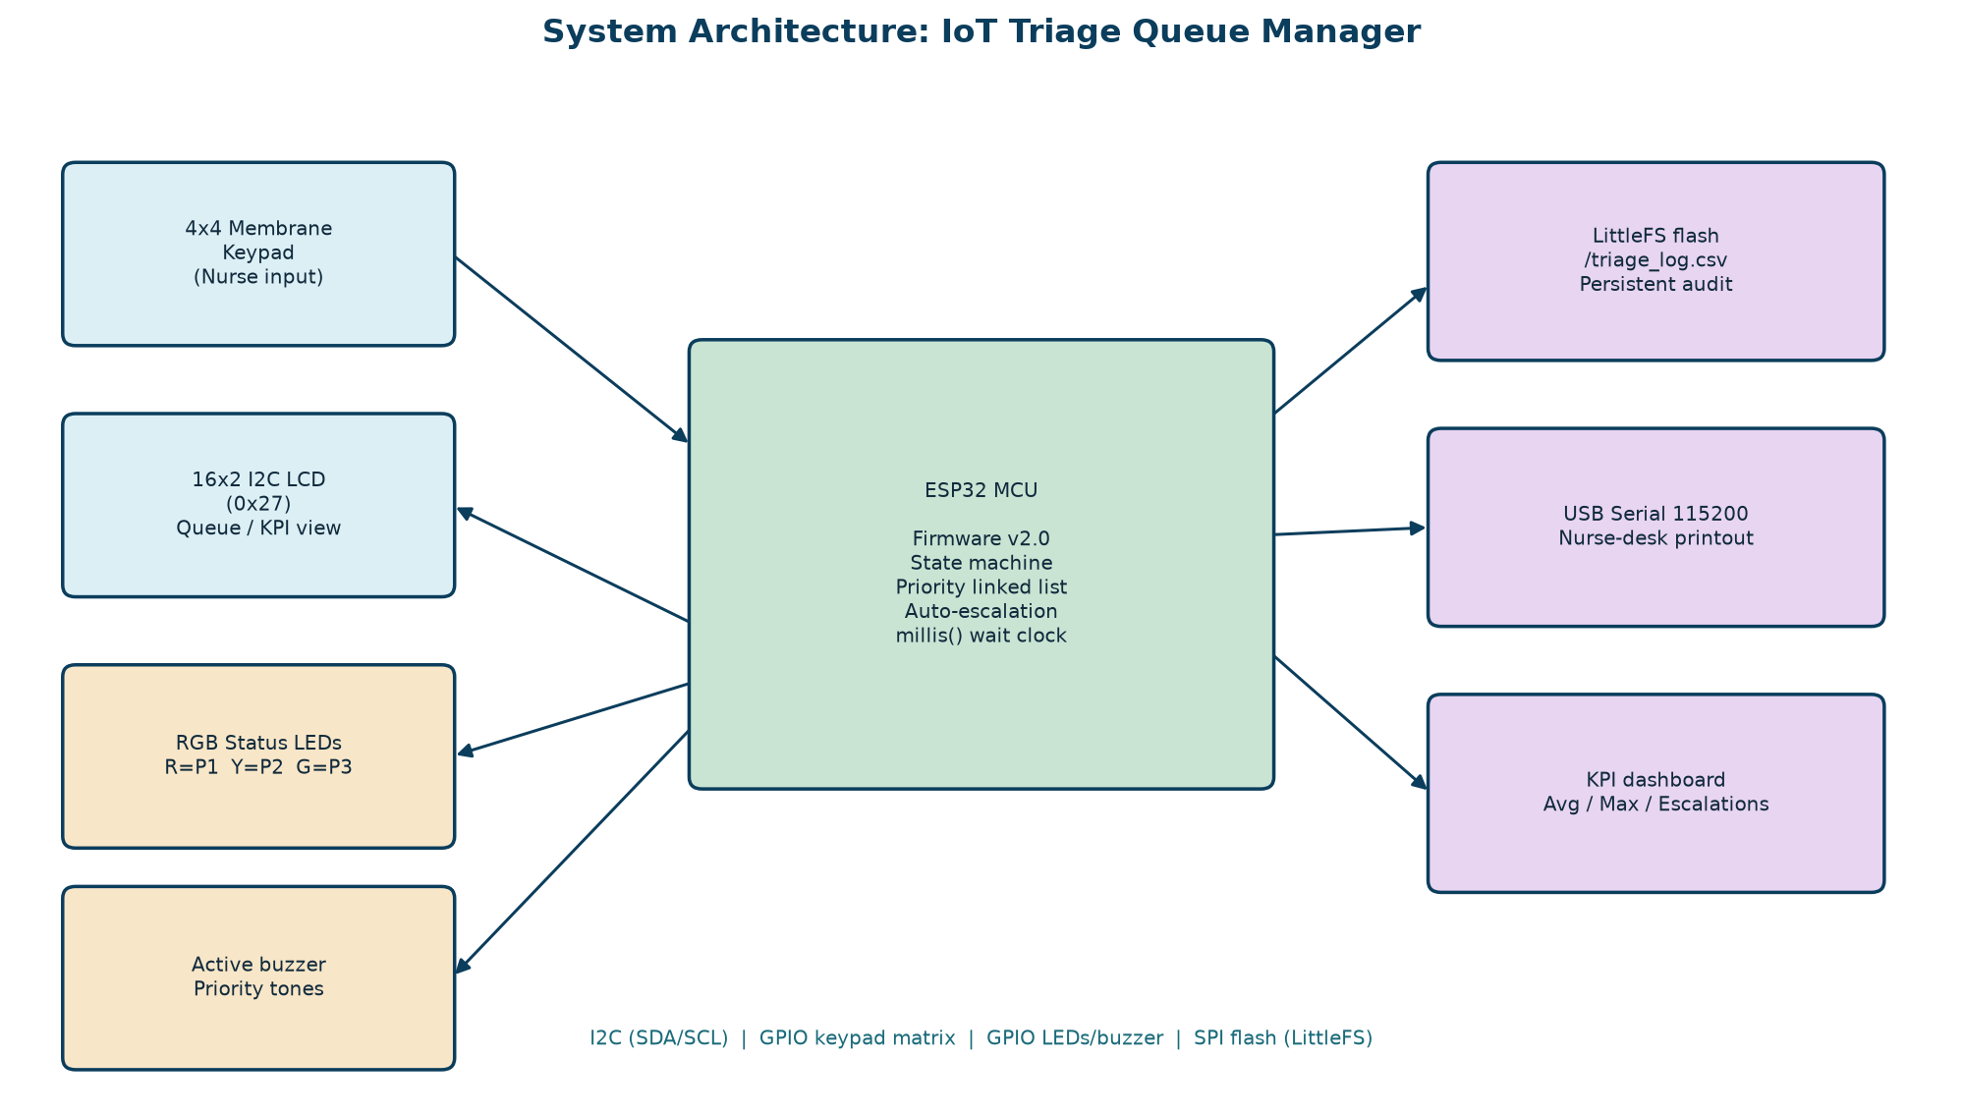
Figure 1. Hardware/software architecture of the ESP32 triage workstation.
8.4 Algorithm / method diagram
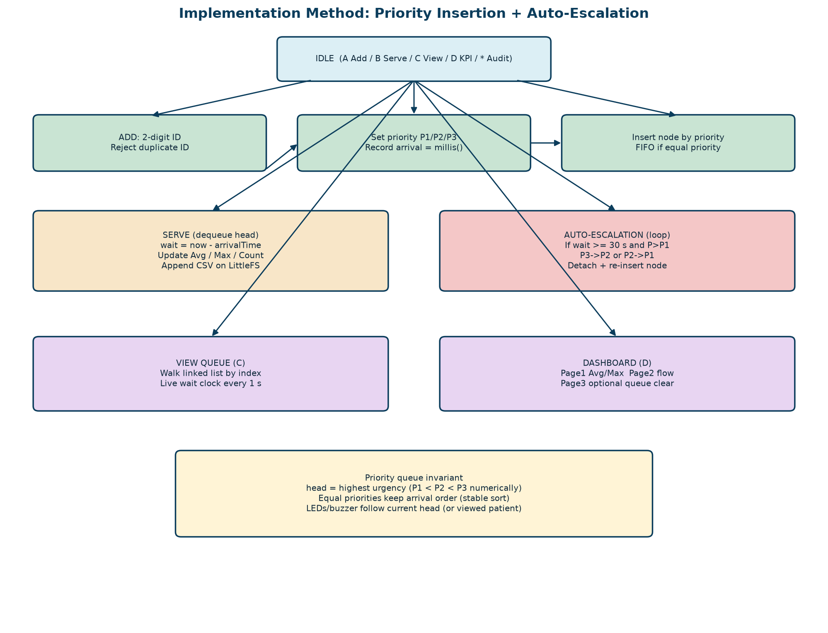
Figure 2. Operator actions, linked-list insert/serve path, and auto-escalation.
8.5 Key mapping (operator method)
- A — Start add-patient flow (2-digit ID, then 1/2/3 for P1/P2/P3, # to confirm).
- B — Serve / call the current head patient; log wait time; play priority alert.
- C — Browse waiting patients (C or # steps to the next node).
- D — KPI dashboard (Avg/Max, Done/Wait/Escalated, optional clear queue).
- * — In IDLE: reprint LittleFS audit log. In other states: cancel / back.
- # — Confirm ID/priority or advance dashboard / confirm clear on last page.
9. ML / DL / NLP / CV / Hardware Specification Used
This case study is an embedded systems and data-structures project. It does not use machine learning, deep learning, natural language processing, or computer vision. Urgency is entered by the nurse as P1/P2/P3; the microcontroller only orders, times, escalates, and logs. Using a learned model here would be inappropriate for a safety-critical lab prototype without labelled clinical data or regulatory review.
Item | Specification / pin
Microcontroller | ESP32 (Arduino core); Serial 115200 baud
Display | 16x2 LCD, I2C address 0x27 (LiquidCrystal_I2C)
Input | 4x4 matrix keypad — rows GPIO 13, 12, 14, 27; cols GPIO 26, 25, 33, 32
P1 Emergency LED | GPIO 15 (red)
P2 Urgent LED | GPIO 2 (yellow)
P3 Normal LED | GPIO 5 (green)
Buzzer | GPIO 4, tone() patterns by priority
Onboard storage | LittleFS flash; log path /triage_log.csv
Libraries | Wire, LiquidCrystal_I2C, Keypad, FS, LittleFS
ML / DL / NLP / CV | Not used. Decisioning is a deterministic priority queue, not a learned model.
Power / lab setup | USB 5 V to ESP32; 3.3 V GPIO to LEDs (with resistors) and keypad; I2C pull-ups as required

Data structure specification: PatientNode { id, priority, name[10], arrivalTime, *next }. Global head pointer and queueSize. KPIs: totalWaitTimeMs, totalPatientsServed, maxWaitTimeMs, autoEscalationCount. Log schema: id,priority,wait_ms,timestamp_ms.
10. Results
Results below are from the implemented firmware behaviour (functional demonstration), not from a hospital clinical trial. They are the outcomes a lab examiner can reproduce on the wired ESP32 kit.
Demonstration | Observed firmware behaviour | Evidence in implementation
Priority ordering | A newly added P1 patient is inserted ahead of waiting P2/P3 patients; equal priorities keep FIFO order. | insertPatient() walks the linked list and inserts before the first lower-urgency node.
Duplicate protection | A second patient with the same ID is rejected with LCD error and warning tone. | isDuplicateID() linear search before insert.
Serve / wait-time KPI | B dequeues the head, shows wait duration, and updates Avg / Max / Done counters. | serveNextPatient() computes millis() - arrivalTime.
Starvation control | A P3 (or P2) patient waiting >= 30 s is auto-promoted and re-ordered in the list. | checkAutoEscalation() each loop(); threshold ESCALATION_THRESHOLD_MS = 30000.
Persistent audit log | Served records survive reset/power loss and reprint as a nurse-station table on Serial. | LittleFS file /triage_log.csv appended by logServedPatient().
Operator UX | Home screen shows NEXT patient + live wait clock; C browses the queue; D opens a 3-page KPI dashboard. | SystemState machine + 1 s LCD refresh in IDLE and VIEW modes.
Audio-visual triage cues | Red / yellow / green LED and distinct buzzer patterns match P1 / P2 / P3 of the current head. | setPriorityLED() and triggerPriorityAlert().

What the results show:
- The queue is clinically ordered (P1 before P2 before P3) rather than arrival-only FIFO.
- Wait time is a first-class metric on LCD, Serial, and flash — not only a hidden millis() variable.
- Auto-escalation is a measurable fairness control (Escalated counter on dashboard page 2).
- The treatment log remains after reboot, which is the main Week-2 persistence upgrade.
- Operator errors (blank ID, duplicate ID, empty serve, memory failure) have explicit LCD + buzzer paths.
Limitation of the result set: 30 seconds is a lab-scaled threshold so escalation is visible in a viva. A ward deployment would use minutes-to-hours thresholds, authenticated IDs, and networked charting. Heap fragmentation from repeated malloc/free was not profiled on long soaks; that remains future work.
11. Conclusion
The case study demonstrates that a small ESP32 workstation can embody the essential ED queueing contract: serve the sickest waiting patient first, do not starve lower-acuity patients forever, make waiting visible, and keep an audit trail. A dynamic linked list with stable priority insertion is a better teaching and runtime model than a fixed FIFO array. Combining that structure with a keypad/LCD state machine, colour/tone cues, KPI dashboard, and LittleFS logging produces a complete lab-grade “nurse station” rather than an isolated algorithm printout.
The work also draws a clear boundary: it is not a substitute for ESI/Manchester triage, not an HIS, and not an ML diagnostic. Its value is a correct, inspectable implementation of priority queueing on real hardware, with upgrades (timestamps, aging, persistence) that map directly to operations research ideas used in real emergency departments.
12. Future Work
- Replace two-digit IDs with barcode/NFC wristbands and store only hashed identifiers.
- Tune escalation thresholds per priority (e.g., P3 after 60 min, P2 after 15 min) from policy, not 30 s.
- Add a heap or skip-list if n grows; profile malloc fragmentation on multi-hour runs.
- Wi-Fi/MQTT or BLE uplink to a nurse-station dashboard; optional cloud backup of the CSV log.
- Multi-resource model: doctors, beds, and labs as separate queues with blocking.
- Optional ML later: wait-time prediction or crowding alerts from historical logs — not acuity diagnosis.
- Optional CV later: camera-based crowd count in the waiting area, strictly separated from clinical priority.
- Role-based access, encrypted flash, and time-sync (NTP/RTC) so timestamps are wall-clock, not millis().
- Usability study with nursing students: error rate on the 4×4 keypad vs. a larger UI.
- Formal mapping of P1/P2/P3 onto a published scale (ESI) with clinician co-design.
13. References (indicative)
Gilboy, N. et al. Emergency Severity Index (ESI): A Triage Tool for Emergency Department Care. AHRQ.
Manchester Triage Group. Emergency Triage. BMJ Books / Wiley.
Cormen, T. H., Leiserson, C. E., Rivest, R. L., Stein, C. Introduction to Algorithms — priority queues and linked lists. MIT Press.
Espressif Systems. ESP32 Technical Reference Manual; Arduino-ESP32 core documentation; LittleFS for ESP32.
Hoot, N. R., Aronsky, D. Systematic review of emergency department crowding: causes, effects, and solutions. Annals of Emergency Medicine.
Note: Fill Team Members and GitHub Link on page 1 before printing. Diagrams were generated from the firmware architecture in Patient Queue Manager v2.0 (linked-list insert, auto-escalation, LittleFS log).

