**Amrita School of Engineering, Bengaluru Amrita Vishwa Vidyapeetham**

**Course: 19PHY113/Computational Engineering Mechanics - 2**

**Course Instructor: Mr. Rajeevlochana G. Chittawadigi (Dept. of Mech. Eng.)**

**Course Project: Position, Velocity and Static Force Analysis of Planar Mechanism**

|  |  |
| --- | --- |
| **Team No. and Members** | **Project Details** |
| No. 24  BL.EN.U4AIE19046  Name N.K.L.NARAYANA  BL.EN.U4AIE19038  Name M.JASWANTH  BL.EN.U4AIE19061  Name S.RAHUL | Screenshot of the mechanism from the URL(from your Question)    <https://www.dmglib.org/dmglib/main/portal.jsp?mainNaviState=browsen.manim.viewer&id=937022> (Sample URL) |

1. **Introduction**

Computational engineering mechanics course is a study of the principles of the mechanics. **Engineering mechanics**subject involves the application of the principles of **mechanics**to solve real-time **engineering**problems. This course also tells about the working of the mechanism and how the mechanism used in real life applications.

The importance of this project is, we learned all the analysis like position, velocity, static force etc., how the mechanism work and how to code the mechanism in MATLAB.

1. **Description of the Mechanism**

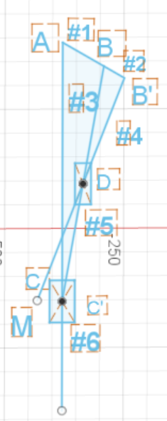

Mechanism consists of six (6) links, six (5) revolute joints and two (2) prismatic joints, (0) higher pair

DOF using the Grubler’s equation

DOF = 3(N-1)-2P1-2P2

N = no. of links

P1 = no. of revolute & prismatic joints

P2 = no. of higher pairs

DOF = 3(6-1)-2(7)-(0)

DOF = 3(5)-14-0

DOF = 15-14

DOF = 1

The lengths of the links, location of the joints hinged to ground and sliding joints in the mechanism:

l1 = 100 mm, l1´ = 50 mm, l2 = 250 mm, l2´ = 250 mm, l4 = 500 mm

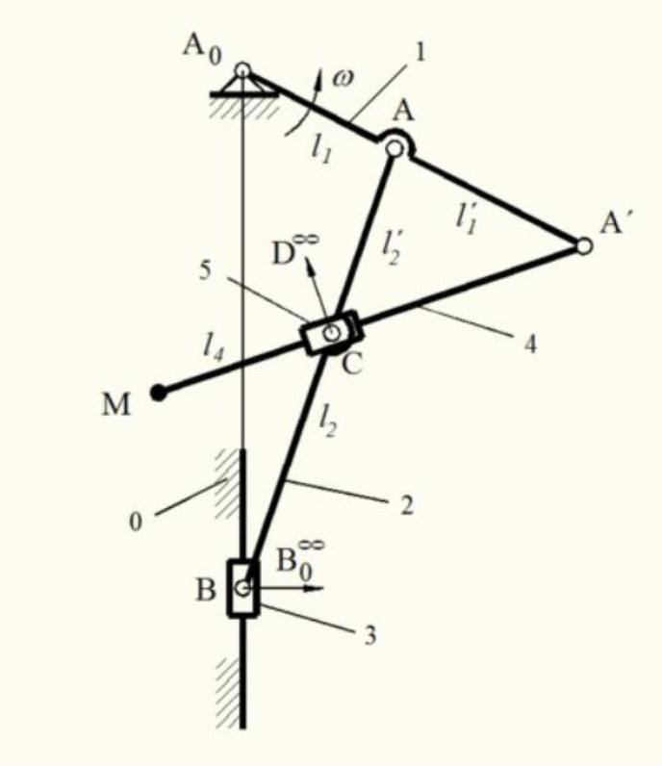 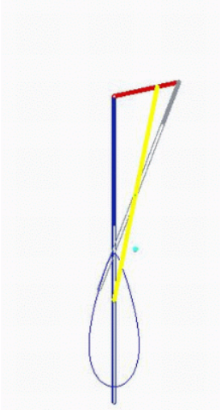

Here the length of the links AB= 100mm, BB’= 50mm, BC’= 500mm, B’M = 500mm, BD=DC’=250mm and the location of the joints hinged to ground are A at (0 , 0) and sliding points are C (0 , -542.4429), C’ (0 , -542.4429), D (43.3013 , -296.2214).

In this project, we are attempting to perform position, velocity and static force analysis using geometric approach.

The required computational geometry derivations are discussed in next section.

1. **Computational Geometry**

**Parametric form:**

Consider the following plot





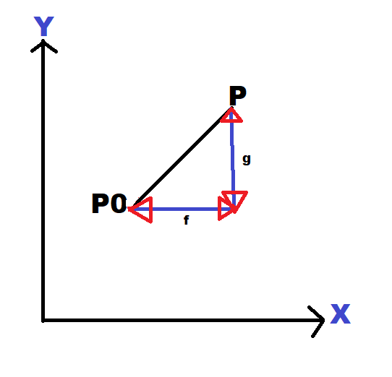



Consider a line  with coordinates  to find 



Where ‘t’ is a scalar quantity and this parameter changes for every point but in this case, ‘t’ is 1 which has

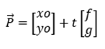

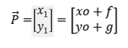

**Line-Line intersection:**

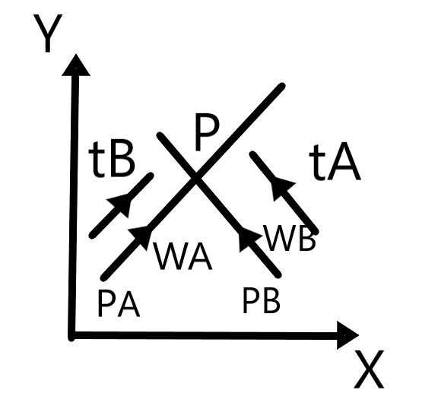

The two equations of lines are coinciding at a point P, the point on the line 1 is denoted as PA(xA,yA) with a unit direction vector along the line. As the same for point PA(xB,yB) on the line 2 with a unit direction vector along the line. Inorder to find the co-ordinates of the point P, we should find through the points PA and PB.



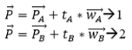



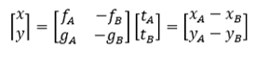

The det of the  matrix is =fB*gA-fA*gB=det.

Then inorder to find the 2 unknowns we must know the cramer’s rule by which we can find the t value which can be written as

tA=[(xB−xA))(yB−yA)−fB−gB]/det

tA=fB(yB−yA)−gB(xB−xA)/det and

tB=fA(yB−yA)−gA(xB−xA)/det

**Line-Circle intersection:**

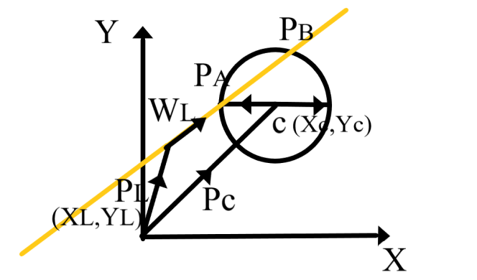

Consider an equation of line which is in the form of yellow line, a circle of radius r and the center of circle is at the point c with coordinates (Xc, Yc) and a vector PL on the yellow line with coordinates (XL,YL) and Pc vector with coordinates(Xc , Yc). To find the coordinates of the PA and PB which are intersecting points of the circle and the line as follows

Let's consider P as the intersecting point, to find the intersection point

---- eq (1)

and

---- eq (2)

And we know the equation of the circle which is

(X-XC)2 +(Y-YC)2=r2



We know that,



equating 1 and 2 equations we get,

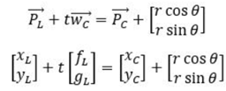

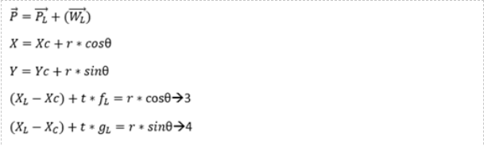

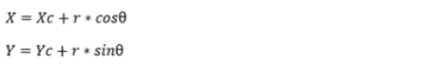

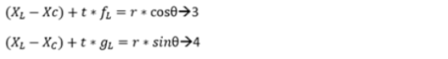

Adding 3 and 4 we get,



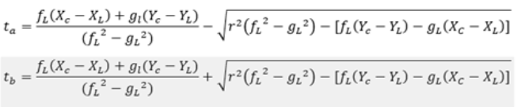



Therefore, PA and PB are

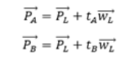

1. **Position Analysis**

First, we drawn a crank of length 100mm and input angle as 60 degrees with respect to y-axis. And we drawn a extension rod for the crank of length 50mm.We drawn a free line on y-axis, and we drawn a connecting rod (1) from extension rod of length 500mm touching to freely drawn line on the y-axis. And we drawn a circle from the extended rod of radius 250mm touching the connecting rod (1). And we drawn a connecting rod (2) from crank of length 500mm passing through intersection of circle and connecting rod (1) and touching the freely drawn line.

In position analysis we used line-line intersection algorithm and line-circle intersection algorithm.

For getting the intersection point(c) of ground and connecting rod line-circle intersection algorithm.

For getting the point (D) i.e., of connecting rod and output link at the midpoint of the connecting rod we used line-line intersection algorithm

Firstly, In MATLAB all links inputs are given and then by using the length and direction of each link Position analysis is done

These lines below explain fig (1)

First from A in direction of red link the length of the red link is extended and then and we will get B and B’ then by using line – line intersection algorithm the connection of yellow link with blue (ground) is found, now from the midpoint of the yellow link in the direction of green link the end of the green link is located, the direction can be found by normalizing two points or if we know theta then the direction will be [cos(theta) sin(theta)]

For 45 degrees input angle Matlab output

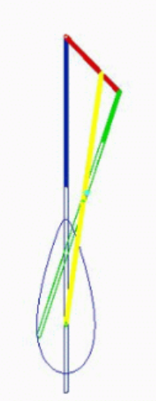 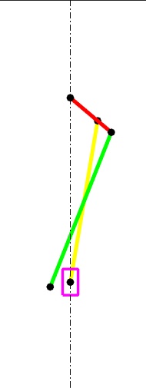

Fig(1)

For 90 degrees input angle Matlab output

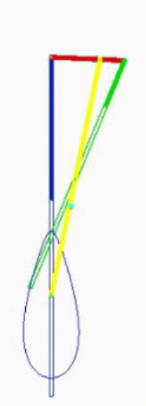 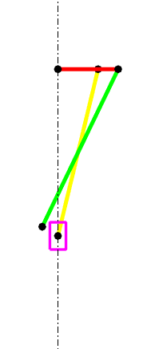

For 60 degrees input angle Matlab output

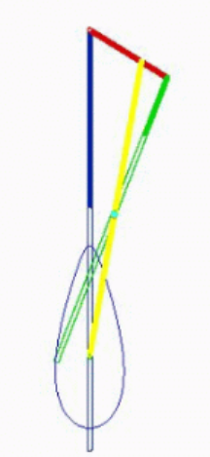 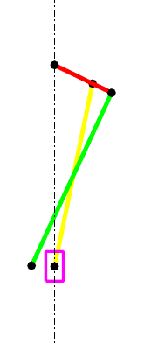

Traces in our Mechanism: Matlab output

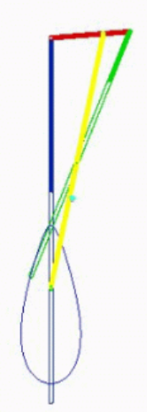 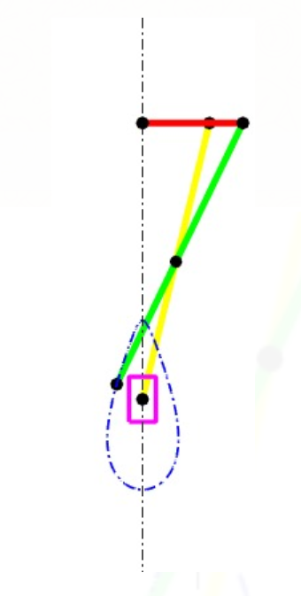

1. **Velocity Analysis**

In velocity analysis we used line-line intersection algorithm.

To find point c’ we used line-line intersection algorithm as we know point a and point b by using line

Line intersection algorithm we found c’.

As point d is the midpoint of bc’ and the sliding directions are drawn parallel and the rotating directions

are drawn perpendicular. For finding the point m we used line-line intersection algorithm.

Input angle 60 degrees in fusion Input angle 60 degrees in matlab

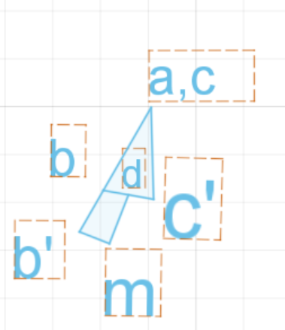 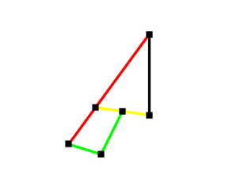

Input angle 45 degrees in matlab Input angle 90 degrees in matlab

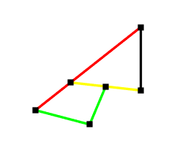 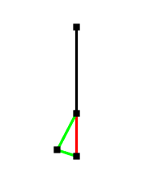

1. **Static Force Analysis**

In static force analysis we used line-line intersection.

We applied the force on the slider in upwards direction such that the force traverses along all links

When the Force acts on slider it gets divided in the direction of ground and in the direction of connecting rod by drawing the force polygon we can get the direction and magnitude of the unknown forces

The force obtained from the force polygon of the slider is acted on the connecting rod .The connecting rod has sliding point at the midpoint so the force acting at the midpoint and the two ends are known by drawing force polygon and the force obtained at the midpoint is going to act at the end of output link

The Forces at B and B1 are the connecting rod’s force and output link’s force on the crank by drawing the force polygon of the crank we will get the force at point O

1. **Conclusions**

In this project we have learnt and done the position, velocity, static force Analysis for the above six bar mechanism. We have done MATLAB coding for position analysis, velocity analysis, static force analysis for the above six bar mechanism. And we have done all the analysis in the Autodesk inventor fusion software. And we learned how to animate the mechanism in MATLAB.