Case Study
Namburi Vivek
CB.SC.U4CSE24762

Stage:1
1. sudo apt-get install libreadline-dev flex bison make gcc wget curl
2. curl -sSf https://raw.githubusercontent.com/eXpOSNitc/expos-bootstrap/main/download.sh | sh
3. cd $HOME/myexpos
4.make
Output:
After downloading the myexpos
Stage:2
1. cd $HOME/myexpos/xfs-interface
./xfs-interface
2. # fdisk
# exit
3. cd $HOME/myexpos/xfs-interface
./xfs-interface
4. # load --data $HOME/myexpos/sample.dat
5. # copy 3 4 $HOME/myexpos/inode_table.txt
# exit
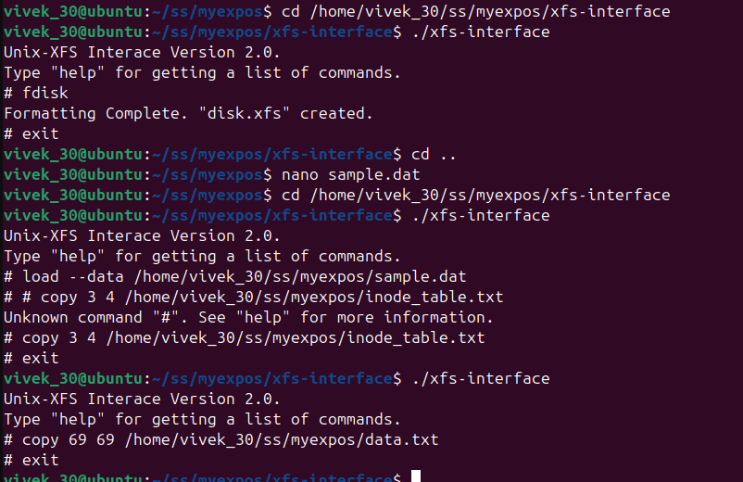

assigment:1,2
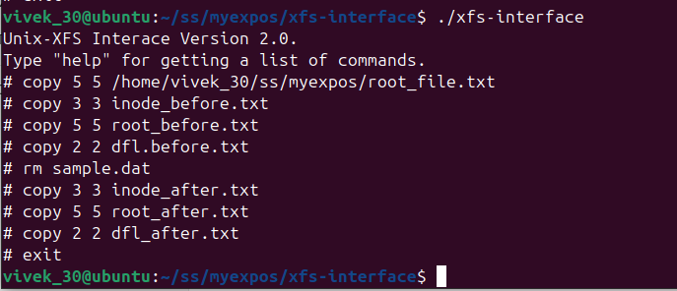
1. dfl_before and dfl_after
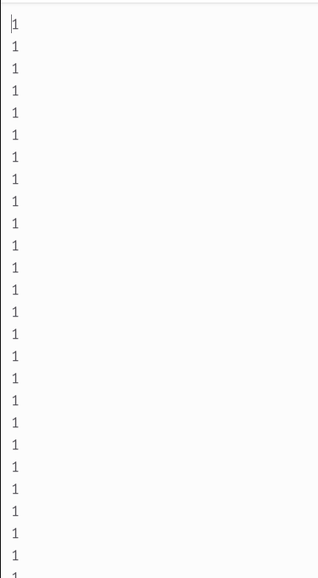
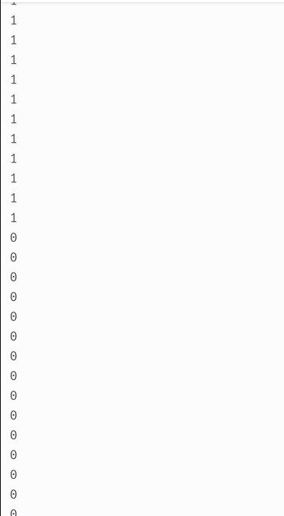

2. root_before and root_after
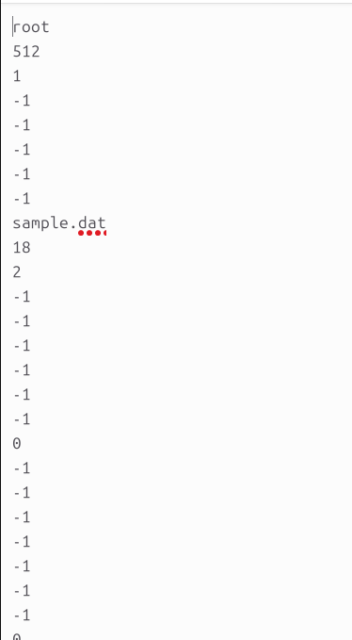
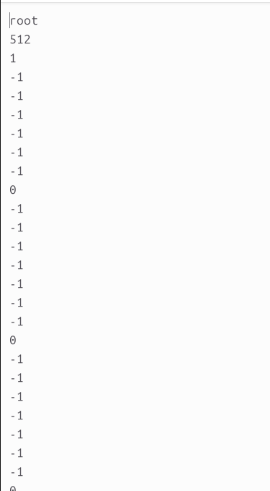
Stage:3
input:
MOV R0, "HELLO_WORLD"
MOV R16, R0
PORT P1, R16
OUT
HALT
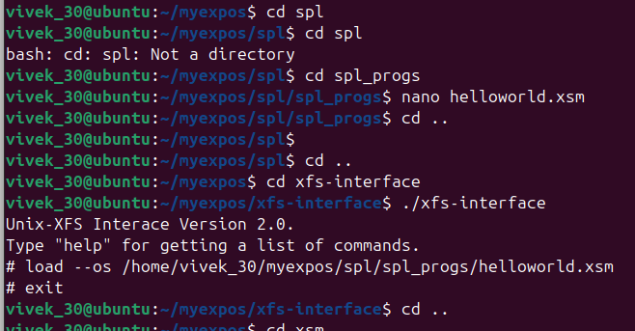
Output:
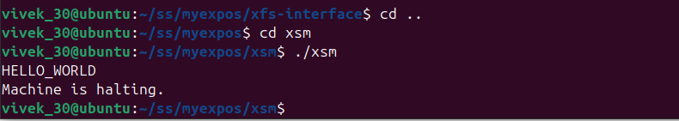
Assignment:

MOV R0, 1
_L1:
MOV R16, 20
GE R16, R0
JZ R16, _L2
MOV R16, R0
PORT P1, R16
OUT
MOV R16, R0
ADD R16, 1
MOV R0, R16
JMP _L1
_L2:
HALT
HALT
output:

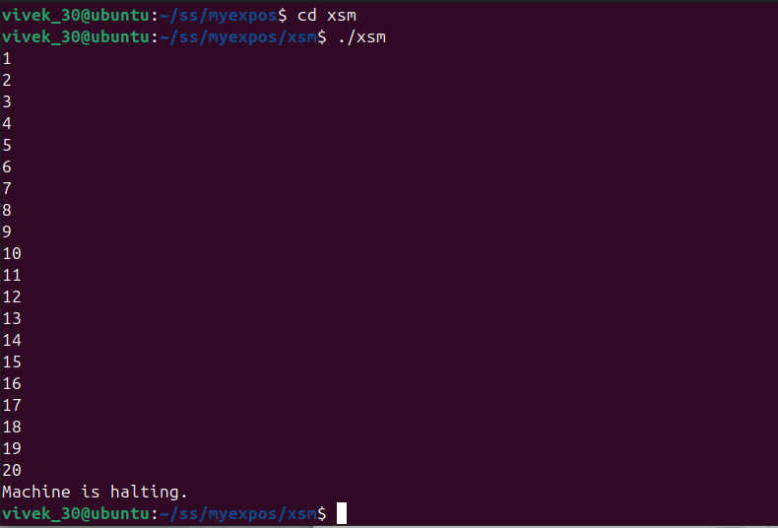
Stage:4
alias counter R0;
counter = 0;
while(counter <= 20) do
if(counter%2 != 0) then
print counter;
endif;
counter = counter + 1;
endwhile;
output:
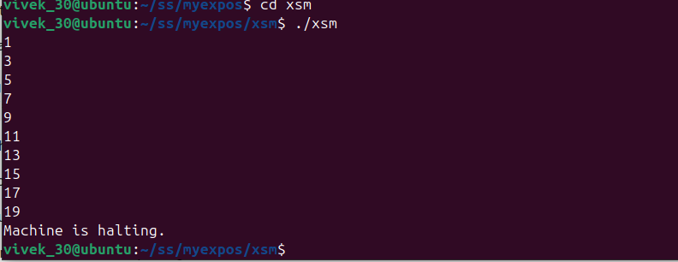
Assignment:
alias counter R0;
alias sum R1;
alias square R2;

counter = 1;
sum = 0;

while(counter <= 20) do
square = counter * counter;
sum = sum + square;
counter = counter + 1;
endwhile;

print sum;
halt;

output:
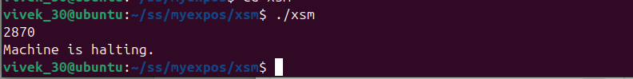
Stage:5
alias counter R0;
counter = 0;
while(counter <= 10) do
if(counter%2 != 0) then
breakpoint;
endif;
counter = counter + 1;
endwhile;
output:
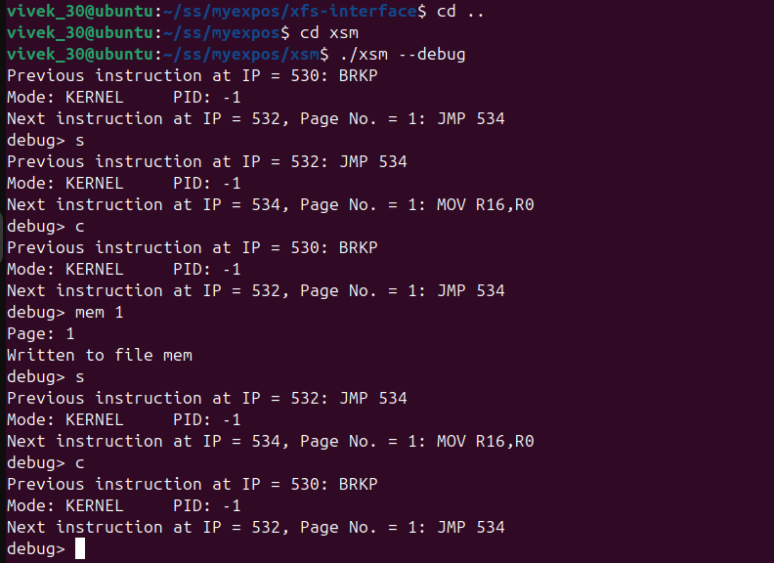
Stage:6
input:
os_startup.spl:
loadi(65,7);
loadi(66,8);
loadi(22,35);
loadi(23,36);
loadi(2, 15);
loadi(3, 16);
PTBR = PAGE_TABLE_BASE;
PTLR = 3;
[PTBR+0] = 65;
[PTBR+1] = "0100";
[PTBR+2] = 66;
[PTBR+3] = "0100";
[PTBR+4] = 76;
[PTBR+5] = "0110";
[76*512] = 0;
SP = 2*512;
ireturn;

haltprog.spl:
halt;

squares.xsm:
MOV R0, 1
MOV R2, 5
GE R2, R0
JZ R2, 2066
MOV R1, R0
MUL R1, R0
BRKP
ADD R0, 1
JMP 2050
INT 10
Output:
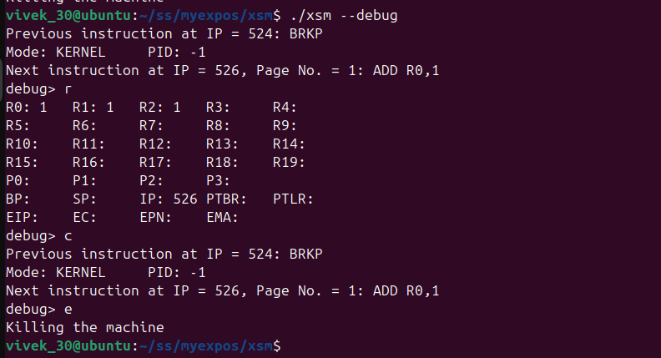
assignment:1
code:squares
MOV R0, 1
MOV R2, 5
GE R2, R0
JZ R2, 2066
MOV R1, R0
MUL R1, R0
BRKP
ADD R0, 1
JMP 2050
INT 10
os_startup.spl:
loadi(65,7);
loadi(66,8);
loadi(22,35);
loadi(23,36);
loadi(2,15);
loadi(3,16);
PTBR = PAGE_TABLE_BASE;
PTLR = 9;
[PTBR+8] = 65;
[PTBR+9] = 4;
[PTBR+10] = 66;
[PTBR+11] = 4;
[PTBR+16] = 76;
[PTBR+17] = 6;
[76*512] = 2048;
SP = 8*512;
ireturn;

output:
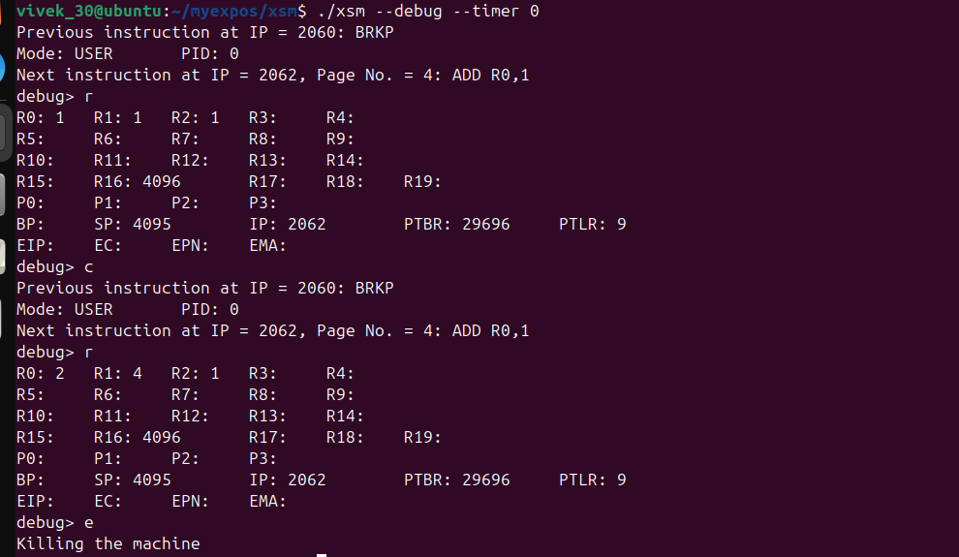

Stage 7:
os_startup.spl:
loadi(63, 13);
loadi(64, 14);
loadi(65, 7);
loadi(66, 8);
loadi(2, 17);
loadi(3, 18);
PTBR = PAGE_TABLE_BASE;
PTLR = 10;
[PTBR+0] = 63;
[PTBR+1] = "0100";
[PTBR+2] = 64;
[PTBR+3] = "0100";
[PTBR+4] = 78;
[PTBR+5] = "0110";
[PTBR+6] = 79;
[PTBR+7] = "0110";
[PTBR+8] = 65;
[PTBR+9] = "0100";
[PTBR+10] = 66;
[PTBR+11] = "0100";
[PTBR+12] = -1;
[PTBR+13] = "0000";
[PTBR+14] = -1;
[PTBR+15] = "0000";
[PTBR+16] = 76;
[PTBR+17] = "0110";
[PTBR+18] = 77;
[PTBR+19] = "0110";
SP = 8 * 512;
[76*512] = [65 * 512 + 1];
ireturn;

init.xsm:
0
2056
0
0
0
0
0
0

MOV R0, 1
MOV R2, 5
GE R2, R0
JZ R2, 2076
MOV R1, R0
MUL R1, R0
BRKP
ADD R0, 1
JMP 2058
INT 10
output:
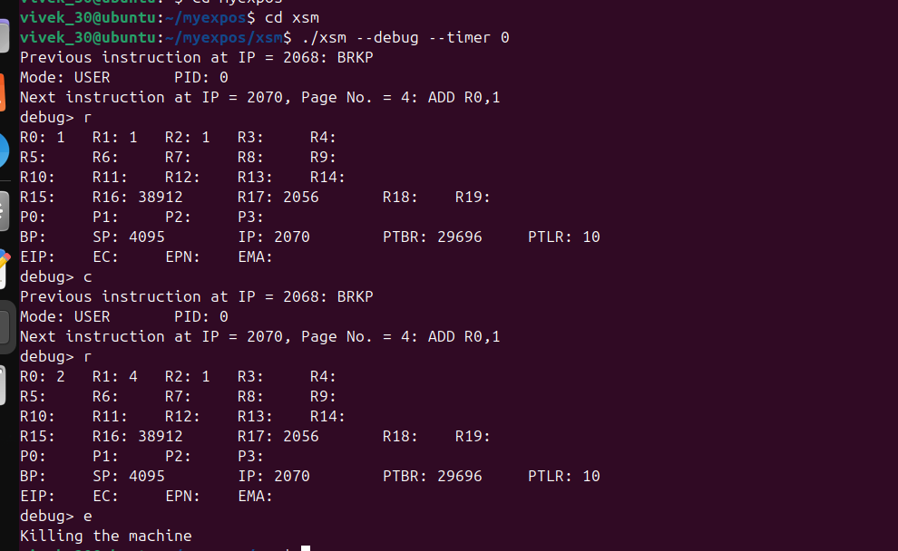
Assignment:
input:
os_startup.spl:
loadi(63, 13);
loadi(64, 14);
loadi(65, 7);
loadi(66, 8);
loadi(2, 17);
loadi(3, 18);
PTBR = PAGE_TABLE_BASE;
PTLR = 10;
[PTBR+0] = 63;
[PTBR+1] = "0100";
[PTBR+2] = 64;
[PTBR+3] = "0100";
[PTBR+4] = 78;
[PTBR+5] = "0110";
[PTBR+6] = 79;
[PTBR+7] = "0110";
[PTBR+8] = 65;
[PTBR+9] = "0100";
[PTBR+10] = 66;
[PTBR+11] = "0100";
[PTBR+12] = -1;
[PTBR+13] = "0000";
[PTBR+14] = -1;
[PTBR+15] = "0000";
[PTBR+16] = 76;
[PTBR+17] = "0110";
[PTBR+18] = 77;
[PTBR+19] = "0110";
SP = 8 * 512;
[76*512] = [65 * 512 + 1];
ireturn;
cubes.xsm:

0
2056
0
0
0
0
0
0

MOV R0, 1
MOV R2, 5
GE R2, R0
JZ R2, 2076
MOV R1, R0
MUL R1, R0
MUL R1, R0
BRKP
ADD R0, 1
JMP 2058
INT 10

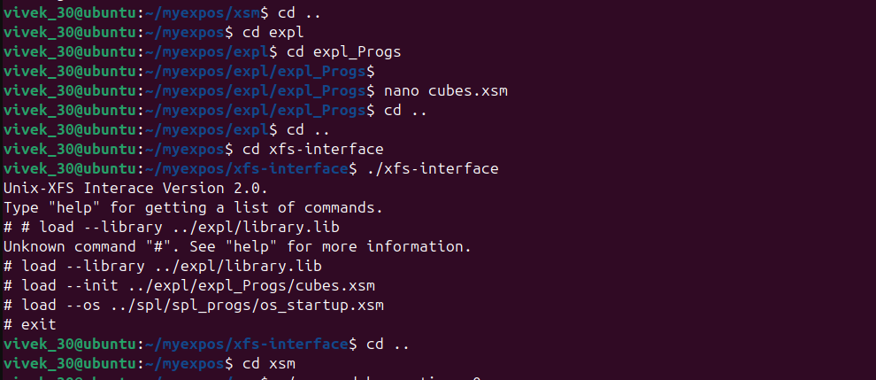
output:
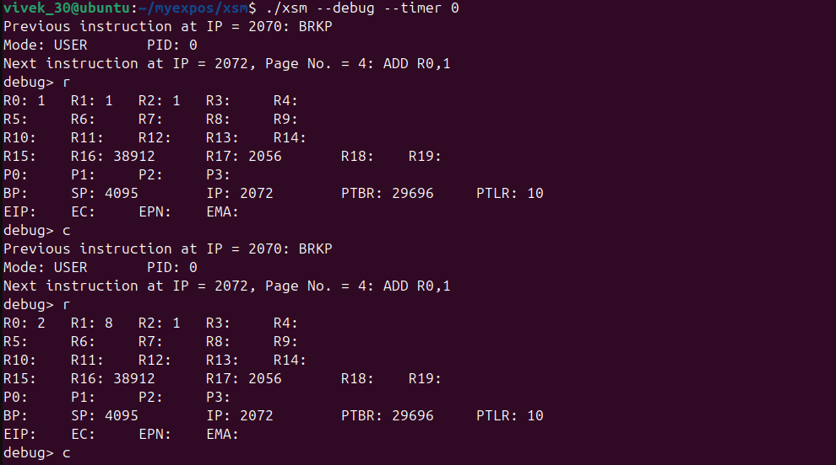
Stage:8
os_startup.spl:
loadi(63, 13);
loadi(64, 14);

loadi(65, 7);
loadi(66, 8);

loadi(4, 17);
loadi(5, 18);

loadi(2, 17);
loadi(3, 18);

PTBR = PAGE_TABLE_BASE;
PTLR = 10;

[PTBR+0] = 63;
[PTBR+1] = "0100";

[PTBR+2] = 64;
[PTBR+3] = "0100";

[PTBR+4] = 78;
[PTBR+5] = "0110";

[PTBR+6] = 79;
[PTBR+7] = "0110";

[PTBR+8] = 65;
[PTBR+9] = "0100";

[PTBR+10] = 66;
[PTBR+11] = "0100";

[PTBR+12] = -1;
[PTBR+13] = "0000";

[PTBR+14] = -1;
[PTBR+15] = "0000";

[PTBR+16] = 76;
[PTBR+17] = "0110";

[PTBR+18] = 77;
[PTBR+19] = "0110";

PTLR = 10;

SP = 8*512;

[76*512] = [65*512 + 1];

ireturn;

sample_timer.spl

print "TIMER";
ireturn;
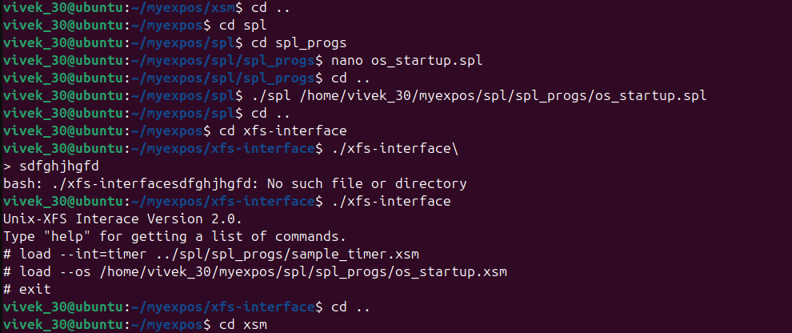
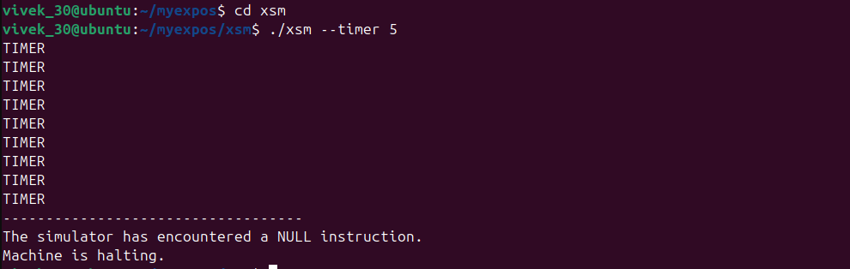
output:
Stage:9
os_startup
[PROCESS_TABLE + 11] = 80;
[PROCESS_TABLE + 1] = 0;
[SYSTEM_STATUS_TABLE + 1] = 0;
loadi(63, 13);
loadi(64, 14);
loadi(65, 7);
loadi(66, 8);
loadi(4, 17);
loadi(5, 18);
loadi(2, 17);
loadi(3, 18);
PTBR = PAGE_TABLE_BASE;
PTLR = 10;
[PTBR+0] = 63;
[PTBR+1] = "0100";
[PTBR+2] = 64;
[PTBR+3] = "0100";
[PTBR+4] = 78;
[PTBR+5] = "0110";
[PTBR+6] = 79;
[PTBR+7] = "0110";
[PTBR+8] = 65;
[PTBR+9] = "0100";
[PTBR+10] = 66;
[PTBR+11] = "0100";
[PTBR+12] = -1;
[PTBR+13] = "0000";
[PTBR+14] = -1;
[PTBR+15] = "0000";
[PTBR+16] = 76;
[PTBR+17] = "0110";
[PTBR+18] = 77;
[PTBR+19] = "0110";
PTLR = 10;
SP = 8*512;
[76*512] = [65*512 + 1];
ireturn;
sample_timer
[PROCESS_TABLE + ( [SYSTEM_STATUS_TABLE + 1] * 16) + 13] = SP;
// Setting SP to UArea Page number * 512 - 1
SP = [PROCESS_TABLE + ([SYSTEM_STATUS_TABLE + 1] * 16) + 11] * 512 - 1;
backup;
print "TIMER";
restore;
SP = [PROCESS_TABLE + ( [SYSTEM_STATUS_TABLE + 1] * 16) + 13];
ireturn;
input:
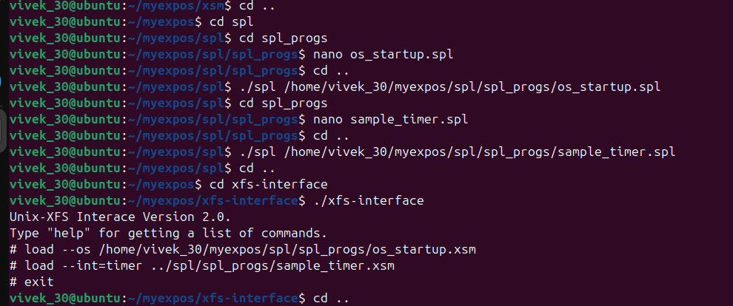
output:
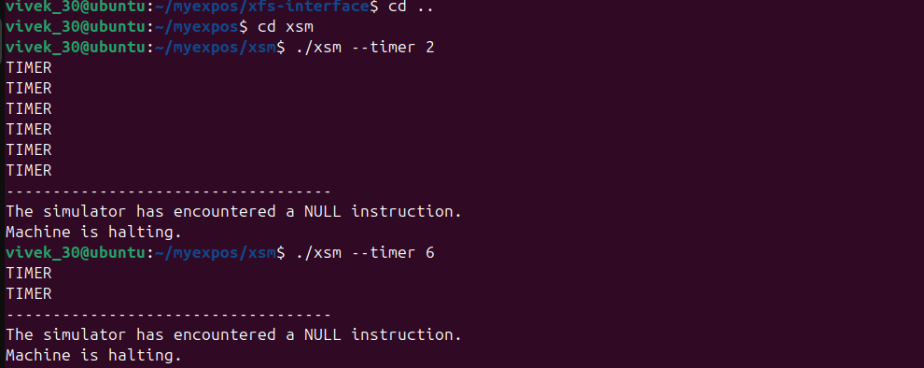
assignment:1
input:
sample_timer
[PROCESS_TABLE + ( [SYSTEM_STATUS_TABLE + 1] * 16) + 13] = SP;
// Setting SP to UArea Page number * 512 - 1
SP = [PROCESS_TABLE + ([SYSTEM_STATUS_TABLE + 1] * 16) + 11] * 512 - 1;
backup;
print "TIMER";
restore;
SP = [PROCESS_TABLE + ( [SYSTEM_STATUS_TABLE + 1] * 16) + 13];
ireturn;
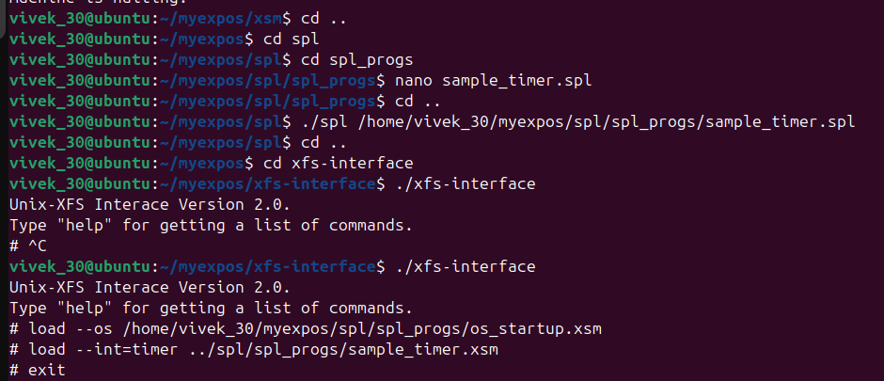
output:
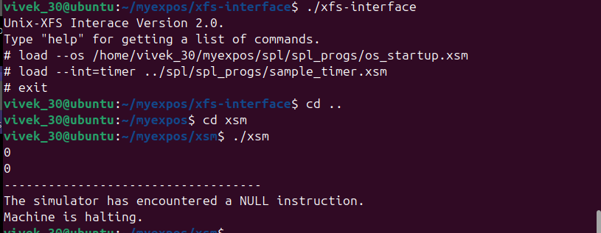
Stage:10
input:
sample_int7.spl
alias userSP R0;
userSP = SP;
[PROCESS_TABLE + [SYSTEM_STATUS_TABLE + 1] * 16 + 13] = SP;
SP = [PROCESS_TABLE + [SYSTEM_STATUS_TABLE + 1] * 16 + 11] * 512 - 1;
alias word R1;
word = [[PTBR + 2 * ((userSP - 3) / 512)] * 512 + ((userSP - 3) % 512)];
print word;
alias retAddr R2;
retAddr = ([PTBR + 2 * ((userSP - 1) / 512)] * 512) + ((userSP - 1) % 512);
[retAddr] = 0;
SP = userSP;
ireturn;
os_startup
loadi(65,7);
loadi(66,8);

loadi(16,29);
loadi(17,30);
loadi(22,35);
loadi(23,36);
loadi(2,15);
loadi(3,16);
PTBR = PAGE_TABLE_BASE;
PTLR = 10;
[PTBR+8] = 65; [PTBR+9] = "0100";
[PTBR+10] = 66; [PTBR+11] = "0100";
[PTBR+16] = 76; [PTBR+17] = "0110";
[PTBR+18] = 77; [PTBR+19] = "0110";
[76*512] = [65*512 + 1];
SP = 8 * 512;
ireturn;
init.xsm
0
2056
0
0
0
0
0
0
MOV R0, 1
MOV R2, 5
GE R2, R0
JZ R2, 2110
MOV R1, R0
MUL R1, R0
PUSH R0
PUSH R1
PUSH R2
MOV R0, 5
MOV R2, -2
PUSH R0
PUSH R2
PUSH R1
PUSH R0
PUSH R0
INT 7
POP R1
POP R1
POP R1
POP R1
POP R1
POP R2
POP R1
POP R0
ADD R0, 1
JMP 2058
INT 10
output:
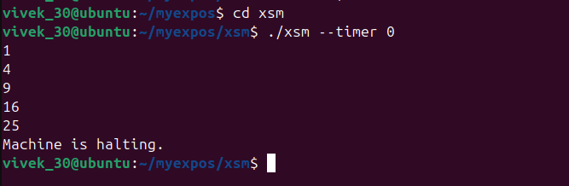
assigment:1
input:
init.xsm
0
2056
0
0
0
0
0
0
MOV R0, 1
MOV R2, 20
GE R2, R0
JZ R2, 2110
MOV R1, R0
PUSH R0
PUSH R1
PUSH R2
MOV R0, 5
MOV R2, -2
PUSH R0
PUSH R2
PUSH R1
PUSH R0
PUSH R0
INT 7
POP R1
POP R1
POP R1
POP R1
POP R1
POP R2
POP R1
POP R0
ADD R0, 1
JMP 2058
INT 10
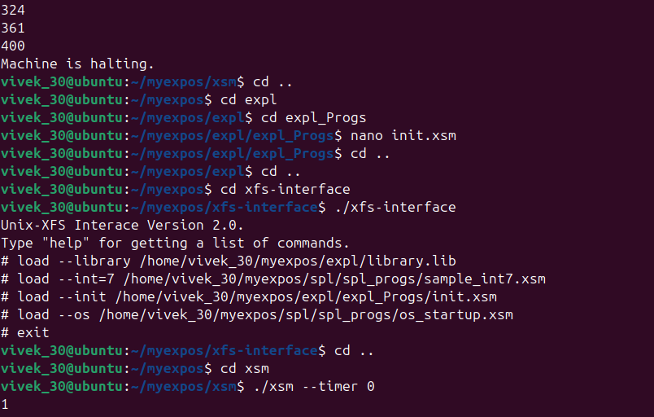
output:
