**Homework #9**

**201724456 남대유**

**AI Programming**

**Numeric:**

1. **‘Convex.txt’ with Steepest-Ascent algorithm:**

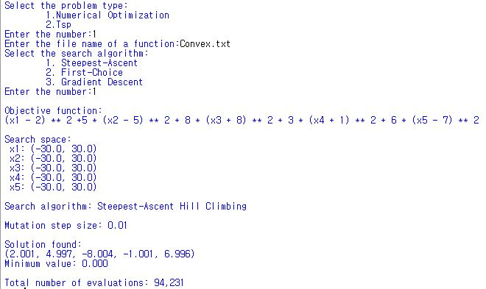

1. **‘Ackley.txt’ with First-choice algorithm:**

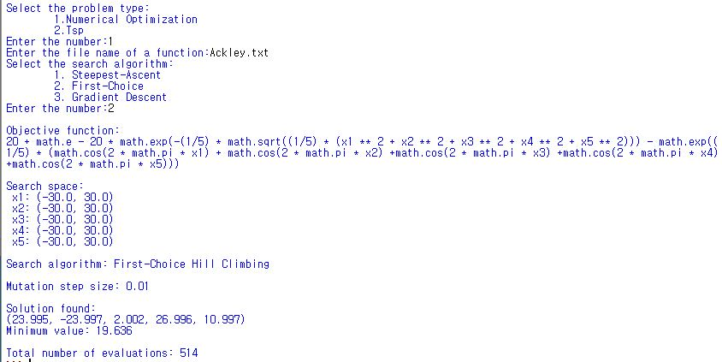

1. **‘Griewank.txt’ with Gradient-Descent algorithm:**

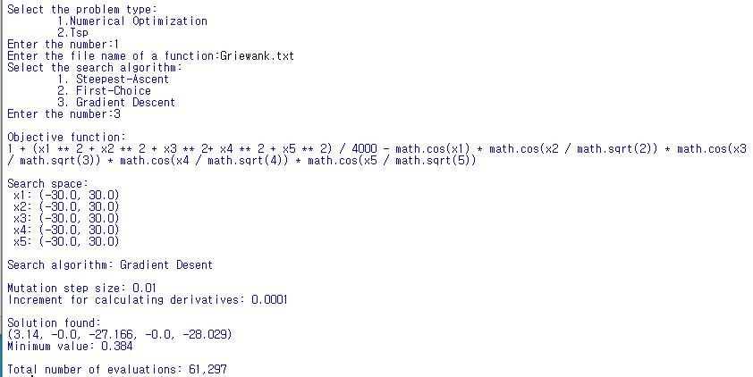

**TSP:**

1. **‘tsp30.txt’ with Steepest-Ascent algorithm:**

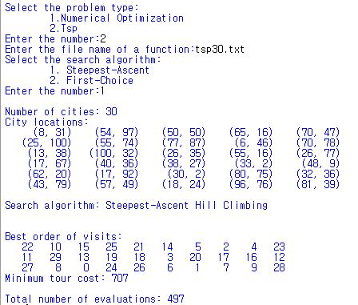

1. **‘tsp100.txt’ with First-choice algorithm:**

