|  |  |  |
| --- | --- | --- |
|  | |  |
|  | | |
| Arena_CCU_GUI_19; Arena_CCU_Firmware_19_0_1 – Testing Documentation | | |
| **Module code:** | **EG4007** | |
| **Module name:** | **Fourth Year Project 2022-23** | |
|  | | |
| April 2023 | | |
|  | | |
| **Author(s):** | **Matt Dunbobbin** | |
| **Student ID(s):** | **189018369** | |
| **Degree:** | **MEng Electronic and Electrical Engineering (with Foundation Year)** | |
|  | | |
|  | | |

By submitting this report for assessment I confirm that this assignment is my own work, is not copied from any other person's work (published or unpublished), and that it has not previously been submitted for assessment on any other module or course.

I am aware of the University of Leicester’s policy on plagiarism, and have taken the online tutorial on avoiding plagiarism.  I am aware that plagiarism in this project report may result in the application of severe penalties up to and including expulsion from the University without a degree.

|  |
| --- |
|  |
| Summary |
| This document contains the relevant testing procedures followed to ensure the released version of the software is fit for use. This document will need updating for any future versions of software being issued for use with the UoL Fighting Robot Arena and its relevant hardware. All these tests were performed on a Microsoft Windows 11 Pro, 64-bit operating system machine with an AMD Ryzen 5900X CPU at 4.20GHz and 32 GB of DDR4 RAM. The arena hardware includes the arena CCU, 9 lighting modules, 2 door sensors, pit trap motor and turntable trap motor. Cameras were not connected to the CCU for these tests. |

Contents

1 Introduction 2

1.1 Data Validation 2

1.2 Types of Testing 2

2 Results 3

3 Discussion 4

4 Conclusion 4

# Introduction

## Data Validation

The GUI can only accept user input in the form of mouse clicks so testing for data validation can be excluded from this testing procedure. All data being sent over the serial line is predefined in the source code and should not be changed end user.

## Types of Testing

All tests completed for these systems will be black box tests. This means that the software will be given an input from the user in the form of mouse clicks, and then the output from both the software and hardware will be recorded. This allows the predicted response to be compared with the actual response and allow issues to be identified.

It is outside of the scope of this documentation to complete any extra testing on the software in the form of penetration tests, vulnerability tests, or memory leak tests. This testing procedure is only in place to ensure the software and hardware performs as expected for the end user.

# Tests

## Ensure Stable Launch

This test has been designed to ensure the GUI launches from the file stored on the CCU onboard storage.

Table 1

|  |  |  |  |
| --- | --- | --- | --- |
| Conditions | Expected Outcome | Actual Outcome | Evidence |
| CCU connected to host PC with all hardware stated in the introduction connected. Door sensors should be CLOSED | GUI opens up on host pc with no errors reported. All trap controls, lighting controls, and stop/resume buttons should be greyed out | As Expected |  |
| CCU connected to host PC with all hardware stated in the introduction connected. Door sensors should be OPEN | GUI opens up on host pc with no errors reported. All trap controls, lighting controls, and stop/resume buttons should be greyed out | As Expected |  |

## COM Connection

Ensure when the COM connection is initiated, the relevant buttons become active, and the serial connection is correct.

Table 2

|  |  |  |  |
| --- | --- | --- | --- |
| Conditions | Expected Outcome | Actual Outcome | Evidence |
| CCU connected to host PC with all hardware stated in the introduction connected. Door sensors should be CLOSED. CCU Arduino selected from Tools -> Select COM port | GUI opens up on host pc with no errors reported. All trap controls and resume should be greyed out, lighting and stop buttons should become active when port selected. Serial monitor should print “DOOR CLOSED @ START” and “Connected to Arena” | As Expected |  |
| CCU connected to host PC with all hardware stated in the introduction connected. Door sensors should be OPEN. CCU Arduino selected from Tools -> Select COM port | GUI opens up on host pc with no errors reported. All trap controls and resume should be greyed out, lighting and stop buttons should become active when port selected. Serial monitor should print “DOOR OPEN @ START” and “Connected to Arena” | As Expected |  |
| CCU connected to host PC with all hardware stated in the introduction connected. Door sensors should be CLOSED. No COM port selected. Click Tools -> Door Sensors Enabled | Error should appear saying no connection. Door sensor enable checkbox should remain unchecked | As Expected |  |
| CCU connected to host PC with all hardware stated in the introduction connected. Door sensors should be CLOSED. No COM port selected. Click Tools -> Turntable Enabled | Error should appear saying no connection. Turntable enable checkbox should remain unchecked | As Expected |  |
| CCU connected to host PC with all hardware stated in the introduction connected. Door sensors should be CLOSED. No COM port selected. Click Tools -> Pit Trap Enabled | Error should appear saying no connection. Pit trap enable checkbox should remain unchecked | As Expected |  |

## Exit Methods

This test has been designed to ensure the GUI closes correctly from either the red X or File -> Exit.

Table 1

|  |  |  |  |
| --- | --- | --- | --- |
| Conditions | Expected Outcome | Actual Outcome | Evidence |
| CCU connected to host PC with all hardware stated in the introduction connected. Door sensors should be CLOSED. Red X is pressed on GUI window | GUI closes with no errors shown in monitoring python shell | As Expected | N/A |
| CCU connected to host PC with all hardware stated in the introduction connected. Door sensors should be CLOSED | GUI closes with no errors shown in monitoring python shell | As Expected | N/A |

# Results

Contains the results, usually presented using tables and figures. The results must have a commentary that describes any key trends and experimental errors rather than just a collection of data, but in this section there should not be any interpretation of the results – leave that for the discussion.

When you insert a figure or a table, ensure that it also has a descriptive caption that is referenced in the preceding text. Examples of this can be seen with Table 1 and Figure 1 below. Captions can be added to figures and tables using the ‘Caption…’ feature and referred to in the text using ‘Cross-reference…’ in Word, or added manually later.

Table 3 – An example of a captioned table.

|  |  |  |
| --- | --- | --- |
| Table column heading | Another heading | Another heading |
| This text is written using… | …the style named ‘table’… | ..that has no line spacing |
|  |  |  |
|  |  |  |

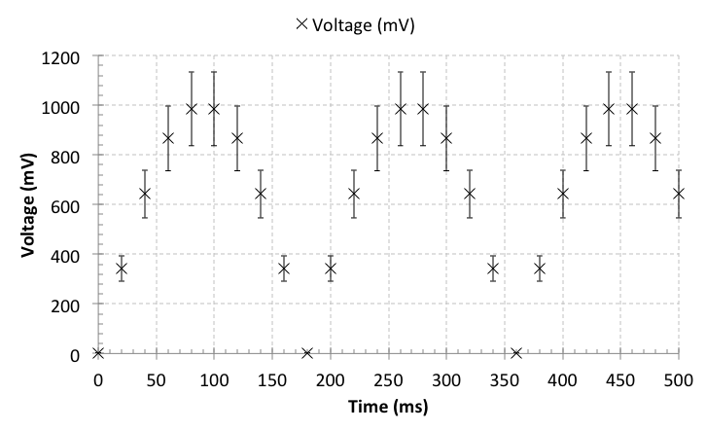

Figure 1 – An example of a captioned figure.

Equations presented in a report should be numbered, and all the variables defined in the text. For example, the stagnation heat flux on a blunt body $Q''$ entering a planetary atmosphere can be estimated by the relationship:

$Q''=C V^{3} \sqrt{\frac{ρ}{R}}$ (1)

where $C$ is a constant, $V$ is the velocity of the body, $ρ$ is the atmospheric density and $R$ is the radius of curvature of the leading surface of the body.

# Discussion

Here the aim is to explain the findings, why they are important and how they compare with the theory and previous work (‘the literature’). Sometimes simple statements evaluating the results is all that is needed, but usually this section seeks to explain or propose the reasons behind the results. Limitations should also be discussed. The best Discussions carefully relate the results with the theory and explain how this relates to real-world application.

# Conclusion

Here is the place to sum up what new knowledge has been generated by the work – this should ideally be quantified and the significance of the work stated. No new discussion or references should be introduced in the conclusions (that should be in the discussion). Bullet points and/or short statements are commonly used. Suggestions for future work may be included. The conclusions are not the same as the summary or abstract – the conclusions describe the findings, the summary/abstract summarises the whole report.