CS Lab # 3 Point Class

- Write a class Point that represents a point in the Cartesian Coordinate plane.
Every point is identified by its x- and y-coordinates.

The Point class has to have the following:

- two instance variables representing x- and y-coordinates;
- a default constructor that creates a (0, 0) point;
- a constructor that creates a point with the given coordinates (x, y);
- accessor and mutator method(s) for each instance variable;
- toString() that returns a String representation of this Point in the form "(x , y)";
- void translate(int dx, int dy) that shifts this point's location by the given amount;
- double distanceFromOrigin() that returns the distance between this point and (0, 0);

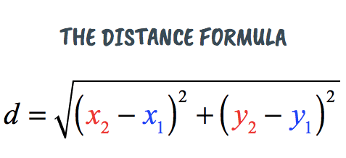

- BONUS: public void printWarning()that prints a warning using the results of the distanceFromOrigin() method.
if d = 0, “it’s the same point”
if d ≤ 3.14, “it’s too close”
if d > 3.14, “it’s a safe distance”

- Write a PointTester program. Make sure to test every method.

public class Point {

}

