Arrays Quiz Practice: Standard Deviation

Write a program, StdDev.java, that will calculate the standard deviation of a set of integers.

You can see how it is done here: <https://www.mathsisfun.com/data/standard-deviation-formulas.html>

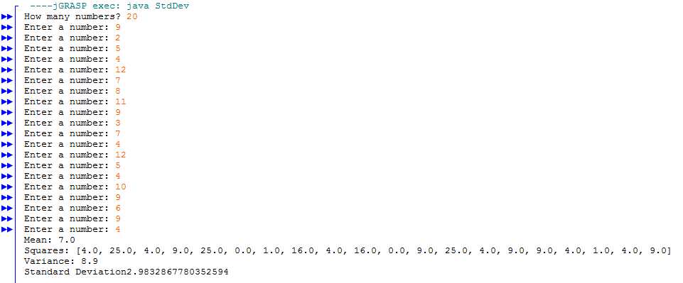

Sample Quiz Rubric:

* Program is named properly
* Comment header
* Indentation
* Prompt the user for how many numbers
* Make an array to hold that many numbers
* Read in that many numbers from the user using a for loop
* Calculate the mean using a for loop
* Use a separate for loop to calculate the squares
* Calculate the variance
* Calculate and output the standard deviation