**CS Arrays Unit Lab: Percent Even**

*Learning Target: I will write a program that uses a Scanner, for loop, and array to solve a fencepost problem*

Write a program, PercentEven.java, that asks the user how many numbers they want to enter. Then let them type that many numbers. Output what percent of the numbers were even and then print out all the even values in the array **in the given format.**

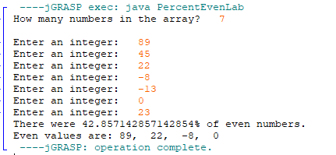

**Rubric**

* Program is named PercentEven.java
* Comment header
* Indentation
* Program asks the user how many numbers to enter
* Program makes an array that holds that many elements
* Program reads in that many numbers to the array
* Program calculates the percentage of even numbers (2 pts)
* Program prints out the even numbers
* No trailing or leading comma (fencepost)