**CS Arrays Unit Lab: Array Library**

Write a library ArrayLibrary.java with the following methods:

* reverse()

must reverse the array. Make sure to check the slides!

* shuffle()

must shuffle the array. Make sure to check the slides!

* create()

takes one parameter: the size of the array to create. Generate that many **random numbers between 1 and 20** and put them into an array. **Return the new array**. Note: it is a common mistake to generate random numbers between 1 and size instead of 1 and 20.

* howManyOf()

the method takes 2 parameters, an array and an integer target. Make a counter. Search the array for the target parameter and count how many values in the array match the target value. Return your counter. I think you did this problem on codingbat before.

* contains()

the method is similar to the above method except it returns true if the value is found **at least once**, and false otherwise. If you can figure out a way to use your howManyOf() method to **make your code one line only**, you will get a bonus point!

* main()

Test all of your methods.

**DO NOT try to write all 5 methods before testing any of them. You need to write 1 method at a time, and then test that it works in the main.**

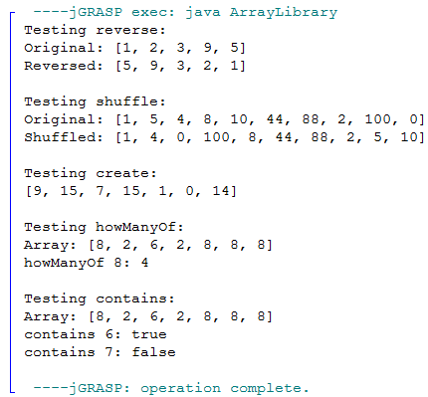

**Rubric: Each method 1 point, each method call in the main 1 point.**

See some skeleton code below:

public class ArrayLibrary {

//reverse an array  
 public static void reverse(int[] array) {  
   
 }  
   
 //shuffle an array  
 public static void shuffle(int[] array) {  
   
 }  
  
 //create a new array of size parameter  
 //filled with random numbers 1 - 20  
 public static int[] create(int size) {  
 //replace the line below with your code  
 return new int[]{};  
 }

//returns how many times the array contains the value  
 public static int howManyOf(int[] array, int value) {  
 //replace the line below with your code  
 return 0;  
 }  
   
 //returns true if the array contains the value  
 //returns false otherwise  
 public static boolean contains(int[] array, int value) {  
 //replace the line below with your code  
 return false;  
 }  
   
  
 public static void main(String[] args) {  
 //test the methods here  
   
   
 }  
   
}