Unit 7B Lab 2B: Yahtzee

Write a working Yahtzee Program. Included is the scoring method to help you.

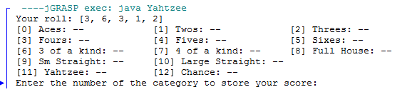

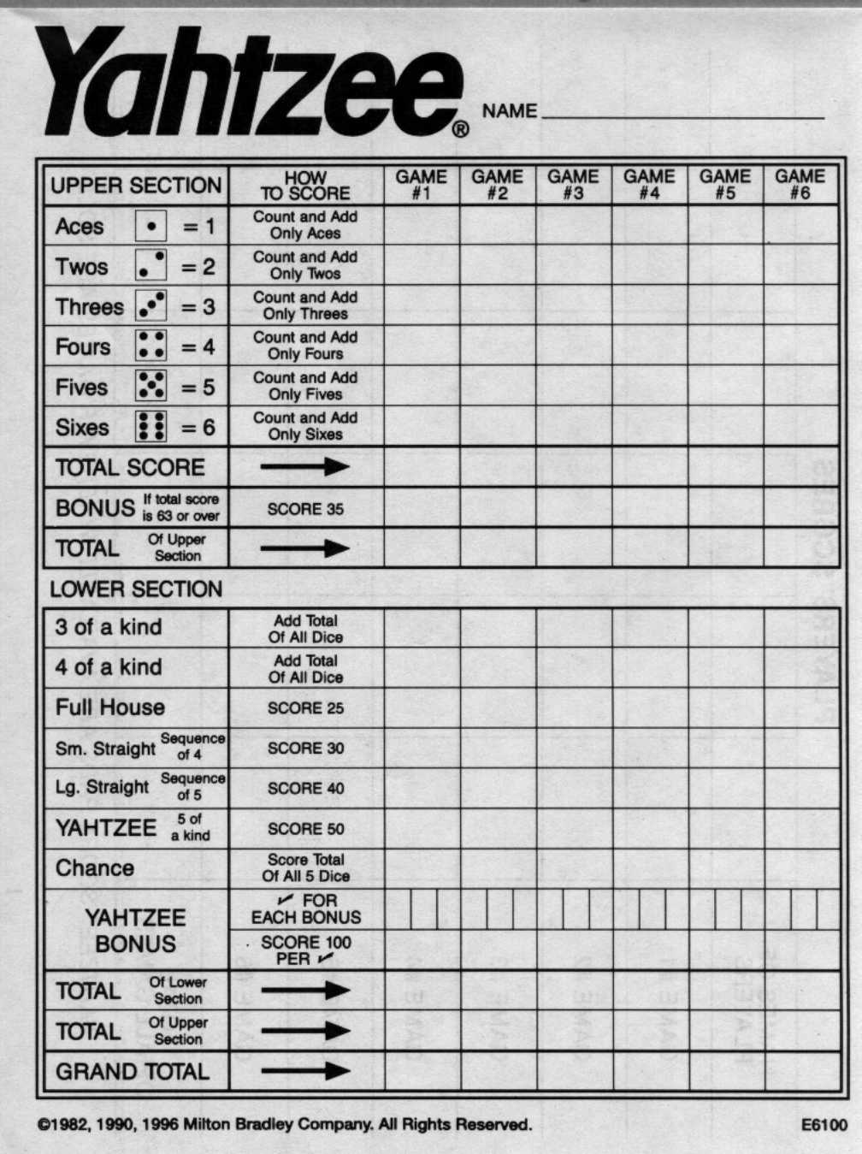

public static int getPoints(int[] rolls, int index) {  
 if (index < 6) {  
 int count = 0;  
 for (int i = 0; i < rolls.length; i++) {  
 if (rolls[i] == index + 1) count++;  
 }  
 return count \* (index + 1);  
 }  
 else if (index == 11) {  
 int match = rolls[0];  
 for (int i = 1; i < rolls.length; i++) {  
 if (rolls[i] != match) return 0;  
 }  
 return 50;  
 }  
 else if (index == 12) {  
 int sum = 0;  
 for (int i = 0; i < rolls.length; i++) {  
 sum += rolls[i];  
 }  
 return sum;  
 }  
 else if (index == 9 || index == 10) {  
 boolean[] has = new boolean[6];  
 for (int i = 0; i < rolls.length; i++) {  
 has[rolls[i] - 1] = true;  
 }  
 if (index == 10) {  
 if (has[1] && has[2] && has[3] && has[4] && (has[0] || has[5])) {  
 return 40;  
 }  
 else {  
 return 0;  
 }  
 }  
 if (has[2] && has[3] && ((has[0] && has[1]) ||   
 (has[1] && has[4]) ||  
 (has[4] && has[5]))) {  
 return 30;  
 }  
 else {  
 return 0;  
 }  
 }  
 else {  
 int[] counts = new int[6];  
 for (int i = 0; i < rolls.length; i++) {  
 counts[rolls[i] - 1]++;  
 }  
 if (index == 6 || index == 7) {  
 for (int i = 0; i < counts.length; i++) {  
 if (counts[i] >= index - 3) return getPoints(rolls, 12);  
 }  
 return 0;  
 }  
 else {  
 if (getPoints(rolls, 11) == 50) return 25;  
   
 boolean found3 = false;  
 boolean found2 = false;  
 for (int i = 0; i < counts.length; i++) {  
 if (counts[i] == 3) found3 = true;  
 if (counts[i] == 2) found2 = true;  
 }  
 if (found2 && found3) return 25;  
 else return 0;  
   
 }  
 }   
 }