Final Assignment Log Whisperer Learning Guide

Dawson Brown, Judah Csanyi, Joshua Leslie, Jeremy P.R Paruch
Department of IT: Programming, Nova Scotia Community College
INFT 3075 / Emerging Technologies
Delano, Marques
April 05, 2026

Table of Contents
Team Member Contributions 2
Team Members: 2
Jeremy 2
Josh: 2
Dawson: 2
Judah: 2
Setup Instructions 3
Prerequisites: Before you start 3
Step 1: Environment Configuration 4
Step 2: API Provisioning (Groq) 4
What is “Function Calling? 5
Log Whisperer Code 6
How it works 7
How to Run it 8
Development Tips And Troubleshooting 9
The PowerShell Variable Bug: 9
Handling Rate Limits: 9
JSON Validation: 9
Screenshots of completed work 10
Screenshots of completed work(Cont) 11
Screenshots of completed work(Path is established) 12
Screenshots of completed work(Final Outlook) 13

Table of Figures

Figure 1: An example of defining the schema in php using the tools array 5
Figure 2:Proof of LogWhisperer Code 6
Figure 3: Proof of example of successful testlog 8
Figure 4: Proof of Succesful AI API Call 10
Figure 5: Proof of the ENV File being read properly 10
Figure 6: Proof of Initialized GitHub Repo 10
Figure 7: Proof of PHP installed on windows VM 11
Figure 8: Proof of PHP skeleton installed 11
Figure 9: Proof of File Path Added for PHP 12
Figure 10:Proof of Logwhisperer in action 13

Team Member Contributions

Team Members:
Jeremy: Finalized our project scope (AI-powered error log analysis), secured instructor approval to use LLM function Calling and defined a real-world problem, drafted, wrote, edited progress reports and this learning guide.
Josh: Acted as DevOps Lead: configured GitHub repo, created the. gitignore file to protect our secrets and establish. env template so we do not leak our API keys, was also responsible for developing the look and style of the terminal
Dawson: Researched AI API documentation and bug fixer
Judah: Wrote the initial CURL script to test the connection between our local environment and the LLM, was also responsible for the final hook-up of the backend of logwhisperer communicating with the groqs API and the particular model, and returning the information to the console.

Setup Instructions

Prerequisites: Before you start
- Have PHP 8.1 or Higher: Older versions of PHP handle SSL(secure connections to APIs) differently. You MUST have 8.1 or higher for modern curl compatibility.
- A terminal environment is required. Unlike standard web development, this project runs entirely in PowerShell (Windows), Terminal (macOS), or Bash (Linux).
- Basic JSON understanding: You need to understand that {key” “value”} is how the AI sends data back! If you can’t parse a JSON string, you cannot use Function Calling.
- Up to date C++ redistributal. If you are running this on a Windows virtual machine (VM), most often a fresh VM install lacks the C++ Redistributable. Without this, PHP will never work. Download vc_redist.x64.exe from Microsoft if you get an immediate .dll missing error.

Step 1: Environment Configuration
- Download PHP from php.net
- Install PHP: Extract your PHP folder to C:\php
- Edit Environment Variables: Search for “Path in your Edit environment variables in Windows settings, click edit and add C:\php. This allows you to type PHP anywhere in your terminal.
- After adding PHP to your Windows path, you MUST close and reopen your terminal! If you don’t, the terminal doesn’t recognize the -v command in PHP.
- Enable cURL: Open php.ini in your php folder, find the line extension=curl and remove the semicolon (;) to “uncomment” it, which turns on the internet for PHP.

Step 2: API Provisioning (Groq)
- Head over to console.groq.com.
- Create an account and generate an API Key.
- In your project root, create a file called .env
- Add the line :GROQ_API_KEY=gsk_your_key_here
- Critical Security: Be certain that your .gitignore file contains the word .env. This keeps your API key hidden from the public internet.

What is “Function Calling?
The way most are familiar with when it comes to function calling is using a basic API: you send an error log to an AI, and it sends back a multi-paragraph response. It’s messy and hard to read.
The NEW emerging way is to provide the AI with a JSON schema. You tell the AI, essentially, “Don’t speak to me, just fill out the form.”
An example of your schema could look like the following:
- Severity: Must be either “Low”, “Medium”, or “Critical”.
- root_cause: A short string explaining what the bug is.
- Solution: provide step-by-step instructions on how to fix the problem.
Figure 1: An example of defining the schema in php using the tools array
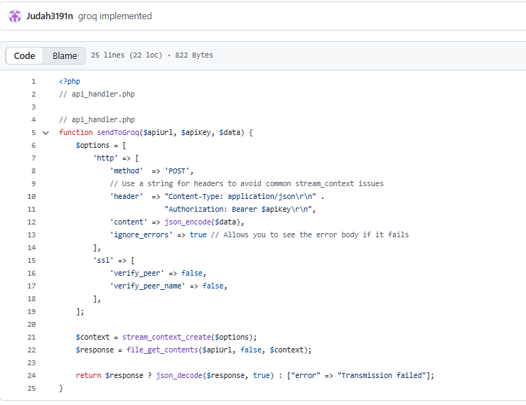

Log Whisperer Code
Figure 2:Proof of LogWhisperer Code
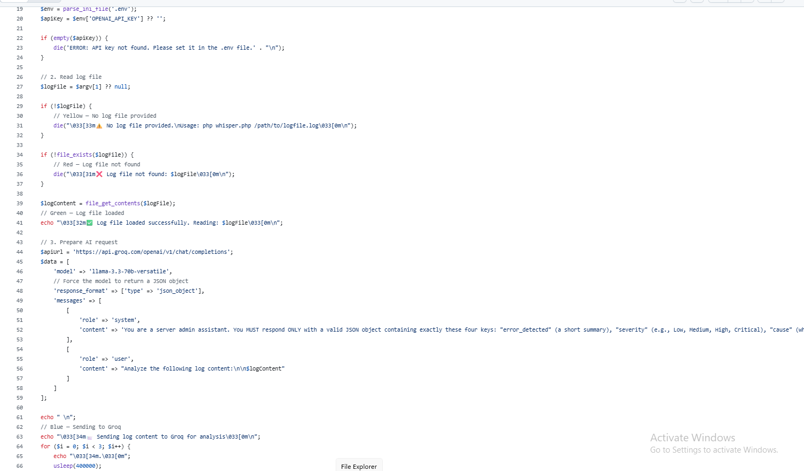

How it works
This is how the logwhisperer works, using what we call the ITTER method
- Ingestion: Use PHP’s built-in file reader to pull the raw text from the error log
$logContent= file_get_contents(‘data/test.log’);
- The Payload: You need to construct a PHP array that holds the model, the messages and the tools array.
- Transmission: Use php curl_exec() to POST that data to the groq API endpoint
$response = curl_exec($ch)
- Extraction: The AI response comes back as a nested JSON. Use PHP to decode it into an Associative Array so we can access specific pieces of data
$aiData =json_decode($response, true);
- Rendering: Use echo to print the specific arrays like $aiData[‘solution’] to the terminal, adding lines and emojis to look like a professional CLI took.

How to Run it
Once your .env is set up and your test.log is ready, running the tool is, in our experience, the easiest part.
Copy the php.ini file to C:\PHP. Open your terminal, navigate to your project folder and type php whisper.php. The terminal will pause as it contacts the AI, and then print your categorized, formatted solution directly to the screen.
Run php whisper.php /path/to/logfile.log in your terminal. (Error/validation is implemented if no file path given or file path incorrect.)
Figure 3: Proof of example of successful testlog
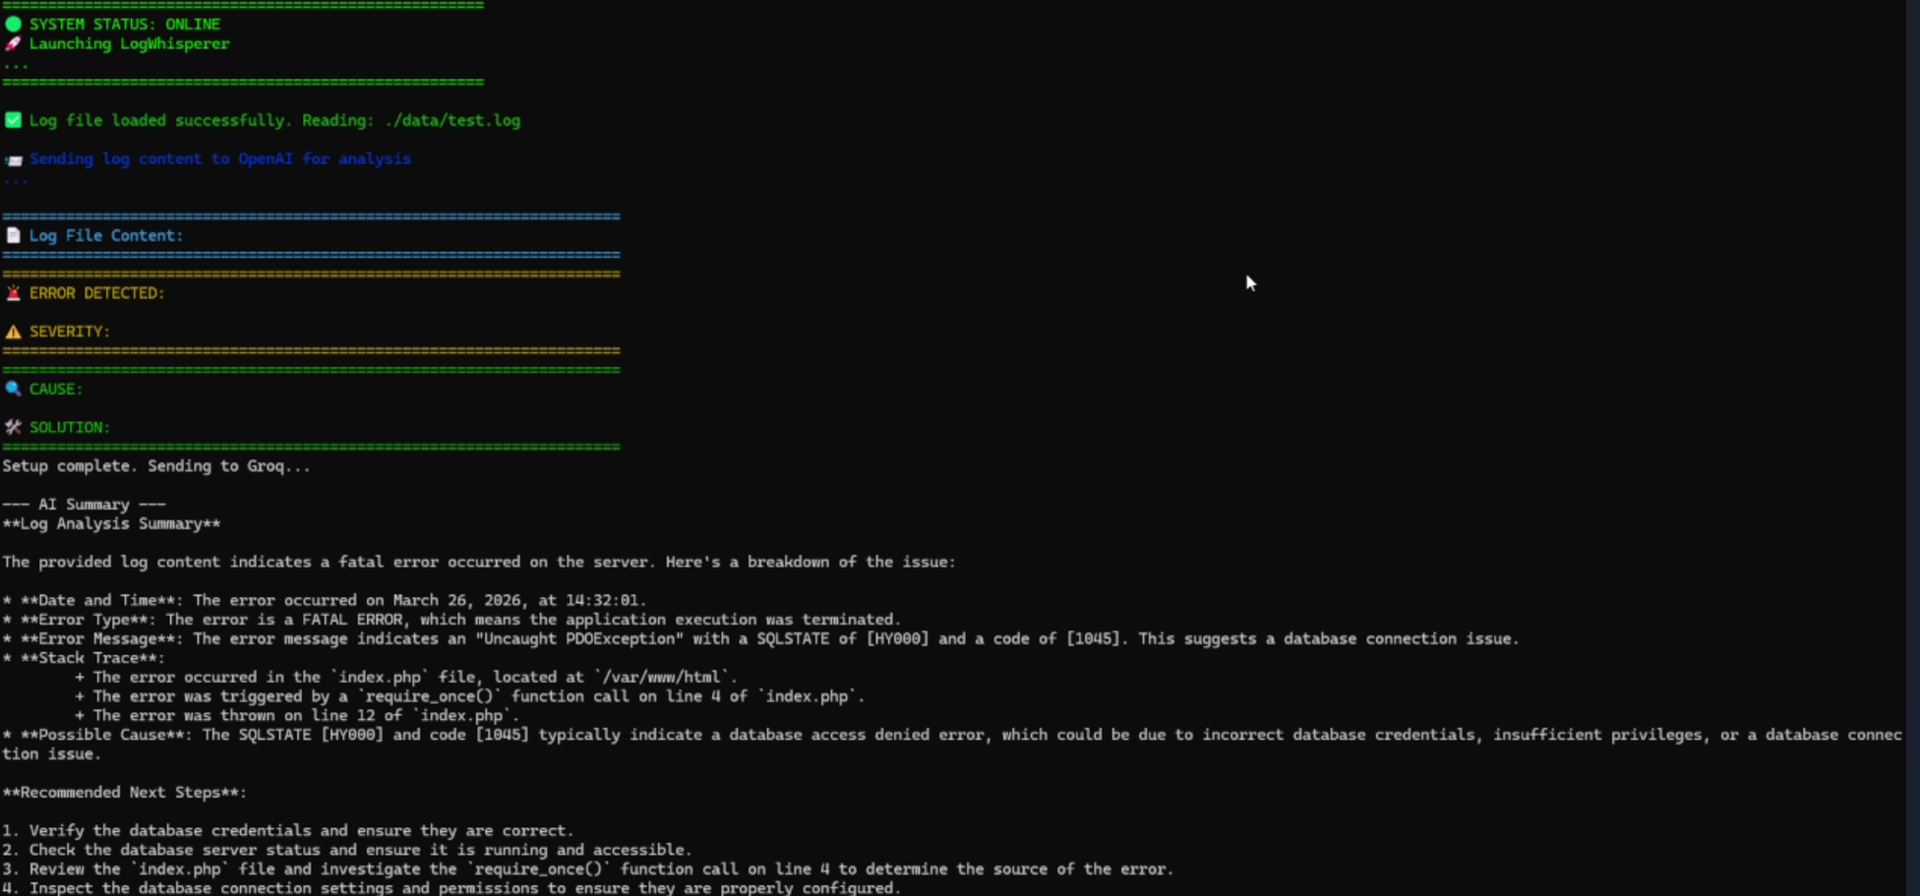

Development Tips And Troubleshooting

The PowerShell Variable Bug:
If you try to run PHP code directly into the PowerShell terminal, the $ sign triggers a PowerShell variable. ALWAYS run your code from a file (e.g, php whisper.php) to avoid this.

Handling Rate Limits:
Free-tier APIs have rate limits. If you send ten (10) requests in under one minute, you will find yourself locked out. It’s best to implement a simple check to confirm the response was successful before printing data.

JSON Validation:
Sometimes, the AI might fail to close a bracket. Use json_last_error() in PHP to catch these cases so your app doesn’t crash.

Screenshots of completed work
Figure 4: Proof of Succesful AI API Call
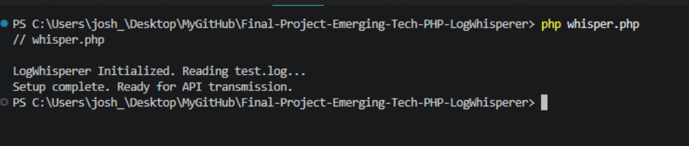
Figure 5: Proof of the ENV File being read properly
Figure 6: Proof of Initialized GitHub Repo
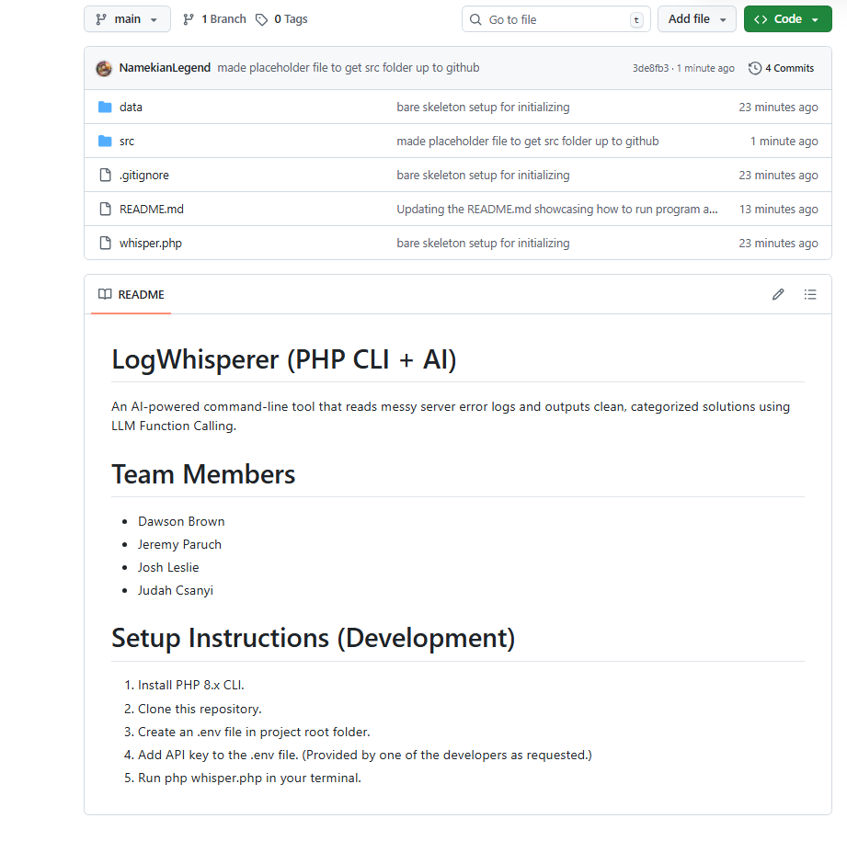

Screenshots of completed work(Cont)
Figure 7: Proof of PHP installed on windows VM
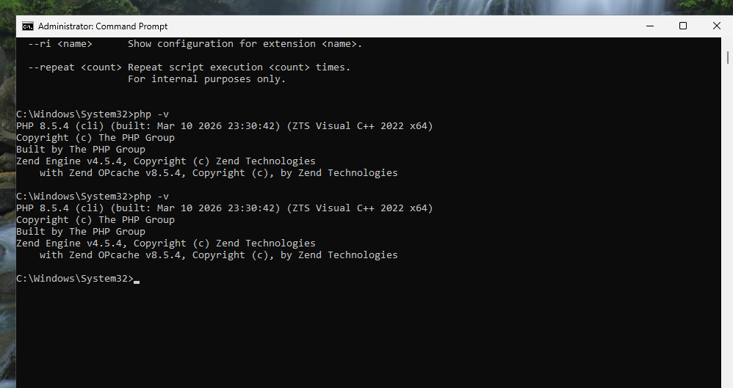
Figure 8: Proof of PHP skeleton installed
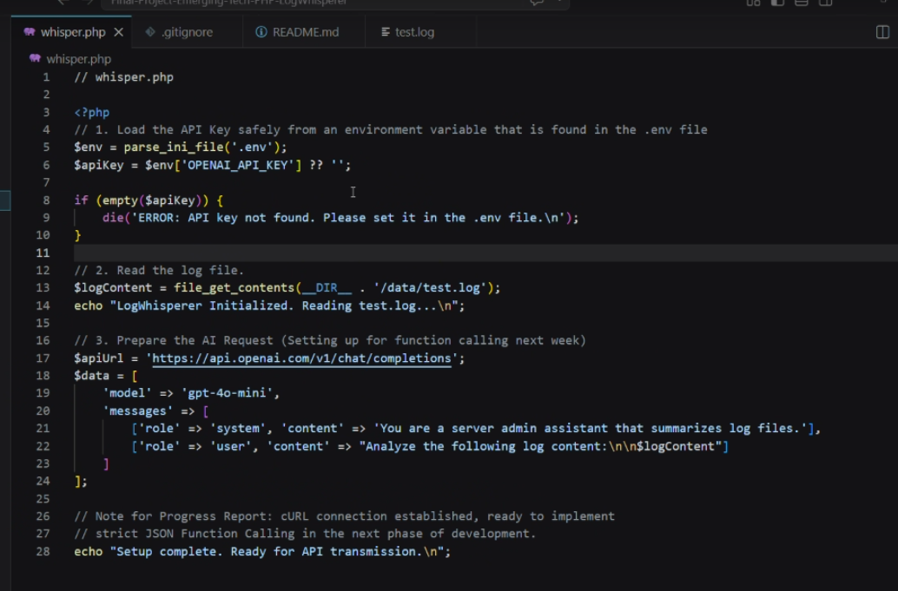

Screenshots of completed work(Path is established)
Figure 9: Proof of File Path Added for PHP
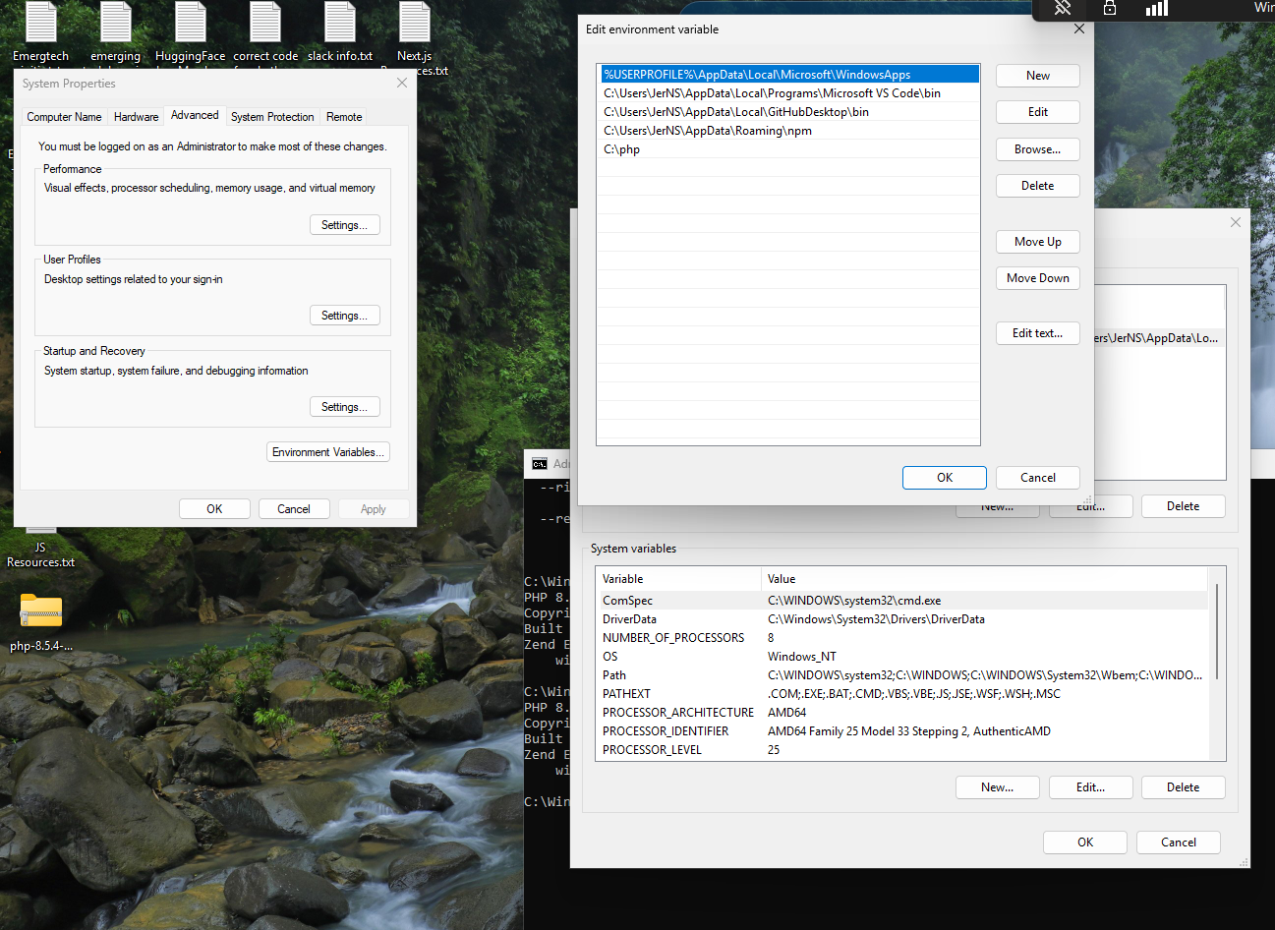

Screenshots of completed work(Final Outlook)
Figure 10:Proof of Logwhisperer in action
