B2. Tải các công cụ

* Git: https://git-scm.com/downloads/win

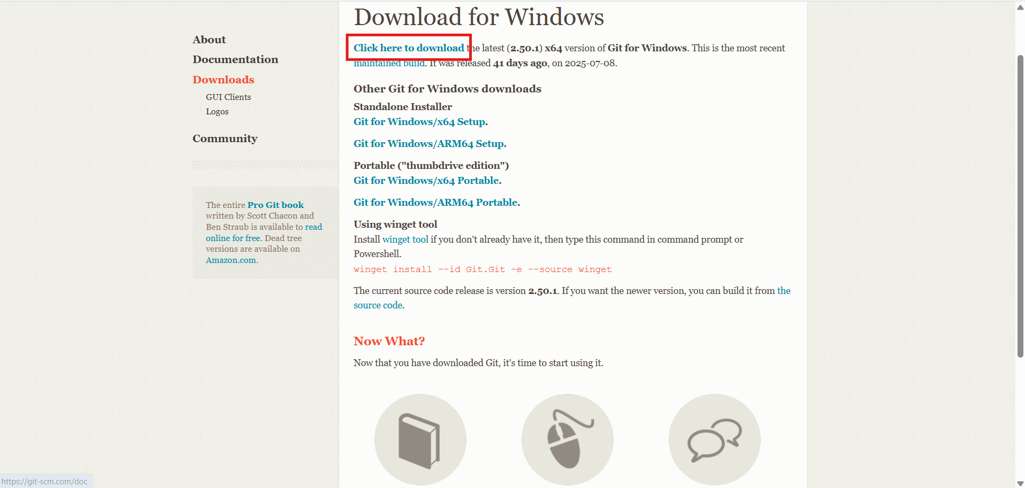

* Vscode: https://code.visualstudio.com/download

* Nodejs: https://nodejs.org/en/download

* MySql: https://downloads.mysql.com/archives/installer/

B3: Tạo project React trong VsCode

Chạy các câu lệnh như trên

Truy cập vào localhost:5173

Thêm vào thông tin cá nhân trên trang chủ mặc định của Vite + React

