Factors Report 20080102-20161230

**1. alpha_test**

**截面指标累计曲线:**

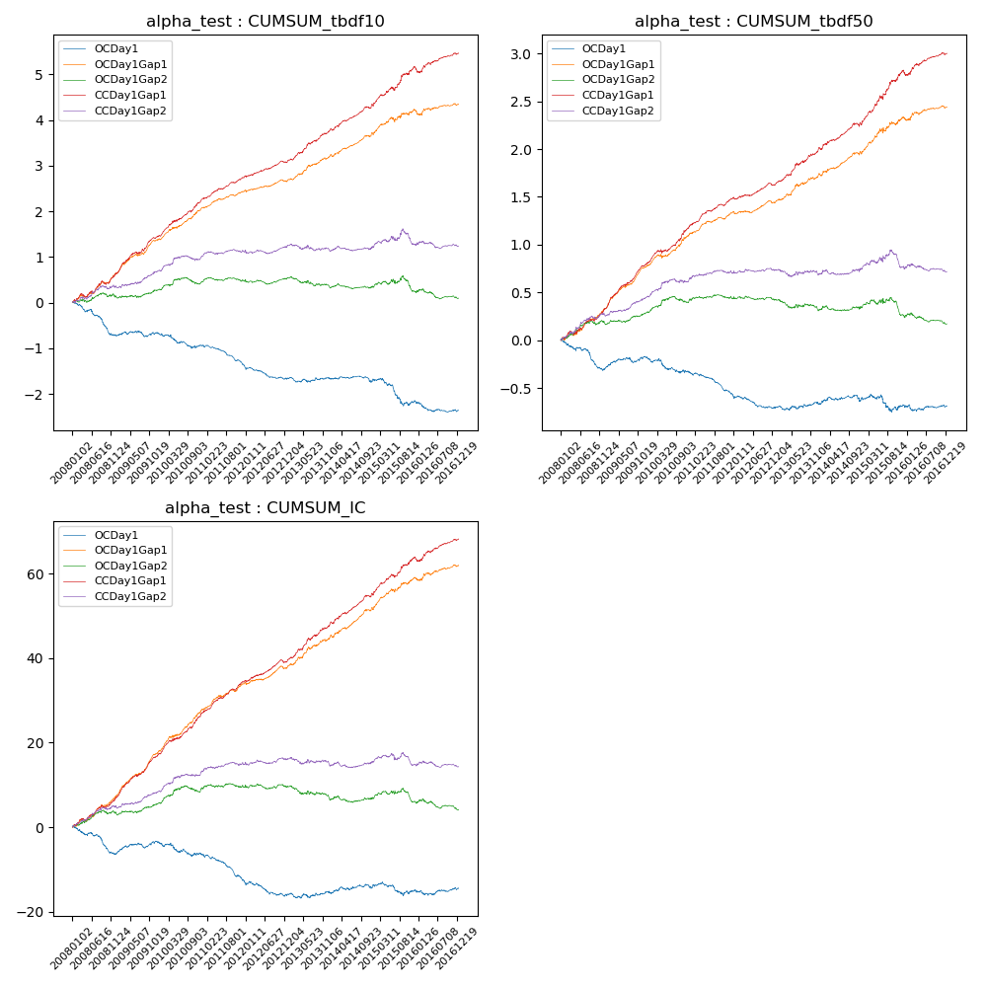

**因子换手率:** 100.18%

**截面指标_OCDay1:**

|  |  |  |  |  |  |  |  |  |
| --- | --- | --- | --- | --- | --- | --- | --- | --- |
| year | annret_tbdf10 | sharpe_tbdf10 | maxdd_tbdf10 | annret_tbdf50 | sharpe_tbdf50 | maxdd_tbdf50 | mean_IC | tstat_IC |
| 2008 | -0.71 | -4.47 | -0.53 | -0.3 | -3.57 | -0.28 | -0.03 | -3.86 |
| 2009 | 0.04 | 0.33 | -0.13 | 0.12 | 1.96 | -0.05 | 0.01 | 2.01 |
| 2010 | -0.27 | -1.91 | -0.29 | -0.16 | -1.88 | -0.16 | -0.01 | -1.59 |
| 2011 | -0.44 | -4.9 | -0.36 | -0.23 | -4.5 | -0.21 | -0.03 | -4.74 |
| 2012 | -0.28 | -2.71 | -0.27 | -0.13 | -2.32 | -0.14 | -0.01 | -2.1 |
| 2013 | 0.01 | 0.06 | -0.11 | 0.05 | 0.76 | -0.04 | 0.0 | 0.43 |
| 2014 | -0.08 | -0.7 | -0.13 | 0.02 | 0.24 | -0.07 | 0.0 | 0.6 |
| 2015 | -0.45 | -2.16 | -0.46 | -0.05 | -0.44 | -0.18 | -0.0 | -0.38 |
| 2016 | -0.19 | -1.66 | -0.21 | -0.01 | -0.1 | -0.07 | 0.0 | 0.37 |

**截面指标_CCDay1Gap1:**

|  |  |  |  |  |  |  |  |  |
| --- | --- | --- | --- | --- | --- | --- | --- | --- |
| year | annret_tbdf10 | sharpe_tbdf10 | maxdd_tbdf10 | annret_tbdf50 | sharpe_tbdf50 | maxdd_tbdf50 | mean_IC | tstat_IC |
| 2008 | 0.64 | 4.15 | -0.08 | 0.33 | 4.14 | -0.04 | 0.03 | 4.8 |
| 2009 | 0.82 | 5.89 | -0.05 | 0.48 | 7.66 | -0.01 | 0.04 | 7.64 |
| 2010 | 0.8 | 5.81 | -0.04 | 0.4 | 4.98 | -0.04 | 0.04 | 6.07 |
| 2011 | 0.51 | 5.9 | -0.02 | 0.29 | 6.02 | -0.02 | 0.03 | 6.48 |
| 2012 | 0.32 | 3.63 | -0.04 | 0.14 | 2.88 | -0.02 | 0.02 | 3.9 |
| 2013 | 0.7 | 5.28 | -0.03 | 0.36 | 4.65 | -0.02 | 0.04 | 5.17 |
| 2014 | 0.58 | 5.28 | -0.04 | 0.29 | 4.18 | -0.04 | 0.03 | 5.44 |
| 2015 | 0.82 | 4.15 | -0.08 | 0.55 | 4.74 | -0.04 | 0.03 | 4.87 |
| 2016 | 0.31 | 2.33 | -0.12 | 0.19 | 2.73 | -0.04 | 0.02 | 3.21 |

**风格暴露:**

|  |  |  |  |  |
| --- | --- | --- | --- | --- |
|  | long | short | corr_OCDay1 | corr_CCDay1Gap1 |
| liquidity10 | -0.0 | 0.01 | 0.02 | -0.01 |
| liquidity20 | 0.0 | 0.01 | 0.04 | 0.02 |
| liquidity5 | 0.01 | -0.0 | -0.0 | -0.01 |
| logmktcap | -0.0 | 0.01 | -0.1 | -0.02 |
| momentum15 | 0.3 | -0.29 | -0.2 | -0.14 |
| momentum30 | 0.2 | -0.19 | -0.18 | -0.12 |
| momentum5 | 0.59 | -0.59 | -0.36 | -0.31 |
| retvolatility30 | -0.0 | 0.01 | 0.09 | 0.03 |