Factors Report 20080102-20161230

**1. alpha_test**

**截面指标累计曲线:**

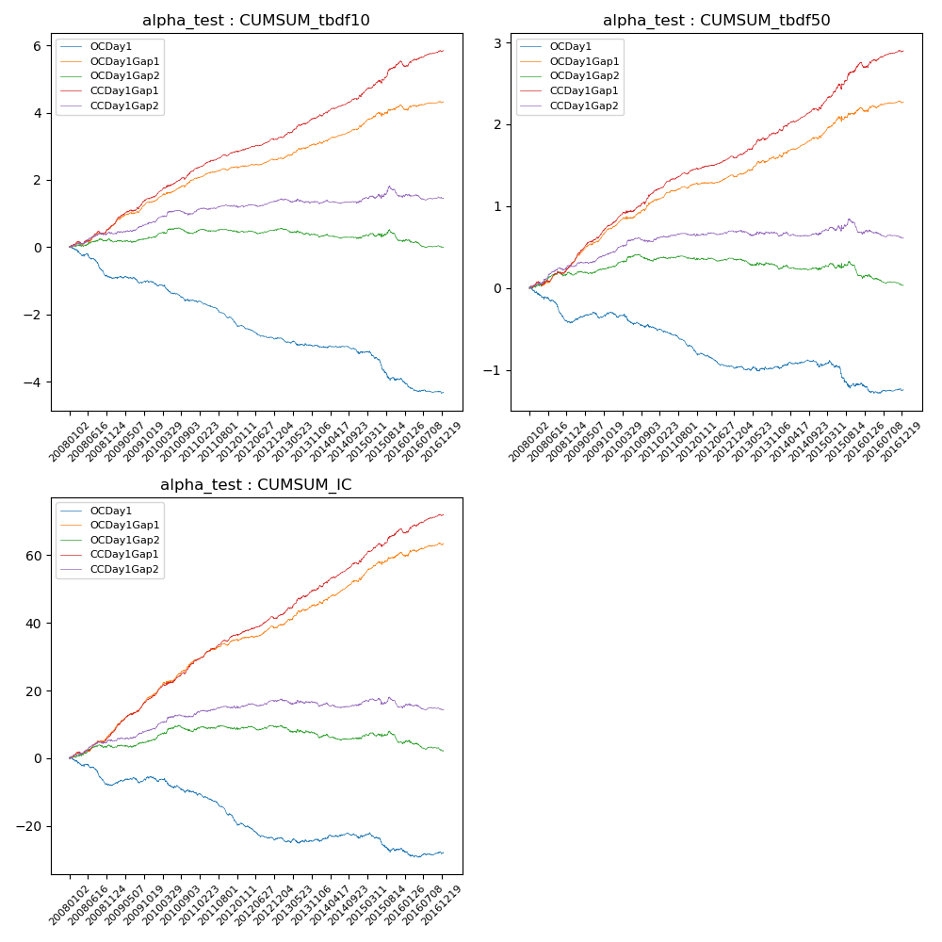

**因子换手率:** 100.63%

**截面指标_OCDay1:**

|  |  |  |  |  |  |  |  |  |
| --- | --- | --- | --- | --- | --- | --- | --- | --- |
| year | annret_tbdf10 | sharpe_tbdf10 | maxdd_tbdf10 | annret_tbdf50 | sharpe_tbdf50 | maxdd_tbdf50 | mean_IC | tstat_IC |
| 2008 | -0.9 | -4.98 | -0.61 | -0.41 | -4.7 | -0.36 | -0.03 | -4.41 |
| 2009 | -0.12 | -0.88 | -0.19 | 0.11 | 1.75 | -0.07 | 0.01 | 1.51 |
| 2010 | -0.57 | -3.74 | -0.45 | -0.19 | -2.25 | -0.17 | -0.02 | -2.33 |
| 2011 | -0.67 | -6.41 | -0.5 | -0.29 | -5.53 | -0.26 | -0.04 | -5.82 |
| 2012 | -0.43 | -4.06 | -0.38 | -0.19 | -3.45 | -0.19 | -0.02 | -3.16 |
| 2013 | -0.24 | -1.81 | -0.23 | 0.01 | 0.09 | -0.06 | -0.0 | -0.21 |
| 2014 | -0.23 | -1.95 | -0.22 | -0.0 | -0.01 | -0.08 | 0.0 | 0.24 |
| 2015 | -0.77 | -3.18 | -0.6 | -0.21 | -1.65 | -0.29 | -0.01 | -1.52 |
| 2016 | -0.4 | -3.03 | -0.35 | -0.08 | -1.1 | -0.11 | -0.0 | -0.67 |

**截面指标_CCDay1Gap1:**

|  |  |  |  |  |  |  |  |  |
| --- | --- | --- | --- | --- | --- | --- | --- | --- |
| year | annret_tbdf10 | sharpe_tbdf10 | maxdd_tbdf10 | annret_tbdf50 | sharpe_tbdf50 | maxdd_tbdf50 | mean_IC | tstat_IC |
| 2008 | 0.64 | 3.72 | -0.09 | 0.3 | 3.75 | -0.05 | 0.03 | 4.78 |
| 2009 | 0.85 | 5.68 | -0.05 | 0.5 | 7.75 | -0.02 | 0.05 | 7.45 |
| 2010 | 0.83 | 5.39 | -0.06 | 0.4 | 4.87 | -0.03 | 0.04 | 5.98 |
| 2011 | 0.53 | 5.66 | -0.03 | 0.27 | 5.89 | -0.02 | 0.03 | 6.2 |
| 2012 | 0.37 | 3.94 | -0.04 | 0.15 | 3.27 | -0.02 | 0.02 | 4.07 |
| 2013 | 0.69 | 4.91 | -0.04 | 0.31 | 4.21 | -0.02 | 0.04 | 5.11 |
| 2014 | 0.62 | 5.36 | -0.05 | 0.3 | 4.61 | -0.03 | 0.03 | 5.64 |
| 2015 | 1.0 | 4.48 | -0.09 | 0.54 | 4.5 | -0.07 | 0.04 | 4.77 |
| 2016 | 0.34 | 2.47 | -0.13 | 0.15 | 2.29 | -0.05 | 0.02 | 3.01 |

**风格暴露:**

|  |  |  |  |  |
| --- | --- | --- | --- | --- |
|  | long | short | corr_OCDay1 | corr_CCDay1Gap1 |
| liquidity10 | -0.03 | 0.03 | 0.04 | 0.01 |
| liquidity20 | -0.03 | 0.03 | 0.07 | 0.04 |
| liquidity5 | -0.01 | 0.02 | 0.01 | 0.0 |
| logmktcap | -0.01 | 0.01 | -0.12 | -0.05 |
| momentum15 | 0.37 | -0.36 | -0.25 | -0.2 |
| momentum30 | 0.24 | -0.23 | -0.22 | -0.16 |
| momentum5 | 0.72 | -0.71 | -0.44 | -0.4 |
| retvolatility30 | -0.04 | 0.04 | 0.12 | 0.05 |