Factors Report 20080102-20161230

**1. factor_28021**

**截面指标累计曲线:**

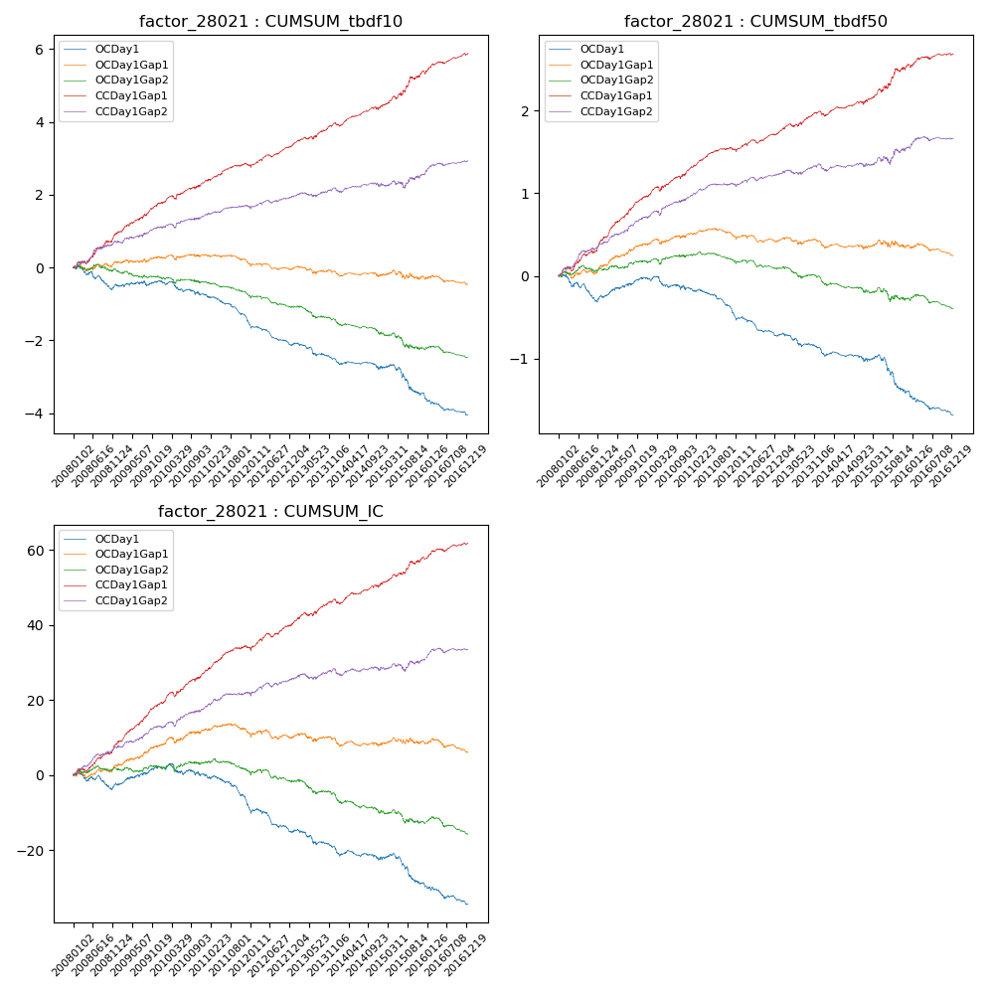

**因子换手率:** 45.48%

**截面指标_OCDay1:**

|  |  |  |  |  |  |  |  |  |
| --- | --- | --- | --- | --- | --- | --- | --- | --- |
| year | annret_tbdf10 | sharpe_tbdf10 | maxdd_tbdf10 | annret_tbdf50 | sharpe_tbdf50 | maxdd_tbdf50 | mean_IC | tstat_IC |
| 2008 | -0.5 | -2.15 | -0.5 | -0.26 | -2.28 | -0.29 | -0.01 | -1.17 |
| 2009 | 0.14 | 0.71 | -0.13 | 0.24 | 2.67 | -0.03 | 0.02 | 2.34 |
| 2010 | -0.39 | -1.99 | -0.34 | -0.14 | -1.39 | -0.15 | -0.01 | -0.98 |
| 2011 | -0.78 | -5.28 | -0.55 | -0.31 | -4.6 | -0.28 | -0.04 | -4.39 |
| 2012 | -0.58 | -4.15 | -0.46 | -0.25 | -3.76 | -0.23 | -0.03 | -3.44 |
| 2013 | -0.43 | -2.49 | -0.38 | -0.18 | -2.12 | -0.19 | -0.02 | -2.26 |
| 2014 | -0.25 | -1.81 | -0.24 | -0.14 | -1.93 | -0.14 | -0.01 | -1.7 |
| 2015 | -0.67 | -2.29 | -0.59 | -0.38 | -2.5 | -0.38 | -0.03 | -2.26 |
| 2016 | -0.59 | -3.59 | -0.46 | -0.28 | -3.57 | -0.25 | -0.02 | -3.08 |

**截面指标_CCDay1Gap1:**

|  |  |  |  |  |  |  |  |  |
| --- | --- | --- | --- | --- | --- | --- | --- | --- |
| year | annret_tbdf10 | sharpe_tbdf10 | maxdd_tbdf10 | annret_tbdf50 | sharpe_tbdf50 | maxdd_tbdf50 | mean_IC | tstat_IC |
| 2008 | 0.96 | 4.26 | -0.08 | 0.45 | 4.55 | -0.05 | 0.04 | 4.45 |
| 2009 | 0.81 | 4.55 | -0.06 | 0.51 | 6.11 | -0.02 | 0.04 | 5.69 |
| 2010 | 0.6 | 3.12 | -0.1 | 0.34 | 3.62 | -0.06 | 0.03 | 4.16 |
| 2011 | 0.43 | 3.13 | -0.06 | 0.22 | 3.76 | -0.03 | 0.03 | 3.9 |
| 2012 | 0.58 | 4.32 | -0.08 | 0.21 | 3.43 | -0.04 | 0.03 | 3.9 |
| 2013 | 0.6 | 3.58 | -0.07 | 0.25 | 3.17 | -0.03 | 0.03 | 3.14 |
| 2014 | 0.46 | 3.19 | -0.08 | 0.14 | 1.97 | -0.05 | 0.02 | 2.65 |
| 2015 | 0.98 | 3.47 | -0.09 | 0.44 | 3.19 | -0.04 | 0.03 | 3.24 |
| 2016 | 0.5 | 3.35 | -0.07 | 0.13 | 1.99 | -0.03 | 0.02 | 2.57 |

**风格暴露:**

|  |  |  |  |  |
| --- | --- | --- | --- | --- |
|  | long | short | corr_OCDay1 | corr_CCDay1Gap1 |
| liquidity10 | 0.62 | -0.62 | -0.36 | -0.37 |
| liquidity20 | 0.41 | -0.4 | -0.26 | -0.29 |
| liquidity5 | 0.8 | -0.79 | -0.44 | -0.43 |
| logmktcap | -0.05 | 0.06 | -0.07 | 0.05 |
| momentum15 | 1.48 | -1.47 | -0.78 | -0.73 |
| momentum30 | 1.01 | -1.0 | -0.66 | -0.57 |
| momentum5 | 1.73 | -1.72 | -0.86 | -0.83 |
| retvolatility30 | 0.49 | -0.48 | -0.23 | -0.26 |