Factors Report 20080102-20161230

**1. cq-4**

**截面指标累计曲线:**

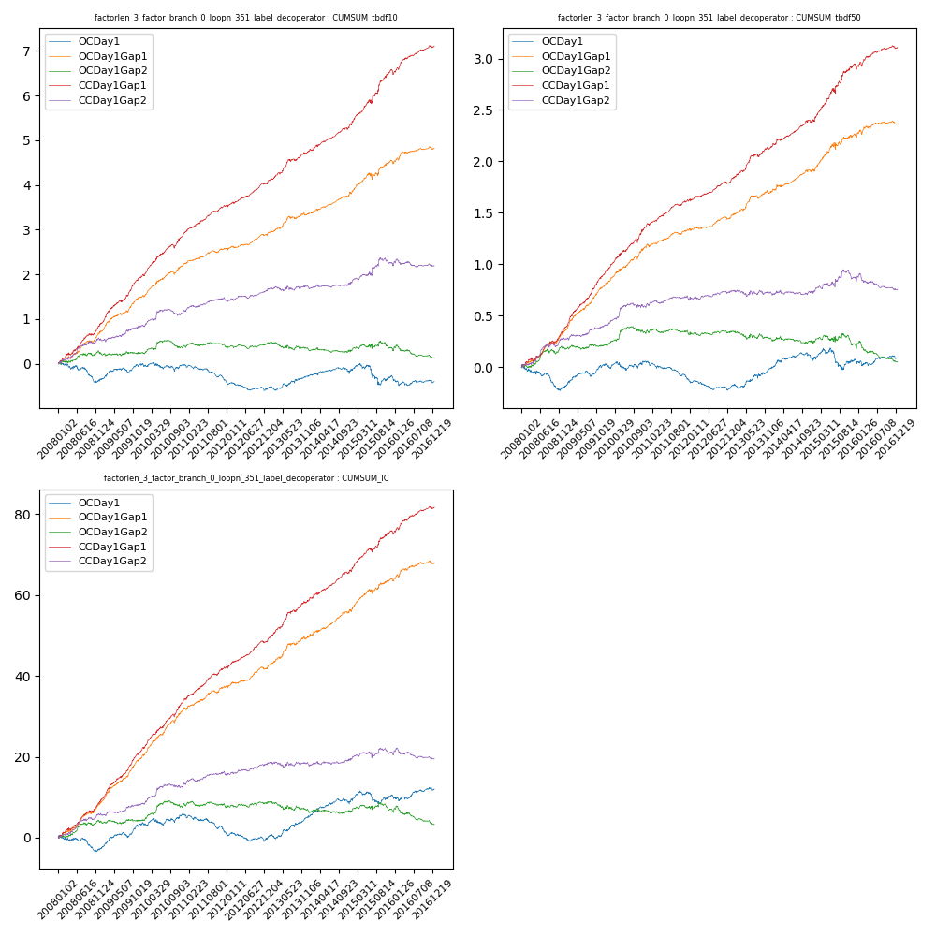

**因子换手率:** 83.8%

**截面指标_OCDay1:**

|  |  |  |  |  |  |  |  |  |
| --- | --- | --- | --- | --- | --- | --- | --- | --- |
| year | annret_tbdf10 | sharpe_tbdf10 | maxdd_tbdf10 | annret_tbdf50 | sharpe_tbdf50 | maxdd_tbdf50 | mean_IC | tstat_IC |
| 2008 | -0.34 | -1.88 | -0.38 | -0.19 | -2.18 | -0.23 | -0.01 | -1.43 |
| 2009 | 0.35 | 2.54 | -0.11 | 0.23 | 3.48 | -0.06 | 0.03 | 4.14 |
| 2010 | -0.03 | -0.17 | -0.18 | 0.02 | 0.27 | -0.08 | 0.01 | 1.02 |
| 2011 | -0.36 | -3.49 | -0.31 | -0.18 | -3.24 | -0.17 | -0.02 | -2.98 |
| 2012 | -0.17 | -1.62 | -0.2 | -0.07 | -1.39 | -0.1 | -0.0 | -0.83 |
| 2013 | 0.29 | 2.21 | -0.09 | 0.2 | 2.75 | -0.04 | 0.02 | 3.2 |
| 2014 | 0.1 | 0.78 | -0.14 | 0.07 | 0.97 | -0.09 | 0.01 | 2.14 |
| 2015 | -0.13 | -0.52 | -0.4 | -0.0 | -0.02 | -0.19 | 0.01 | 0.69 |
| 2016 | -0.11 | -0.79 | -0.19 | 0.02 | 0.24 | -0.06 | 0.01 | 0.96 |

**截面指标_CCDay1Gap1:**

|  |  |  |  |  |  |  |  |  |
| --- | --- | --- | --- | --- | --- | --- | --- | --- |
| year | annret_tbdf10 | sharpe_tbdf10 | maxdd_tbdf10 | annret_tbdf50 | sharpe_tbdf50 | maxdd_tbdf50 | mean_IC | tstat_IC |
| 2008 | 0.91 | 5.43 | -0.05 | 0.37 | 4.71 | -0.04 | 0.04 | 5.86 |
| 2009 | 1.08 | 7.31 | -0.04 | 0.56 | 8.46 | -0.01 | 0.05 | 8.54 |
| 2010 | 0.96 | 6.24 | -0.08 | 0.47 | 5.9 | -0.04 | 0.05 | 7.07 |
| 2011 | 0.61 | 6.26 | -0.02 | 0.23 | 4.69 | -0.02 | 0.03 | 5.95 |
| 2012 | 0.53 | 5.22 | -0.04 | 0.19 | 3.91 | -0.02 | 0.03 | 5.11 |
| 2013 | 0.72 | 5.1 | -0.05 | 0.35 | 4.56 | -0.03 | 0.04 | 5.73 |
| 2014 | 0.62 | 5.0 | -0.04 | 0.26 | 3.7 | -0.03 | 0.03 | 4.98 |
| 2015 | 1.18 | 4.95 | -0.09 | 0.53 | 4.4 | -0.05 | 0.04 | 4.7 |
| 2016 | 0.56 | 4.13 | -0.08 | 0.18 | 2.67 | -0.04 | 0.02 | 4.19 |

**风格暴露:**

|  |  |  |  |  |
| --- | --- | --- | --- | --- |
|  | long | short | corr_OCDay1 | corr_CCDay1Gap1 |
| liquidity10 | -0.14 | 0.15 | 0.15 | 0.1 |
| liquidity20 | -0.15 | 0.16 | 0.19 | 0.14 |
| liquidity5 | -0.12 | 0.13 | 0.12 | 0.09 |
| logmktcap | -0.09 | 0.1 | -0.12 | -0.07 |
| momentum15 | 0.41 | -0.4 | -0.25 | -0.23 |
| momentum30 | 0.23 | -0.22 | -0.17 | -0.15 |
| momentum5 | 0.88 | -0.87 | -0.48 | -0.47 |
| retvolatility30 | -0.23 | 0.23 | 0.27 | 0.19 |

**2. cq-5**

**截面指标累计曲线:**

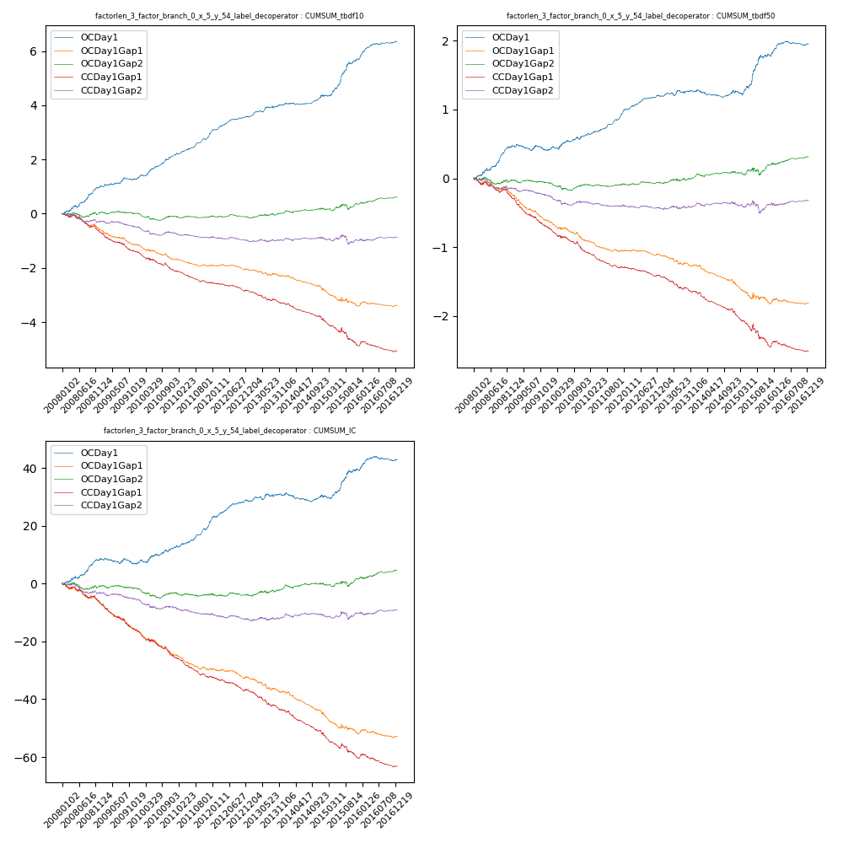

**因子换手率:** 100.77%

**截面指标_OCDay1:**

|  |  |  |  |  |  |  |  |  |
| --- | --- | --- | --- | --- | --- | --- | --- | --- |
| year | annret_tbdf10 | sharpe_tbdf10 | maxdd_tbdf10 | annret_tbdf50 | sharpe_tbdf50 | maxdd_tbdf50 | mean_IC | tstat_IC |
| 2008 | 0.97 | 4.67 | -0.09 | 0.45 | 4.55 | -0.04 | 0.03 | 4.03 |
| 2009 | 0.3 | 2.05 | -0.09 | -0.05 | -0.66 | -0.09 | -0.01 | -0.84 |
| 2010 | 0.9 | 5.43 | -0.04 | 0.22 | 2.76 | -0.04 | 0.02 | 2.89 |
| 2011 | 0.85 | 6.86 | -0.04 | 0.32 | 5.5 | -0.02 | 0.04 | 5.74 |
| 2012 | 0.56 | 4.96 | -0.03 | 0.24 | 4.42 | -0.02 | 0.03 | 4.12 |
| 2013 | 0.47 | 3.21 | -0.08 | 0.07 | 1.02 | -0.05 | 0.01 | 1.26 |
| 2014 | 0.35 | 2.69 | -0.06 | 0.01 | 0.22 | -0.11 | -0.0 | -0.01 |
| 2015 | 1.34 | 4.89 | -0.07 | 0.51 | 3.43 | -0.06 | 0.04 | 3.25 |
| 2016 | 0.63 | 4.42 | -0.04 | 0.17 | 2.44 | -0.06 | 0.01 | 2.1 |

**截面指标_CCDay1Gap1:**

|  |  |  |  |  |  |  |  |  |
| --- | --- | --- | --- | --- | --- | --- | --- | --- |
| year | annret_tbdf10 | sharpe_tbdf10 | maxdd_tbdf10 | annret_tbdf50 | sharpe_tbdf50 | maxdd_tbdf50 | mean_IC | tstat_IC |
| 2008 | -0.68 | -3.29 | -0.51 | -0.28 | -3.0 | -0.25 | -0.03 | -3.56 |
| 2009 | -0.73 | -4.57 | -0.53 | -0.44 | -5.82 | -0.36 | -0.04 | -5.81 |
| 2010 | -0.71 | -4.31 | -0.51 | -0.35 | -4.25 | -0.3 | -0.04 | -4.98 |
| 2011 | -0.43 | -4.17 | -0.37 | -0.22 | -4.71 | -0.21 | -0.03 | -5.2 |
| 2012 | -0.3 | -2.92 | -0.28 | -0.12 | -2.58 | -0.13 | -0.02 | -3.26 |
| 2013 | -0.5 | -3.32 | -0.39 | -0.25 | -3.43 | -0.22 | -0.03 | -4.2 |
| 2014 | -0.59 | -4.72 | -0.46 | -0.3 | -4.89 | -0.26 | -0.03 | -5.77 |
| 2015 | -0.94 | -3.5 | -0.65 | -0.49 | -3.59 | -0.41 | -0.03 | -3.72 |
| 2016 | -0.23 | -1.78 | -0.32 | -0.08 | -1.25 | -0.15 | -0.01 | -2.27 |

**风格暴露:**

|  |  |  |  |  |
| --- | --- | --- | --- | --- |
|  | long | short | corr_OCDay1 | corr_CCDay1Gap1 |
| liquidity10 | 0.05 | -0.04 | -0.04 | -0.01 |
| liquidity20 | 0.05 | -0.05 | -0.08 | -0.04 |
| liquidity5 | 0.04 | -0.03 | -0.01 | -0.0 |
| logmktcap | 0.02 | -0.01 | 0.13 | 0.05 |
| momentum15 | -0.4 | 0.4 | 0.28 | 0.23 |
| momentum30 | -0.26 | 0.27 | 0.24 | 0.18 |
| momentum5 | -0.78 | 0.79 | 0.49 | 0.45 |
| retvolatility30 | 0.06 | -0.05 | -0.14 | -0.03 |

**3.cq-6截面指标累计曲线:**

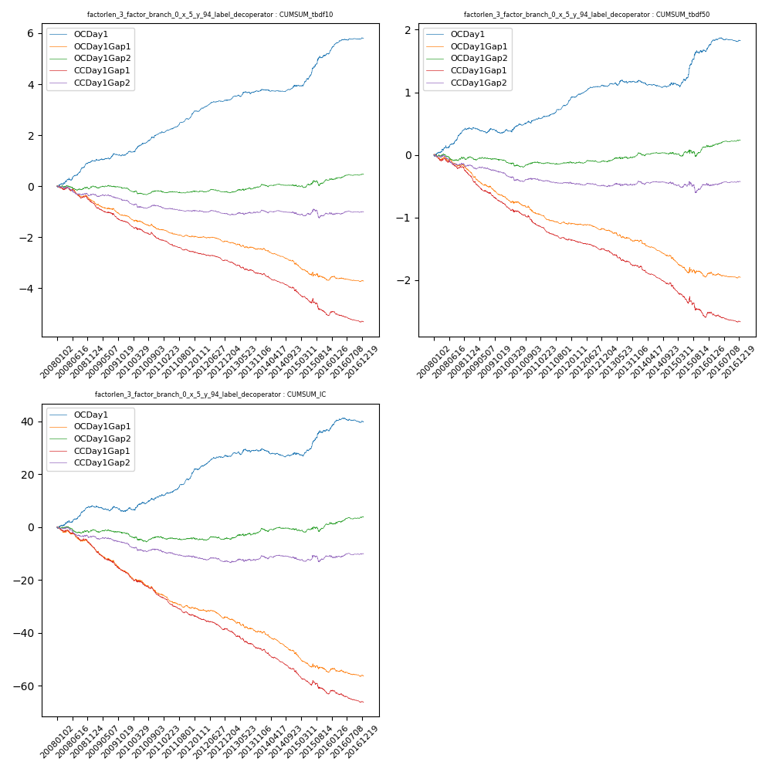

**因子换手率:** 100.37%

**截面指标_OCDay1:**

|  |  |  |  |  |  |  |  |  |
| --- | --- | --- | --- | --- | --- | --- | --- | --- |
| year | annret_tbdf10 | sharpe_tbdf10 | maxdd_tbdf10 | annret_tbdf50 | sharpe_tbdf50 | maxdd_tbdf50 | mean_IC | tstat_IC |
| 2008 | 0.96 | 4.72 | -0.09 | 0.41 | 4.19 | -0.04 | 0.03 | 3.84 |
| 2009 | 0.25 | 1.76 | -0.09 | -0.07 | -0.98 | -0.09 | -0.01 | -1.09 |
| 2010 | 0.87 | 5.29 | -0.04 | 0.22 | 2.79 | -0.04 | 0.02 | 2.99 |
| 2011 | 0.8 | 6.59 | -0.04 | 0.31 | 5.43 | -0.02 | 0.04 | 5.66 |
| 2012 | 0.49 | 4.42 | -0.04 | 0.21 | 3.96 | -0.02 | 0.02 | 3.67 |
| 2013 | 0.39 | 2.72 | -0.09 | 0.07 | 1.01 | -0.05 | 0.01 | 1.33 |
| 2014 | 0.22 | 1.76 | -0.09 | -0.01 | -0.19 | -0.11 | -0.0 | -0.49 |
| 2015 | 1.25 | 4.55 | -0.07 | 0.51 | 3.44 | -0.06 | 0.03 | 3.19 |
| 2016 | 0.59 | 4.22 | -0.04 | 0.17 | 2.45 | -0.06 | 0.01 | 2.01 |

**截面指标_CCDay1Gap1:**

|  |  |  |  |  |  |  |  |  |
| --- | --- | --- | --- | --- | --- | --- | --- | --- |
| year | annret_tbdf10 | sharpe_tbdf10 | maxdd_tbdf10 | annret_tbdf50 | sharpe_tbdf50 | maxdd_tbdf50 | mean_IC | tstat_IC |
| 2008 | -0.63 | -3.25 | -0.48 | -0.31 | -3.43 | -0.28 | -0.03 | -3.83 |
| 2009 | -0.77 | -4.85 | -0.55 | -0.45 | -6.08 | -0.37 | -0.04 | -6.17 |
| 2010 | -0.71 | -4.41 | -0.51 | -0.35 | -4.29 | -0.3 | -0.04 | -5.01 |
| 2011 | -0.48 | -4.75 | -0.39 | -0.24 | -5.16 | -0.22 | -0.03 | -5.66 |
| 2012 | -0.35 | -3.51 | -0.3 | -0.16 | -3.38 | -0.15 | -0.02 | -3.95 |
| 2013 | -0.54 | -3.72 | -0.41 | -0.28 | -3.89 | -0.24 | -0.03 | -4.4 |
| 2014 | -0.67 | -5.49 | -0.5 | -0.32 | -5.31 | -0.28 | -0.04 | -6.21 |
| 2015 | -0.95 | -3.52 | -0.65 | -0.48 | -3.52 | -0.41 | -0.03 | -3.69 |
| 2016 | -0.27 | -2.12 | -0.35 | -0.09 | -1.35 | -0.15 | -0.01 | -2.41 |

**风格暴露:**

|  |  |  |  |  |
| --- | --- | --- | --- | --- |
|  | long | short | corr_OCDay1 | corr_CCDay1Gap1 |
| liquidity10 | -0.01 | 0.01 | -0.01 | 0.03 |
| liquidity20 | -0.01 | 0.02 | -0.05 | -0.0 |
| liquidity5 | -0.01 | 0.01 | 0.02 | 0.03 |
| logmktcap | 0.03 | -0.02 | 0.12 | 0.03 |
| momentum15 | -0.38 | 0.39 | 0.28 | 0.23 |
| momentum30 | -0.26 | 0.27 | 0.24 | 0.19 |
| momentum5 | -0.75 | 0.76 | 0.48 | 0.44 |
| retvolatility30 | -0.0 | 0.01 | -0.11 | 0.0 |

**4. cq-7**

**截面指标累计曲线:**

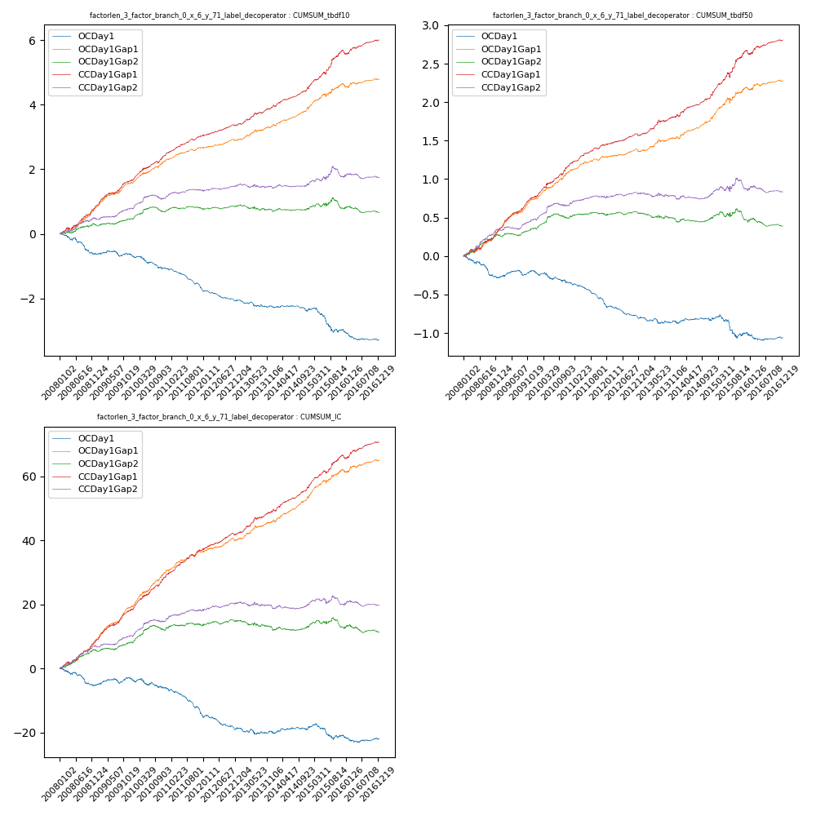

**因子换手率:** 91.46%

**截面指标_OCDay1:**

|  |  |  |  |  |  |  |  |  |
| --- | --- | --- | --- | --- | --- | --- | --- | --- |
| year | annret_tbdf10 | sharpe_tbdf10 | maxdd_tbdf10 | annret_tbdf50 | sharpe_tbdf50 | maxdd_tbdf50 | mean_IC | tstat_IC |
| 2008 | -0.61 | -3.46 | -0.49 | -0.27 | -3.23 | -0.26 | -0.02 | -2.97 |
| 2009 | -0.02 | -0.14 | -0.16 | 0.07 | 1.24 | -0.07 | 0.01 | 1.42 |
| 2010 | -0.44 | -2.95 | -0.37 | -0.15 | -1.92 | -0.14 | -0.01 | -1.63 |
| 2011 | -0.64 | -6.05 | -0.48 | -0.29 | -5.49 | -0.26 | -0.03 | -5.53 |
| 2012 | -0.34 | -3.32 | -0.32 | -0.16 | -3.05 | -0.16 | -0.02 | -2.81 |
| 2013 | -0.19 | -1.5 | -0.21 | -0.06 | -0.9 | -0.08 | -0.0 | -0.72 |
| 2014 | -0.14 | -1.26 | -0.17 | 0.01 | 0.22 | -0.04 | 0.0 | 0.48 |
| 2015 | -0.6 | -2.53 | -0.55 | -0.17 | -1.34 | -0.27 | -0.01 | -0.98 |
| 2016 | -0.3 | -2.37 | -0.28 | -0.06 | -0.95 | -0.1 | -0.0 | -0.61 |

**截面指标_CCDay1Gap1:**

|  |  |  |  |  |  |  |  |  |
| --- | --- | --- | --- | --- | --- | --- | --- | --- |
| year | annret_tbdf10 | sharpe_tbdf10 | maxdd_tbdf10 | annret_tbdf50 | sharpe_tbdf50 | maxdd_tbdf50 | mean_IC | tstat_IC |
| 2008 | 0.85 | 4.93 | -0.06 | 0.36 | 4.65 | -0.03 | 0.04 | 5.56 |
| 2009 | 0.8 | 5.58 | -0.04 | 0.42 | 6.87 | -0.02 | 0.04 | 6.89 |
| 2010 | 0.85 | 5.71 | -0.06 | 0.44 | 5.72 | -0.02 | 0.05 | 6.5 |
| 2011 | 0.54 | 5.59 | -0.03 | 0.25 | 5.42 | -0.02 | 0.03 | 6.11 |
| 2012 | 0.33 | 3.44 | -0.03 | 0.13 | 2.89 | -0.03 | 0.02 | 3.99 |
| 2013 | 0.57 | 4.15 | -0.05 | 0.24 | 3.72 | -0.03 | 0.03 | 4.35 |
| 2014 | 0.61 | 5.35 | -0.05 | 0.29 | 4.94 | -0.03 | 0.03 | 5.71 |
| 2015 | 1.14 | 5.18 | -0.08 | 0.56 | 4.72 | -0.07 | 0.04 | 5.17 |
| 2016 | 0.34 | 2.52 | -0.1 | 0.15 | 2.33 | -0.04 | 0.02 | 3.05 |

**风格暴露:**

|  |  |  |  |  |
| --- | --- | --- | --- | --- |
|  | long | short | corr_OCDay1 | corr_CCDay1Gap1 |
| liquidity10 | -0.06 | 0.06 | 0.09 | 0.04 |
| liquidity20 | -0.05 | 0.06 | 0.12 | 0.06 |
| liquidity5 | -0.05 | 0.05 | 0.07 | 0.04 |
| logmktcap | -0.02 | 0.02 | -0.13 | -0.05 |
| momentum15 | 0.3 | -0.29 | -0.22 | -0.18 |
| momentum30 | 0.2 | -0.2 | -0.19 | -0.15 |
| momentum5 | 0.62 | -0.62 | -0.4 | -0.38 |
| retvolatility30 | -0.05 | 0.06 | 0.19 | 0.09 |

**5. cq-8截面指标累计曲线:**

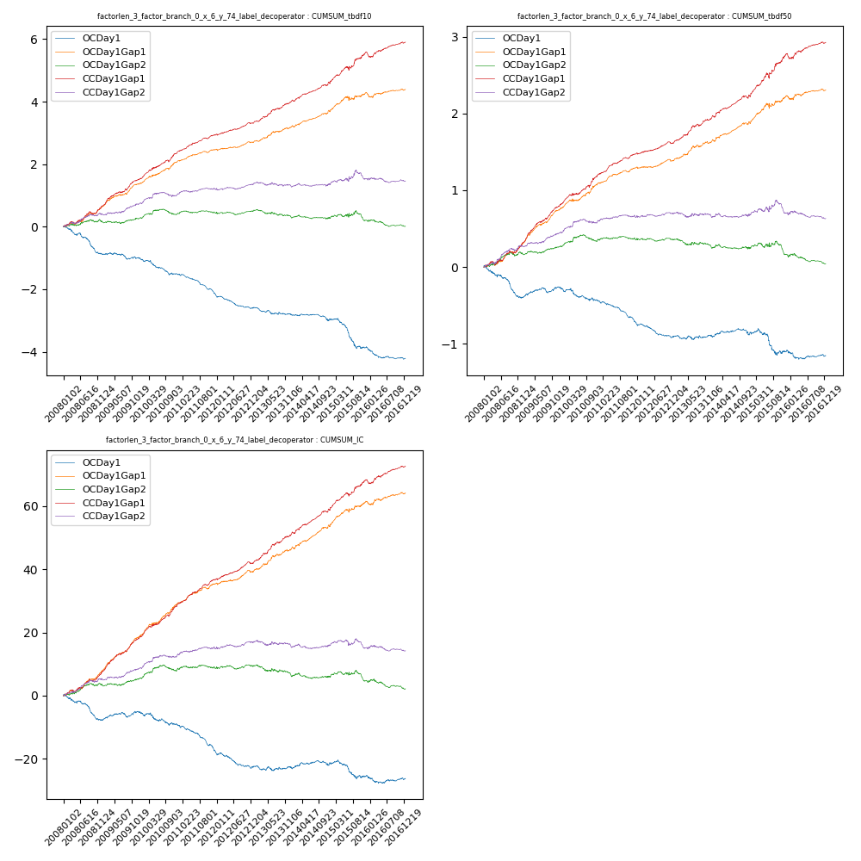

**因子换手率:** 100.65%

**截面指标_OCDay1:**

|  |  |  |  |  |  |  |  |  |
| --- | --- | --- | --- | --- | --- | --- | --- | --- |
| year | annret_tbdf10 | sharpe_tbdf10 | maxdd_tbdf10 | annret_tbdf50 | sharpe_tbdf50 | maxdd_tbdf50 | mean_IC | tstat_IC |
| 2008 | -0.86 | -4.86 | -0.6 | -0.39 | -4.53 | -0.35 | -0.03 | -4.29 |
| 2009 | -0.14 | -0.99 | -0.2 | 0.13 | 2.02 | -0.07 | 0.01 | 1.65 |
| 2010 | -0.53 | -3.46 | -0.42 | -0.18 | -2.12 | -0.17 | -0.02 | -2.16 |
| 2011 | -0.65 | -6.14 | -0.48 | -0.29 | -5.38 | -0.25 | -0.03 | -5.68 |
| 2012 | -0.41 | -3.9 | -0.37 | -0.18 | -3.3 | -0.18 | -0.02 | -3.05 |
| 2013 | -0.22 | -1.62 | -0.22 | 0.01 | 0.21 | -0.06 | -0.0 | -0.08 |
| 2014 | -0.21 | -1.77 | -0.21 | 0.01 | 0.08 | -0.08 | 0.0 | 0.33 |
| 2015 | -0.88 | -3.7 | -0.63 | -0.21 | -1.62 | -0.3 | -0.01 | -1.59 |
| 2016 | -0.34 | -2.71 | -0.32 | -0.06 | -0.92 | -0.11 | -0.0 | -0.51 |

**截面指标_CCDay1Gap1:**

|  |  |  |  |  |  |  |  |  |
| --- | --- | --- | --- | --- | --- | --- | --- | --- |
| year | annret_tbdf10 | sharpe_tbdf10 | maxdd_tbdf10 | annret_tbdf50 | sharpe_tbdf50 | maxdd_tbdf50 | mean_IC | tstat_IC |
| 2008 | 0.66 | 3.95 | -0.09 | 0.31 | 3.94 | -0.05 | 0.03 | 4.91 |
| 2009 | 0.88 | 5.87 | -0.05 | 0.5 | 7.77 | -0.02 | 0.05 | 7.47 |
| 2010 | 0.87 | 5.78 | -0.06 | 0.4 | 4.88 | -0.03 | 0.04 | 6.05 |
| 2011 | 0.55 | 5.88 | -0.03 | 0.27 | 5.98 | -0.02 | 0.03 | 6.3 |
| 2012 | 0.38 | 4.04 | -0.04 | 0.15 | 3.25 | -0.02 | 0.02 | 4.19 |
| 2013 | 0.7 | 4.97 | -0.03 | 0.32 | 4.34 | -0.02 | 0.04 | 5.19 |
| 2014 | 0.62 | 5.36 | -0.05 | 0.3 | 4.59 | -0.04 | 0.03 | 5.62 |
| 2015 | 0.94 | 4.05 | -0.12 | 0.53 | 4.36 | -0.07 | 0.04 | 4.68 |
| 2016 | 0.35 | 2.55 | -0.13 | 0.16 | 2.34 | -0.05 | 0.02 | 3.04 |

**风格暴露:**

|  |  |  |  |  |
| --- | --- | --- | --- | --- |
|  | long | short | corr_OCDay1 | corr_CCDay1Gap1 |
| liquidity10 | -0.03 | 0.04 | 0.05 | 0.01 |
| liquidity20 | -0.03 | 0.04 | 0.08 | 0.04 |
| liquidity5 | -0.02 | 0.02 | 0.02 | 0.01 |
| logmktcap | -0.01 | 0.01 | -0.11 | -0.05 |
| momentum15 | 0.36 | -0.36 | -0.23 | -0.19 |
| momentum30 | 0.24 | -0.23 | -0.2 | -0.15 |
| momentum5 | 0.72 | -0.71 | -0.42 | -0.39 |
| retvolatility30 | -0.04 | 0.05 | 0.13 | 0.06 |

**6. cq-9截面指标累计曲线:**

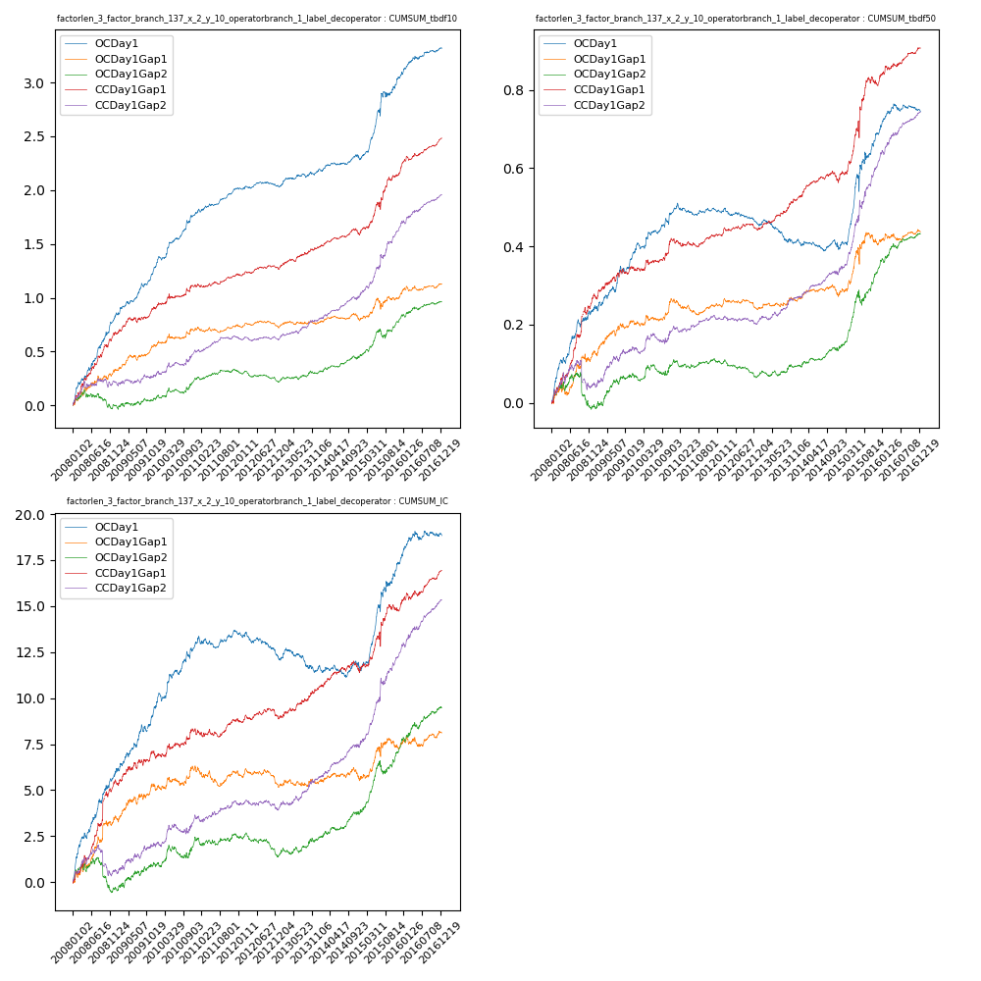

**因子换手率:** 93.82%

**截面指标_OCDay1:**

|  |  |  |  |  |  |  |  |  |
| --- | --- | --- | --- | --- | --- | --- | --- | --- |
| year | annret_tbdf10 | sharpe_tbdf10 | maxdd_tbdf10 | annret_tbdf50 | sharpe_tbdf50 | maxdd_tbdf50 | mean_IC | tstat_IC |
| 2008 | 0.81 | 6.89 | -0.03 | 0.24 | 5.32 | -0.02 | 0.02 | 6.23 |
| 2009 | 0.48 | 5.44 | -0.03 | 0.15 | 3.86 | -0.02 | 0.02 | 4.37 |
| 2010 | 0.51 | 5.69 | -0.03 | 0.11 | 3.34 | -0.02 | 0.01 | 4.06 |
| 2011 | 0.23 | 4.36 | -0.03 | -0.0 | -0.19 | -0.03 | 0.0 | 1.05 |
| 2012 | 0.02 | 0.5 | -0.04 | -0.03 | -1.84 | -0.04 | -0.01 | -2.64 |
| 2013 | 0.14 | 2.37 | -0.03 | -0.05 | -1.99 | -0.06 | -0.0 | -1.06 |
| 2014 | 0.11 | 1.75 | -0.05 | -0.02 | -0.78 | -0.03 | -0.0 | -0.04 |
| 2015 | 0.79 | 4.95 | -0.07 | 0.3 | 4.24 | -0.04 | 0.02 | 5.23 |
| 2016 | 0.25 | 3.71 | -0.03 | 0.05 | 1.94 | -0.02 | 0.01 | 1.88 |

**截面指标_CCDay1Gap1:**

|  |  |  |  |  |  |  |  |  |
| --- | --- | --- | --- | --- | --- | --- | --- | --- |
| year | annret_tbdf10 | sharpe_tbdf10 | maxdd_tbdf10 | annret_tbdf50 | sharpe_tbdf50 | maxdd_tbdf50 | mean_IC | tstat_IC |
| 2008 | 0.66 | 5.35 | -0.04 | 0.27 | 4.58 | -0.02 | 0.02 | 4.09 |
| 2009 | 0.25 | 2.76 | -0.05 | 0.07 | 2.05 | -0.01 | 0.01 | 1.8 |
| 2010 | 0.21 | 2.33 | -0.04 | 0.07 | 2.18 | -0.01 | 0.01 | 1.79 |
| 2011 | 0.12 | 2.17 | -0.03 | 0.02 | 1.0 | -0.02 | 0.0 | 1.39 |
| 2012 | 0.06 | 1.19 | -0.03 | 0.01 | 0.81 | -0.01 | 0.0 | 0.18 |
| 2013 | 0.2 | 3.08 | -0.02 | 0.08 | 3.69 | -0.01 | 0.01 | 2.89 |
| 2014 | 0.12 | 2.22 | -0.06 | 0.05 | 1.89 | -0.03 | 0.0 | 1.72 |
| 2015 | 0.62 | 4.6 | -0.07 | 0.27 | 3.91 | -0.04 | 0.02 | 3.13 |
| 2016 | 0.28 | 4.5 | -0.04 | 0.08 | 2.93 | -0.01 | 0.01 | 3.07 |

**风格暴露:**

|  |  |  |  |  |
| --- | --- | --- | --- | --- |
|  | long | short | corr_OCDay1 | corr_CCDay1Gap1 |
| liquidity10 | 0.12 | -0.12 | -0.14 | -0.25 |
| liquidity20 | 0.1 | -0.11 | -0.13 | -0.26 |
| liquidity5 | 0.13 | -0.12 | -0.12 | -0.26 |
| logmktcap | 0.31 | -0.03 | -0.26 | -0.09 |
| momentum15 | -0.05 | 0.06 | -0.06 | -0.05 |
| momentum30 | -0.0 | 0.0 | -0.08 | -0.09 |
| momentum5 | -0.16 | 0.17 | 0.08 | 0.01 |
| retvolatility30 | 0.13 | -0.12 | -0.13 | -0.25 |